FINAL YEAR PROJECT REPORT
Explainable Accounting-Fraud Detection
An extension of Bao, Ke, Li, Yu and Zhang (Journal of Accounting Research, 2020): from the base paper, through every stage of improvement, to results and future scope
Headline | Result
ROC AUC, test years 2003-2012 | 0.705 (paper baseline) → 0.748 (this project)
Frauds caught in the top 5% of the ranking | 9.8% → 15.1%
Evaluation rules | Same as the paper: expanding window, 2-year gap, serial-fraud masking
Explanations | SHAP on all four deployed models, with an audit of the Transformer's

Prepared from the project repository (code, protocols, result files and the two slide decks), November 2026.

Contents
1. Summary 3
2. The problem 3
3. The base paper 4
4. Literature review 5
5. Project workflow 6
6. Stage 0: rebuilding the base paper 6
7. Improvements, stage by stage 7
8. What was tested and rejected 12
9. Why the features are fixed, not dynamic 13
10. Results 15
11. Limitations 17
12. Scope for future improvement 18
13. Reproducibility and deliverables 20
14. Conclusion 20
Appendix A. Protocols and what each decided 21
Appendix B. Glossary 21

If the page numbers look out of date, right-click the list in Word and choose Update Field.

1. Summary
Accounting fraud is rare, costly and hard to see from the outside. Bao et al. (2020) showed that a machine-learning model, trained on 28 raw accounting items, can rank U.S. public firms by their risk of being charged with fraud by the SEC. This project rebuilt that model, found five things it leaves open, and closed them step by step, measuring every change under the same strict rules the paper uses.
What was achieved
Reproduced the paper's baseline in Python (ROC AUC 0.705 to 0.724, against about 0.72 reported).
Raised ROC AUC from 0.705 to 0.748 on test years 2003-2012, and the share of frauds caught in the top 5% from 9.8% to 15.1%. Both gains are significant under a bootstrap clustered by fraud case.
Added what the paper lacks: scale-free features, an investigation-budget decision step, calibrated probabilities, confidence intervals, SHAP explanations for every model, and a scorer for new firms.
Tested 20+ further ideas fairly under rules written before any run, including 12 ways of choosing or generating features dynamically. Most failed, and the failures are reported.

What the project does not claim. The AUC stays below 0.8, and the report explains why (Section 10.5). The model is a tool for prioritising investigations, not a fraud detector: at a 1% review budget about 98 of every 100 flagged firms are not labelled fraud. The last two improvements are small and are labelled “promising, not confirmed”.
How to read this report. Sections 2 to 5 cover the problem, the base paper, the literature and the workflow. Sections 6 and 7 cover the rebuild and the improvements in stages. Section 8 covers the ideas that were tested and rejected, and Section 9 the argument for a fixed feature set. Sections 10 to 12 cover results, limits and future scope.

2. The problem
Regulators and auditors can investigate only a few firms a year. The useful question is therefore not “is this firm committing fraud?” but “which firms should be looked at first?”. A model that ranks firms well, and ranks the riskiest ones correctly at the very top, saves scarce investigative effort.
Fraud labels are the SEC's Accounting and Auditing Enforcement Releases (AAERs). A firm-year is labelled fraud if an AAER covers it. This brings three difficulties that shape the whole project:
- Extreme imbalance. Only 0.66% of firm-years are fraud.
- Late and incomplete labels. Fraud is usually discovered years later, so recent years look cleaner than they are. In the data, test-year frauds fall from 69 in 2003 to 4 in 2014.
- Dependence between rows. A fraud case often spans several years of one firm, so rows are not independent, and a model can “remember” a firm instead of learning fraud patterns.

3. The base paper
Bao, Ke, Li, Yu and Zhang (2020), “Detecting Accounting Fraud in Publicly Traded U.S. Firms Using a Machine Learning Approach”, Journal of Accounting Research 58(1).

3.1 What the paper does
Element | Choice in the paper
Goal | Rank U.S. public firms by the risk of SEC fraud enforcement, one year ahead
Data | Compustat annual fundamentals, fiscal years 1991-2014: 146,045 firm-years from 18,444 firms; 964 fraud firm-years in 412 AAER cases (base rate 0.66%)
Inputs | 28 raw accounting items (assets, sales, receivables, debt and so on) chosen from accounting theory, instead of hand-made ratios
Model | RUSBoost: boosted trees with random under-sampling of the majority class, built for rare events. 300 trees, minimum leaf size 5, learning rate 0.1, non-fraud under-sampled to 1:1 in every round (MATLAB fitensemble)
Tuning | Train on 1991-1999, validate on 2001; grid over the number of learners
Benchmarks | Dechow et al. (2011) F-score, a logistic model on 14 expert ratios; Cecchini et al. (2010) support vector machine with a financial kernel
Metrics | AUC, plus NDCG@k, sensitivity@k and precision@k, which judge the top of the ranking
Table 1. The base paper in one table.

3.2 How the paper tests: three rules that prevent leakage
- Expanding window. For each test year T, train on all years up to T minus 2 and test on T. The window grows by a year each time, as a regulator would use it.
- Two-year gap. Year T minus 1 is left out of training because its frauds are usually not public yet.
- Serial-fraud masking. A fraud case that continues into the test year is removed from training, so the model cannot memorise the firm.
This project keeps all three rules unchanged. That is what makes every number here comparable with the paper, and it is also why the AUC is lower than in papers that use weaker rules (Section 10.5).

3.3 What the paper found
RUSBoost on 28 raw items reached an AUC of about 0.72 over test years 2003-2008, ahead of the logistic F-score (about 0.69) and the support vector machine (about 0.63), and it also won at the top of the ranking (NDCG@1%). The result held for a one-year gap and alternative test windows.
The paper's figures here are recalled from its Table 3 and are approximate. Check them against the paper before citing them.

3.4 Limits the authors acknowledge
- Only SEC-caught fraud is labelled, so “clean” firms include undetected fraud.
- Labels keep arriving for years after the fact.
- The model ranks firms. It does not decide who is guilty.

4. Literature review
The works below are the ones this project builds on, uses or tests. AUC values for the earlier benchmarks are approximate, as reported in Bao et al.
Year | Work | What it contributes | Role in this project
2010 | Cecchini, Aytug, Koehler and Pathak | Support vector machine with a financial kernel for management fraud (AUC about 0.63) | Benchmark that the base paper beats
2011 | Dechow, Ge, Larson and Sloan | F-score: a logistic model on 14 expert financial ratios (AUC about 0.69); AAER-based fraud setting | Benchmark; source of the 14 ratios the project keeps
2017 | Lundberg and Lee | SHAP: consistent, per-prediction explanations of model output | Method used to explain every deployed model
2020 | Bao, Ke, Li, Yu and Zhang | RUSBoost on 28 raw items beats both benchmarks (AUC about 0.72) | The base paper that is rebuilt and extended
2021 | Bertomeu, Cheynel, Floyd and Pan | Audit, governance and market variables add predictive signal | Motivated the market features; audit data is future work
2021 | Erion et al. | Expected gradients, a SHAP-type method for neural networks | Explains the Temporal Transformer
2023 | Zhang et al. (OpenFE), ICML | Automatic feature generation by expand-and-reduce | Own time-ordered implementation tested and rejected
2005-2010 | Ding and Peng; Kursa and Rudnicki; Meinshausen and Buhlmann | mRMR, Boruta shadow features and stability selection | Three of the 10 dynamic selection families tested
Table 2. Literature positioned against the project.

4.1 Where the field stood, and the gaps
Earlier work used hand-built ratios and linear or kernel models. Bao et al. replaced the ratios with raw items and a boosted-tree ensemble and gained clearly. Rebuilding their pipeline line by line exposed five places where it stops short:
Gap | What is missing in the paper | Fix in this project
1. Scale bias | Raw dollar items (assets, sales, share price) let firm size drive the score | Scale-free ratios, each ranked within its own fiscal year
2. A black box | 300 boosted trees give no reason for a flag | SHAP explanation from every deployed model
3. No decision step | A ranking only: no cutoff, no confusion matrix, no usable probability | Precision, recall and lift at 1%, 2% and 5% budgets; calibrated probability
4. Thin statistics | Differences between models are reported without confidence intervals, although fraud cases span years | Paired bootstrap clustered by AAER case and by firm
5. Not deployable | No way to score new firms; later training years have incomplete labels | A model trained to 2010 and a scoring script
Table 3. Five gaps and the matching fix.

5. Project workflow
The pipeline (run_pipeline.py and the src/ package) runs in six steps, from raw filings to an explained score.
Step | What happens | Detail
1. Data | Compustat fundamentals joined to SEC AAER labels | 146,045 firm-years, 1991-2014; 964 fraud firm-years in 412 cases
2. Features | Scale-free ratios and within-year ranks; market signals; five-year firm history | 133 ratio and rank features plus 7 market ranks = 140
3. Models | LightGBM, XGBoost, logistic regression and a Temporal Transformer | Scores are ranked within each year and averaged
4. Evaluation | Train on the past, test on a later year | Expanding window, 2-year gap, serial-fraud masking; test years 2003-2012
5. Explain | SHAP on all four members | Sample of 2012-2014 at the real base rate
6. Deploy | Calibrated probability and a scoring script | Model trained on 1991-2010; score_new_data.py
Table 4. The six workflow steps.

5.1 Tuning discipline
All model choices (hyper-parameters, feature set, which models join the ensemble) are made on rolling-origin folds that validate on 1999, 2000 and 2001, using fiscal years before 2003 only. The test years never influence a choice. Winsorising is refit on every expanding training window, so no fixed 1991-2001 caps leak into later years. Test years with fewer than 15 labelled frauds (2013 with 11, 2014 with 4) are listed but excluded from averages and bootstraps.

5.2 Rules written first
Every experiment after the rebuild has a protocol file written before its first run (experiments/PROTOCOL*.md). Each fixes the candidates, the validation gate, the adoption rule and the metrics. No threshold or candidate changed after results were seen, and failed candidates are reported, not dropped. Section 8 and Appendix A list all of them.

6. Stage 0: rebuilding the base paper
The authors published their MATLAB settings and data. The project re-implemented RUSBoost in Python from those settings: 300 trees, minimum leaf 5, learning rate 0.1, 1:1 under-sampling in each round, and MATLAB's boosting default of 10 splits per tree. It was run on the same data and under the same protocol.
Version | ROC AUC | Note
Paper (as reported) | about 0.72 | 2003-2008 test years
Rebuild, paper tree settings (10 splits per tree) | 0.705 | 2003-2012; used as the baseline from here on
Rebuild, deeper trees (an earlier version of this repo) | 0.724 | 2003-2014; a stronger baseline that the later ensemble does not beat significantly
Table 5. The rebuilt baseline lands in the paper's range.
Both rebuilds bracket the paper's figure, so the baseline is trustworthy. The more conservative 0.705 is the reference for every gain reported below. Two caveats belong here: against the deeper-tree variant the ensemble's AUC gain was not significant, and the paper's own baseline is slightly stronger at the very top of the ranking (NDCG@1%).

7. Improvements, stage by stage
The improvements came in stages. Stages 1 to 3 close the five gaps. Stages 4 and 5 are two model refinements that each passed a pre-written adoption rule, and Stage 6 adds explainability. The chart shows how test AUC grew, and the table gives the validation score at each stage.
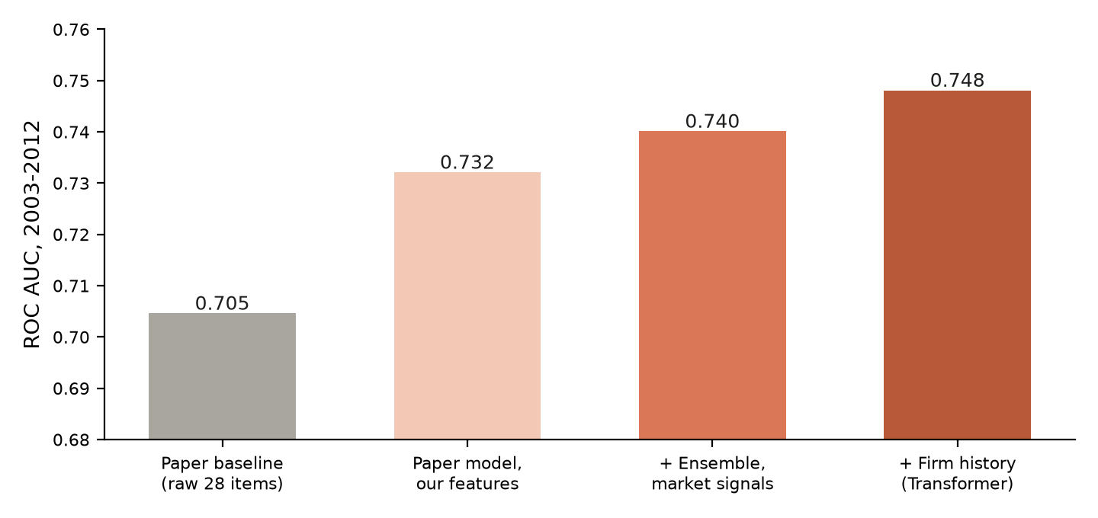
Figure 1. Test ROC AUC (2003-2012) as the project's changes are added. The axis starts at 0.68.
Stage | Change | Validation CV AUC | Test AUC 2003-2012
0 | Paper RUSBoost, raw 28 items (baseline) | 0.690 | 0.705
1 | Scale-free features, same RUSBoost | 0.736 | 0.732
2 | Balanced-bagged LightGBM + XGBoost + logistic regression | 0.760 | 0.740*
3 | Decision step, statistics, calibration, deployment | no score change | no score change
4 | + Temporal Transformer (firm history) | 0.772 | 0.743
5 | + Market features, recency weights, retuned trees | 0.787 | 0.748
6 | SHAP for all members and an audit | no score change | no score change
Table 6. The stages. Validation scores use pre-2003 folds; the test column is the mean of yearly AUC. *The 0.740 is the final configuration without the Transformer; the early Stage 2 ensemble was not scored on the test years on its own. The rows are not one clean ladder, because hyper-parameters and the market block changed between stages.

Stage 1. Scale-free features (gap 1)
The paper feeds in raw dollar amounts, so a large firm looks different from a small one for reasons unrelated to fraud. The project dropped all 28 raw items from its own model (they remain in the baseline only) and built features that do not depend on scale:
- 14 ratios from the paper (change in working capital, receivables, inventory, soft assets, issuance, book-to-market and others).
- Beneish M-score components (DSRI, GMI, AQI, SGI, DEPI, TATA, LVGI), the Altman Z-score, common-size balance-sheet ratios, growth gaps and external-financing need.
- Within-year percentile ranks of every ratio. A firm is compared with the firms of its own year, which also removes drift between 1991 and 2014.
The set was chosen on validation years only. Of four candidates, the 133-feature “enhanced + rank” set scored best:
Feature set | Features | Validation AUC (LightGBM)
Raw 28 items (paper) | 28 | 0.701
Enhanced ratios | 67 | 0.735
Ranks only | 68 | 0.743
Enhanced ratios + ranks (chosen) | 133 | 0.745
Table 7. Feature set selection on pre-2003 validation folds.
Effect. On the test years, the paper's own RUSBoost on these features alone rose from 0.705 to 0.732 (AUC gain +0.028, 95% CI +0.010 to +0.046). Most of the project's total gain comes from the features, not the model.
Caveat found later. Firm size (log sales, log assets and their ranks) still dominates the SHAP ranking even without raw dollar items. Dropping those two features would make the model size-neutral. They were kept because the paper's own features carry size. A size-neutral model is listed under future scope.

Stage 2. A tuned, balanced-bagged ensemble
RUSBoost was replaced by an ensemble of three diverse models trained on the new features:
- LightGBM and XGBoost as balanced bags: all frauds plus a 20-times sample of non-frauds in each of 10 bags. This handles the imbalance without discarding most of the data.
- Logistic regression, a simple linear model that adds diversity.
Hyper-parameters were found by random search on rolling-origin folds using pre-2003 data only: 20 trials, then 40 more per tree model, chosen by the whole ensemble's AUC. The members' scores are ranked within each test year and averaged, the same way the paper scores within a year. The paper's RUSBoost is never a member.
Candidate | Validation CV AUC
RUSBoost raw 28 (baseline) | 0.690
RUSBoost enhanced | 0.736
LightGBM | 0.746
XGBoost | 0.749
Logistic regression | 0.743
LightGBM + XGBoost | 0.751
LightGBM + XGBoost + logistic regression (chosen) | 0.760
Table 8. Ensemble selection on validation folds. The simple three-member blend won on AUC with a simplicity tie-break.

Stage 3. Decisions, statistics and deployment (gaps 3 to 5)
These changes add no AUC. They make the result usable and credible.
- Decision step. Precision, recall and lift at 1%, 2% and 5% investigation budgets, per year, with a confusion matrix at 1%. An isotonic regression turns the rank score into a calibrated fraud probability, fitted on out-of-sample 2003-2010 scores (top decile: 2.2% predicted, 2.2% observed). It saturates near 2-3%, because it is a step function fitted on 8 years.
- Honest statistics. A paired bootstrap of 1,000 resamples, clustered by AAER case for frauds and by firm for non-frauds, gives confidence intervals for AUC, NDCG@5% and Sens@5%. Clustering matters because one case contributes many correlated rows.
- Deployment. The deployable model trains on 1991-2010 only, because labels for later years are still being discovered. score_new_data.py ranks new firms against the full market cross-section of the same fiscal year, since 73 of the features and the final score are within-year ranks. It writes raw_score, risk_percentile, fraud_probability and market_size.

Stage 4. Firm history with a Temporal Transformer
Fraud builds up over several years, so the project added a member that reads each firm's last five fiscal years (68 rank features per year; an average of 3 networks). It was tested under Protocol 1, which fixed the rules in advance: the candidate had to gain at least 0.002 validation AUC, then show a significant test gain that held on all 3 seeds and in both 2003-2008 and 2009-2012, with no metric harmed.
Measure | Without | With Temporal Transformer
Validation CV AUC | 0.760 | 0.772 (+0.0126)
Test AUC, 3 seeds | 0.735 | 0.743
Gain, 95% CI | - | +0.0084 [+0.0036, +0.0135], p = 0.003
Seeds and sub-periods | - | Positive on all 3 seeds and in both sub-periods
Holm-adjusted p | - | 0.11, so “promising, not confirmed”
Table 9. The Temporal Transformer step.
Only models that read a firm's history helped. Feature-token networks that see one year at a time (FT-Transformer, TabM, Mambular) did not beat the trees, in line with recent tabular benchmarks (Section 8). A leakage audit found that every history entry is the same firm in earlier consecutive years, that a model trained on labels shuffled within each year scores 0.53 to 0.55, and that the gain holds for frauds at firms with no fraud label in training (0.757 to 0.769).

Stage 5. Market features, recency weights and retuned trees
Following Bertomeu et al. (2021), who find market variables informative, and the observation that old years describe a different world, three changes were tested together under Protocol 3 (rules fixed on 2026-11-04):
- 7 market features: within-year ranks of market-value and share-count movement, from price and share data already in the file.
- Recency weights: tree training rows lose half their weight every 3 years of age.
- Retuned trees: hyper-parameters searched for the full ensemble, not for each tree alone.
Measure | Result
Fresh-seed validation gain | +0.0145 (CV AUC 0.7723 to 0.7868)
Test AUC, 2003-2012 | 0.7433 to 0.7484 (gain +0.0051, 95% CI [+0.0003, +0.0103], p = 0.019)
Seeds and periods | Positive on all 3 seeds (+0.0047 to +0.0054); 2003-2008 +0.0072, 2009-2012 +0.0019
Holm-adjusted p | 0.17: adopted as “promising, not confirmed” and exploratory, because the test years were used before
Table 10. The Stage 5 step.
Two honest notes on Stage 5
About two thirds of the validation gain did not survive on the test years (+0.0145 against +0.0051). The candidates had been chosen on those same validation years.
Market variables can reflect a fraud becoming public, not only fraud being committed. A fall in market value may follow a disclosure, so part of the signal may be early detection rather than prediction. Shuffling the market block within each year halves the gain (+0.0145 to +0.0073), and training on shuffled labels gives AUC 0.48, so the gain is not a leak.

Stage 6. Explainability with an audit
Every member is explained directly, with no proxy model: TreeExplainer on all LightGBM and XGBoost bags, permutation SHAP for logistic regression, and expected gradients (Erion et al. 2021, the method behind shap.GradientExplainer) for the Temporal Transformer. The sample is 3,000 firm-years of 2012-2014 at the real base rate. The members are rank-averaged, so their SHAP values cannot be added together, but risk_percentile is exactly the mean of the four within-year ranks, and top_flagged_explained.csv lists each rank beside the drivers.

What drives the score
For the tree members, the top drivers are firm size, security issuance, gross PPE over assets, external financing need, investments over assets, depreciation over assets and receivables over sales. These are drivers an auditor recognises. Market-value volatility is the strongest of the new market features, 11th overall. SHAP explains what the model uses, not why a firm committed fraud, and the labels are SEC-enforced cases only.
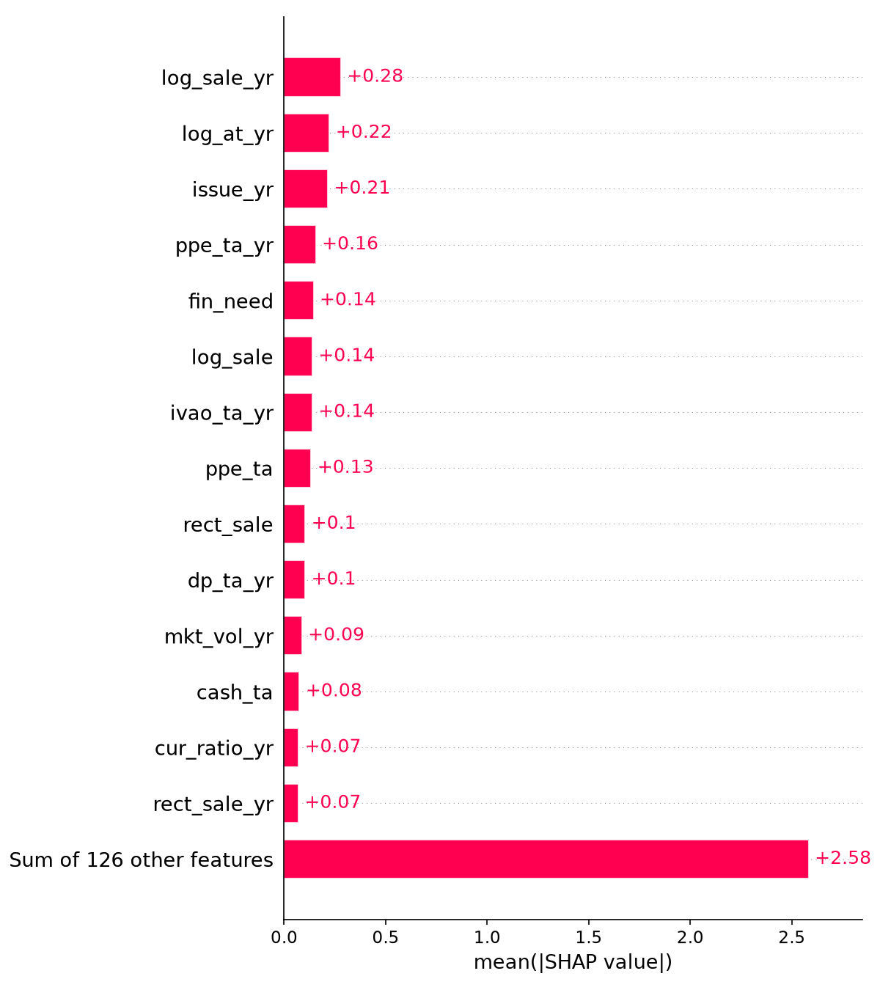
Figure 2. Mean absolute SHAP value of the leading features in the deployed tree members (results/explain/shap_bar.png).
The Temporal Transformer's top features are the rank of sales, the loss flag, and the ranks of depreciation, Altman Z, retained earnings and soft assets. Five of its top 10 are also in the trees' top 10. It puts about 38% of its attribution on the latest year and 9% on the year four earlier. Part of that slope is because older years exist for fewer firm-years (t-4 for 58%), but it remains among firm-years that have the year.

Can the Transformer's explanations be trusted?
Protocol 4 set eight checks and their limits before any attribution was computed. Seven passed, so the audit as a whole did not pass.
 | Check | Result | Limit | Verdict
A | Known answer on a linear network; missing cells get nothing | error 4.8e-07; exactly 0 | below 1e-4; exactly 0 | Pass
B | Same output and firm ranking as the deployed network | gap 9.5e-07; Spearman 0.997 | below 1e-4; at least 0.99 | Pass
C | Attributions add up to the output | median 0.004; 99th pct 0.020 | 0.01; 0.05 | Pass
D | Agrees with permutation and exact Shapley on 300 rows | 0.986; 0.974; gap 0.037 | 0.80; 0.80; 0.05 | Pass
E | Stable across reference samples and across networks | 0.984; 0.806 | 0.95; 0.70 | Pass
F | Resetting a row's top 20 cells lowers the logit more than 20 random cells | 0.962 vs 0.018 (53.6 times) | 2 times | Pass
G | Global ranking against re-initialised weights; shuffled labels | 0.425; 0.179 | 0.30; 0.50 | FAIL
H | Same result on a repeat run | difference 0.0 | below 1e-3 | Pass
Table 11. The SHAP audit of the Temporal Transformer.
What the failure means. An untrained network shares part of the real model's global feature ordering (mean Spearman 0.35 over 10 random networks, chosen after seeing the failure so it cannot overturn it). Within a firm-year, though, random networks are unrelated to the real one (median correlation −0.03), and resetting the real top 20 cells lowers the logit by 0.96 while a random network's raise it by 0.09. So firm-level explanations depend on the trained model and are the ones to rely on, while the Transformer's global ranking is indicative only. The audit changed no score. It did expose one existing problem, now fixed: the unseeded logistic-regression SHAP column changed on every run.

8. What was tested and rejected
A project that reports only its wins hides how much of its apparent improvement is noise. With only about 960 fraud firm-years and 3 validation years, differences of around 0.005 AUC between candidates are within noise. Each candidate below was frozen on validation data, gated by a fixed rule, and only then allowed to see the test years. The code for the rejected methods was removed after testing and is in git history (commits 255e803, f7c0284, 5628dd9 and a05dff8). The scores remain in results/experiments/.

8.1 Deep tabular models and other model families (Protocol 1)
Each candidate had to gain at least 0.002 CV AUC to advance, then pass the test-year adoption rule. Reference: LightGBM + XGBoost + logistic regression.
Candidate | CV AUC gain | Test AUC | NDCG@5% | Sens@5% | Verdict
Reference | - | 0.735 | 0.079 | 0.152 | -
+ Temporal Transformer | +0.0126 | 0.743 | 0.082 | 0.159 | Adopted
+ Temporal Mamba | +0.0041 | 0.738 | 0.080 | 0.150 | Passed, weaker; not used
+ FT-Transformer | −0.0036 | 0.728 | 0.073 | 0.136 | Rejected
+ TabM | −0.0026 | 0.726 | 0.076 | 0.139 | Rejected
+ Mambular | −0.0011 | 0.729 | 0.069 | 0.130 | Rejected
Dynamic RFE (re-selected per window) | +0.0003 | 0.733 | 0.074 | 0.139 | Rejected
Focal PU XGBoost replacing XGBoost | +0.0005 | 0.731 | 0.080 | 0.146 | Rejected
Table 12. Model candidates under Protocol 1.

8.2 Raising AUC towards 0.8 (Protocols 3 and 3b)
The project owner asked about reaching an AUC above 0.8. The target was stated as a goal, not an acceptance rule, since reaching 0.8 by leakage would be worthless. Thirteen families (market features, peer deviations, abnormal accruals, recency weights, extra learners, bigger Transformer ensembles, other blend weights, longer history, year-aware modulation, surprise features, retuned trees, pairwise AUC loss, covariate-shift weights) were screened on validation data first.
Candidate on test years | Validation gain | Test AUC | Gain [95% CI] | Verdict
Market features + recency weights + retuned trees | +0.0145 | 0.7484 | +0.0051 [+0.0003, +0.0103] | Adopted
The same + peer deviations + Transformer × 3 | +0.0149 | 0.7482 | +0.0049 [−0.0019, +0.0121] | Rejected (p = 0.078)
The same as adopted + Transformer × 3 | +0.0141 | 0.7476 | +0.0043 [−0.0022, +0.0110] | Rejected (p = 0.095)
Table 13. The only candidates that passed validation and reached the test years.
Families that failed the validation gate, by fresh-seed gain: pairwise AUC loss +0.0013, firm surprise features −0.0001, covariate-shift weights +0.0001, 8-year history −0.0004, abnormal accruals −0.0023, six networks −0.0024, year-aware modulation −0.0028, and adding a random forest −0.0047.
Filing data also failed. Loughran-McDonald 10-K summaries, linked through the farr GVKEY-CIK table, gave industry-relative ratios +0.0014, amendment counts +0.0004, all combined −0.0001, filing timing −0.0006 and text and tone −0.0002. A trap was found before modelling: having a filing link predicts fraud on its own (flag-only AUC about 0.57), probably through survivorship of the link table. The features were therefore built with no missingness signal, and a placebo shuffle test was required. The gains above are what is left after that guard, and none reached the test years.

8.3 Automatic feature generation (Protocol 5)
Selection only chooses among existing features, so the next question was whether new features could be built automatically inside each training window. The method is an own implementation of OpenFE's expand-and-reduce, because the published package does not respect time order. It expands to 1,134 ratios and asset-scaled differences of the 28 raw items (each as a within-year rank), with an optional recursive second round, then reduces by boosting from the current model's margin on two inner folds that keep the 2-year gap, with successive halving.
Setting | Gain, seed 42 | Gain, fresh seeds (needed +0.002)
G1, one round, k = 10 / 25 / 50 | −0.0000 / +0.0002 / −0.0027 | k = 25: −0.0009
G2, two rounds, k = 10 / 25 / 50 | −0.0021 / +0.0005 / −0.0026 | k = 25: −0.0018
Table 14. Automatic feature generation. Neither family passed, so the test years were not used.
Described after the result: the chosen features change almost completely between windows and seeds (Jaccard overlap 0.02 to 0.17) and none was chosen in all 9 runs. With about 900 frauds, picking ratios out of over a thousand candidates is mostly noise. LLM-proposed features (CAAFE) were not tried because they need an external API.

9. Why the features are fixed, not dynamic
A natural question is whether the feature set should be re-selected automatically for each training window, rather than fixed. The project tested this carefully, and the answer is a design choice supported by evidence, not a shortcut. The argument has four steps.

Step 1. The set was chosen once, on validation years, as a set
The 133 features were picked as a group on 1999-2001 folds, and the 7 market ranks later under separate rules. The test years never influenced the choice, so the fixed set is not tuned to the test.

Step 2. Dynamic options were tested fairly, not dismissed
Twelve methods were run inside every training window under rules written before any run (Protocols 2 and 5): stability selection, Boruta shadow features, out-of-time permutation importance, an adversarial drift filter, mRMR, dynamic recursive feature elimination (DRFE) in three forms, importance-weighted bags, per-firm-year gates inside the Transformer, and automatic feature generation in two forms. Each needed +0.002 validation AUC on fresh seeds. None cleared the bar.
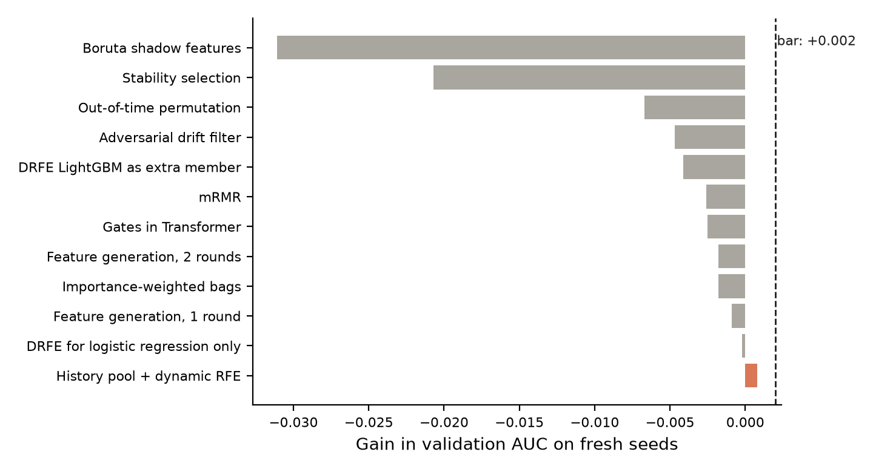
Figure 3. Every dynamic method fell short of the +0.002 bar. The best, a pool with firm-history features and DRFE, reached +0.0008.
Family (Protocol 2) | Fresh-seed CV AUC gain
Pool of 133 + 60 firm-history features, then DRFE | +0.0008
DRFE for logistic regression only | −0.0002
Soft selection: each bag samples features by importance | −0.0018
Per-firm-year gates inside the Temporal Transformer | −0.0025
mRMR | −0.0026
DRFE-subset LightGBM as an extra member | −0.0041
Adversarial drift filter | −0.0047
Out-of-time permutation importance | −0.0067
Stability selection | −0.0207
Shadow-feature test (Boruta) | −0.0311
Table 15. Ten selection families. The list is what was tried, not every method that exists.

Step 3. A direct test on the test years: no measurable difference
Protocol 6 asked a different question, non-inferiority: can selection run inside every window at no measurable cost? The best setting (pool of 140 + 60 history features, DRFE) was run on test years 2003-2012 against the current model, with a margin of 0.003 AUC fixed in advance. The verdict rules were fixed too. It is exploratory, because the test years had been used before.
Metric | Fixed 140 | Dynamic | Change | 95% CI
ROC AUC | 0.7484 | 0.7493 | +0.0008 | −0.0043 to +0.0062
NDCG@5% | 0.0836 | 0.0817 | −0.0020 | −0.0146 to +0.0080
Sens@5% | 0.1571 | 0.1574 | +0.0003 | −0.0236 to +0.0192
Prec@1% | 0.0188 | 0.0197 | +0.0009 | not computed
Table 16. Protocol 6, mean of 3 seeds. By seed the AUC change was +0.0022, +0.0003 and +0.0001; by period −0.0006 (2003-2008) and +0.0031 (2009-2012).
Verdict: inconclusive. The lower bound, −0.0043, is below −0.003 and the upper bound is above 0. The point estimate is close to zero, but the test cannot rule out a loss larger than the margin. As fixed in advance, the pipeline keeps the fixed pool. The honest summary is that dynamic selection makes no measurable difference either way. This does not prove it is no worse, and the report does not claim that.

Step 4. Fixed features are stable and explainable
The selector was unstable: for the same test year it kept between 59 and 200 features depending only on the random seed (in 2005 the three seeds chose 59, 200 and 111). Validation AUC along the elimination path is nearly flat, so the “best” point moves with the seed. The chosen subsets overlap only partly (mean Jaccard 0.70), and just 45 features were kept in all 30 runs. A different feature set in every window would also change the SHAP explanations from year to year, which makes them hard to compare and to audit.
The defensible position
Fixed features were chosen on validation data only. Dynamic alternatives were tested under pre-written rules and did not help. The best of them showed no measurable improvement on the test years. And fixed features keep explanations comparable across years.
What is still dynamic: the winsorising limits are refit on every training window, every ratio is ranked within its own fiscal year, and the models are retrained for every test year. Only the list of features is fixed.
Why selection fails here: about 960 fraud firm-years are too few to pick reliably among hundreds of candidate features, so the choice fits noise.

10. Results
Test years 2003-2012; 2013 and 2014 are excluded from averages (11 and 4 frauds). Metrics are the mean of yearly values, from one pipeline run (seed 42) unless stated. The same protocol as the paper is used throughout.

10.1 Headline
Model | AUC | NDCG@5% | Sens@5% | Prec@1% | Lift@1%
Baseline RUSBoost (raw 28) | 0.705 | 0.066 | 0.098 | 1.8% | 3.1
RUSBoost (enhanced features) | 0.732 | 0.071 | 0.127 | 1.6% | 2.7
LightGBM bagged (enhanced) | 0.730 | 0.074 | 0.142 | 1.9% | 3.5
Temporal Transformer alone | 0.721 | 0.056 | 0.103 | 1.0% | 1.4
Previous ensemble (no market, no recency weights) | 0.743 | 0.084 | 0.162 | 2.2% | 3.3
Ensemble without firm history | 0.740 | 0.085 | 0.157 | 1.7% | 2.7
Proposed ensemble (LGBM + XGB + LR + Transformer) | 0.748 | 0.081 | 0.151 | 1.9% | 2.7
Table 17. Test years 2003-2012.
Metric | Gain over baseline | 95% CI | P(gain ≤ 0)
AUC | +0.044 | [+0.025, +0.062] | 0.000
NDCG@5% | +0.015 | [−0.011, +0.042] | 0.118
Sens@5% | +0.053 | [+0.013, +0.093] | 0.003
Table 18. Paired bootstrap, clustered by AAER case and firm, 1,000 resamples. The AUC and Sens@5% gains are significant; the NDCG@5% gain is not.
For test years 2003-2008 only, the baseline scores AUC 0.705 and Sens@5% 0.090, and the proposed model 0.745 and 0.163 (AUC gain +0.040 [+0.018, +0.061]; Sens@5% gain +0.073 [+0.023, +0.121]).

10.2 Ahead in every scored year
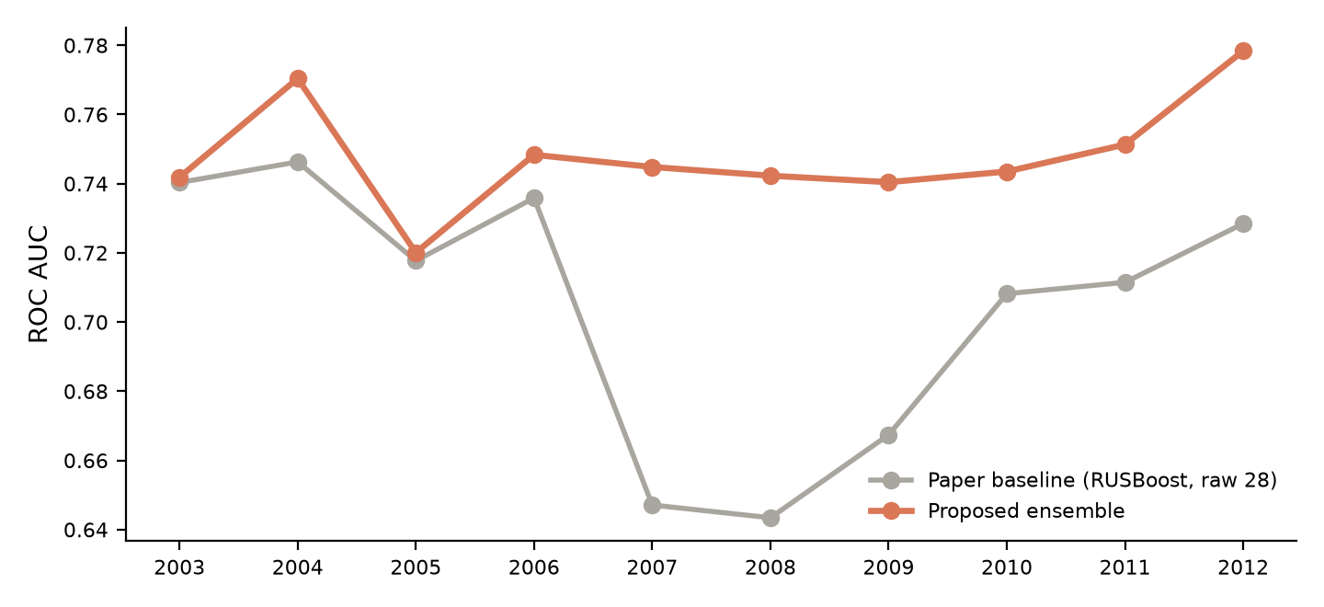
Figure 4. ROC AUC by test year. The paper baseline falls to 0.64-0.67 in 2007-2009, the financial-crisis years; the proposed model stays near 0.74.
The proposed model leads in all ten scored years. The smallest margins are 2003 and 2005, about 0.002 each. Fraud counts fall from 69 in 2003 to 19 in 2012, so later years are noisier.

10.3 What an investigator gets
Budget | Precision | Recall | Lift
Top 1% | 1.9% | 2.7% | 2.7×
Top 2% | 1.8% | 5.6% | 2.8×
Top 5% | 2.0% | 15.1% | 3.0×
Table 19. Decision metrics, mean yearly values, proposed ensemble.
At a 1% budget the model finds about 1.9 fraud cases per 100 investigations, against 1.8 for the baseline and 0.6 for random picking (the base rate). Roughly 98 of every 100 flagged firms are not labelled fraud, so this is a prioritisation tool. Three years (2008, 2009 and 2012) have zero hits at 1%; per-year confusion matrices are in results/confusion_top1pct.csv.

10.4 What the results do not show
- The latest gain improves the ranking as a whole, not its top. Over 3 seeds against the previous ensemble, AUC rises from 0.743 to 0.748, while Prec@1% falls from 2.1% to 1.9%. If an investigator can review only the top 1%, the previous ensemble is at least as good.
- Most of the gain is the features. RUSBoost on the new features alone reaches 0.732; the ensemble, firm history and market signals add about 0.016.
- The last step is small. +0.005 over the previous ensemble did not survive a Holm correction for multiple tests.
- Firm size still matters to the model, and market features may partly reflect a fraud becoming public.

10.5 Why the AUC is not above 0.8
The same adopted trees and logistic regression, without the Temporal Transformer, were scored under weaker evaluation rules (experiments/diagnostic_splits.py). These numbers are a diagnostic of why other papers report more than 0.8. They are not results of this project.
Evaluation rule | AUC
Expanding window, 2-year gap, serial-fraud masking (this project) | 0.741
The same without serial-fraud masking | 0.788
Also no gap: train up to the year before the test year | 0.828
Random 5-fold split by firm, 1991-2012 | 0.777
Random 5-fold split of firm-years, 1991-2012 | 0.821
Table 20. The model is the same in every row; only the rule changes. The random splits average over different years, so compare them loosely.
Crossing 0.8 needs only a weaker rule: labels from a fraud case that spans the test year stay in training, or that case's own years fall on both sides of a random split. A real user cannot have those labels at scoring time, because AAER labels arrive years later. So 0.8 was not claimed.

11. Limitations
- Labels are enforcement actions. “Clean” firms include undetected fraud, and labels for 2011 onward are still being discovered.
- Three validation years (about 300 frauds) are used for all model selection, so differences of about 0.005 between candidates are within noise.
- The test years have been reused across several protocols, so later results are exploratory, not confirmatory.
- Beneish components are approximations: SGAI is fixed at 1, gross PPE replaces net, and accruals come from working capital. Altman Z uses the paper's EBIT ratio.
- Firm size dominates the SHAP ranking, and a size-neutral model has not been tested.
- The Transformer's global ranking is indicative only (audit check G failed); its firm-level explanations hold.
- The calibrated probability is a step function fitted on the same scores, so its close agreement is partly by construction.
- The paper's figures quoted here are approximate and should be verified against the paper.

12. Scope for future improvement
Each item below follows from a finding in this project. They are ordered by expected value per week of work. None is implemented, and each would be tested under the same strict protocol with its rules written first.

12.1 Audit and governance data
Why | Bertomeu et al. (2021) find audit and governance variables matter, and the market block here already helped. Filing text and tone were tested and failed their gate, so the next data to add is structured, not textual.
How | Add audit fees, auditor changes, restatement history, board and ownership data (a WRDS subscription is needed). Build them with no missingness signal and run the placebo-shuffle check from Protocol 3b, since linkage itself predicted fraud. Retest under the same rules.
Proof it worked | A gain of at least +0.002 validation AUC on fresh seeds, then a positive test gain that holds on all seeds and in both sub-periods.

12.2 A size-neutral model
Why | Firm size still tops the SHAP ranking. It is unclear whether size is genuine signal or a bias that flags large firms because large firms get investigated.
How | Drop log assets and log sales, or model fraud risk within size buckets. Compare AUC and, above all, precision at 1%.
Proof it worked | If precision at 1% holds without size, size was bias. If it falls, size carries real signal and should be reported as such.

12.3 A cost-based review budget
Why | The 1%, 2% and 5% budgets are arbitrary. A regulator picks a budget from costs, and the model finds only 1.9 hits per 100.
How | Set the cutoff from the cost of one review against the loss avoided per fraud caught, using the calibrated probability. Report expected value at each budget.
Proof it worked | A defendable policy: the cutoff and its expected net benefit, with a bootstrap interval.

12.4 Label-delay modelling
Why | Labels for 2011 onward are incomplete, so the deployable model stops at 2010, which throws away recent data.
How | Weight recent training years by the probability that their frauds are already discovered, using a survival-style model of time to enforcement, in place of a hard 2010 cutoff.
Proof it worked | Better out-of-time AUC on a later test period, with no loss on the earlier years.

12.5 A fresh test period
Why | The 2003-2012 test years have been reused by several protocols, so every recent result is exploratory.
How | Score filings from 2015 onward once their labels mature, with every model and threshold frozen first. Keep the pre-written protocol format.
Proof it worked | A confirmatory result that no model choice has seen. This is the strongest single piece of evidence still missing.

12.6 Stronger statistics
Why | Selection used three validation years, and the last two gains did not survive a Holm correction.
How | Add a DeLong test per year, firm-level cross-validated calibration, and nested selection so the validation years cannot be overfit. Use more validation years when the labels allow.
Proof it worked | Fewer candidates that pass validation and then fail on the test years (here, two thirds of a gain was lost).

12.7 Other markets
Why | Accounting standards and fraud patterns differ outside the U.S.
How | Re-run the pipeline on an Indian or EU sample, with the labels available there (regulator enforcement actions).
Proof it worked | Whether the scale-free, rank-based design transfers without retuning.

12.8 LLM-proposed features
Why | Automatic feature generation by ratios failed because there are too few frauds to pick among thousands of candidates. A language model could propose a short list of accounting-theory features instead.
How | Use a CAAFE-style loop that proposes a handful of features with accounting rationale, then filter them with the same frozen validation gate. This was not tried here because it needs an external API.
Proof it worked | A small number of theory-driven features gaining at least +0.002 validation AUC, which random expansion could not do.

13. Reproducibility and deliverables
Everything in this report is regenerated by the repository. Library versions are pinned in requirements.txt, because the saved model only loads with those versions.
Item | Where
Full pipeline (test years 2003-2014, about 2 hours on a laptop CPU) | python run_pipeline.py
Fast run (test years 2003-2008, 30-45 minutes) | python run_pipeline.py --fast
Score new firms | python score_new_data.py --input firms.csv --year 2012 --out scored.csv
20-firm end-to-end check | python scripts/smoke_score.py
Code | run_pipeline.py, src/ (features, models, deep models, evaluation, SHAP), score_new_data.py
Protocols and tests | experiments/PROTOCOL*.md and audit scripts; outputs in results/experiments/
Results | results/ (metrics, decision metrics, calibration, predictions, plots, explain/)
Slides | presentation/Fraud_Detection_Project.pptx (30 slides) and Fraud_Detection_Overview.pptx (19 slides)

14. Conclusion
The project reproduced a leading accounting-fraud model and measurably improved it under the paper's own strict rules. ROC AUC rose from 0.705 to 0.748 and top-5% recall from 9.8% to 15.1%, with confidence intervals, calibrated probabilities and SHAP explanations that the paper does not offer. Most of the gain comes from scale-free features, with smaller steps from an ensemble, firm history and market signals.
Equally important is what was ruled out. Twelve ways of choosing or generating features dynamically did not help, and the one direct test on the test years was inconclusive, so the feature set stays fixed, which is also what keeps explanations comparable across years. The AUC stays below 0.8 by design, and the report shows that higher figures come from weaker evaluation rules, not better models. The most valuable next step is a confirmatory test on a fresh period, plus audit and governance data.

Appendix A. Protocols and what each decided
Protocol | File | Question | Outcome
1 | PROTOCOL.md | Do DRFE, sequence models, TabM or focal PU risk improve the ensemble? | Temporal Transformer adopted; the rest rejected
2 | PROTOCOL_FS.md | Does dynamic feature selection raise AUC? (10 families) | None cleared +0.002; pool kept fixed
3 | PROTOCOL_AUC.md | Can AUC be raised using existing data? (13 families) | Market features, recency weights and retuned trees adopted
3b | PROTOCOL_TEXT.md | Do filing text, industry, timing or amendment features help? | Failed the validation gate; none reached test years
4 | PROTOCOL_SHAP.md | Can the Transformer's explanations be trusted? | 7 of 8 checks passed; check G failed
5 | PROTOCOL_FG.md | Does automatic feature generation raise AUC? | No: −0.0009 and −0.0018 on fresh seeds
6 | PROTOCOL_NI.md | Is dynamic selection no worse than the fixed pool? | Inconclusive; pool kept fixed

Appendix B. Glossary
Term | Meaning
AAER | Accounting and Auditing Enforcement Release: an SEC action that defines the fraud label
Serial fraud | A fraud case that spans several years of one firm; all its rows share a case id
ROC AUC | Probability that a random fraud ranks above a random non-fraud; 0.5 is chance
NDCG@k | Discounted count of hits in the top k% of the ranking; rewards a good top of the list
Sens@k / Prec@k | Share of all frauds found in the top k%, and share of the top k% that are fraud
Lift | Precision at a budget divided by the base rate; 1 means no better than random
RUSBoost | Boosting with random under-sampling of the majority class each round
Balanced bagging | Many models, each trained on all frauds plus a random sample of non-frauds
Temporal Transformer | A neural network that reads a firm's last five years as a sequence
SHAP | A method that splits a model's output into a contribution per feature
DRFE | Dynamic recursive feature elimination: repeatedly drop the least useful features
Holm adjustment | A correction for testing many candidates at once, so lucky wins are not over-claimed
Non-inferiority | A test of whether a method is no worse than another by more than a set margin
Winsorising | Capping extreme values at chosen percentiles

