1. docker –version

This command is used to get the currently installed version of docker

2. docker images

This command lists all the locally stored docker images



3. docker pull

This command is used to pull images from the docker repository(hub.docker.com)

3. docker run

This command is used to create a container from an image



4. docker ps

This command is used to list the running containers



5. docker ps -a

This command is used to show all the running and exited containers



6. docker exec

This command is used to access the running container

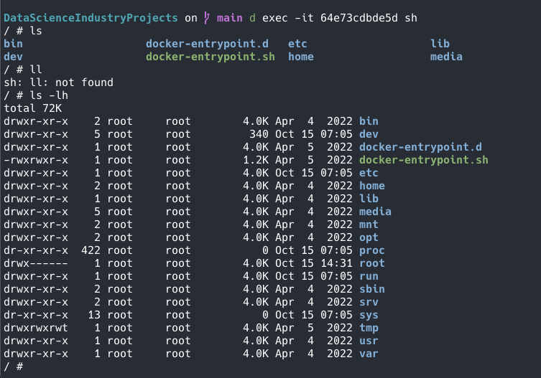

7. docker stop

This command stops a running container



8. docker kill

This command kills the container by stopping its execution immediately. The difference between ‘docker kill’ and ‘docker stop’ is that ‘docker stop’ gives the container time to shutdown gracefully.



9. docker commit

This command creates a new image of an edited container on the local system

10. docker login

This command is used to login to the docker hub repository

11. docker push

This command is used to push an image to the docker hub repository

13. docker rm

This command is used to delete a stopped container



14. docker rmi

This command is used to delete an image from local storage



15. docker build

This command is used to build an image from a specified docker file

