1. Git Version

This command returns the version of git installed in your system.



1. Git init

The git init command creates a new Git repository. It can be used to convert an existing, unversioned project to a Git repository or initialize a new, empty repository. Most other Git commands are not available outside of an initialized repository, so this is usually the first command you'll run in a new project.

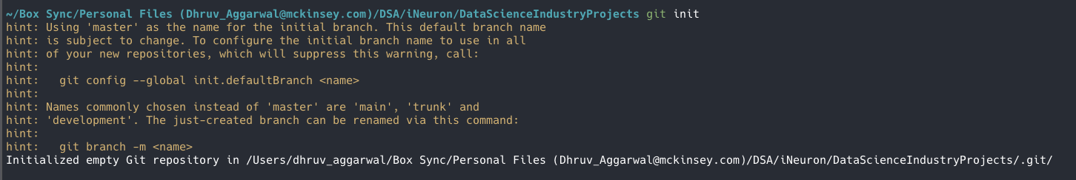

1. Git config –global

The git config command is used to set Git configuration values on a global or local project level.

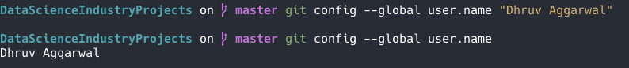

1. Git credential store

This command stores credentials indefinitely on disk for use by future Git programs.

1. Git config list

This command shows the credentials stored on disk for use by Git.

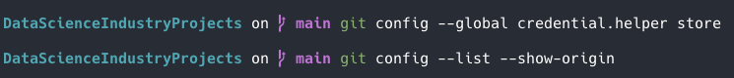

1. Git status

The git status command displays the state of the working directory and the staging area. It lets you see which changes have been staged, which haven't, and which files aren't being tracked by Git.

1. Git add

The git add command adds a change in the working directory to the staging area. It tells Git that you want to include updates to a particular file in the next commit. However, git add doesn't really affect the repository in any significant way—changes are not actually recorded until you run git commit .

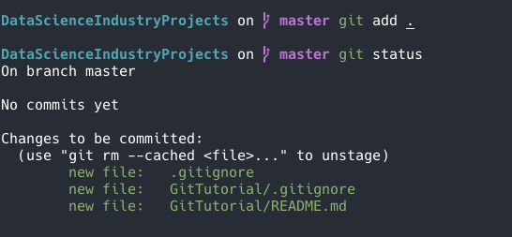

1. Git branch

A branch is a version of the repository that diverges from the main working project. It is a feature available in most modern version control systems.

It lists all the available branches on your local system in git

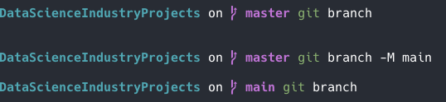

1. Git remote

The git remote command lets you create, view, and delete connections to other repositories.

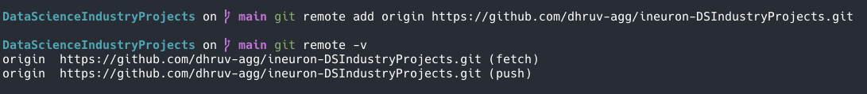

1. Git pull

The git pull command is used to fetch and download content from a remote repository and immediately update the local repository to match that content.

1. Git rebase

Rebasing is the process of moving or combining a sequence of commits to a new base commit.



1. Git push

The git push command is used to upload local repository content to a remote repository. Pushing is how you transfer commits from your local repository to a remote repo.

1. Git restore

The "restore" command helps to un-stage or even discard uncommitted local changes.



1. Git checkout

The git checkout command lets you navigate between the branches created by git branch . Checking out a branch updates the files in the working directory to match the version stored in that branch, and it tells Git to record all new commits on that branch.



1. Git merge

It is used to combine two branches. Git merge will combine multiple sequences of commits into one unified history.

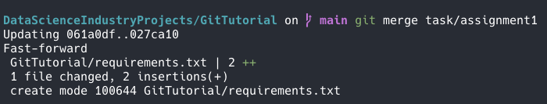

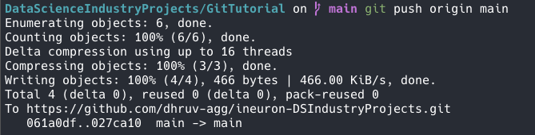

1. Git log

Git log is a utility tool to review and read a history of everything that happens to a repository. Multiple options can be used with a git log to make history more specific. Generally, the git log is a record of commits.

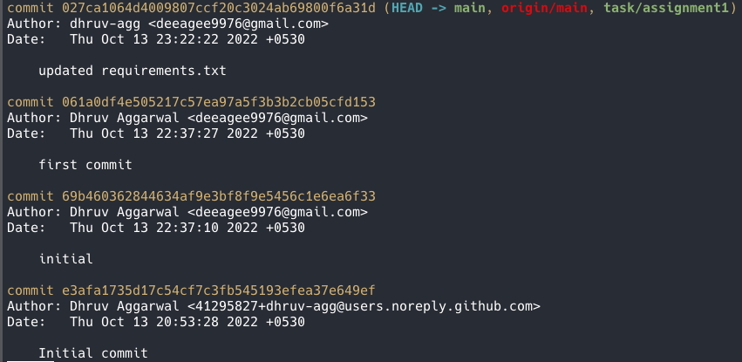

1. Git delete branch

To delete a local branch once it have been merged with main.



