Task 2:

1. Add Collaborator

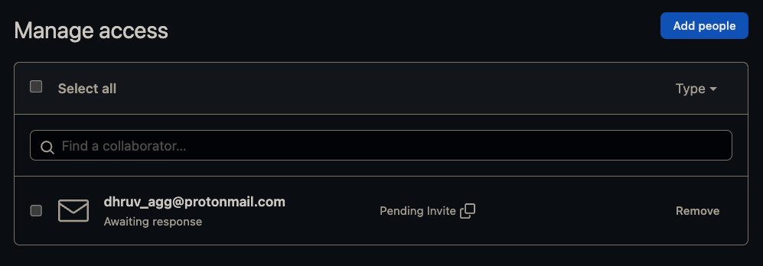

1. Create Proper Structure for Project

1. Add Proper README.md

<https://github.com/dhruv-agg/ineuron-DSIndustryProjects/blob/main/GitTutorial/Task2/OSSExample/README.md>

1. Host Github Pages

[ineuron-DSIndustryProjects (dhruv-agg.github.io)](https://dhruv-agg.github.io/ineuron-DSIndustryProjects/)