Task 3:

1. Create Issue on repository

1. Raise a PR

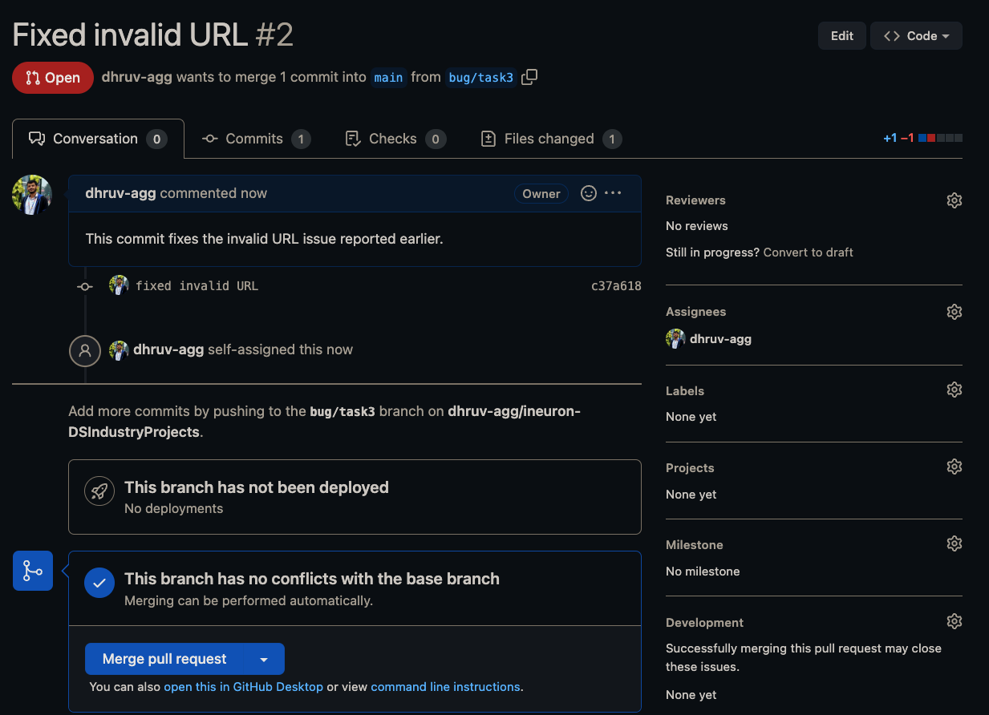

1. Merge a PR

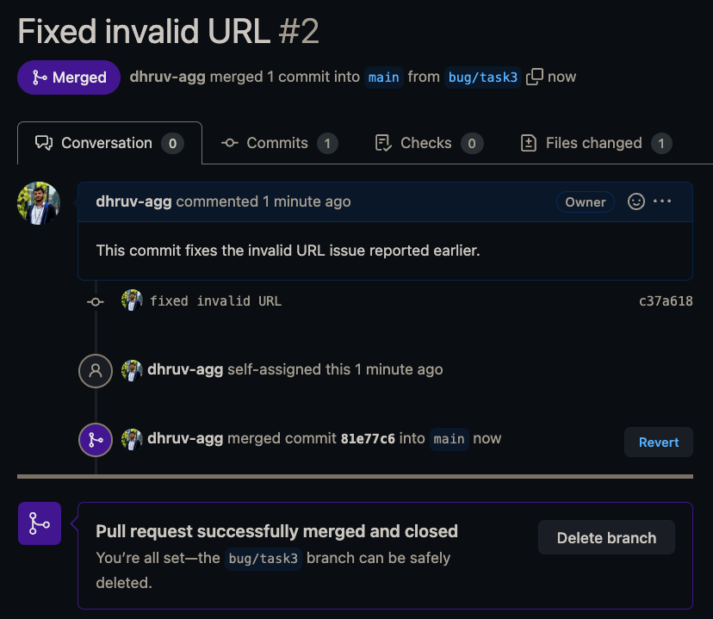

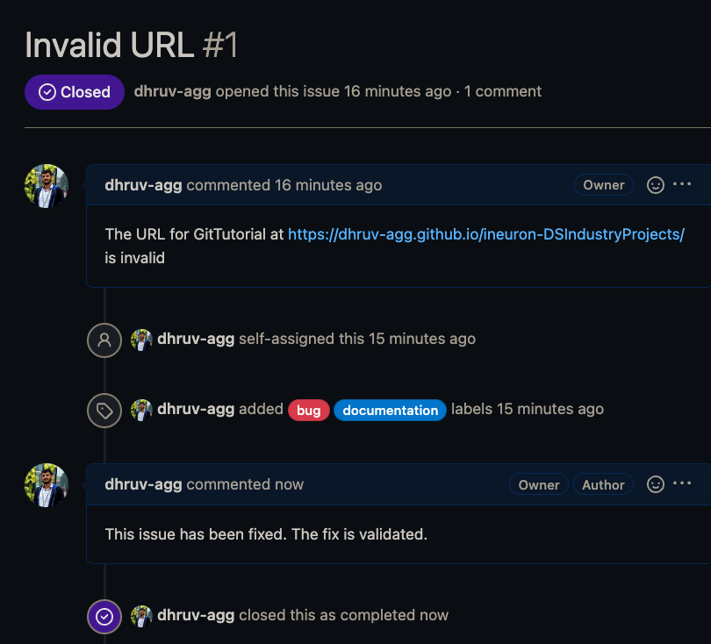

1. Reject a PR

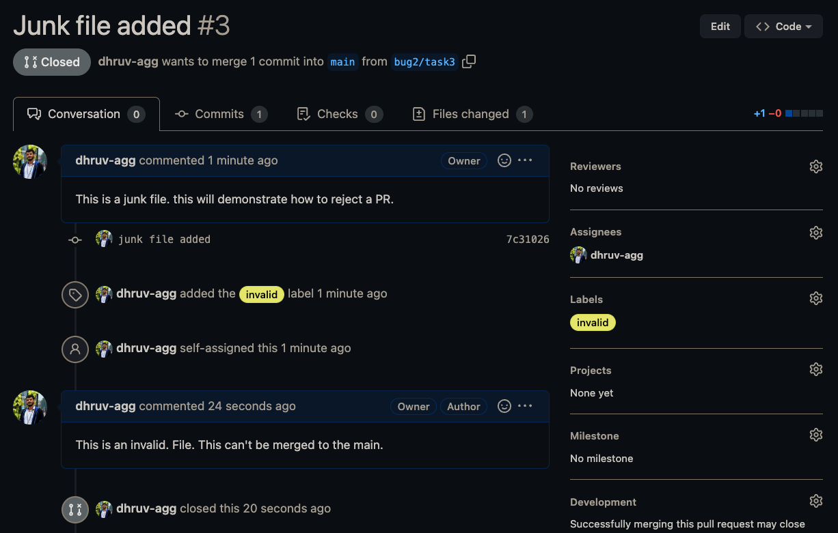

1. Add dependabot to your repo

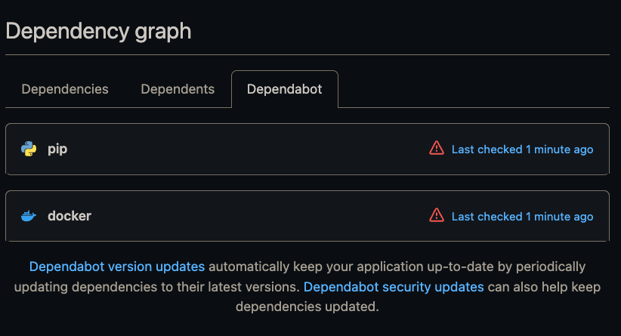

1. Stash changes

1. Create Release for Repo

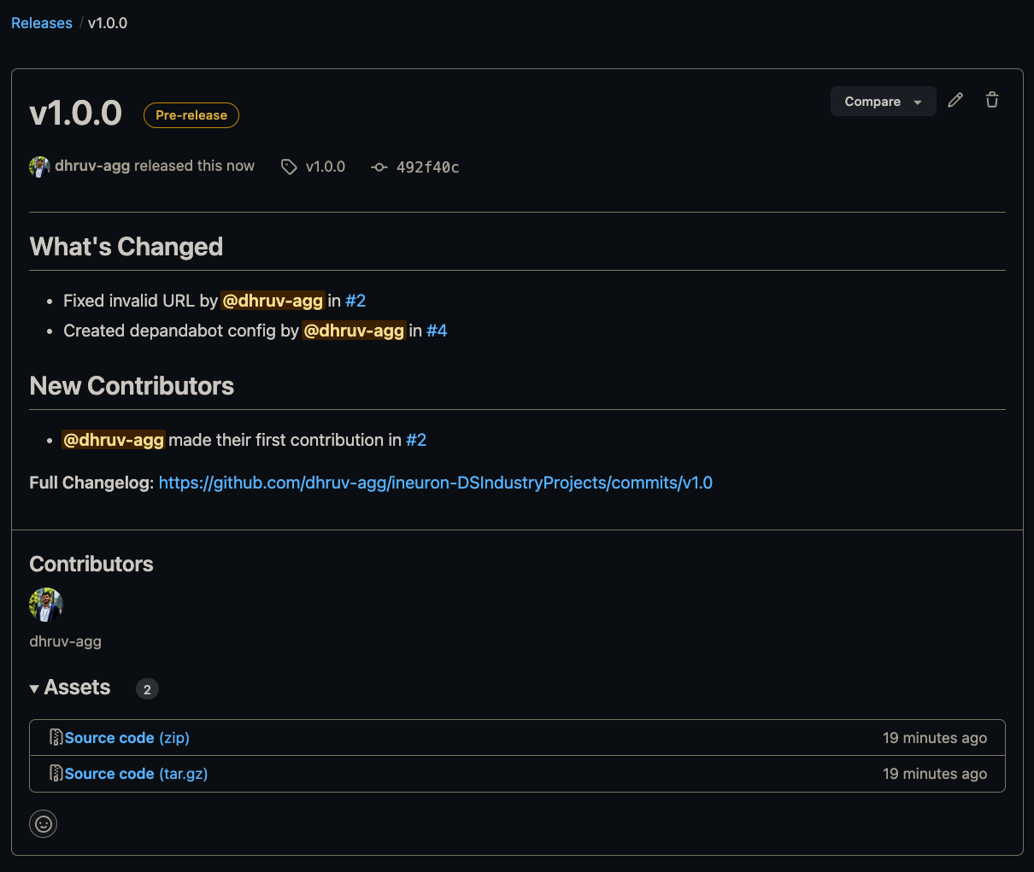

1. Create Project board for repo

