CHIMERA
A closed-loop adversarial AI lab for GenAI-era payment fraud
Mastercard Innovation Challenge @ GFF 2026 · AI Defense Lab for Payment Security

Team | Chimera
Member | Dhruv Tibarewal · dhruvtibarewal@gmail.com (confirm Kaggle-registered email)
Track | AI Defense Lab for Payment Security
Code repository | https://github.com/dhruv-decoder/chimera
Live web prototype | https://chimera-8vx7.onrender.com

Executive summary
Generative AI has made payment fraud faster, cheaper, and adaptive, and a fraud model trained on a fixed dataset only measures how well it fits yesterday's fraud. Chimera treats attack and defence as a single feedback loop rather than three separate deliverables. An AI red team discovers emerging GenAI fraud vectors, simulates them at fidelity across card, real-time account-to-account, and agentic-commerce rails, evolves each attack to evade the live detector, and the detector retrains on exactly what breaks through. The headline is not a static AUC. It is a measured hardening curve: under live evasion, aggregate recall collapses from 72.9% to 19.2% in one round, retraining restores it to 82.9%, and by round three the red team can no longer find easy evasion and the loop converges.
The headline new capability is delegated-token / agent-identity abuse - a 2026 attack surface created by Mastercard Agent Pay and Visa's Trusted Agent Protocol that did not exist a year ago, defended not on behaviour but on the integrity of the delegated credential itself.

Evidence at a glance
Each line is a separate, reproducible experiment. The credible generalisation number is the real-data one; the near-perfect synthetic AUC is expected against first-generation attacks and is not what we lean on.
Property | Claim | Evidence
Adaptive (simulated) | the loop breaks and recovers | recall 72.9% -> 19.2% -> 82.9% -> 99.6% over 3 rounds
Adaptive (real data) | the loop transfers off the simulator | on ULB real fraud, recall 84% -> 59% under evasion -> 100% after retrain
Novel vector | catches an attack never seen in training | AGENT-HIJACK leave-one-out: supervised 14.9% -> novelty 100%
Causally correct | no look-ahead inflating the score | point-in-time PR-AUC 0.9999 -> 0.9987, recall 0.992 -> 0.978
Relational | graph structure is decisive, not leaked | GNN ring PR-AUC 0.84 -> 0.99, holds inductively (no test edges in training)
Generalises | works beyond synthetic data | ULB real benchmark ROC-AUC 0.95, PR-AUC 0.81, in line with published baselines
Honest floor | states where it fails | deepfake-authorised push payment ~80% recall, by construction

How this maps to the five judging criteria
Criterion | What we deliver | Key evidence
Diversity of attacks | 16 techniques across a 6-tactic kill chain; 9 simulated end-to-end across card, real-time A2A and agentic rails; a live LLM agent proposes more. | Threat matrix; live ideation tagged groq:gpt-oss-120b
Fidelity of simulation | Latent-profile population, entity graph, and hard negatives placed where fraud lives, so no single flag separates the classes. Validated on real data. | Best single-feature AUC 0.84 (harder than real ULB's 0.93); same ensemble scores ROC 0.95 on real ULB
Detection efficacy | Two channels (LightGBM + novelty) + agent-identity family + GraphSAGE GNN for rings; cost-aware operating point. | Real ULB ROC 0.95 / PR 0.81; 100% of fraud value at ~140 alerts/10k; holds point-in-time and across 5 seeds
Novelty | A closed loop with a measured hardening curve; agentic-commerce identity abuse with a matching defence; a live multi-agent (LangGraph) red team. | Hardening 73->19->83%; LOO AGENT-HIJACK 15->100%; loop transfers to real fraud
Real-world feasibility | Auth-time schema; graded controls (3-DS / RBI friction); NPCI-style graph signals; agent-identity fields that map to Agent Pay / TAP. | Inline scoring path; per-event SHAP reason codes for model-risk audit

1. Identify - mapping the threat
We built an ATT&CK-style matrix for payment fraud: six kill-chain tactics (recon, access, setup, execution, cash-out, evasion) crossed with 16 techniques, each grounded in 2026 fraud intelligence and annotated with the observable signatures a defender can act on. Nine are simulated end-to-end; the rest are mapped for breadth and feed the ideation agent. Highlights chosen for novelty and impact:
- Delegated-token / agent-identity abuse (AGENT-HIJACK, headline vector). A hijacked or malicious AI shopping agent spends inside a cardholder's delegated mandate under Mastercard Agent Pay (Agentic Token) or Visa's Trusted Agent Protocol. Industry consensus is that agent-fraud risk concentrates at the authentication layer - proving a real user delegated the purchase - which is exactly where our defence acts.
- Agentic-commerce carding (AGENT-CARD). Autonomous agents run machine-speed carding on delegated tokens. Visa logged a 450%+ rise in dark-web "AI Agent" chatter in H1 2026 and a 25% rise in malicious bot-initiated transactions.
- Deepfake-authorised push payments (DF-APP). Cloned voice/video induces the victim to authorise a real-time transfer. Auth cannot stop a genuine authorisation, so this is the single hardest vector to detect - and our results reflect that honestly. Deepfake attempts rose ~94% year-on-year while total fraud volume stayed flat.
- Money-mule networks (MULE-NET) on real-time rails. 524,121 mule accounts were flagged in India in March 2026 alone; fan-in/fan-out layering within minutes. Plus synthetic-identity bust-out, account takeover, pig-butchering, structuring, and automated card testing.
Ideation agent. A RAG-grounded agent proposes novel variants where the detector is currently weak, retrieving from a cited intel corpus and returning a structured attack spec. It runs live on Groq with the open-weight gpt-oss-120b model and degrades to a deterministic planner if no key is present or the rate limit is hit, so a live demo never stalls.

2. Generate - fidelity is the point
A synthetic dataset is only useful if it is hard. Three design choices make it credible:
- Realistic population and behaviour. Each account carries a latent profile (home geography weighted toward India for UPI relevance, Poisson diurnal spend cadence, log-normal ticket size, preferred merchant categories, a stable known-payee set, devices, balance). The run reported here is ~5,000 accounts over 30 days, ~237,905 events at a 1.39% fraud rate.
- An entity graph. Accounts, devices, merchants and beneficiaries form a NetworkX graph, so coordinated attacks (mule rings, shared-device carding, one agent draining many mandates) surface as structural anomalies rather than single-flag outliers.
- Hard negatives. We inject legitimate look-alikes (benign agentic shopping through trusted agents, large first-time payees, travel, high-in-degree collector accounts, recurring investments, shared family devices) into the exact feature regions where fraud lives. The single most discriminative feature reaches an AUC of only 0.84, so no one flag separates the classes. Without hard negatives, any model scores a meaningless AUC of 1.0.
Nine attack synthesizers each manipulate only observable fields, reuse a shared transaction factory (no label leakage), and expose a bounded parameter space split into volume knobs and shape knobs. A black-box evolutionary (mu + lambda) search treats the detector as an oracle and tunes each attack's shape parameters to minimise mean risk; volume is frozen so it cannot cheat by emitting fewer events. The output is an evasive configuration and the detection collapse it causes, which becomes the next round's training data.

3. Defend - accuracy with an honest novelty story
The detector combines two channels over ~45 engineered features across four families:
- Event: amount, tenure, auth/channel/rail/entry, geo, MCC risk.
- Behavioural velocity: per-account time-windowed counts/sums, inter-arrival, amount z-score vs the account's own history.
- Structural / graph: device fan-out, counterparty in-degree, A2A degree and PageRank.
- Agent-identity (new): network attestation, directory trust, mandate-cap breach, off-scope merchant risk, and agent-id replay fan-out - separating a hijacked delegated agent from a legitimate one on credential integrity, not behaviour.
Two channels. A supervised LightGBM gradient booster (class-imbalance weighted) plus a novelty channel - an isolation forest and PCA reconstruction error fit on legitimate traffic only - that flags events which do not look normal even when the supervised model has never seen that attack type. The blended risk lets novelty escalate an unknown but never mask a known hit. Every decision carries per-event reason codes from LightGBM's exact TreeSHAP contributions, and risk maps to graded actions (allow, step-up auth, hold, block), mirroring 3-DS step-up and RBI's proposed friction and kill-switch.

4. The closed loop (multi-agent, LangGraph)
The loop is a genuine multi-agent system, not a for-loop in disguise. It ships as a compiled LangGraph StateGraph with four agent nodes that pass a shared typed state and cycle until the round budget is spent: recon (RAG ideation on gpt-oss-120b) -> red_team (evolutionary evasion) -> attack (generate the evasive stream, measure the breach) -> blue_team (retrain, measure the recovery) -> route back or END.
Each node appends to an execution trace, so the run is observable end-to-end; the shipped loop report is generated by this engine and the console renders both the agent pipeline and the trace.
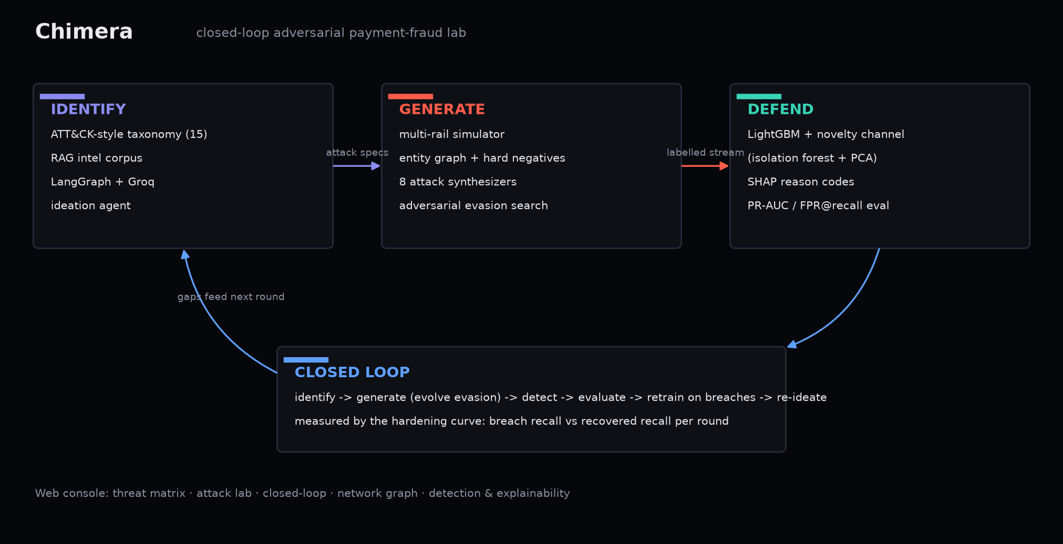
Figure 1. Chimera architecture - identify, generate and defend as one loop.

5. Results
All numbers are seeded and reproducible (make train && make loop).

5.1 Detection (held-out test set)
Metric | Value
ROC-AUC | 1.0000
PR-AUC | 0.9999
Precision / Recall @ max-F1 | 0.998 / 0.992
F1 | 0.995
FPR at operating point | 0.003% (2 of 70,384 good txns)
Fraud value recovered (cost-optimal) | 100%
Alerts / 10k txns (cost-optimal) | 140

The near-perfect in-distribution numbers are expected, not the point: first-generation campaigns carry loud structural signatures. Per-vector recall is honest - deepfake authorised push sits at 80.5% because the victim uses their own device and genuine auth. The credible numbers are the real-data validation (ROC 0.95) and the two adaptive tests below.

5.2 Novelty channel - leave-one-vector-out
Each attack type is entirely removed from training, then scored. The result to read is the first row.
Unseen vector | Supervised | Novelty | Blended
AGENT-HIJACK | 14.9% | 100% | 100%
ATO-STUFF | 57.6% | 78.1% | 79.5%
CARD-TEST | 100% | 95.8% | 100%
MULE-NET | 100% | 100% | 100%
DF-APP | 80.0% | 19.1% | 32.2%
SYN-ID | 1.7% | 19.9% | 19.9%

With delegated-token abuse entirely removed from training, the supervised model catches 14.9% of it - but the agent-identity features plus the novelty channel recover 100%. That is a genuinely emerging vector caught as an anomaly before the detector has ever been trained on it.

5.3 Closed-loop hardening curve
Round | Recall under live evasion (breach) | Recall after retrain (hardened)
0 (baseline) | 72.9% | 72.9%
1 | 19.2% | 82.9%
2 | 33.7% | 99.6%
3 | 99.6% | 99.1%

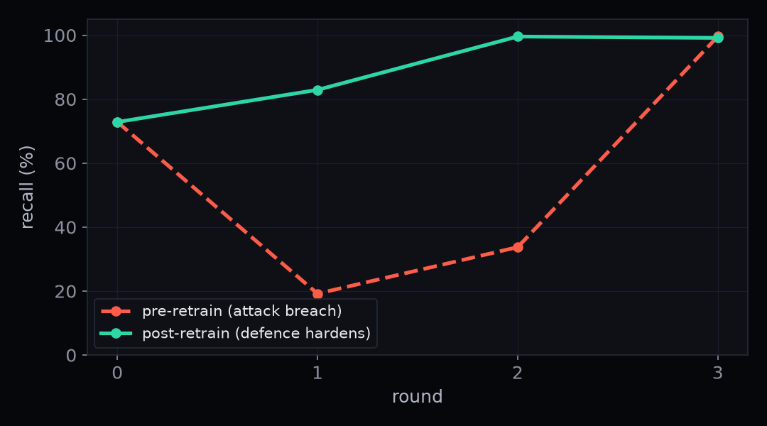
Figure 2. The loop closes: each round the breach shrinks until the red team can no longer find easy evasion.
A fixed detector does not adapt to evasion it has never seen; the closed loop trains on exactly those failures.

5.4 External validation on real fraud data
To check the approach is not overfit to our own synthetic data, we applied the same two-channel ensemble, unchanged, to the ULB real-world credit-card fraud benchmark (284,807 genuine European card transactions, 492 fraud; the public mlg-ulb/creditcardfraud Kaggle dataset). Out of the box it reaches ROC-AUC 0.95 and PR-AUC 0.81, in line with published gradient-boosting baselines, confirming the method transfers to real fraud. Against standard models it is competitive rather than superior (held-out PR-AUC: XGBoost 0.84, Random Forest 0.82, LightGBM 0.81, Chimera 0.78, Logistic Regression 0.70) - which is the point: the contribution is the loop, and the loop transfers to real fraud (84% -> 59% under evasion -> 100% after retrain at the same operating threshold).

5.5 A graph neural network for coordinated rings
Ring detection (held-out accounts) | ROC-AUC | PR-AUC
Gradient boosting (node features only) | 0.89 | 0.84
GraphSAGE GNN (transductive) | 1.00 | 0.998
GraphSAGE GNN (inductive, no leakage) | 1.00 | 0.992

Message passing lifts ring-detection PR-AUC from 0.84 to 0.998 on the simulator's ring topology - the takeaway is the lift. It is guarded against leakage twice: gradient boosting on the same features scores only 0.84 (features do not give the label away), and an inductive split that removes every test-account edge during training still lifts PR-AUC to 0.992.

5.6 Evaluation rigor (summary)
- Point-in-time (no look-ahead): rebuilding structural features causally barely moves detection (PR-AUC 0.9999 -> 0.9987, recall 0.992 -> 0.978).
- Stability across 5 seeds: ROC-AUC 1.00 +/- 0.00, recall 0.994 +/- 0.003.
- Component ablation: graph features are the decisive lift (PR-AUC 0.94 -> 0.9999); agent-identity features are not a crutch in-distribution, earning their place only on the unseen vector.
- Combined attack chains (beta): a two-stage synthetic-identity bust-out + authorised-push cash-out evades the supervised classifier (38% -> 8%), the novelty channel holds it at 62%, and retraining recovers both channels - the same lesson as AGENT-HIJACK on a multi-stage threat.

6. Headline capability - agentic-commerce identity abuse
The 2026 frontier is that a payment can now be initiated by an autonomous agent on a cardholder's behalf. Mastercard Agent Pay issues an Agentic Token that binds three identities into one credential (the cardholder, the registered agent, and the scope of the mandate); Visa's Trusted Agent Protocol signs the agent's identity into request headers for merchants to verify against a directory. That binding is what an attacker attacks.
The hard part, in Visa's own words, is telling a legitimately delegated agent from a scripted attacker reusing a stolen token. Velocity, device and cadence cannot answer it: a real trusted agent is also fast, automated, runs on reputable cloud, and serves many principals. We modelled this faithfully, so the only thing left to separate them is credential integrity:
- Attestation - was the agent's network signature verified, or missing/replayed?
- Directory trust - reputation of the agent identity.
- Mandate scope - amount over the delegated cap, off-scope high-risk merchant.
- Replay structure - one agent id draining many mandates at once.
The leave-one-out result (15% to 100%) is the proof that this family turns an unseen, emerging vector into a detectable anomaly - defended on the integrity of the credential, not on behaviour.

7. What is novel here
- A working closed loop with a measured hardening curve (73% to 19% to 83% to convergence), not three disconnected deliverables.
- Agentic-commerce identity abuse as a first-class simulated vector with a matching defence family - the 2026 frontier grounded in Agent Pay and the Trusted Agent Protocol.
- Live red-team ideation from an open-weight model (gpt-oss-120b), running in the real loop, not mocked.
- Adversarial evasion as a live red team (black-box evolutionary search against the deployed model), turning the generator into a stress-tester.
- A novelty channel evaluated with leave-one-vector-out, directly answering "novel, emerging".
- Cost-aware reporting (fraud value recovered, alerts per 10k, cost-optimal threshold) - the metrics a fraud team actually uses.

8. Real-world feasibility
Chimera is designed to sit where a bank already decides, not to replace that stack.
- Inline scoring at authorisation. The detector scores the fields a switch sees at authorisation (ISO 8583 on card rails, the request/response API on UPI / FedNow) and returns a graded action inline in single-digit milliseconds; velocity and graph features are read from a streaming feature store computed point-in-time-correct.
- Label feedback. Chargebacks, confirmed-fraud tags and mule confirmations flow into a labelled buffer; the closed loop becomes a scheduled offline retrain in the model-risk sandbox with champion/challenger promotion and shadow scoring.
- Native integration points. Risk-graded mitigation is how 3-DS step-up and RBI's friction/kill-switch work; graph features mirror NPCI's MuleHunter.AI; and the agent-identity features model the public concepts Agent Pay and the Trusted Agent Protocol describe, so that vector is a directory lookup from production.
- Governance. Per-event SHAP reason codes satisfy model-risk (SR 11-7-style) and audit. Paid infrastructure (managed streaming store, a temporal GNN, managed embeddings + vector DB, a hosted low-latency endpoint) is a quality dial on latency, grounding and recall - not a rewrite.

9. Responsible use & limitations
Chimera runs entirely on synthetic data it generates itself, with no real cardholders, PII, credentials, or live payment connectivity. The attack modules are parameterised statistical patterns that stress a detector, not operational playbooks or working exploit code, and cannot be pointed at a real system. The red team exists only to harden the blue team.
Stated plainly: synthetic data is not live traffic, so absolute metrics should be read as relative and methodological; batch aggregation is temporally optimistic vs streaming (flagged, not hidden); and the adversarial search is a practical black-box optimiser, not a formal robustness guarantee. The honest floor is deepfake-authorised push payment at ~80% recall, which needs pre-transaction intelligence (scam-intent detection, confirmation-of-payee), not a better classifier.

Reproduce: git clone https://github.com/dhruv-decoder/chimera · make setup && make train && make loop · live console at https://chimera-8vx7.onrender.com

