SOFTWARE REQUIREMENTS SPECIFICATION

HAR-Cloud
Human Activity Recognition - A Scalable Cloud Framework

Submitted By:
Patel Krish Falgun | - | 22162581006
Patel Viraj Jigarkumar | - | 22162121018
Dhruv Jethwani | - | 22162171008

Under the Guidance of:
Mr. Nirav Rajgor
B-Tech CSE
Institute of Computer Technology (ICT)
Ganpat University
2025

TABLE OF CONTENTS

Section | Title | Sub-sections | Page No.
1.0 | Introduction | 1.1 Purpose  1.2 Scope  1.3 Definitions, Acronyms, and Abbreviations  1.4 Overview | 1 - 2
2.0 | Overall Description | 2.1 Product Perspective  2.2 Product Functions  2.3 User Classes and Characteristics  2.4 Operating Environment  2.5 Design and Implementation Constraints  2.6 Assumptions and Dependencies | 3 - 5
3.0 | System Requirements | 3.1 Functional Requirements (FR-1 to FR-13)  3.2 Non-Functional Requirements | 6 - 7
4.0 | External Interface Requirements | 4.1 Frontend User Interface (UI) Design  4.2 Hardware Interface  4.3 Software Interface  4.4 Communications Interfaces | 8 - 9
5.0 | System Models & Design | 5.1 Use Case Diagram  5.2 Sequence Diagram  5.3 Data Flow Diagram  5.4 Entity-Relationship (ER) Diagram  5.5 High-Level Architecture Diagram  5.6 System Component Diagram | 10 - 15
6.0 | Machine Learning & AI Pipeline | 6.1 Model Evaluation and Selection  6.2 Model Training Methodology | 16 - 17
7.0 | API Specifications | 7.1 Authentication Endpoints  7.2 Media & Inference Endpoints | 18
8.0 | Risk Management |  | 19
9.0 | Testing Strategy | 9.1 Unit Testing  9.2 Integration Testing  9.3 System Testing  9.4 User Acceptance Testing (UAT) | 20 - 21
10.0 | Deployment & DevOps Strategy | 10.1 Version Control & Collaboration  10.2 CI/CD Pipeline  10.3 Frontend -- Vercel  10.4 Backend -- Render  10.5 ML Model -- Hugging Face | 22 - 24
11.0 | Future Scope | 11.1 Multimodal Integration  11.2 Anomaly Detection  11.3 Edge-Cloud Hybrid Models | 25
12.0 | Conclusion | Summary of Project Goals and Achievements | 26

1. Introduction

1.1 Purpose
This Software Requirements Specification (SRS) formally defines the functional and non-functional requirements of HAR-Cloud -- a cloud-based Human Activity Recognition platform developed by the B.Tech CSE team at the Institute of Computer Technology, Ganpat University. The document serves as the authoritative reference for all stakeholders including developers, testers, academic supervisors, and future maintainers.
HAR-Cloud automates the detection and classification of human activities from uploaded images using machine learning, providing secure user authentication, an intuitive web interface, and a privacy-preserving design that stores images securely via ImgBB and processes activity classification using EfficientNetB3. This SRS adheres to the IEEE 830-1998 standard and governs all phases of the software development lifecycle.

1.2 Scope
HAR-Cloud is a web-accessible, cloud-hosted platform enabling users to upload image data through any standard browser for automated human activity classification. The system employs a deep learning-based pose estimation pipeline and EfficientNetB3 to recognise activities including walking, running, sitting, standing, and falls.
All computationally intensive tasks execute on cloud servers, ensuring scalability and reducing the need for powerful local hardware. The system enhances user privacy by storing uploaded images on ImgBB and retaining only the image URL and classification results in the application database.

- Image upload and automated activity classification
- Real-time activity classification using EfficientNetB3 hosted on Hugging Face
- Secure user authentication with JWT-based session management
- Role-based access control for General Users, Healthcare Staff, and Administrators
- Persistent activity history and result dashboard
- RESTful API with Swagger UI documentation
- Privacy-preserving design: raw media discarded immediately post-processing

1.3 Definitions, Acronyms, and Abbreviations
Term | Definition
HAR | Human Activity Recognition — computational identification of human motions from sensor or image data.
SRS | Software Requirements Specification — document describing purpose, environment, and functionality of a software system.
API | Application Programming Interface — a set of definitions and protocols for building and integrating application software.
REST | Representational State Transfer — an architectural style for distributed hypermedia systems using stateless HTTP.
JWT | JSON Web Token — a compact, URL-safe token for securely transmitting information between parties.
CNN | Convolutional Neural Network — a class of deep neural network applied to analyse visual imagery.
MobileNetV2 | Lightweight deep neural network architecture optimised for efficient cloud inference, used as the HAR classification model.
FastAPI | High-performance Python web framework for building RESTful APIs.
CI/CD | Continuous Integration / Continuous Deployment — automated software delivery practice for rapid and reliable release cycles.
HTTPS | Hypertext Transfer Protocol Secure — HTTP extended with TLS encryption for secure communication.
TLS | Transport Layer Security — cryptographic protocol providing secure communication over a network.
CDN | Content Delivery Network — geographically distributed server network delivering web content with low latency.
RBAC | Role-Based Access Control — security model restricting system access based on individual user roles.
Vercel | Cloud platform for deploying frontend static applications with a global CDN.
Render | Cloud platform for deploying backend web services with managed infrastructure and GitHub auto-deploy.
Hugging Face | ML platform hosting model repositories and providing an Inference API for scalable model serving.
LSTM | Long Short-Term Memory — a recurrent neural network architecture suited to sequential/temporal data.

1.4 Overview
This document is organised into twelve sections following IEEE 830. Section 2 provides an overall product description. Section 3 defines functional and non-functional requirements. Section 4 details external interface requirements. Section 5 presents system models including use case, sequence, data flow, ER, architecture, and component diagrams. Section 6 describes the machine learning pipeline. Section 7 specifies API endpoints. Section 8 covers risk management. Section 9 outlines the testing strategy. Section 10 documents deployment and DevOps. Section 11 discusses future scope. Section 12 presents the conclusion.

2. Overall Description

2.1 Product Perspective
HAR-Cloud is a self-contained, cloud-native web application built on a three-tier client-server architecture. The frontend React SPA runs in the user's browser, handling authentication, media upload, and result visualisation. The backend FastAPI service, deployed on Render, manages request routing, business logic, and pose estimation orchestration. The machine learning inference layer is hosted on Hugging Face, processing skeletal keypoint data to produce activity classifications.
The system is independent but exposes a versioned RESTful API, enabling future integration with third-party applications. Cloud deployment ensures centralised model management, seamless version updates, and elastic scalability without client-side modifications.

2.2 Product Functions
Function | Description
User Authentication | Secure registration, login, and session management using JWT tokens with 24-hour expiry over HTTPS.
Image Upload | Authenticated users upload image files via a drag-and-drop web interface. Files are validated for type and size before acceptance.
Activity Classification | Normalised keypoint data is transmitted to the EfficientnetB3 model on Hugging Face for real-time activity inference.
Result Display | Predicted activity labels and confidence scores are rendered on the result dashboard.
Fall Alert | When a fall is detected above a confidence threshold, the system dispatches an alert to associated Healthcare Staff.
History Management | Inference results are persisted in the database and accessible via the History tab.
Admin Management | Administrators can view metrics, manage user accounts, monitor logs, and oversee model updates.
Privacy Enforcement | Raw media files are discarded immediately after pose extraction; only normalised skeletal vectors are retained.

2.3 User Classes and Characteristics

2.3.1 General User
General users interact with HAR-Cloud through a standard web browser with no technical expertise required, primarily using the image upload interface and activity result dashboard.
- Access via any modern web browser on desktop, tablet, or mobile
- Limited to their own upload history and inference results
- No access to administrative functions or other users' data

2.4 Operating Environment

Component | Environment Details
Frontend | React SPA deployed on Vercel's global CDN. Accessible via Chrome 90+, Firefox 88+, Edge 90+, Safari 14+. No installation required.
Backend API | Python FastAPI application deployed on Render. Managed Linux infrastructure with GitHub auto-deploy integration.
ML Inference | EfficientNetB3 model hosted on Hugging Face Inference API. Accessed via authenticated HTTPS from the Render backend.
Database | Relational database managed within the Render deployment, storing user credentials, session tokens, and activity records.
Networking | All communication secured via HTTPS (TLS 1.3). RESTful HTTP/1.1 for standard API calls.
Client Device | Any internet-connected device with a modern browser. No minimum hardware specification on end-user devices.

2.5 Design and Implementation Constraints
- The system must operate entirely over HTTPS; unencrypted HTTP is not permitted in production.
- File uploads are constrained to image formats (JPEG, PNG, WEBP) with a maximum size of 10 MB per image.
- The ML inference service is subject to the rate limits of the Hugging Face Inference API.
- The Render backend may have cold-start latency on free-tier plans; production must use a paid plan for always-on availability.
- The system must store uploaded images via ImgBB API and retain only the ImgBB URL in the application database, not the raw image binary.
- Authentication tokens expire after 24 hours and must be refreshed via re-authentication.
- All development is version-controlled using Git repositories hosted on GitHub.

2.6 Assumptions and Dependencies
- End users have a stable internet connection with minimum 1 Mbps upload speed.
- Hugging Face Inference API is available and performing within documented SLA parameters.
- Vercel and Render provide 99.5%+ monthly uptime for frontend and backend services respectively.
- All team members have access to GitHub, Python 3.9+, and the relevant cloud platform accounts. The ImgBB API is available and the API key is configured for image hosting.

3. System Requirements

3.1 Functional Requirements
ID | Requirement | Description
FR-01 | User Registration | The system shall allow new users to create an account by providing a unique email, password, display name, and role. Fields shall be validated with appropriate error messages.
FR-02 | User Authentication | The system shall authenticate registered users via email and password, issuing a signed JWT Bearer token valid for 24 hours on success.
FR-03 | Role-Based Access | The system shall enforce RBAC differentiating General User and Administrator roles. Unauthorised access shall return HTTP 403.
FR-04 | Image Upload | Authenticated users shall upload image files (JPEG, PNG, WEBP, max 10 MB) via the web interface drag-and-drop zone or file picker.
FR-05 | Image Storage | The system shall upload the image to ImgBB via API key and pass the image URL to the EfficientNetB3 inference service on Hugging Face for activity classification.
FR-06 | Activity Classification | The system shall transmit the image URL to the EfficientNetB3 inference service on Hugging Face and receive a probability distribution across activity classes.
FR-07 | Result Display | The system shall present the predicted activity label and confidence score on the authenticated user's result dashboard.
FR-08 | Fall Alert | When a fall is detected above the configured confidence threshold, the system shall display a prominent fall alert on the result dashboard.
FR-09 | History Persistence | Each inference result (activity, confidence, timestamp, user ID) shall be stored in the database for subsequent retrieval.
FR-10 | History Retrieval | Authenticated users shall retrieve their complete inference history, ordered by timestamp descending, via the History tab.
FR-11 | Privacy Enforcement | Uploaded images are stored on ImgBB for reference and the resulting ImgBB URL is stored in the database. No raw image binary data is stored in the application database.
FR-12 | Admin User Management | Administrator users shall view, deactivate, and delete user accounts through the admin dashboard.
FR-13 | System Audit Logging | The system shall log all administrative actions with actor identity and timestamp.

3.2 Non-Functional Requirements

ID | Category | Requirement | Acceptance Criterion
NFR-01 | Performance | Response Time | API shall return inference results within 3 seconds under normal load (< 50 concurrent users).
NFR-02 | Performance | Throughput | Backend shall support at least 50 concurrent image uploads without accuracy or latency degradation.
NFR-03 | Availability | Uptime | Production system shall maintain minimum 99.5% monthly uptime, excluding scheduled maintenance.
NFR-04 | Security | Data in Transit | All data shall be encrypted using HTTPS with TLS 1.2+. HTTP shall redirect to HTTPS.
NFR-05 | Security | Authentication | All endpoints except /api/register and /api/login shall require a valid JWT Bearer token (HS256, 24-hour expiry).
NFR-06 | Security | Password Storage | Passwords shall be hashed using bcrypt (work factor 12). Plaintext passwords shall never be persisted or logged.
NFR-07 | Scalability | Horizontal Scale | The Render backend shall support horizontal scaling by adding service instances without code modification.
NFR-08 | Usability | Accessibility | The frontend shall be accessible via any modern web browser without plugins or local software installation.
NFR-09 | Portability | Cross-Platform | The system shall function on Windows, macOS, Linux, iOS, and Android via modern browsers.
NFR-10 | Reliability | Error Handling | The system shall return structured JSON error responses with appropriate HTTP status codes for all error conditions.
NFR-11 | Privacy | Data Minimization | Raw image binary data shall not be stored in the application database. Images are hosted on ImgBB and only the resulting URL and activity results are stored.
NFR-12 | Maintainability | Code Quality | Backend code shall follow PEP 8. Frontend code shall follow ESLint configuration. Automated test coverage shall exceed 70%.

4. External Interface Requirements

4.1 Frontend User Interface (UI) Design
The HAR-Cloud user interface is a responsive, zero-install Single-Page Application (SPA) built with React and deployed on Vercel. The design employs a modern dark-themed aesthetic -- deep navy, charcoal, and neon-blue accents -- that minimises eye strain during extended monitoring sessions.

4.1.1 Global Sidebar
Fixed left navigation panel displaying the HAR-Cloud logo with a stylised 'H' icon, primary navigation tabs (Analysis [active], History), and a pinned 'Sign Out' button at the bottom for immediate session termination.

4.1.2 Main Analysis Workspace
System Status Indicator: A dynamic pill-shaped badge reading 'NEURAL SYSTEM ACTIVE' with a pulsating blue dot, confirming backend inference service connectivity in real time.
Interactive Drop Zone: A large rounded rectangular container with dashed inner border, cloud upload icon, and 'Drop photo here' instructional text. Supports HTML5 Drag-and-Drop API and standard file picker. On successful drop, transitions to a loading skeleton while inference executes.
Result Panel: After inference, displays predicted activity label, confidence percentage, and a skeletal overlay visualisation on the original image.
Footer Trust Badge: 'SECURE CLOUD PROCESSING • POWERED BY HAR-CLOUD AI' -- reinforcing data privacy and architectural trust.

UX Interaction Flow:
- Initiation: The user navigates to the Analysis workspace. The distraction-free layout directs attention immediately to the central drop zone.
- Action: The user drags an image file or clicks the drop zone to open a file picker. The dashed border highlights on hover to signal readiness.
- Upload and Storage: On file selection, the frontend sends the image to the backend API. The backend uploads the image to ImgBB and receives a permanent URL.
- Inference: The ImgBB URL is forwarded to the EfficientNetB3 model on Hugging Face. A loading skeleton animates in the drop zone while inference executes.
- Result: The activity label, confidence score, and the hosted image (via ImgBB URL) are rendered on the Result Panel. A fall detection alert banner is displayed if the Falling class is identified above the confidence threshold.

4.1.3 History Dashboard
- Paginated table of past inference results: Date/Time, Activity, Confidence Score
- Filter and sort capabilities by date range and activity type

4.2 Hardware Interface
Client Camera (Optional): The user's device camera may capture images prior to upload. The system does not access the camera directly.
Vercel Edge Network: The frontend SPA is served from Vercel's global CDN, distributing static assets to reduce load times across all regions.
Render Cloud Servers: The FastAPI backend runs on Render's managed Linux infrastructure with configurable compute and auto-scaling.
Hugging Face Inference Hardware: The EfficientNetB3 model is hosted on Hugging Face infrastructure providing CPU or GPU compute depending on the selected hosting tier.

4.3 Software Interface
Software | Version | Interface Role
React | 18+ | Frontend SPA framework. Manages UI state, routing, and API communication.
FastAPI | 0.100+ | Backend REST API framework on Render. Handles routing, JWT middleware, CORS, and auto-generated Swagger documentation.
SQLAlchemy | 2.0+ | ORM for database interaction on Render. Manages schema definitions, query construction, and connection pooling.
Hugging Face Hub | Latest | Python client for the Hugging Face Inference API. Transmits image data to EfficientNetB3 and parses activity classification responses.
ImgBB API | Latest | Image hosting service. Uploaded images are stored on ImgBB via authenticated API key requests, returning a permanent URL stored in the database for result reference.
PyJWT | 2.8+ | JWT library for encoding and decoding authentication tokens. Implements HS256 signing and expiry validation middleware.

4.4 Communications Interfaces

4.4.1 REST APIs
RESTful endpoints handle all transactional operations including user registration, authentication, image upload, and history retrieval. All requests and responses are JSON-formatted. Endpoints are prefixed with /api/ and documented via Swagger UI at /docs.

4.4.2 Hugging Face Inference API
The Render backend communicates with the Hugging Face-hosted EfficientNetB3 model via authenticated HTTPS POST requests. Image URLs from ImgBB are passed as the inference payload, and the API returns a probability distribution over activity classes.

4.4.3 WebSockets
WebSocket connections are implemented to maintain persistent, bidirectional communication between the client and server for real-time frame streaming and immediate activity prediction responses, ensuring low latency during live analysis.

4.4.4 ImgBB Image Hosting API
Uploaded images are sent from the Render backend to the ImgBB API via authenticated HTTP POST requests using an API key. ImgBB returns a permanent, publicly accessible image URL which is stored in the database alongside the inference result. This enables result review without storing raw image binaries in the application database.

5. System Models and Design

5.1 Use Case Diagram
The use case diagram below identifies the primary actor -- General User -- and their interactions within the HAR-Cloud system boundary.
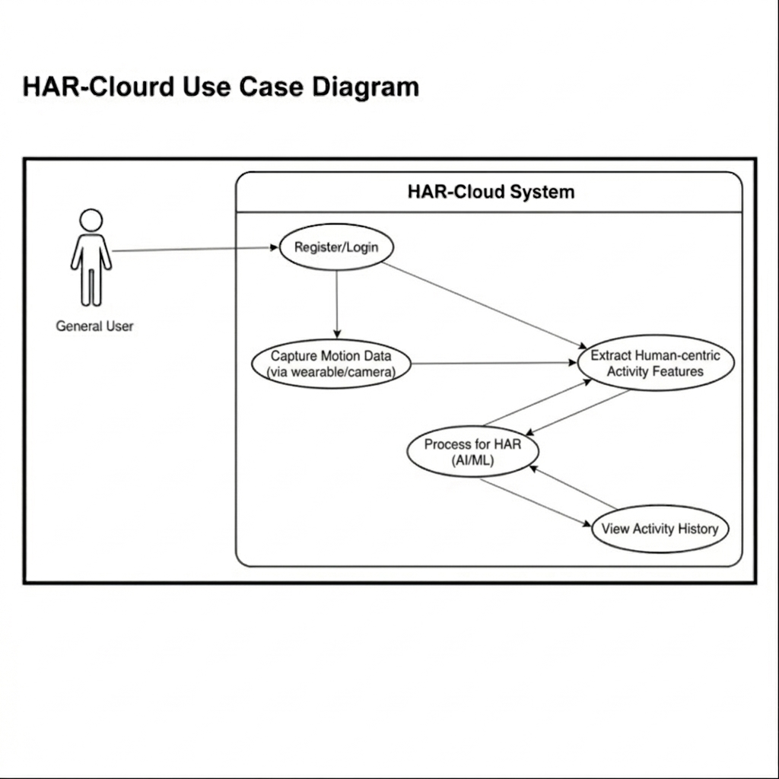
Figure 5.1 -- HAR-Cloud Use Case Diagram
General User: Register/Login, Upload Media (includes Extract Skeletal Keypoints), View Activity Results, View Personal History, Start Live Motion Sensing.

5.2 Sequence Diagram
The sequence diagram illustrates the end-to-end message flow during image upload and activity classification across six participants: User, Web Interface, Backend API, ImgBB, AI Model, and Result Dashboard.

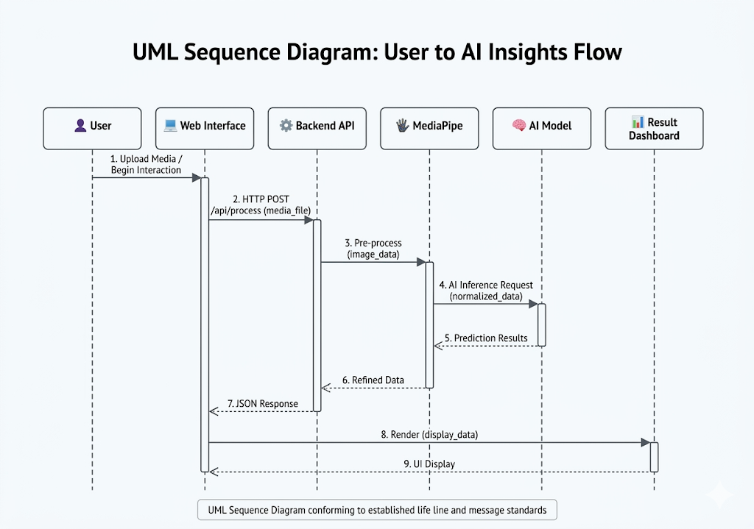
Figure 5.2 -- System Sequence Architecture Diagram

Step 1 -- Upload / Interaction: User interacts with the Web Interface to upload an image.
Step 2 -- POST /process: Web Interface sends the image and JWT token to the Backend API on Render via authenticated HTTP POST.
Step 3 -- Pre-process: Backend API pre-processes the uploaded image. The image is stored on ImgBB via API, and feature extraction is performed for activity classification.
Step 4 -- Inference Request: Processed image data is forwarded to EfficientNetB3 on Hugging Face for activity classification.
Step 5 -- Prediction Data: AI Model returns a probability distribution across activity classes.
Step 6 -- Refined Data: Backend formats and validates the inference result.
Step 7 -- JSON Response: Backend returns structured JSON with predicted activity and confidence score to the Web Interface.
Step 8 -- Render View: Web Interface renders the activity result on the Result Dashboard.

5.3 Data Flow Diagram
The HAR-Cloud DFD maps General User activity flows, showing two core processing nodes and two persistent data stores.

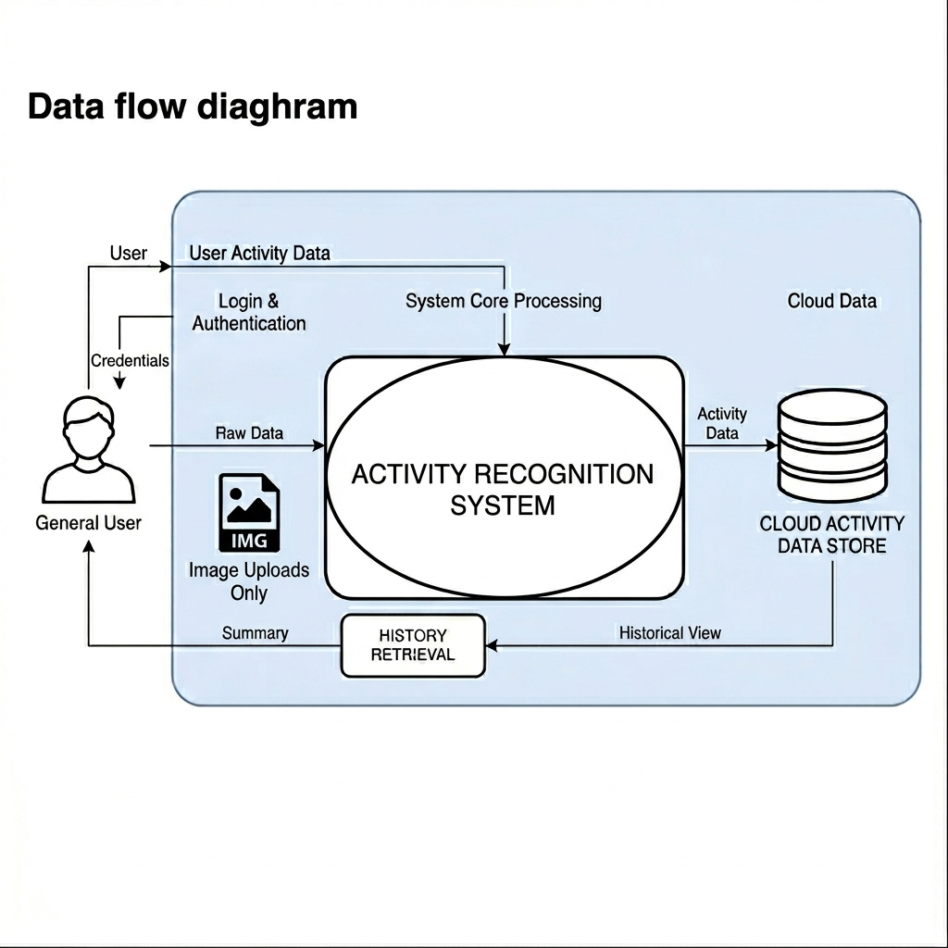
Figure 5.3 -- HAR-Cloud Data Flow Diagram

P1 -- Image Processing Engine: Receives uploaded media from the General User, stores images via ImgBB API, and passes the data into the inference engine.
P2 -- HAR-Cloud System (Inference Engine): Central processing node. Reads and writes D1 for access control, stores activity records in D2, and returns results to the General User.
D1 -- User & Auth Vault: Persistent storage for user credentials, session tokens, and authentication metadata.
D2 -- Activity & Audit Logs: Persistent storage for activity classification results, inference history, and administrative audit entries.

5.4 Entity-Relationship (ER) Diagram

The HAR-Cloud database schema is modelled around six primary entities. The ER diagram illustrates the relational structure and cardinality constraints governing data persistence.

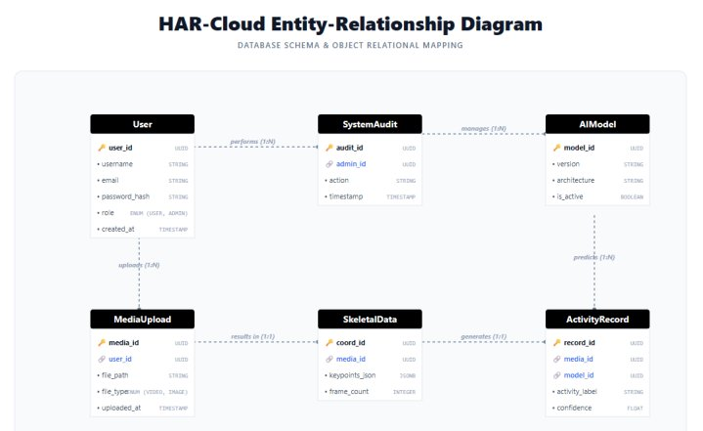
Figure 5.4 -- HAR-Cloud Entity-Relationship Diagram

The schema enforces strict relational integrity through primary and foreign key constraints. Every ActivityRecord is traceable back to a specific MediaUpload, a specific AIModel version, and a specific User, enabling complete audit trails for all classification outcomes.
The ImgBB image URL returned after upload is stored in the file_path field of the MediaUpload entity, providing a permanent reference link to the hosted image. This design ensures that the application database remains lightweight, storing only metadata and results rather than raw binary image data.
The AIModel entity supports multi-version governance: when a new EfficientNetB3 model version is promoted to production on Hugging Face, a new AIModel record is inserted and the is_active flag is toggled, preserving historical inference records against their original model version for reproducibility and audit purposes.

5.5 High-Level Architecture Diagram
The high-level architecture organises HAR-Cloud into four discrete functional layers with defined responsibilities and inter-layer communication protocols.

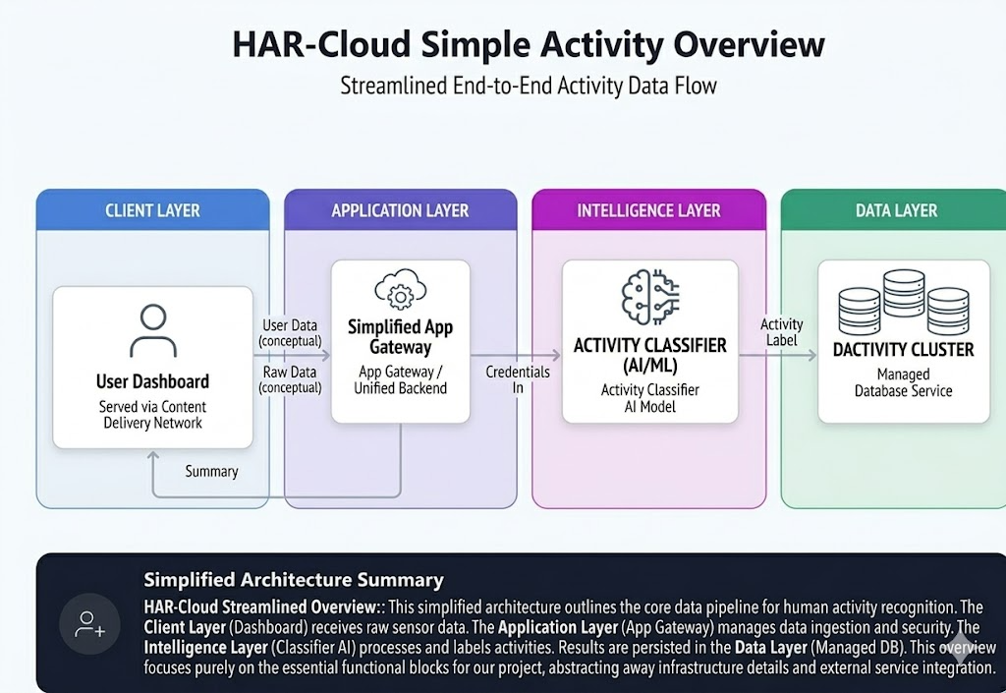
Figure 5.5 -- HAR-Cloud High-Level Architecture Diagram

Layer | Components | Responsibilities
Client Layer | React SPA (Vercel CDN) | General User Interface -- media upload, result viewing, and history. Served from Vercel's global edge network.
Application Layer | FastAPI Backend (Render) + Auth Module (JWT) | API routing, JWT authentication middleware, CORS enforcement, request validation, and session management.
Intelligence Layer | EfficientNetB3 (Hugging Face) | Activity classification and inference via EfficientNetB3 on the Hugging Face Inference API.
Data Layer | Relational DB on Render | D1 (User & Auth Vault) for credentials; D2 (Activity & Audit Logs) for classification records.

5.6 System Component Diagram
The component diagram below illustrates the internal software components of each architectural layer and the interfaces through which they communicate. This provides developers with a clear blueprint of module boundaries and integration points.

HAR-Cloud System -- Component Overview
CLIENT LAYER | APPLICATION LAYER | INTELLIGENCE LAYER | DATA LAYER
• Auth UI (Login/Register)  • Upload Drop Zone  • Result Dashboard  • History Tab  • Axios HTTP Client  Deployed: Vercel CDN | • FastAPI Router  • JWT Auth Middleware  • CORS Middleware  • Upload Handler  • SQLAlchemy ORM  Deployed: Render | • Image Pre-processor  • Feature Extractor  • HF Inference Client  • EfficientNetB3 Model  • Alert Dispatcher  Deployed: Hugging Face | • User Table  • MediaUpload Table  • SkeletalData Table  • ActivityRecord Table  • SystemAudit Table  Hosted: Render DB
Figure 5.6 -- HAR-Cloud System Component Diagram

6. Machine Learning and AI Pipeline

6.1 Model Evaluation and Selection
An empirical model selection study was conducted to identify the optimal neural network architecture for the HAR-Cloud classification engine. Four architectures were evaluated under identical experimental conditions -- same dataset, preprocessing, training epochs, and evaluation metrics.

Architecture | Validation Accuracy | Inference Speed | Notes
Simple CNN (Baseline) | ~28% | Fast | Insufficient capacity for complex skeletal activity patterns. Used as baseline reference.
EfficientNetB3 | ~86% | Very Fast | Best accuracy with optimised architecture and transfer learning. Selected as production model.
ResNet50 | ~20% | Moderate | Deeper architecture underperformed on skeletal data; prone to overfitting.
EfficientNetB0 | < 10% | Moderate | Poor performance on skeletal keypoint input modality in this configuration.

Based on its superior validation accuracy, efficient architecture, and strong transfer learning capability, EfficientNetB3 has been selected as the production classification model and is hosted on Hugging Face for inference.

Note: The ~86% validation accuracy is achieved on an internal dataset using EfficientNetB3 with ImageNet transfer learning.
Accuracy is expected to improve with larger and more diverse training datasets in future iterations. EfficientNetB3 leverages transfer learning from ImageNet for robust feature extraction.

6.2 Model Training Methodology

Dataset: Curated internal dataset of skeletal coordinate sequences across five activity categories: Walking, Running, Sitting, Standing, and Falling. Data augmentation including coordinate jitter, horizontal flipping, and scale perturbation was applied to improve generalisation.
Training Configuration: Adam optimiser, learning rate 1e-4, batch size 32, early stopping with patience 10, cross-entropy loss function.
Evaluation Metrics: Validation accuracy, per-class precision, recall, F1-score, and inference latency on cloud hardware.

Transfer Learning Strategy: EfficientNetB3 is initialised with pre-trained ImageNet weights. The convolutional base is frozen during an initial training phase to preserve low-level feature representations. In the second phase, the top layers are unfrozen and the entire network is fine-tuned end-to-end with a reduced learning rate of 1e-5 to prevent catastrophic forgetting of ImageNet features.

Data Preprocessing: All input images are resized to 300x300 pixels (the native input resolution of EfficientNetB3) and normalised to the [-1, 1] pixel value range. Augmentation transforms including random horizontal flip, brightness jitter, contrast adjustment, and random zoom are applied during training only to improve generalisation.

Class Imbalance Handling: The Falling activity class is inherently underrepresented in real-world datasets. Class weights are computed inversely proportional to class frequency and passed to the cross-entropy loss function. Synthetic augmentation using geometric transformations is applied specifically to the Falling class to improve recall for this safety-critical category.

Model Persistence and Versioning: The trained EfficientNetB3 model weights are serialised in SafeTensors format for security and efficiency. The model artefact, configuration file (config.json), and label mapping (labels.json) are pushed to the Hugging Face model repository via the huggingface_hub library. Version tags follow the format v{MAJOR}.{MINOR} (e.g., v1.0, v1.1) with model cards documenting accuracy metrics and training provenance.

ImgBB Integration in Training Pipeline: During inference, the backend uploads the user-submitted image to ImgBB via the REST API using the configured IMGBB_API_KEY. The API returns a permanent publicly accessible URL, which is forwarded alongside any additional metadata to the EfficientNetB3 inference endpoint on Hugging Face. The returned URL is stored in the MediaUpload.file_path field, ensuring full traceability of each inference request to its source image.

The complete training pipeline is reproducible via a dedicated training script in the project repository. All hyperparameters, dataset splits, and random seeds are logged to ensure experimental reproducibility for future model improvement iterations.

7. API Specifications

The HAR-Cloud backend exposes a secure RESTful API built with FastAPI, deployed on Render. All endpoints are prefixed with /api/. Interactive documentation is auto-generated via Swagger UI at /docs. All protected endpoints require a valid JWT Bearer token in the HTTP Authorization header. All request and response bodies are JSON. All endpoints enforce HTTPS.

7.1 Authentication Endpoints
These endpoints manage user registration, authentication, and access control. Passwords are securely hashed before storage, and authentication tokens are issued upon successful login.
Endpoint | Method | Payload | Description
/api/register | POST | {email, password, name, role} | Registers a new user account. Validates input fields, hashes the password, assigns the specified role, and stores user details. Returns 409 if email already exists.
/api/login | POST | {email, password} | Authenticates the user and returns a JWT Bearer token valid for 24 hours. The token must be included in subsequent protected API requests. Returns 401 for invalid credentials.

7.2 Media and Inference Endpoints
These endpoints handle media submission and activity recognition processing. All processing requests are routed to the Hugging Face-hosted EfficientNetB3 model via the Render backend for inference.
Endpoint | Method | Payload | Description
/api/upload_image | POST | multipart/form-data (image file) | Accepts image uploads from authenticated users. Returns HTTP 202 (Accepted) indicating asynchronous processing. The inference task is queued and results stored in the user's session history.

The API architecture ensures secure communication over HTTPS, supports asynchronous processing for scalability, and uses versioned endpoints (/api/) to maintain backward compatibility for future enhancements.

8. Risk Management
ID | Risk Description | Probability | Impact | Mitigation Strategy
RSK-01 | Hugging Face Inference API downtime disrupts ML availability. | Medium | High | Implement retry logic with exponential backoff. Display a service status message to users during outage periods.
RSK-02 | Render backend cold-start latency (up to 30s on free tier) degrades UX. | High | Medium | Upgrade to a paid Render plan for production. Implement a health-check endpoint pinged every 5 minutes to prevent sleep mode.
RSK-03 | Image quality issues (blur, poor lighting, occlusion) reduce classification accuracy. | Medium | Medium | Add UI validation with image quality checks before submission. Return user-friendly error guidance for low-quality uploads.
RSK-04 | Security breach of user credential data. | Low | Critical | Enforce bcrypt hashing (work factor 12). Implement RBAC. Encrypt database volumes on Render. Never log plaintext credentials.
RSK-05 | JWT token interception enabling unauthorised API access. | Low | High | Enforce HTTPS on all endpoints. Set 24-hour token expiry. Implement server-side token invalidation on logout. Rate-limit auth endpoints.
RSK-06 | Hugging Face rate limits (HTTP 429) under heavy usage. | Medium | Medium | Implement per-user request rate limiting in FastAPI middleware. Queue inference requests using an async task approach.
RSK-07 | Classification accuracy insufficient for safety-critical use. | Medium | High | Clearly document model accuracy limitations. Display confidence scores with low-confidence warning indicators in the UI.
RSK-08 | Non-compliance with data privacy regulations (IT Act 2000, GDPR). | Low | High | Implement data minimisation: discard raw images post-processing. Provide user data deletion. Publish a clear privacy policy.

9. Testing Strategy
HAR-Cloud employs a multi-level testing strategy integrated into the CI/CD pipeline via GitHub Actions, ensuring automated validation on every pull request to the main branch.

9.1 Unit Testing
Objective: Verify individual functions and methods operate correctly in isolation.
Tools: pytest for the backend; Jest with React Testing Library for the frontend.
Scope: Password hashing and verification. JWT encoding, decoding, and expiry validation. Keypoint normalisation logic. API endpoint response structure. React component rendering and state transitions.
Coverage Target: Minimum 70% line coverage for backend; minimum 60% for frontend.

Key Unit Test Cases:
- test_register_user_success: POST /api/register with valid payload returns HTTP 201 and user object.
- test_login_invalid_password: POST /api/login with wrong password returns HTTP 401.
- test_jwt_expiry: Token generated with past expiry date is rejected with HTTP 401.
- test_imgbb_upload_mock: Mock ImgBB API returns a URL; backend correctly stores it in MediaUpload.file_path.
- test_upload_image_type_validation: Upload of a .gif file returns HTTP 422 Unprocessable Entity.
- test_activity_result_structure: Inference result JSON contains activity_label, confidence, and timestamp fields.

9.2 Integration Testing
Objective: Verify that system components communicate correctly when integrated.
Tools: pytest with httpx for async API testing; mock libraries for external service simulation.
Key Scenarios: End-to-end authentication flow. Mock image upload tested against EfficientNetB3 inference pathway. Database read/write through SQLAlchemy ORM. Hugging Face API mock responses for result parsing.

9.3 System Testing
Objective: Evaluate the fully integrated system against all requirements in this SRS.
Load Testing: Locust or k6 will simulate 50 concurrent users uploading images, verifying response times remain under 3 seconds and no server errors occur.
Security Testing: Manual testing of JWT bypass attempts, SQL injection vectors, and CORS policy enforcement. Verification that raw images are inaccessible after processing.
Browser Compatibility: Functional testing across Chrome 120+, Firefox 121+, Edge 120+, and Safari 17+ on desktop and mobile viewports.

Performance Benchmarks:
- P95 response time for /api/upload_image must remain below 3 seconds under 50 concurrent virtual users.
- ImgBB upload round-trip (POST to URL receipt) must complete within 2 seconds on average.
- EfficientNetB3 inference on Hugging Face must return a result within 1.5 seconds per request.
- The system must handle a burst of 100 requests within a 60-second window without returning HTTP 5xx errors.

Regression Testing: After every model update or backend deployment, a regression suite of 50 labelled test images is run automatically via the model-update CI workflow. Results are compared against a baseline accuracy threshold; deployments that degrade accuracy below 80% are automatically blocked.

9.4 User Acceptance Testing (UAT)
Objective: Validate that the system satisfies end-user expectations and business requirements.
Participants: Academic supervisor (Mr. Nirav Rajgor), project team members, and at least 5 independent student testers.
Scenarios:
- User registers, logs in, uploads a photo of a person sitting, and receives 'Sitting' as the predicted activity.
- User uploads a photo of a person falling; system returns 'Falling' with confidence above 0.50.
- Admin logs in, verifies the system audit logs, and confirms all user activity records are correctly persisted.
- User accesses inference history after multiple uploads and verifies all results are correctly persisted.
Acceptance Criteria: All four test scenarios pass without manual intervention. UI usability rated 4/5 or higher on a standardised SUS questionnaire.

Defect Classification: Defects identified during UAT are classified by severity: Critical (system crash, data loss), Major (incorrect classification output, broken authentication), Minor (UI layout issues, non-blocking errors). All Critical and Major defects must be resolved before sign-off. Minor defects may be deferred to the next iteration with documented rationale.
Sign-off Process: UAT completion requires written sign-off from the academic supervisor confirming that all Critical and Major acceptance criteria have been met. The signed UAT report is archived in the project GitHub repository under /docs/uat-report.pdf as a permanent project deliverable.

10. Deployment and DevOps Strategy
HAR-Cloud leverages a modern cloud-native stack with automated CI/CD pipelines, separating concerns across three specialised hosting platforms chosen for their strengths in serving frontend, backend, and machine learning workloads respectively.

10.1 Version Control and Collaboration
- All source code is managed with Git, hosted on GitHub under the project organisation.
- Feature development occurs on short-lived branches, merged to main via reviewed pull requests.
- Branch protection rules enforce passing CI checks and peer code review before merge.
- Semantic versioning (MAJOR.MINOR.PATCH) is used for all release tags.

10.2 CI/CD Pipeline
A GitHub Actions workflow triggers automatically on every pull request targeting the main branch, executing the following stages in sequence:
# | Stage | Description
1 | Checkout & Environment Setup | Clones the repository and configures Python 3.11 and Node.js 20 environments with cached dependency layers.
2 | Dependency Installation | Installs backend dependencies via pip (requirements.txt) and frontend dependencies via npm ci.
3 | Linting & Code Quality | Runs flake8 and black --check on Python code. Runs ESLint and Prettier --check on React code. Fails pipeline on any violation.
4 | Unit & Integration Tests | Executes pytest for backend with coverage reporting. Executes Jest for frontend. Minimum coverage thresholds enforced.
5 | Deployment -- Frontend | On merge to main: triggers Vercel deployment via GitHub integration. Preview deployments created automatically for all PRs.
6 | Deployment -- Backend | On merge to main: triggers Render deployment via GitHub auto-deploy integration with zero-downtime rolling update.
7 | Deployment -- ML Model | Model artifacts versioned via Hugging Face Hub. Model pushes triggered via a dedicated model-update workflow after accuracy validation.

10.3 Frontend Deployment -- Vercel
Configuration | Details
Build Command | npm run build -- executes the production build generating optimised static assets.
Output Directory | dist/ or build/ -- compiled static files served by Vercel's edge network.
Environment Vars | VITE_API_BASE_URL (Render backend URL), VITE_APP_ENV ('production'). Configured in Vercel project settings.
Preview Deployments | Every pull request receives an isolated preview URL for stakeholder review before merge.
Custom Domain | Production domain configured in Vercel dashboard with automatic SSL via Let's Encrypt.
CDN & Caching | Static assets served from Vercel's global CDN with Brotli/gzip compression and appropriate cache-control headers.

10.4 Backend Deployment -- Render
Configuration | Details
Service Type | Web Service -- Render manages infrastructure, health checks, and automatic HTTPS termination.
Runtime | Python 3.11. Render's native Python runtime installs all FastAPI dependencies from requirements.txt at build time.
Start Command | uvicorn app.main:app --host 0.0.0.0 --port 10000 -- starts the ASGI server on Render's assigned port.
Environment Vars | DATABASE_URL, SECRET_KEY (JWT signing), HF_API_TOKEN (Hugging Face), IMGBB_API_KEY (image hosting), ALLOWED_ORIGINS (CORS). Stored in Render's environment variable manager.
Auto-Deploy | Enabled via Render's GitHub integration. Every merge to main triggers a zero-downtime rolling deployment automatically.
Health Check | Render pings /health at 60-second intervals. Failed checks trigger automatic service restart.
Scaling | Horizontal scaling via Render's service settings. Additional instances can be added under high load on paid plans.
Cold Start Note | Free tier instances sleep after 15 minutes of inactivity. Production deployment uses a paid plan for always-on availability.

10.5 ML Model Deployment -- Hugging Face
Configuration | Details
Model Repository | A dedicated Hugging Face model repo hosts model weights, a model card (README.md), config.json, and class label mapping.
Inference API | Hugging Face's Inference API provides an authenticated HTTPS endpoint. The Render backend sends POST requests with normalised keypoint JSON payloads.
Authentication | All requests from the Render backend are authenticated using an HF_API_TOKEN stored as a Render environment variable. Never exposed client-side.
Model Versioning | Versions tracked using Hugging Face Hub's Git-based versioning. Each version is tagged with accuracy metrics and deployment date.
Model Updates | New versions pushed via huggingface_hub Python library through a dedicated GitHub Actions workflow. A staging repo validates before promotion.
Fallback | If the Inference API returns 5xx errors or exceeds timeout thresholds, the backend retries up to 3 times with exponential backoff before returning HTTP 503.

The end-to-end inference flow between deployment components operates as follows: (1) the user uploads an image via the React frontend; (2) the Render backend receives the image, forwards it to the ImgBB API using the IMGBB_API_KEY environment variable, and receives a permanent public URL; (3) the URL is included in the inference request payload sent to the EfficientNetB3 model on Hugging Face; (4) the Hugging Face Inference API returns the predicted activity class and confidence score; (5) the backend persists the result alongside the ImgBB URL in the Render database; (6) the frontend renders the activity label and confidence score to the user. This three-platform architecture ensures that each service operates within its area of specialisation while maintaining clean interface boundaries.

11. Future Scope
The HAR-Cloud framework is designed with extensibility as a core architectural principle. The following enhancements are planned for future development phases.

11.1 Multimodal Integration
Multi-Person Tracking: Extending the inference pipeline to simultaneously process skeletal keypoints for multiple individuals in a single frame, enabling group activity analysis and crowd monitoring.
Emotion and Behavioural Analysis: Integrating facial landmark detection alongside skeletal tracking to correlate physical movement with emotional states for mental health monitoring.
Video Stream Support: Extending beyond single image uploads to continuous video frame analysis via WebSocket connections for real-time live activity monitoring.

11.2 Anomaly Detection
Predictive Fall Risk: Developing models trained on geriatric movement patterns for real-time fall risk prediction and proactive alert on the user dashboard.
Industrial Safety Monitoring: Activity models for detecting unsafe behaviours such as workers entering restricted zones or using incorrect lifting posture.
Explainable AI (XAI): Integration of Grad-CAM visualisation to show which skeletal joints most influenced each classification decision.

11.3 Edge-Cloud Hybrid Models
Edge Device Deployment: Developing a lightweight TensorFlow Lite or ONNX model variant for edge devices to perform preliminary keypoint extraction locally, reducing bandwidth requirements.
Wearable Device Synchronisation: Integrating with IoT wearable sensors to combine physiological parameters (heart rate, SpO2) with skeletal motion data for comprehensive health monitoring.
Low-Bandwidth Optimisation: Implementing adaptive streaming and compression protocols for reliable operation in areas with limited internet connectivity.
Smart Camera Integration: Native integration with RTSP/ONVIF-compatible IP cameras for direct frame ingestion without requiring a client browser intermediary, enabling fixed-installation deployment in industrial, healthcare, or smart-building environments.
Rehabilitation and Fitness Applications: Interactive browser-based therapeutic applications where patient or athlete movements are analysed by EfficientNetB3 in real time, providing form correction feedback and progress tracking to support physical rehabilitation and sports performance coaching.

12. Conclusion
HAR-Cloud establishes a robust, scalable, and privacy-conscious framework for cloud-based Human Activity Recognition, addressing the limitations of traditional passive surveillance through intelligent automation and a modern three-platform cloud architecture.
By deploying the EfficientNetB3 classification model on Hugging Face's inference infrastructure, the FastAPI backend on Render's managed cloud platform, and the React frontend on Vercel's global edge network, the system achieves a clean separation of concerns across its three-tier architecture. This deployment model provides platform-appropriate scalability, operational simplicity, and cost efficiency.
The system's privacy-by-design approach -- using ImgBB for image hosting and immediately processing uploaded images through EfficientNetB3 without storing raw binary data in the application database -- represents a significant advancement over conventional surveillance architectures. This minimises privacy risk while maintaining classification accuracy, making HAR-Cloud suitable for sensitive environments such as healthcare facilities, educational institutions, and residential settings.
The empirical model selection study provides a rigorous scientific foundation for the EfficientNetB3 selection. The current ~86% validation accuracy achieved using EfficientNetB3 with transfer learning is expected to improve further as larger and more diverse training datasets are incorporated. The extensible API architecture, comprehensive testing strategy, and automated CI/CD pipeline collectively ensure that HAR-Cloud is a maintainable, production-ready foundation for intelligent activity monitoring across healthcare, industrial safety, and smart environment domains.

-- End of Document --
HAR-Cloud SRS v1.3 | Institute of Computer Technology, Ganpat University | 2026

