**Bank-Web-App**

**Download Service**

Table of Contents

1.INTRODUCTION 2

2. TECH STACK 3

3.Redis 4

4.REST API ENDPOINTS 5

4.1.1/ download-transaction-report 5

1.1 Download Request 5

1.2 Email Request 7

4.2.1 Usage Limits 8

5. Project Structure 9

# 1.INTRODUCTION

This service allows you to securely download your **bank statements** or **emails**.  
Simply choose the type of document you need, and the service will generate a downloadable file for you.

Fast, secure, and easy to use — designed to help you access your important information anytime you need it.

Features

1. Download Statement in time range
2. Email Statement in time range

# 2. TECH STACK

|  |  |
| --- | --- |
| Technology | Version |
| JDK | 17 |
| Maven | 3.6.3 |
| Spring Boot | 3.5.3 |
| Kafka | 7.4.3 |
| Zookeeper | 7.4.3 |
| OpenPDF (pdf generation) | 2.0.4 |
| Redis | 8.0.3 |
| Zipkin | 2.23 |

# 3.REDIS

**Redis Details**

**Storage Format:** <String, Integer>

**Key Format:** rate_limit:<UID>

* **Example:** rate_limit:aefcfdtrev-rebvsddasdsdf-sdfsf
* This key represents the unique identifier (UID) for the user.

**Value:**

* **Type:** Integer
* **Description:** The number of actions (downloads or sends) the user has performed today.
* **Example:** 3 (User has used 3 out of 4 allowed actions)

**Expiration:**

* Keys are set to expire at midnight UTC to reset the daily usage automatically.

# 4.REST API ENDPOINTS

**Base URL :-** http://127.0.0.1:8222/api/v1/download/

## 4.1.1/ download-transaction-report

|  |  |  |  |
| --- | --- | --- | --- |
| Field Name | Data Type | Description | Sample Value |
| GET /api/v1/download/download-transaction-report | Endpoint | Download or email bank statement report | /api/v1/download/download-transaction-report |
| Authorization | Header | Bearer token for user authentication | Bearer eyJhbGciOiJIUzI1NiIsInR5cCI6... |
| account | Query Param | Account number for which the statement is requested | 1234567890 |
| startDate | Query Param | Start date of statement (optional, format: YYYY-MM-DD) | 2025-01-01 |
| endDate | Query Param | End date of statement (optional, format: YYYY-MM-DD) | 2025-01-31 |
| month | Query Param | Specific month for statement (optional, format: YYYY-MM) | 2025-01 |
| download | Query Param | yes to download PDF, no to send statement via email | yes or no |

### 1.1 Download Request

|  |  |
| --- | --- |
| Field | Value |
| download | **yes** |

**Request Example**

### 1.2 Email Request

|  |  |
| --- | --- |
| Field | Value |
| download | **no** |

**Request Example**

## 

## 4.2.1 Usage Limits

Users can perform a combined total of **4 actions per day** on this endpoint. This includes both:

* **Statement Downloads**
* **Statement Email**

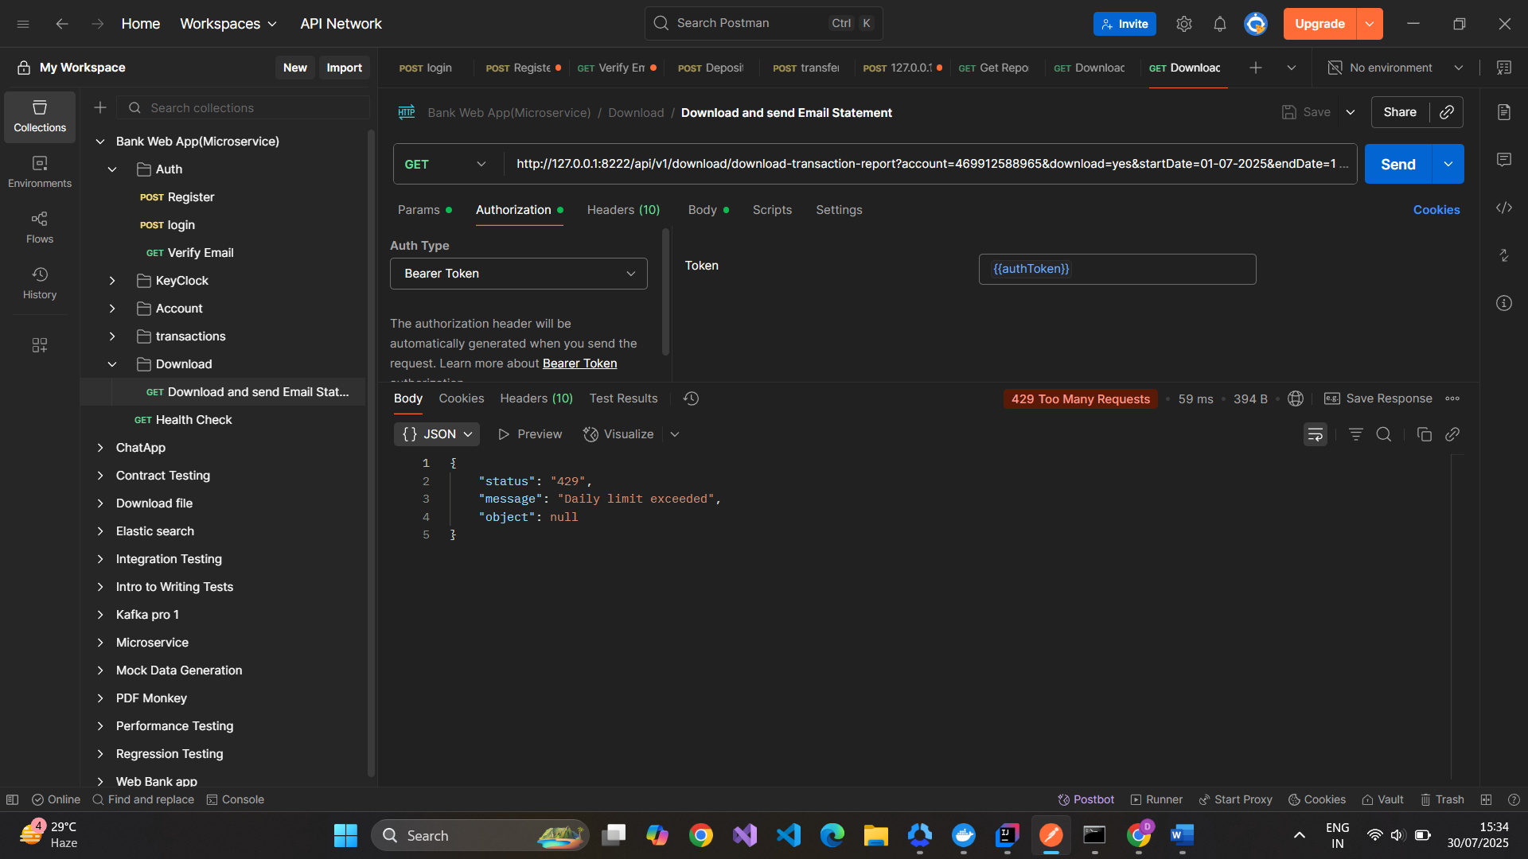

# 5. PROJECT STRUCTURE

Download /

├── src/

│ ├── main/

│ │ ├── java/

│ │ │ └── com/

│ │ │ └── com.bank.web.app.download/

│ │ │ ├── config/

│ │ │ ├── controller/

│ │ │ ├── redis/

│ │ │ ├── service/

│ │ │ ├── dto/

│ │ │ ├── kafka/

│ │ │ ├── exception/

│ │ │ └── DownlaodApplication.java

│ └── resources/

│ ├── application.yml

│ ├── static/

│ └── templates/

├── test/

│ └── java/

│ └── com/

│ └── com.bank.web.app.download/