**Flutter – Deployment**

**Local Stuff Sell and Buy Application**

**Android and iOS Based Local Stuff Sell and Buy Application using Flutter Dart**

# DHRUV A. SARANG

*Correspondence: [dhruvsarang5@gmail.com](mailto:dhruvsarang5@gmail.com)

**ABSTRACT:** This application enables any user to buying & selling from any corner of the world. It is a user-friendly application and easy to use. Once registered to the database a user can post ADD. This application is a Android and iOS based and structural system design and developed with the criteria to make the process of shopping easy and quick for all. The project was developed to fulfill the requirement of the user who wish to buying or selling online.

**KEYWORDS: Local Stuff Sell and Buy Application**

**App Features: -**

# Introduction

# User Feature

# Onboarding Screens

# User Registration and Authentication

# Product Listing

# Search and Filter

# Product Details

# Product Management

# User Profile Management

# All User can Buy and Sell Product

# Technical Features

# Shared Pref

# Firebase

# Payment using Rasor pay

# Conclusion

# Introduction: The system is designed to support the following feature.

# Number of users can access the system simultaneously.

# The system provides an interactive screen to the most normal user.

# User Feature

# Onboarding Screens

# 

# User Registration and Authentication

# Signup/Login: User Can register using Google Login

# 

# Product Listing

# All On Sell Product Shown on home Screen And Also User can search particular Product by products name

# 

# Category vies Product

# 

# Product Management: -

# User can add product for Sell

# 

# User Profile Management: -

# 

# Technical Feature

# Firebase

# Authentication

# 

# Realtime Database

# 

# Firebase Storage

# 

# Payment Using Rasor Pay

# 

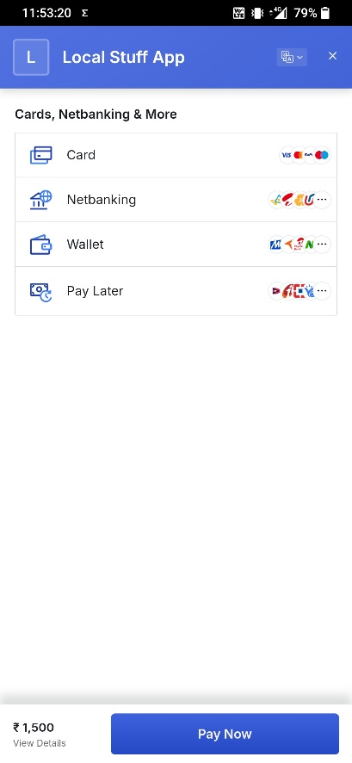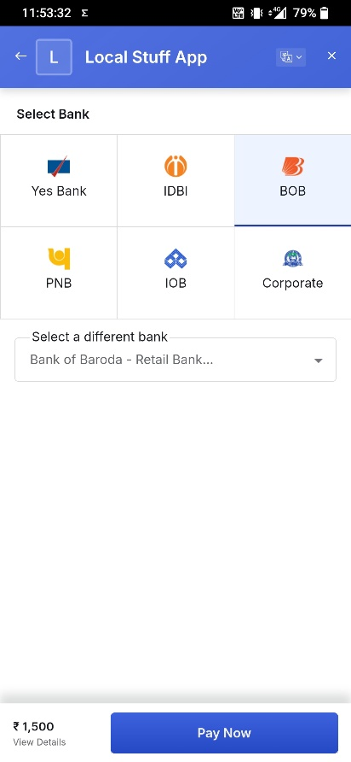

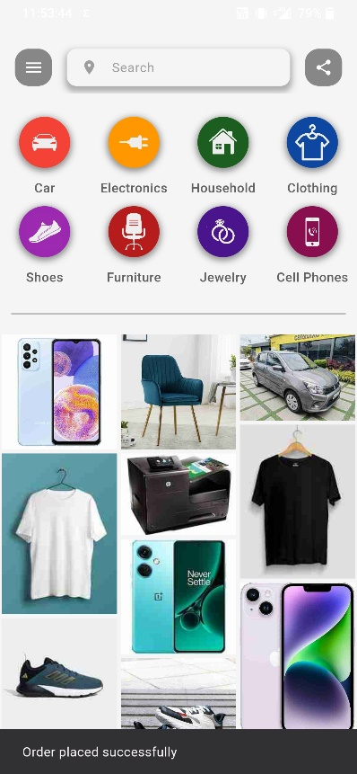

* **Order Record for Seller**

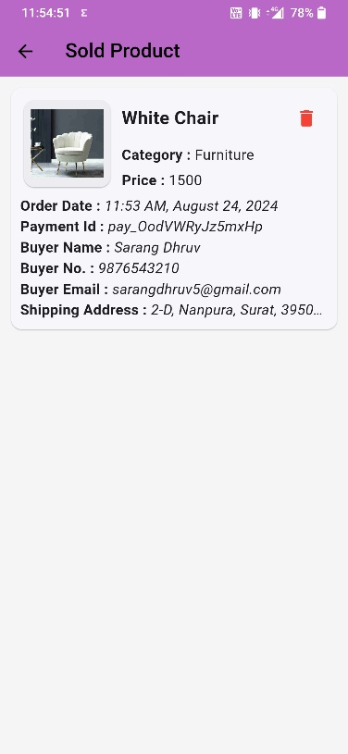

# Conclusion

# This OLX-type marketplace app aims to provide an engaging, secure, and efficient platform for buying and selling products online. With a comprehensive feature set, it is designed to deliver enhanced user experience and satisfaction.