Australian Bank Risk Analytics & Portfolio Optimization
A 25-Year Empirical Study of CBA, NAB, WBC, ANZ and Macquarie Group
Milestone 7 — Final Synthesis Report
Python · CAPM/OLS · Historical & Parametric VaR · Expected Shortfall · Mean-Variance Portfolio Optimisation · Stress Testing
September 2026

Abstract
This study examines market risk, systematic risk, and portfolio-level risk-adjusted performance across the four major Australian banks — Commonwealth Bank (CBA), National Australia Bank (NAB), Westpac (WBC) and ANZ — plus Macquarie Group (MQG), using 25 years of daily price data (30 July 2001 to 28 July 2026, approximately 6,300 trading days) benchmarked against the ASX200 Accumulation (total-return) Index.
Methods applied include descriptive return statistics, historical and parametric Value-at-Risk and Expected Shortfall, single-factor CAPM regression with a full diagnostic battery (Breusch-Pagan, Durbin-Watson, Jarque-Bera), crisis-period beta comparison across the Global Financial Crisis, COVID-19, and the 2022–24 rate-hiking cycle, mean-variance portfolio optimisation (equal-weight, minimum-variance and maximum-Sharpe portfolios under a 40% single-asset cap), out-of-sample validation over 2021–2026, differentiated stress testing, and robustness checks across three overlapping estimation windows.
All five banks carry market betas above 1 (1.03–1.40) with no statistically significant CAPM alpha detected. MQG is a structural outlier: the highest return, volatility (32.5% p.a.), beta (1.40) and drawdown (−81.7%) of the group, alongside markedly fatter tails. The maximum-Sharpe portfolio (Sharpe 0.524) concentrates 40% in MQG and 40% in CBA — a genuine risk-adjusted improvement over the full 25-year hindsight window, but also the most fragile of the three portfolios considered: it loses the most (−16.0%) under a Macquarie-specific stress scenario, and its optimal weights are the least stable across re-estimation windows. In a genuine out-of-sample test — weights estimated using only 2001–2020 data, then frozen and evaluated fresh on 2021–2026 — the minimum-variance portfolio is competitive with, and marginally better than, the maximum-Sharpe portfolio.
The analysis concludes that mean-variance optimisation identifies real diversification gains over naive equal-weighting, but that the full-sample “optimal” maximum-Sharpe solution should not be mistaken for a robust one: its edge is concentrated, estimation-sensitive, and does not reliably survive contact with new data or a bank-specific shock.

1. Introduction

1.1 Background
Banks sit at the centre of the Australian financial system: they intermediate credit, operate the payments infrastructure, and hold the deposits of most households and businesses. The sector is unusually concentrated by international standards — the four major retail banks plus Macquarie Group together account for a substantial share of the ASX200's market capitalisation and dividend income, and are widely held both directly by retail investors (partly for franking-credit income) and indirectly through superannuation. Their risk characteristics are therefore not a narrow sector question but a determinant of outcomes for a large share of Australian household wealth.

1.2 Motivation
Measuring bank risk matters differently to different audiences. For investors, banks are frequently over-weighted relative to a market-cap-neutral allocation, which makes understanding their tail risk — not just their average return — important for portfolio construction. For risk managers and prudential regulators, the sector's interconnectedness means that a common shock to systematic risk (as this study finds during COVID-19) can propagate quickly across institutions. This project approaches the question from the investor's side: given historical data, how risky are these five banks individually and in combination, and can that risk be reduced through portfolio construction rather than security selection alone?

1.3 Research Problem
How do Australia's major banks differ in market risk, tail risk, and systematic risk over a 25-year period spanning multiple crises, and can mean-variance portfolio optimisation improve risk-adjusted outcomes relative to a naive equal-weight allocation — and how robust are any such gains?

1.4 Objectives
- Characterise long-run return, volatility, skewness and tail behaviour for each bank.
- Quantify market and tail risk via historical and parametric Value-at-Risk and Expected Shortfall.
- Estimate systematic risk via CAPM, with a full OLS diagnostic battery rather than beta alone.
- Compare systematic risk across three major crisis regimes (GFC, COVID-19, 2022–24 rate hikes).
- Construct and compare equal-weight, minimum-variance and maximum-Sharpe portfolios under a realistic no-short-selling, 40%-cap constraint set.
- Validate portfolio performance out-of-sample (2021–2026) and under stress.
- Test the robustness of optimised weights across three overlapping estimation windows.

1.5 Contribution
The project's value lies less in any single technique — CAPM and mean-variance optimisation are both standard — and more in combining them end-to-end on a genuinely long (25-year), crisis-spanning dataset, and in treating the portfolio-optimisation output as a hypothesis to be stress-tested rather than a final answer. Three design choices in particular go beyond a purely descriptive risk study: (i) CAPM results are reported alongside heteroskedasticity, autocorrelation and normality diagnostics rather than beta and R² alone; (ii) the “optimal” portfolios are checked out-of-sample and under a bank-specific stress scenario, not just evaluated on the same data used to fit them; and (iii) portfolio weights are re-estimated on three overlapping sub-periods to directly quantify how sensitive the “optimal” allocation is to the estimation window — a question most student (and many practitioner) portfolio studies leave implicit.

2. Data
The dataset covers the five ASX-listed banks named in Table 1 over a 25-year window chosen to span multiple distinct market regimes: the dot-com aftermath, the Global Financial Crisis, the European debt crisis, the COVID-19 crash, and the 2022–24 inflation and rate-hiking cycle.
Table 1. Dataset Summary
Item | Detail
Banks covered | CBA, NAB, WBC, ANZ, MQG (ASX-listed ordinary shares)
Sample period | 30 Jul 2001 – 28 Jul 2026 (~25 years)
Observations | 6,349 raw daily prices per bank; 6,293 daily observations in the CAPM regression sample
Frequency | Daily
Price source | Yahoo Finance (yfinance); adjusted close prices (dividend- and split-adjusted)
Market benchmark | ASX200 Accumulation (Total Return) Index — dividends reinvested
Benchmark source | Historical export (spliced two vintages) supplemented with a recent Yahoo Finance (^AXJT) series
Risk-free proxy | RBA official cash rate, converted to a daily compounding-equivalent return; sample mean 3.38% p.a. over 2001–2026
Missing data | None — 0 missing values across all 6,293 regression residual observations
Bank prices were sourced directly via the Yahoo Finance API. The market benchmark deliberately uses a total-return (accumulation) index rather than the price-only ASX200, since a price index systematically understates both the true market return and, consequently, CAPM beta and alpha estimates by omitting reinvested dividends — material for a 25-year Australian equity sample given the market's historically high dividend yield. The benchmark series required splicing two historical export vintages plus a short recent Yahoo Finance extract to achieve full coverage; this join was not independently re-validated in this synthesis and is flagged in Section 9.
The risk-free proxy is the RBA official cash rate, converted from an annualised rate to a daily compounding-equivalent return and forward-filled between rate-change dates; it is not flat over the sample — it is markedly lower during the 2020–22 near-zero-rate period than in the early 2000s or post-2022 — and averages 3.38% p.a. over the full window. Returns are computed as both simple and log daily returns from adjusted close prices (dividend- and split-adjusted), consistent with the total-return ASX200 benchmark; annualisation throughout follows the standard ×252 (return) and ×√252 (volatility) trading-day convention. No missing values were found in the cleaned return series used for the regression and risk analysis.

3. Methodology

3.1 Returns
Daily simple and log returns are computed from adjusted close prices (dividend- and split-adjusted, matching the total-return market benchmark). Annualised expected return uses the arithmetic mean daily return × 252, consistent with the mean-variance portfolio framework applied later (which requires arithmetic, not geometric, expected returns as inputs).

3.2 Volatility
Annualised volatility is the standard deviation of daily returns scaled by √252, assuming i.i.d. returns for annualisation purposes, a standard simplification for daily financial data.

3.3 Value-at-Risk
Two estimation approaches are reported at the 95% and 99% confidence levels: historical simulation (the empirical percentile of realised daily returns, which is non-parametric and makes no distributional assumption) and parametric VaR (assuming normally distributed returns, using the sample mean and standard deviation). The two are compared directly in Section 4.1.

3.4 Expected Shortfall
Expected Shortfall (ES), also called Conditional VaR, is the average loss conditional on the loss exceeding the VaR threshold. Where VaR answers “how bad is a bad day at this confidence level,” ES answers “how bad is it on average once things are already that bad” — it captures tail severity, not just the threshold. Expected Shortfall is increasingly central to regulatory market-risk frameworks for this reason, though the specific 95%/99% confidence levels used here should not be read as replicating any single regulatory specification (e.g. the Basel Fundamental Review of the Trading Book's market-risk ES uses a 97.5% confidence level).

3.5 Maximum Drawdown
Maximum drawdown is the largest peak-to-trough decline in cumulative value over the full sample. Both the magnitude and the date of the trough are reported, since the date identifies which crisis actually produced each bank's worst historical outcome.

3.6 CAPM
For each bank, daily excess return (bank return minus the risk-free rate) is regressed on market excess return via OLS: r_i − r_f = α_i + β_i(r_m − r_f) + ε_i. Alpha, beta, R², t-statistics, p-values and 95% confidence intervals on beta are reported for the full sample and separately within three crisis windows (GFC, COVID-19, Rate Hikes). Regression residuals are further tested for heteroskedasticity (Breusch-Pagan), autocorrelation (Durbin-Watson) and normality (skewness, kurtosis, Jarque-Bera) — assumption checks that a beta-and-R²-only report would omit.

3.7 Portfolio Optimisation
Three portfolios are constructed under a mean-variance (Markowitz) framework with weights constrained to sum to 1, no short-selling (0 ≤ w ≤ 0.40 per bank), and a 40% single-asset cap intended to prevent the optimiser from collapsing to a one- or two-asset solution. The minimum-variance portfolio minimises portfolio variance; the maximum-Sharpe portfolio maximises (return − risk-free rate)/volatility; both are solved via SLSQP (scipy.optimize.minimize). Results are cross-checked against 10,000 randomly generated feasible portfolios (Dirichlet-distributed weights) and against independent multi-start recomputation. The efficient frontier is traced via 53 separate return-target-constrained optimisations.

3.8 Stress Testing
Two stress designs are applied to the three portfolios. The first applies a uniform shock (−10%, −20%, −30%) identically to all five banks — a mechanical check that, because portfolio weights sum to 1, necessarily produces an identical loss for every portfolio regardless of weights, and is reported as a validation step rather than a differentiating result. The second applies a differentiated shock — −10% to the four retail majors and −25% to MQG, reflecting Macquarie's structurally higher volatility and historical drawdown — which does differentiate the three portfolios by their actual MQG exposure.

3.9 Robustness
Minimum-variance and maximum-Sharpe weights are separately re-optimised on three overlapping historical sub-windows (2001–2015, 2016–2026, 2021–2026) and compared against the full-sample weights using two instability measures: total absolute weight change and the largest single-bank weight change. Separately, all three portfolios (built on the full sample) are evaluated out-of-sample over 2021–2026 — a period that overlaps the most recent robustness window but is used here purely for performance validation, not re-optimisation.

4. Results — Bank-Level Risk
MQG is the standout result of this section, and on every dimension at once. It has the highest mean daily return (0.070%, equivalent to roughly 17.6% annualised arithmetic return under the ×252 convention set out in Section 3.1) but also the highest annualised volatility by a wide margin (32.47%, against 22–24% for the four retail majors), the fattest tails (kurtosis 27.69 versus 6–10 for its peers) and by far the deepest historical drawdown (−81.74%). This is a conventional risk-return trade-off, but of a materially different order of magnitude to the other four banks — MQG behaves more like a higher-beta, higher-volatility diversified financial than a plain domestic retail bank, consistent with its capital-markets and asset-management business mix.
Table 2. Descriptive Statistics of Daily Returns (2001–2026)
Bank | Mean Daily Return | Ann. Volatility | Skewness | Kurtosis | Min Return | Max Return
CBA | 0.058% | 21.95% | 0.08 | 8.54 | -10.43% | 13.26%
NAB | 0.038% | 23.95% | -0.17 | 10.27 | -13.49% | 17.35%
WBC | 0.048% | 23.37% | -0.08 | 6.24 | -11.81% | 9.23%
ANZ | 0.047% | 24.32% | 0.16 | 9.57 | -12.50% | 14.63%
MQG | 0.070% | 32.47% | 0.73 | 27.69 | -23.22% | 37.81%
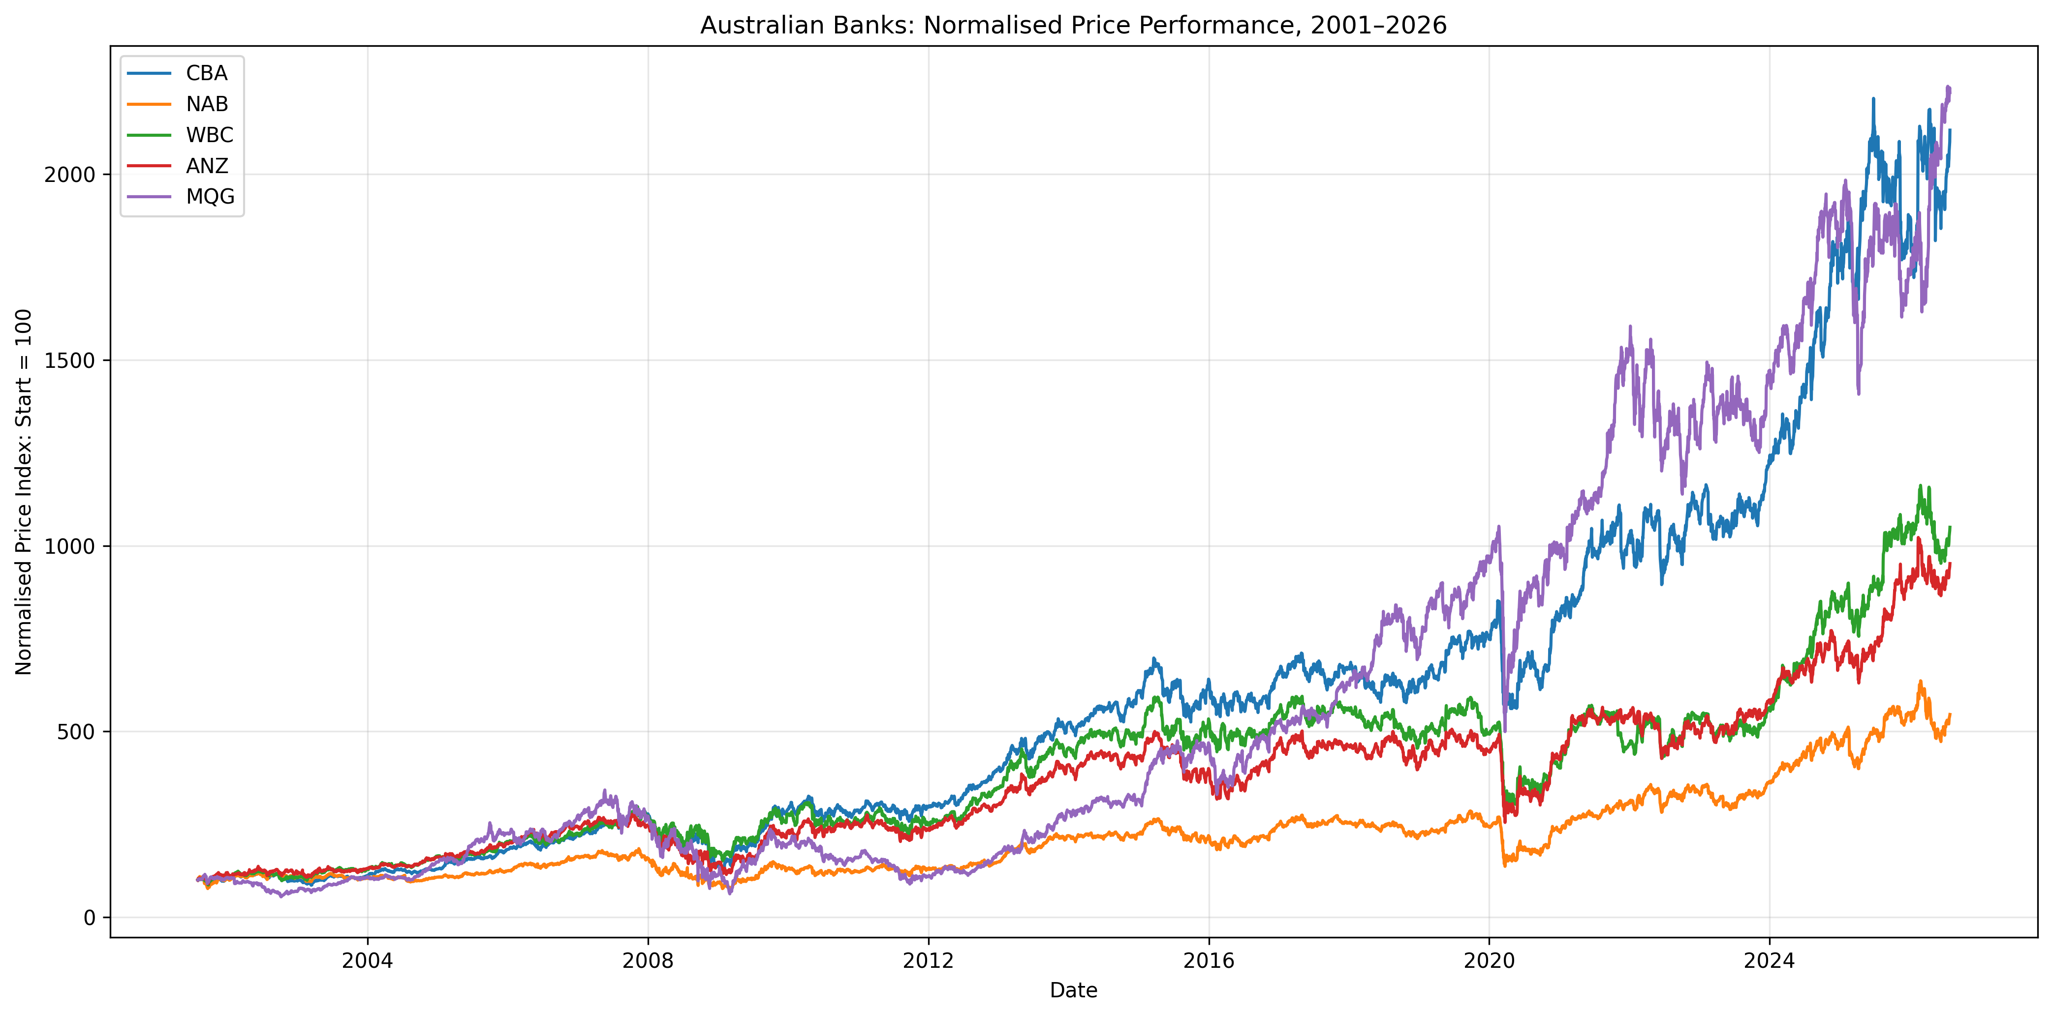
Figure 1. Indexed price performance, 2001–2026 (all series rebased to a common starting value).
Among the four retail majors, NAB stands out as the weakest historical risk-adjusted performer: the lowest mean return of the group (0.038% daily) combined with its highest volatility (23.95%) and second-highest kurtosis (10.27). WBC's worst drawdown is the one genuine surprise in Table 3B: unlike the other four banks, whose deepest historical decline came during the GFC, WBC's largest drawdown (−51.74%) occurred during the COVID-19 crash of March 2020 — the only one of the five whose worst point in 25 years was not the GFC (Table 3B).
Table 3B. Maximum Drawdown and Date of Trough
Bank | Maximum Drawdown | Date / Episode
CBA | -58.53% | 23 Jan 2009 (GFC)
NAB | -60.66% | 9 Mar 2009 (GFC)
WBC | -51.74% | 23 Mar 2020 (COVID-19)
ANZ | -58.64% | 12 Feb 2009 (GFC)
MQG | -81.74% | 2 Mar 2009 (GFC)
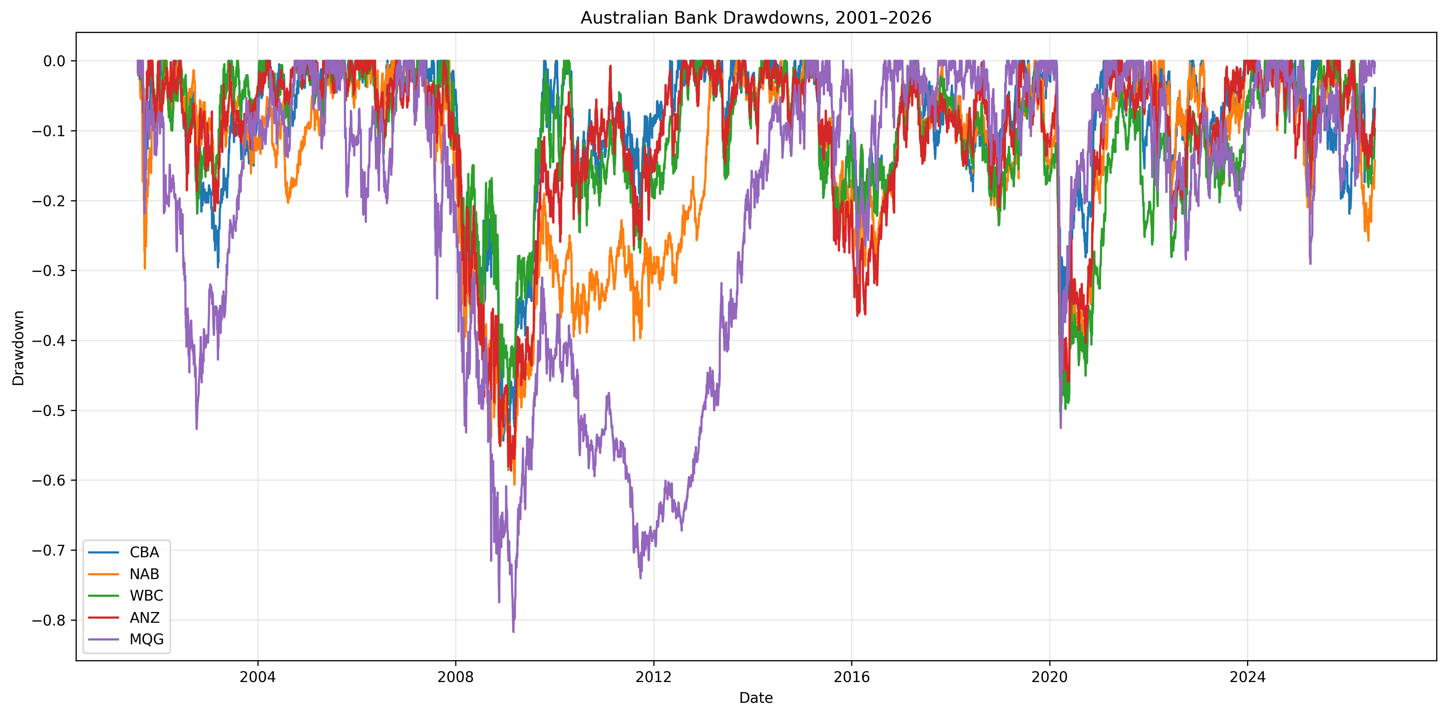
Figure 2. Drawdown paths for all five banks over the full sample, highlighting the concentration of worst outcomes around the GFC.

4.1 Tail Risk: VaR and Expected Shortfall
Table 3 reports both historical (empirical) and parametric (Gaussian) VaR at the 95% and 99% confidence levels, alongside Expected Shortfall. Two patterns stand out. First, historical and parametric VaR produce similar but not identical estimates, and the relationship flips by confidence level: at 95%, parametric VaR is modestly higher than historical VaR for every bank, whereas at 99% historical VaR is consistently higher than parametric VaR for every bank — a signature of the fat-tailed (leptokurtic) realised return distributions documented in Table 2, which push more extreme-tail probability into the historical estimate at 99% than a Gaussian assumption captures, while at the less extreme 95% level the parametric estimate’s reliance on the (also elevated) full-sample standard deviation dominates. Second, and more importantly, Expected Shortfall exceeds VaR by roughly 45–55% at the same confidence level for every bank — e.g. CBA's 99% VaR of 3.82% understates its 99% Expected Shortfall of 5.46% by 43% — a direct, concrete illustration of why VaR alone understates true tail risk.
Table 3. Value-at-Risk and Expected Shortfall (Daily, 95%/99%)
Bank | Hist. VaR 95% | Hist. VaR 99% | Param. VaR 95% | Param. VaR 99% | ES 95% | ES 99%
CBA | 2.04% | 3.82% | 2.22% | 3.16% | 3.18% | 5.46%
NAB | 2.25% | 4.25% | 2.44% | 3.47% | 3.54% | 6.04%
WBC | 2.24% | 3.96% | 2.37% | 3.38% | 3.40% | 5.54%
ANZ | 2.24% | 4.08% | 2.47% | 3.52% | 3.50% | 5.98%
MQG | 2.86% | 5.64% | 3.30% | 4.69% | 4.77% | 8.32%
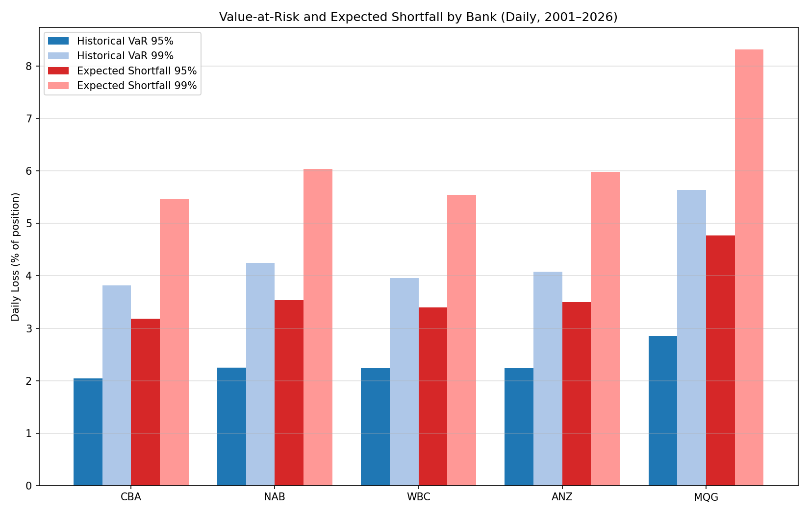
Figure 3. Historical VaR, parametric VaR and Expected Shortfall by bank, 95% and 99% confidence. MQG's tail risk is 35–50% larger than the four-major average across every measure.
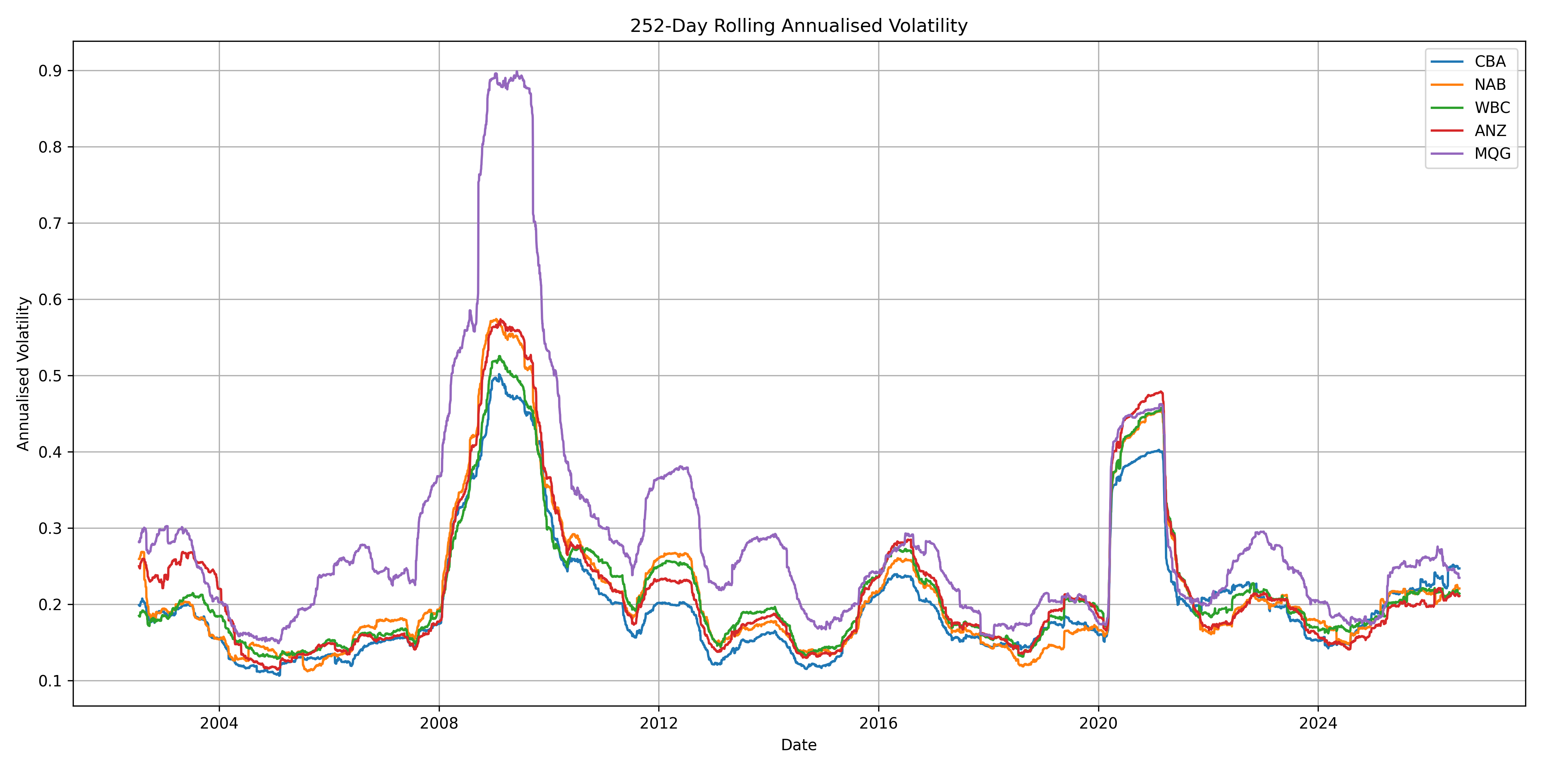
Figure 4. 252-day rolling annualised volatility — risk is highly time-varying, with sustained spikes around the GFC and COVID-19 rather than a stable long-run level.
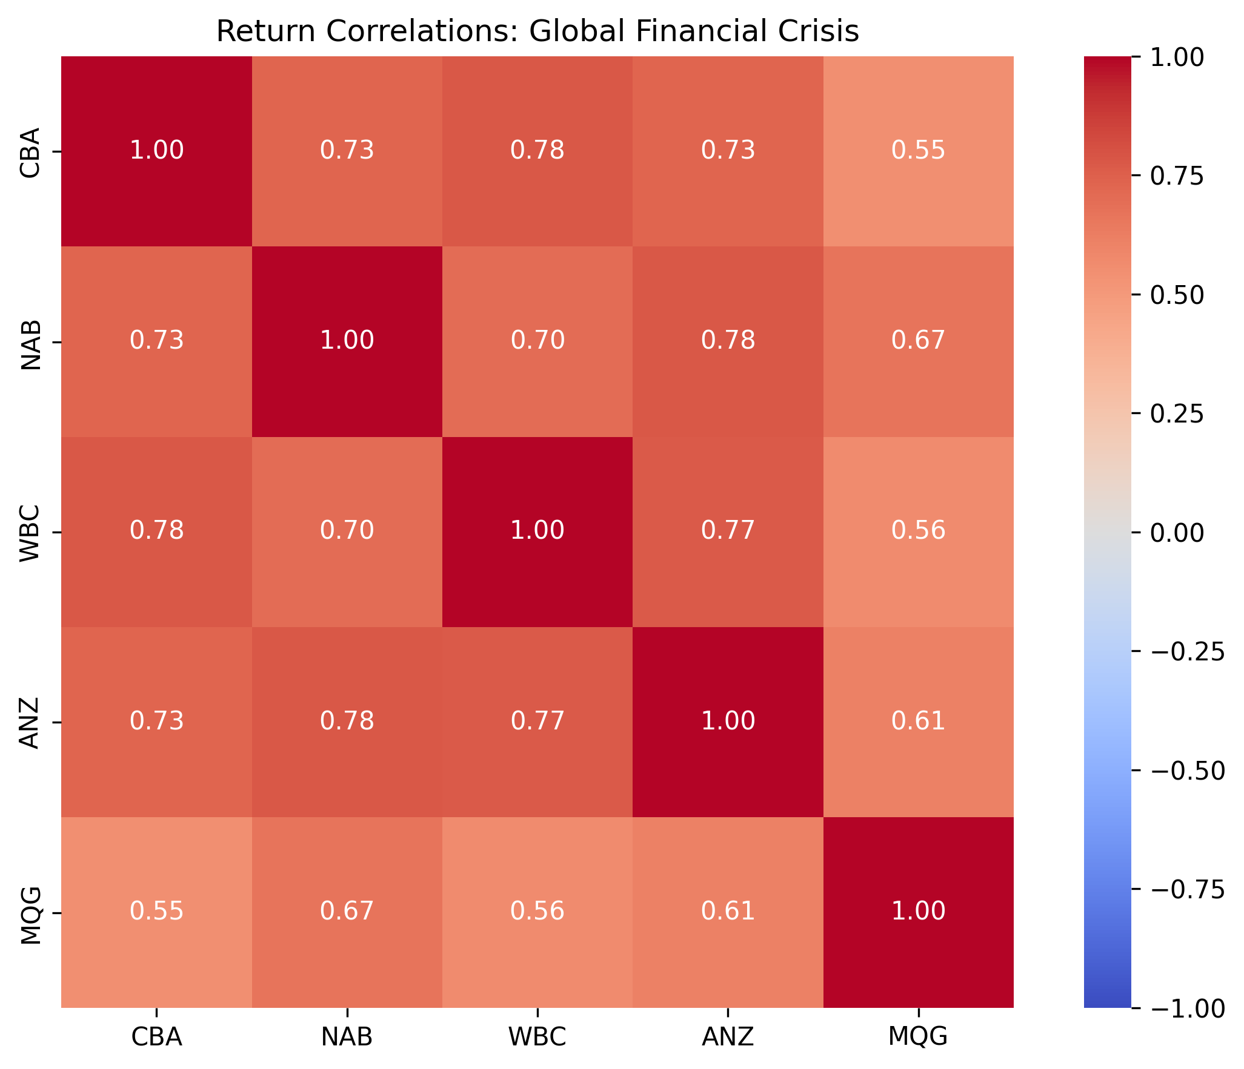
Figure 5. Return correlation matrix during the Global Financial Crisis window — pairwise correlations are high across all five banks (0.55–0.78), consistent with the systemic co-movement discussed in Section 5.1.

5. Results — CAPM & Econometrics
Every bank's market beta is statistically significant at any conventional level (t-statistics of 73–88) and above 1.0, meaning all five banks are structurally more volatile than the broad market — unsurprising given financials' typical role as a high-beta sector. CBA is the lowest-beta bank (1.031, closest to market-neutral sensitivity) and MQG the highest by a clear margin (1.402). By contrast, every alpha is statistically indistinguishable from zero (p-values from 0.087 to 0.792): no bank has a statistically significant abnormal (alpha) return over the full 25-year sample once market exposure is accounted for — the evidence fails to reject a null of zero alpha for all five banks, which is not the same as proving alpha is exactly zero.
Table 4. CAPM Regression Results (Full Sample, N = 6,293)
Bank | Alpha | α t-stat | α p-value | Beta | β t-stat | β p-value | R²
CBA | 0.0201% | 1.71 | 0.087 | 1.031 | 87.63 | <0.001 | 0.550
NAB | -0.0034% | -0.27 | 0.791 | 1.125 | 87.15 | <0.001 | 0.547
WBC | 0.0075% | 0.60 | 0.550 | 1.098 | 87.17 | <0.001 | 0.547
ANZ | -0.0034% | -0.26 | 0.792 | 1.126 | 86.09 | <0.001 | 0.541
MQG | 0.0219% | 1.15 | 0.249 | 1.402 | 73.43 | <0.001 | 0.461
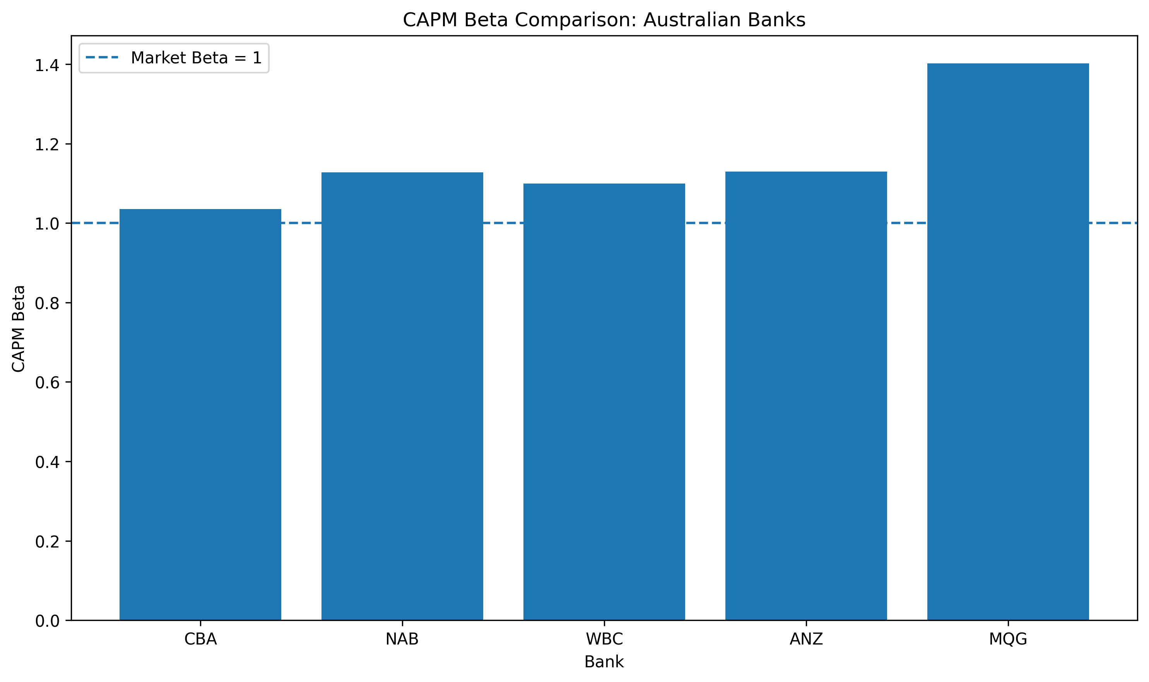
Figure 6. CAPM beta by bank with 95% confidence intervals — all intervals sit clearly above 1.0 except CBA, which sits just above it.
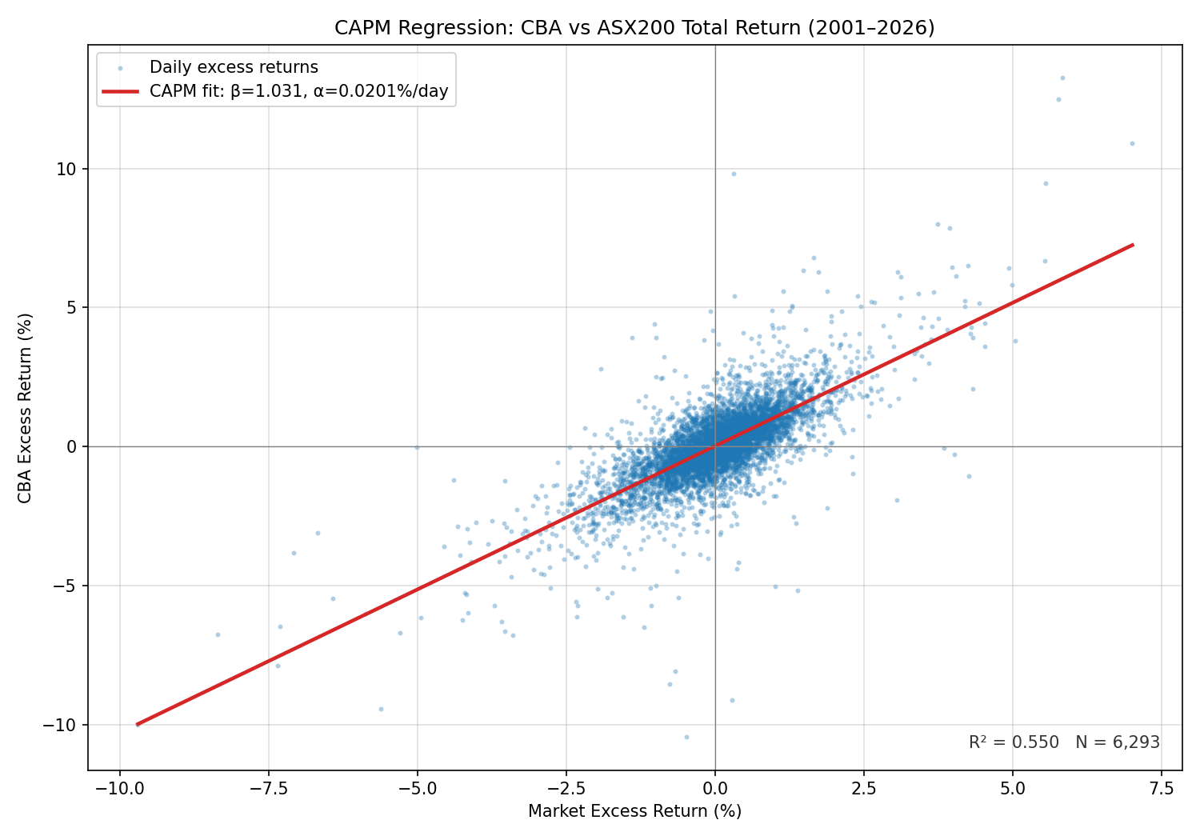
Figure 7. Representative CAPM regression: CBA daily excess return against market excess return, with fitted line (β = 1.031, R² = 0.550).
R² ranges narrowly from 0.461 (MQG) to 0.550 (CBA) — the single market factor explains only around half of daily return variance for any of the five banks, leaving substantial bank-specific (idiosyncratic) risk unexplained. MQG's combination of the highest beta but the lowest R² is not a contradiction: its total volatility is dominated by idiosyncratic risk (consistent with its outlier skewness and kurtosis in Table 2) even though its systematic component is also the largest in absolute terms. This half-explained R² is itself an argument for diversifying across banks rather than concentrating in one — a point picked up again in Section 6.

5.1 Systematic Risk Across Crisis Regimes
Beta is not stable through time. Table 5 compares each bank's full-sample beta to its beta estimated within three distinct crisis windows. COVID-19 stands out as the one episode where systematic risk rose for every bank simultaneously (by 0.09–0.21 over the full-sample beta) — a textbook illustration of correlations and market sensitivity converging across firms during a systemic panic. The GFC shows a more bank-specific pattern: MQG's beta jumped by 0.31 (from 1.40 to 1.71, the largest single shift in the table) while the four retail majors moved far more modestly (+0.01 to +0.09). The 2022–24 rate-hiking cycle inverts the pattern seen elsewhere: beta fell below its full-sample level for four of five banks (by 0.12–0.20), while MQG's held essentially flat — suggesting the retail majors partially decoupled from broad market swings during the tightening cycle, while Macquarie's more market-linked revenue mix kept it tethered to the index.
Table 4B. Beta by Crisis Period vs Full-Sample Beta
Bank | Full Sample | GFC | COVID-19 | Rate Hikes
ANZ | 1.126 | 1.216 | 1.335 | 0.927
CBA | 1.031 | 1.037 | 1.188 | 0.913
MQG | 1.402 | 1.708 | 1.265 | 1.415
NAB | 1.125 | 1.214 | 1.248 | 0.952
WBC | 1.098 | 1.109 | 1.240 | 0.896
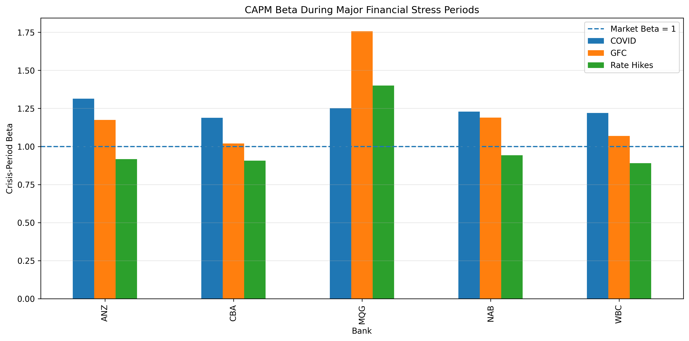
Figure 8. Beta by bank across the full sample and three crisis windows, visualising the COVID-wide increase and the rate-hike-era divergence between MQG and the four majors.
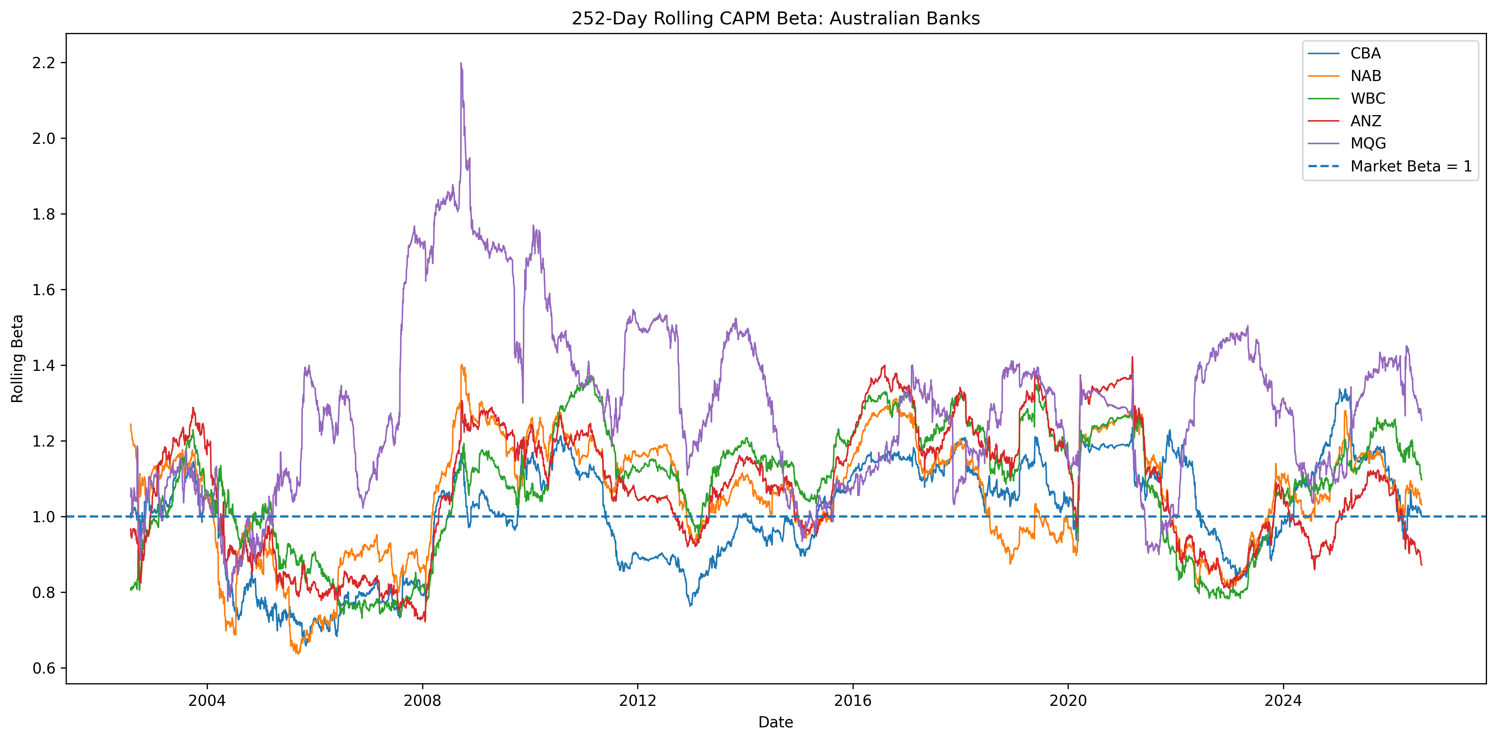
Figure 9. 252-day rolling beta, all five banks — the discrete crisis-window betas in Table 4B are snapshots of a continuously time-varying quantity.
R² also shifts materially by regime: during COVID-19 it rises to 0.66–0.77 across the five banks (versus 0.46–0.55 full-sample), while during the rate-hiking cycle it falls to 0.38–0.59 — direct evidence that market co-movement across banks increases substantially during systemic stress and recedes during calmer, more monetary-policy-driven periods.

5.2 Regression Diagnostics
None of the five regressions shows meaningful autocorrelation (Durbin-Watson statistics all between 1.88 and 2.06, comfortably within the conventional 1.5–2.5 no-autocorrelation band). Heteroskedasticity is detected (Breusch-Pagan p < 0.05) for CBA and ANZ specifically, but not for NAB, WBC or MQG — a mild caveat on the precision of CBA's and ANZ's standard errors that a heteroskedasticity-robust (e.g. White/HAC) correction would address, though both banks' betas remain overwhelmingly significant regardless. Residuals are significantly non-normal for all five banks (Jarque-Bera p < 0.001 throughout), which is the expected stylised fact for daily financial returns rather than a modelling failure; MQG's non-normality is far more extreme than its peers (Jarque-Bera statistic of 631,191 versus 20,000–59,000 for the other four), consistent with the outlier tail behaviour already observed in Table 2.
Table 4C. CAPM Residual Diagnostics
Bank | Breusch-Pagan p | Heteroskedasticity | Durbin-Watson | Jarque-Bera p
CBA | 0.025 | Detected | 1.937 | <0.001
NAB | 0.554 | Not detected | 1.877 | <0.001
WBC | 0.536 | Not detected | 1.924 | <0.001
ANZ | 0.029 | Detected | 1.923 | <0.001
MQG | 0.273 | Not detected | 2.057 | <0.001
The CAPM beta estimates remain highly statistically significant throughout, and the residual diagnostics show no meaningful autocorrelation. The two departures found (mild heteroskedasticity in two of five banks, non-normal residuals in all five) are common in daily-frequency financial regressions and do not change the substantive conclusions, though they are noted explicitly in Section 9 rather than left implicit.

6. Results — Portfolio Optimization
The equal-weight baseline (20% in each bank) returns 13.13% p.a. at 21.47% volatility, for a Sharpe ratio of 0.454. Optimising away from this naive baseline produces two distinct outcomes depending on the objective. The minimum-variance portfolio reduces volatility to 20.83% while giving up only 0.23 percentage points of return (12.90% vs 13.13%) — a genuine, if modest, diversification benefit: Sharpe improves slightly to 0.457. The maximum-Sharpe portfolio is a larger step in a different direction: return rises to 15.25% and Sharpe to 0.524, a meaningfully better risk-adjusted outcome than either alternative — but achieved by pushing weight in CBA and MQG simultaneously to the 40% cap, leaving 80% of the portfolio in just two of five banks, with ANZ reduced to 0.03% and NAB to zero.
Table 5. Portfolio Weights (Full-Sample, 2001–2026)
Portfolio | CBA | NAB | WBC | ANZ | MQG
Equal Weight | 20.00% | 20.00% | 20.00% | 20.00% | 20.00%
Minimum Variance | 40.00% | 18.05% | 23.37% | 12.88% | 5.69%
Maximum Sharpe | 40.00% | 0.00% | 19.97% | 0.03% | 40.00%
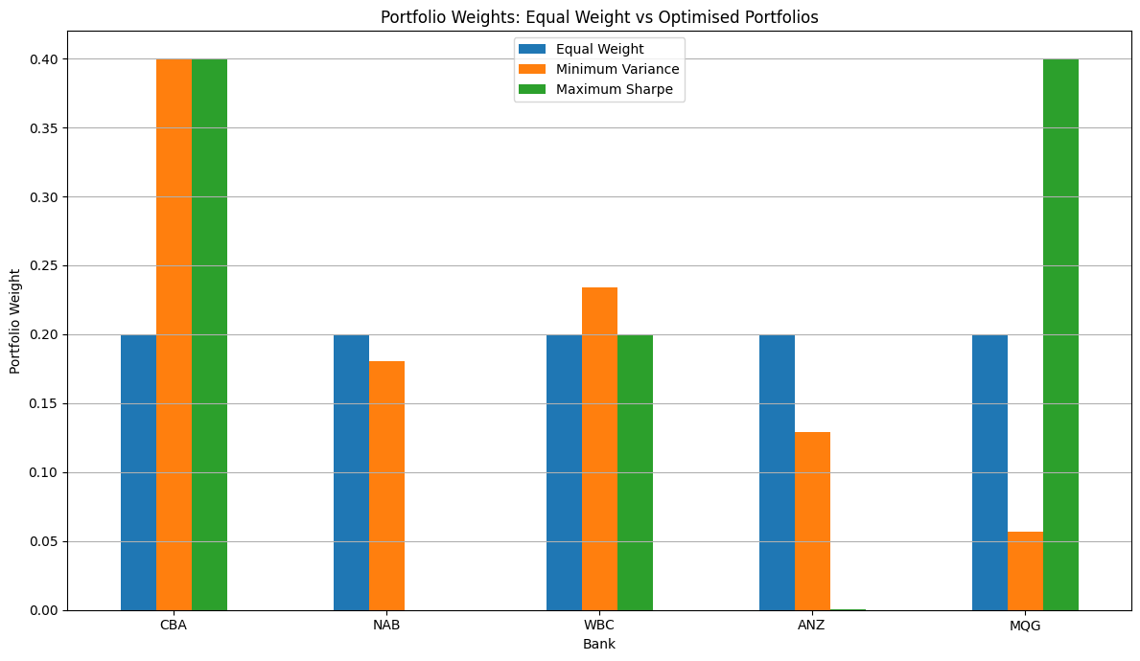
Figure 10. Portfolio weights: equal-weight vs minimum-variance vs maximum-Sharpe. The maximum-Sharpe solution is materially more concentrated than either alternative.
Table 6. Portfolio Performance (Full-Sample, 2001–2026)
Portfolio | Ann. Return | Ann. Volatility | Sharpe Ratio | Max Drawdown
Equal Weight | 13.13% | 21.47% | 0.454 | -56.64%
Minimum Variance | 12.90% | 20.83% | 0.457 | -54.88%
Maximum Sharpe | 15.25% | 22.64% | 0.524 | -60.68%
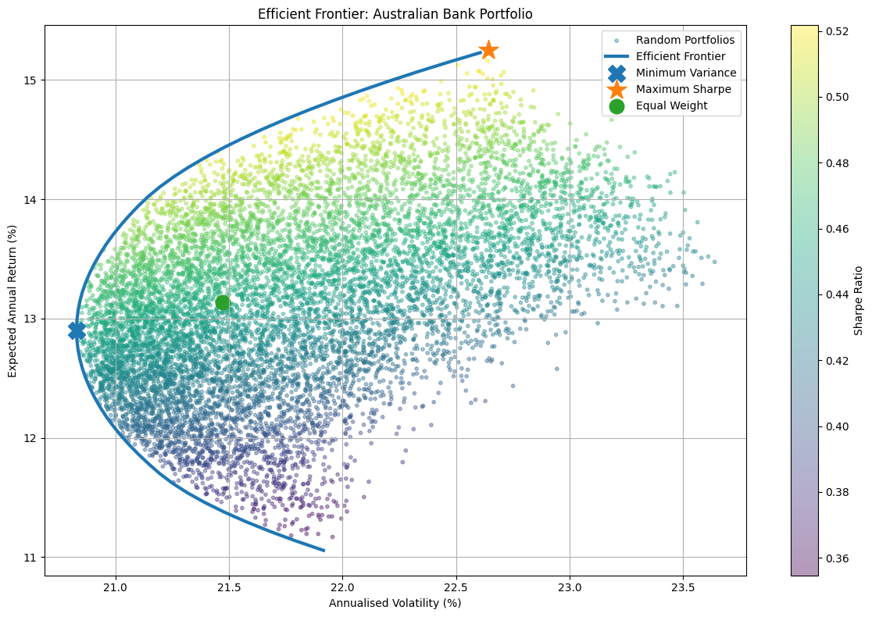
Figure 11. Efficient frontier (53 target-return-constrained optimisations) against 10,000 randomly simulated feasible portfolios, colour-scaled by Sharpe ratio. The three named portfolios sit exactly where theory predicts: minimum-variance at the frontier's leftmost point, maximum-Sharpe at its tangency point, equal-weight inside the feasible region.
Two validation checks support these results. First, an independent search over the 10,000 randomly generated feasible portfolios finds a best achieved Sharpe ratio of 0.522 and a lowest achieved volatility corresponding to a Sharpe of 0.454 — both within 0.003 of the SLSQP-optimised results, confirming the optimiser reached the (essentially) global optimum rather than a poor local one. Second, maximum drawdown across the three portfolios ranks in the same order as volatility (minimum-variance best at −54.88%, maximum-Sharpe worst at −60.68%): the Sharpe ratio's return-to-volatility framing does not fully capture that the maximum-Sharpe portfolio's superior average risk-adjusted return is accompanied by a materially worse plausible worst case, a distinction taken up further in Section 8.
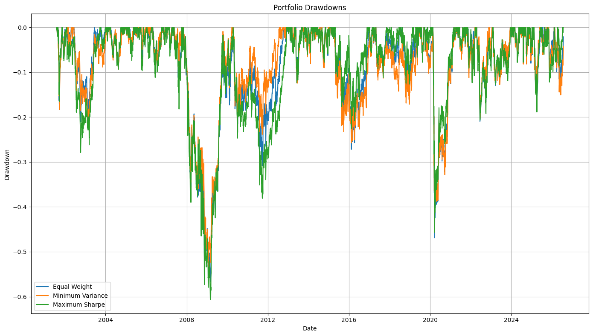
Figure 12. Drawdown paths of the three portfolios over the full sample — maximum-Sharpe's deeper trough mirrors its heavier concentration in CBA and MQG.

7. Robustness & Stress Testing

7.1 Out-of-Sample Performance (2021–2026)
Section 6 characterised the three portfolios using weights estimated from the full 25-year sample (2001–2026) — a hindsight exercise showing what would have been optimal with perfect knowledge of the whole period, not a claim that this was achievable in real time. To test whether an edge would genuinely have been available in advance, this section builds a second, independent set of weights using only data through 31 December 2020 (4,940 observations), freezes them, and evaluates their performance on 2021–2026 data (1,408 observations) that played no role in estimating them. The training-period weights (Table 7) differ from the full-sample weights in Table 5, sometimes considerably — minimum-variance's MQG allocation is 3.66% here versus 5.69% on the full sample, and maximum-Sharpe reallocates from WBC (19.97% → 8.39%) toward ANZ (0.03% → 11.61%) — which is itself an early signal of how sensitive these optimisations are to the estimation window, elaborated further in Section 7.3.
Table 7. Training-Period Portfolio Weights (Estimated on 2001–2020 Only)
Portfolio | CBA | NAB | WBC | ANZ | MQG
Equal Weight | 20.00% | 20.00% | 20.00% | 20.00% | 20.00%
Minimum Variance | 40.00% | 20.70% | 26.73% | 8.90% | 3.66%
Maximum Sharpe | 40.00% | 0.00% | 8.39% | 11.61% | 40.00%
Table 7B reports how these frozen, training-only weights actually performed once applied to the held-out 2021–2026 period. All three portfolios achieve a materially higher Sharpe ratio out-of-sample than any of the full-sample portfolios in Table 6 (0.85–0.88 versus 0.45–0.52) — but this is not evidence the optimisation “worked”: the equal-weight portfolio, which requires no estimation at all, improves by a similar margin, indicating the dominant driver is a more benign realised market regime after 2021 (out-of-sample volatility of 16.7–17.5% versus a full-sample estimate of 21–23%) rather than skill in either optimisation. What the genuinely out-of-sample test does reveal is a reversal relative to the full-sample ranking in Table 6: there, maximum-Sharpe (0.524) beats minimum-variance (0.457); here, minimum-variance (0.875) edges out maximum-Sharpe (0.848). This is a textbook illustration of estimation error in mean-variance optimisation — the maximum-Sharpe objective depends on the noisy, backward-looking sample mean return, while minimum-variance depends only on the comparatively more stable covariance matrix, and degrades more gracefully when weights are genuinely frozen ahead of time.
Table 7B. Genuine Out-of-Sample Performance (Training Weights, Evaluated on 2021–2026)
Portfolio | Ann. Return | Ann. Volatility | Sharpe
Equal Weight | 17.94% | 16.74% | 0.870
Minimum Variance | 18.65% | 17.45% | 0.875
Maximum Sharpe | 18.24% | 17.52% | 0.848
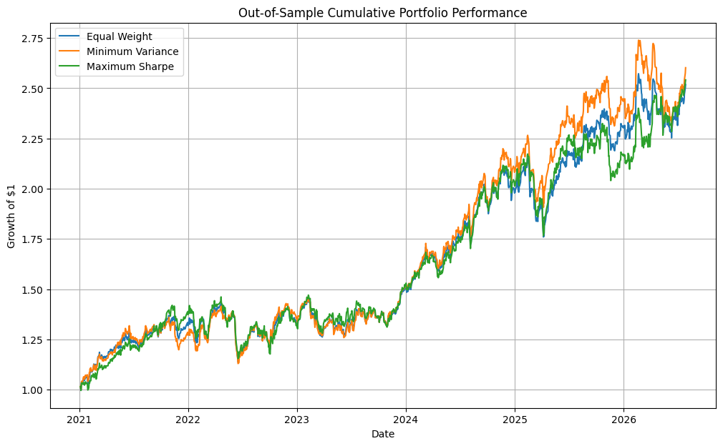
Figure 13. Out-of-sample cumulative performance of the three portfolios, 2021–2026 (training weights, frozen from 2001–2020 estimation).

7.2 Stress Testing
The uniform-shock design (−10%/−20%/−30% applied identically to all five banks) produces, by construction, an identical loss for every portfolio regardless of its weights — since weights sum to 1, a proportional shock to every asset is a proportional shock to the portfolio no matter how it is allocated. This scenario is retained in Table 8 as a mechanical validation check rather than a differentiating result. The differentiated shock (−10% to the four retail majors, −25% to MQG specifically, reflecting MQG's structurally higher historical volatility and drawdown) is the economically meaningful test: minimum-variance loses least (−10.85%), equal-weight sits in the middle (−13.00%), and maximum-Sharpe loses most by a clear margin (−16.00%). This ordering follows directly from Table 5: maximum-Sharpe's 40% MQG weight is more than seven times minimum-variance's 5.69%, so the same concentration that maximises full-sample Sharpe is precisely what makes the portfolio most exposed to a Macquarie-specific shock.
Table 8. Stress-Test Results — Portfolio Loss Under Each Scenario
Portfolio | Uniform −10% | Uniform −20% | Uniform −30% | Differentiated*
Equal Weight | -10.00% | -20.00% | -30.00% | -13.00%
Minimum Variance | -10.00% | -20.00% | -30.00% | -10.85%
Maximum Sharpe | -10.00% | -20.00% | -30.00% | -16.00%
* Differentiated scenario: −10% to CBA, NAB, WBC and ANZ; −25% to MQG.
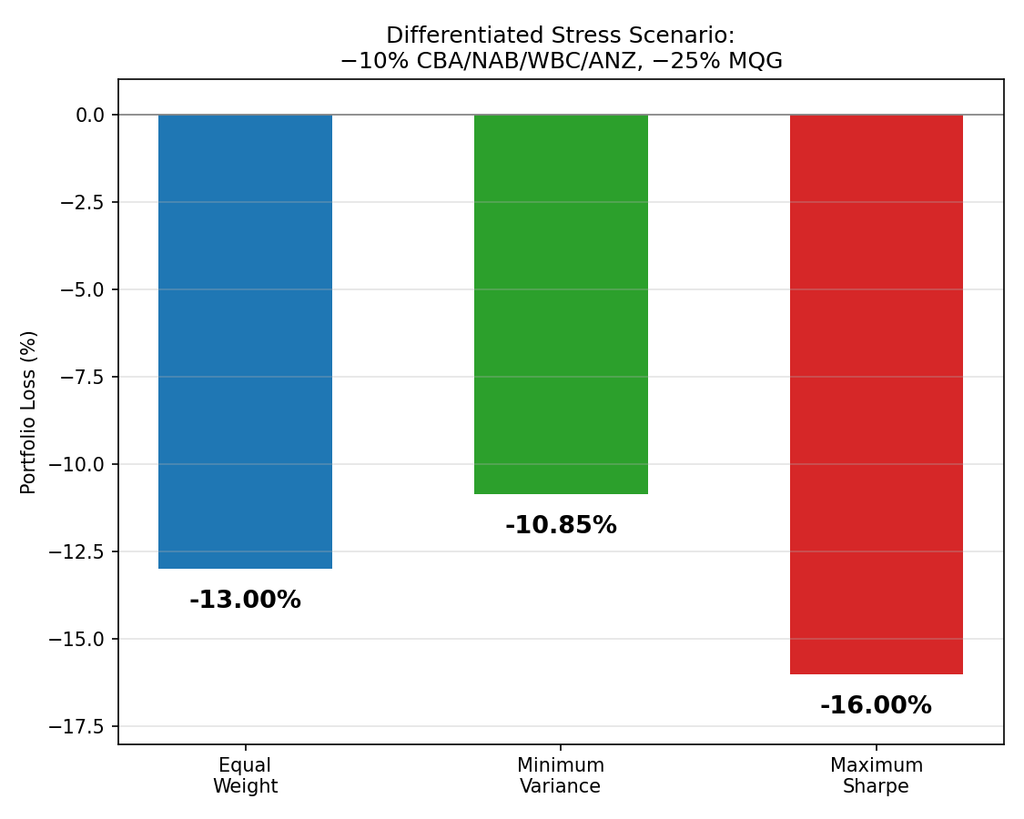
Figure 14. Portfolio loss under the differentiated stress scenario (−10% to the four majors, −25% to MQG).
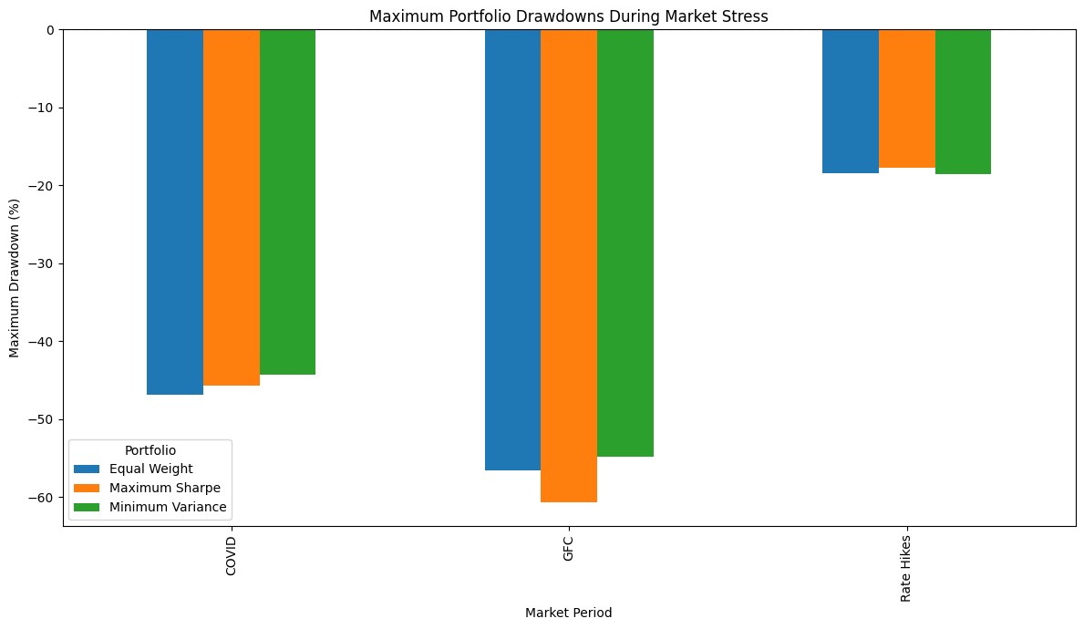
Figure 15. Maximum portfolio drawdown realised during each of three historical crisis periods (COVID-19, GFC, Rate Hikes) — a historical complement to the hypothetical scenario in Figure 14.
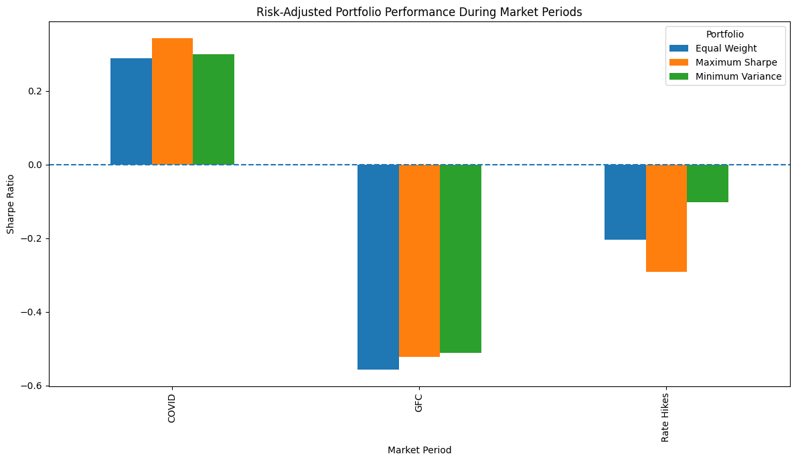
Figure 16. Risk-adjusted performance of the three portfolios across the same historical market periods — the maximum-Sharpe portfolio's advantage is not uniform across regimes.

7.3 Robustness to the Estimation Window
Minimum-variance and maximum-Sharpe weights were independently re-optimised on three overlapping sub-windows (2001–2015, 2016–2026, 2021–2026) and compared to the full-sample weights. Minimum-variance is comparatively stable in the two longer/older windows — CBA sits at or near the 40% cap in three of four windows — but becomes considerably less stable in the most recent, shortest window (total absolute weight change of 0.675 against the full sample, its largest deviation). Maximum-Sharpe, by contrast, is persistently unstable across every window tested (total absolute weight change of 0.40–0.45 in all three, never falling to minimum-variance's more stable readings): MQG's weight alone swings from 0% (2001–2015) to 40% (2016–2026) to 17.95% (2021–2026) to 40% (full sample), a range spanning the entire feasible interval under the 40% cap. Note that the 2021–2026 sub-window used here for robustness re-estimation is the same period used as the genuine out-of-sample test in Section 7.1; this window should therefore be read as testing how sensitive the full-sample-style approach is to the choice of estimation period, not as a second independent validation of the Section 7.1 result.
Table 8B. Portfolio Weight Instability vs Full-Sample Weights (Total Absolute Weight Change)
Portfolio | vs 2001–2015 | vs 2016–2026 | vs 2021–2026
Minimum Variance | 0.115 | 0.382 | 0.675
Maximum Sharpe | 0.401 | 0.400 | 0.449

7.4 Are the Findings Robust?
Directionally, yes: across every test in this section — out-of-sample Sharpe, stress-test loss, and weight stability — minimum-variance is consistently the smoother, less concentrated, more stable of the two optimised portfolios relative to equal-weight. What is not robust is the specific numerical case for maximum-Sharpe's superiority found in Section 6: that portfolio's apparent edge is concentrated in two positions, reverses out-of-sample, and is the least stable allocation across every re-estimation window tested. A reader taking only Table 6 at face value would conclude maximum-Sharpe is the best portfolio; a reader who continues through this section would reasonably conclude it is the best-performing portfolio on the specific historical sample used to build it, and the least trustworthy of the three going forward.

8. Discussion
Where Sections 4–7 report what happened, this section addresses why it matters.

8.1 Diversification Benefits and Concentration Risk
The minimum-variance portfolio demonstrates a real, if modest, diversification benefit over equal-weighting: a Sharpe improvement from 0.454 to 0.457 sounds small, but it is achieved while simultaneously reducing volatility, which is a legitimate result rather than a rounding artefact. The maximum-Sharpe portfolio's larger apparent improvement (to 0.524) is better understood as a concentration bet than a diversification gain: Sharpe-ratio maximisation, absent an explicit penalty for concentration, will gravitate toward whichever individual assets have the highest stand-alone Sharpe ratios — here, CBA (individual Sharpe 0.508) and MQG (0.436) — up to whatever cap the constraint set allows (40% each, 80% combined). The 40% cap in this study was chosen specifically to prevent a still more extreme, single- or two-asset solution; a reader should note that a tighter cap (e.g. 25–30%) would likely produce a maximum-Sharpe portfolio closer in spirit to minimum-variance's diversification profile, at some further cost to full-sample Sharpe.

8.2 Bank Risk Profiles and the Macquarie Outlier
MQG is not simply “a riskier bank” — it is a structurally different asset within this five-bank set: higher return, higher beta, but also far higher idiosyncratic volatility, fatter tails, and (per Section 5) the lowest R² of the five, meaning proportionally more of its risk is company-specific rather than market-driven. This is consistent with Macquarie's globally diversified capital-markets and asset-management business, in contrast to the four majors' more domestically concentrated retail and commercial banking franchises. The practical implication is that MQG behaves less like a substitute for the other four banks than like a distinct risk factor — which is exactly why the optimiser is drawn to combine it with CBA rather than treat all five banks as interchangeable.

8.3 Time-Varying Systematic Risk
A single full-sample beta materially understates systematic risk during a crisis: all five betas rise during COVID-19, and the pattern of change during the GFC and the recent rate-hiking cycle differs meaningfully by bank (Section 5.1). A risk manager relying solely on a static, full-history beta would have been under-hedged for market risk precisely when it mattered most, and the divergence between MQG and the four majors during 2022–24 suggests that even a single “banks” bucket is not risk-homogeneous once the sample is cut by regime.

8.4 Limits of Historical Optimisation
Sections 7.1–7.3 collectively explain why: mean-variance optimisation is highly sensitive to its expected-return input, and that sensitivity is concentrated almost entirely in the maximum-Sharpe objective rather than the minimum-variance one, because minimum-variance depends only on the covariance matrix — empirically the more stably estimated of the two inputs — while maximum-Sharpe depends additionally on sample mean returns, which are well known in the empirical finance literature (e.g. Michaud's characterisation of mean-variance optimisation as “error maximisation,” and DeMiguel, Garlappi and Uppal's finding that naive 1/N allocation is difficult for optimised portfolios to beat out-of-sample) to be estimated with very wide confidence intervals even over long samples. This study's own robustness and out-of-sample results are a direct, self-contained demonstration of that general finding, not merely a citation of it.

8.5 Implications for an Investor or Risk Manager
For an investor who cannot forecast expected returns with confidence — which in practice is nearly everyone — minimum-variance is the more defensible default among the three portfolios studied here, despite maximum-Sharpe's superior backward-looking statistic. A risk-conscious allocator might reasonably use the maximum-Sharpe solution as an upper bound on what concentration could achieve under favourable conditions, while sizing an actual position closer to minimum-variance, or a blend of the two, informed by the stress and stability results in Section 7 rather than Section 6 alone.

9. Limitations
- Historical data does not guarantee future performance — demonstrated directly in this study by out-of-sample Sharpe ratios more than 80% above the full-sample portfolios’ Sharpe ratios (Table 6) under a different, calmer market regime — even though the out-of-sample test used a properly disjoint training window (Section 7.1).
- CAPM is a simplified single-factor model: R² of roughly 0.5 across all five banks leaves about half of daily return variance unexplained by market risk alone; a multi-factor model (e.g. Fama-French, or bank-specific factors such as interest-rate or credit-spread sensitivity) would likely explain materially more.
- Portfolio optimisation is sensitive to estimated inputs — shown directly by Section 7.3's weight-instability results, particularly for the maximum-Sharpe objective.
- Expected returns and covariances are estimated with uncertainty; even a 25-year sample mean return is a statistically noisy estimate of the true expected return, a well-documented result in the empirical finance literature.
- Historical VaR assumes the past is informative about future tail behaviour. The sample includes the GFC and COVID-19, but a genuinely novel future shock could exceed anything observed in this 25-year window.
- Stress scenarios in this study are hypothetical and judgment-based (a stylised −10%/−25% differentiated shock), not modelled from a specific historical or macroeconomic scenario.
- The analysis is confined to market risk. Credit risk, liquidity risk, regulatory capital risk and operational risk are all materially important to bank soundness and are entirely outside this study's scope.
- The robustness sub-windows in Section 7.3 partially overlap the 2021–2026 out-of-sample test period; they test sensitivity of the full-sample optimisation approach to the estimation window, not a second confirmation of the Section 7.1 out-of-sample result, which uses a properly disjoint 2001–2020/2021–2026 split.
- Breusch-Pagan tests found statistically significant heteroskedasticity in CBA's and ANZ's CAPM residuals specifically (Section 5.2); their reported standard errors, t-statistics and p-values may be mildly understated relative to a heteroskedasticity-robust (White/HAC) specification, though both betas remain significant by a wide margin under either approach.

10. Conclusion
The analysis demonstrates that Australia's five major banks share strongly positive, statistically significant market betas above 1.0 with no statistically significant abnormal (alpha) performance detected over 25 years, that systematic risk is materially crisis-dependent — rising uniformly during COVID-19 and diverging by bank during the 2022–24 rate-hiking cycle — and that Macquarie Group stands apart from the four domestic-retail majors on every risk dimension examined, from volatility and drawdown to tail risk and regression R².
Mean-variance portfolio optimisation delivers a genuine, if modest, diversification benefit over naive equal-weighting through the minimum-variance portfolio, and a larger but considerably more fragile Sharpe-ratio improvement through the maximum-Sharpe portfolio — a solution that reduces NAB and ANZ to near zero and doubles down on CBA and MQG, and which underperforms out-of-sample and loses more under a bank-specific stress scenario than either of the alternatives considered. Robustness testing across three estimation windows confirms this fragility is structural rather than incidental: maximum-Sharpe weights are consistently and substantially less stable than minimum-variance weights, regardless of which historical window is used to estimate them.
Taken together, these findings caution against treating backward-looking, full-sample Sharpe-ratio optimisation as sufficient grounds for portfolio construction on its own, and support minimum-variance — or a deliberately blended approach informed by out-of-sample and stress-test evidence, not backward-looking Sharpe alone — as a more defensible default for risk-conscious investors in the Australian banking sector.

