Outlier Classification as a Data Quality Diagnostic
Predicting and Localizing Price-Listing Anomalies in Agmarknet Data
Prepared by: Soni
M.Sc. Agriculture Analytics, Dhirubhai Ambani University
Dataset: cleaned Agmarknet extract, snapshot date 23 August 2026

1. Objective
The earlier predictive modelling stage of this project attempted to predict a commodity's price from its market context and found only modest explanatory power. This report takes a different, complementary framing: rather than predicting the price itself, it predicts whether a given listing is likely to be a flagged price outlier, and — more importantly — uses that model as a lens to identify where in the data collection system anomalies concentrate. The goal is diagnostic rather than purely predictive: to turn a statistical flag into an operational insight about which states, markets, and commodities carry a disproportionate share of data-quality risk.
Only 344 of 9603 records (3.58%) in the cleaned dataset were flagged as price outliers during the earlier data preparation stage. This kind of severe class imbalance — the event of interest being rare — is common in real-world classification problems (fraud detection, disease screening, defect detection), and this report deliberately surfaces the methodological challenges it creates rather than glossing over them.

2. Model Selection
Three models were built and compared, in a deliberate progression that illustrates a core lesson in imbalanced classification: a model's headline accuracy can be actively misleading when the event being predicted is rare.

2.1 Naive Logistic Regression (baseline, no imbalance handling)
A standard Logistic Regression was first trained with no adjustment for class imbalance. Because outliers make up only 3.58% of the data, a model that almost always predicts "normal" achieves high accuracy almost by default — simply always guessing "not an outlier" would already be correct 96.42% of the time. This baseline was included specifically to demonstrate that pitfall, not because it is a good model.

2.2 Class-Balanced Logistic Regression
The standard first remedy for class imbalance is to reweight the training loss so that mistakes on the minority class (outliers) are penalized more heavily than mistakes on the majority class. Scikit-learn's class_weight="balanced" option was used for this.

2.3 Class-Balanced Random Forest
A Random Forest with the same class-balancing was also trained, for the same reasons it was preferred in the earlier price-prediction report: it can capture interactions between State, Commodity, and Grade_Category that a linear model cannot, and it is the model carried forward for the deeper diagnostic analysis in Section 5.

3. Data Preparation

3.1 Features and Target
The target variable is Price_Outlier_Flag, a binary label produced during the earlier data cleaning stage using per-commodity IQR fencing. The features are State, Commodity, and Grade_Category — the same three categorical inputs used in the price-prediction model, allowing the two analyses to be compared directly.

3.2 Category Grouping
Following a correction identified while reviewing the earlier price-prediction model — where an overly aggressive "top 20 categories, everything else is Other" rule had collapsed over half the data into a single uninformative bucket — categories were instead grouped only if they had fewer than 10 records. This preserved 90 distinct commodity categories and 22 state categories, rather than compressing the majority of the data into one bucket.

3.3 Stratified Train-Test Split
The data was split 80/20 into training and test sets, but with one important adjustment compared to the earlier regression model: the split was stratified by the target variable (stratify=y). With only 344 outlier records in the entire dataset, an ordinary random split risks leaving the test set with very few — or by chance, disproportionately many — positive examples, making the resulting evaluation metrics unstable. Stratification guarantees both the training set (275 outliers of 7682 records) and the test set (69 outliers of 1921 records) preserve the same outlier proportion as the full dataset.

4. Implementation and Validation
Because the classes are imbalanced, accuracy alone is an inadequate — even misleading — evaluation metric here, so four metrics are reported together: Accuracy (overall correctness, included specifically to show its limitation), Precision (of the listings flagged as outliers, what fraction genuinely were), Recall (of the true outliers, what fraction the model actually caught), and ROC-AUC (a threshold-independent measure of how well the model ranks outliers above normal listings).
Model | Accuracy | Precision | Recall | F1 | ROC-AUC
Naive Logistic Regression | 96.3% | 20.0% | 1.5% | 0.027 | --
Balanced Logistic Regression | 79.3% | 11.3% | 69.6% | 0.1947 | 0.8362
Balanced Random Forest | 80.7% | 12.8% | 75.4% | 0.2194 | 0.8546
Table 1. Test-set performance across all three models.
The results demonstrate the exact pitfall Section 2.1 anticipated. The naive model achieves the highest accuracy (96.3%) of the three, yet its recall is only 1.5% — it flagged just 5 listings as outliers across the entire test set, out of 69 that genuinely were. A model this conservative is close to useless for the stated goal of surfacing data-quality problems, despite its impressive-looking accuracy figure. The class-balanced Random Forest trades a substantial amount of accuracy (dropping to 80.7%) for a large gain in recall (75.4%), correctly identifying most true outliers at the cost of also flagging a number of normal listings for review.
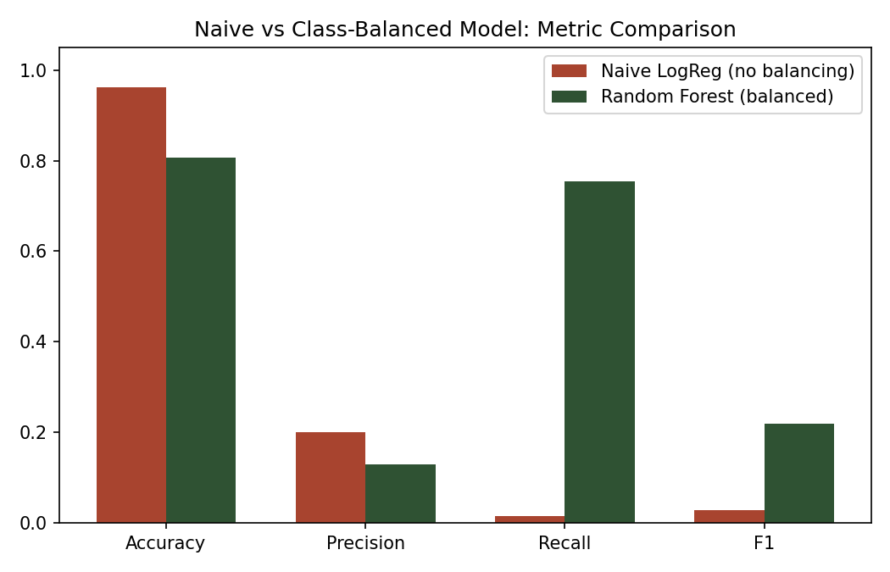
Figure 1. Naive versus class-balanced model performance. Accuracy alone favors the naive model; recall reveals it is nearly non-functional.
The confusion matrix for the final Random Forest model below shows this tradeoff concretely: of 69 true outliers in the test set, 52 were correctly caught (true positives) and only 17 were missed (false negatives), at the cost of 353 normal listings being incorrectly flagged for review (false positives).
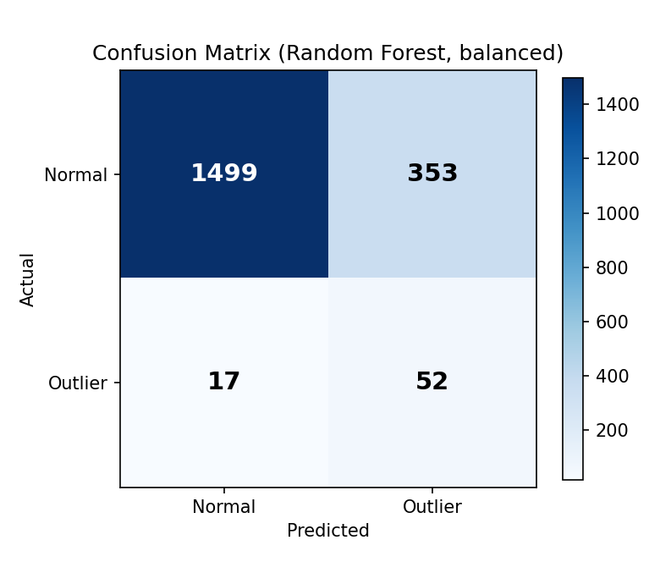
Figure 2. Confusion matrix for the balanced Random Forest classifier.
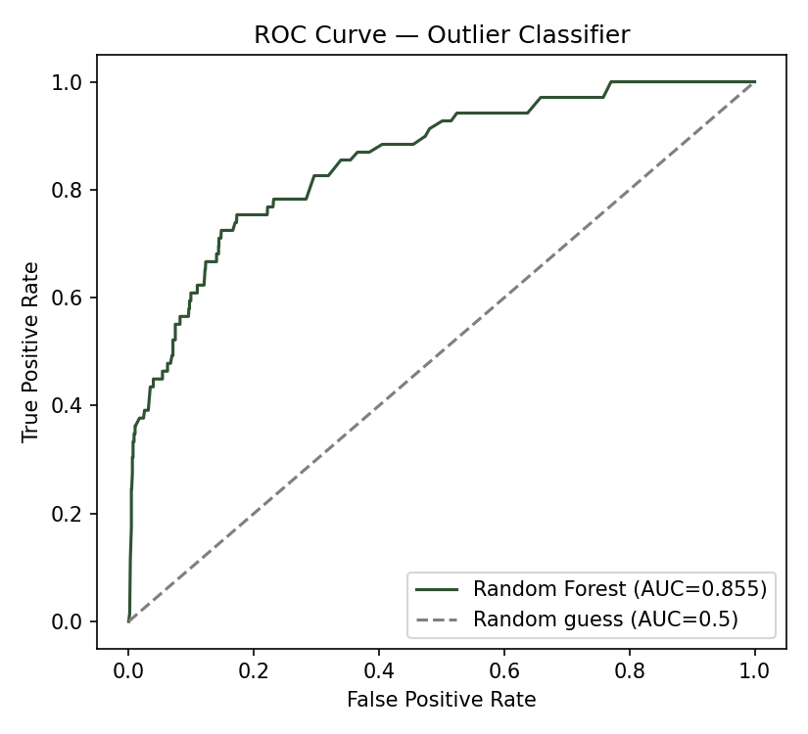
Figure 3. ROC curve for the Random Forest classifier (AUC = 0.8546), showing meaningfully better-than-random ranking of outlier risk.
An ROC-AUC of 0.8546 indicates the model has genuine, moderate discriminative ability — noticeably better than chance (0.5) — even though its precision at the default classification threshold is low. This is an important distinction: a low precision at one fixed threshold does not necessarily mean the model has no signal, only that the current cutoff is tuned toward catching more true positives at the cost of more false alarms, which is an appropriate choice for a screening tool intended to flag listings worth a human review rather than to make a final automated judgment.

5. Interpretation: What Predicts a Data-Quality Problem?

5.1 Feature Importance — a Different Pattern Than Price Prediction
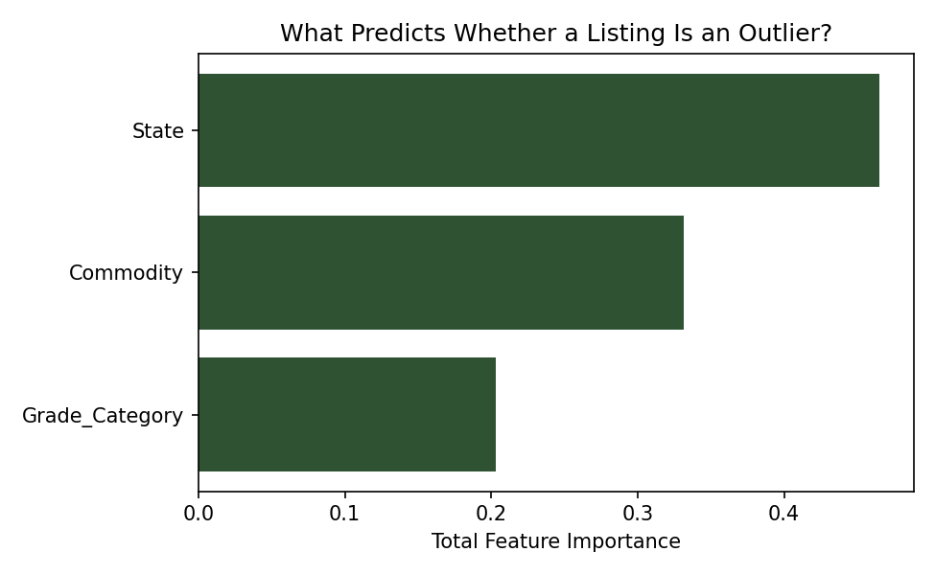
Figure 4. Feature group importance for predicting outlier status.
This is the most notable finding of the report. In the earlier price-prediction model, Commodity dominated (accounting for the large majority of feature importance), with State comparatively minor. For predicting outlier status, that pattern reverses: State accounts for 46.52% of feature importance, ahead of Commodity at 33.14% and Grade_Category at 20.34%. In other words, what a commodity fundamentally is mostly determines its price level, but where a listing is reported from matters more for whether that listing is likely to contain a data-entry anomaly. This distinction points toward the anomalies having more to do with local reporting practices at specific markets than with any inherent volatility of specific crops.

5.2 Outlier Rate by State — Direct Evidence of the Pattern
Grouping the raw outlier flag by state directly confirms the feature-importance finding and puts concrete numbers behind it.
State (highest outlier rate) | Outlier Rate
Punjab | 13.19%
Tripura | 11.7%
Kerala | 11.4%
Uttarakhand | 11.25%
Madhya Pradesh | 11.03%
Himachal Pradesh | 10%
West Bengal | 9.64%
Maharashtra | 9.4%
Uttar Pradesh | 7.85%
Odisha | 7.27%
Table 2. States with the highest price-outlier rates (minimum 50 records). Dataset average: 3.58%.
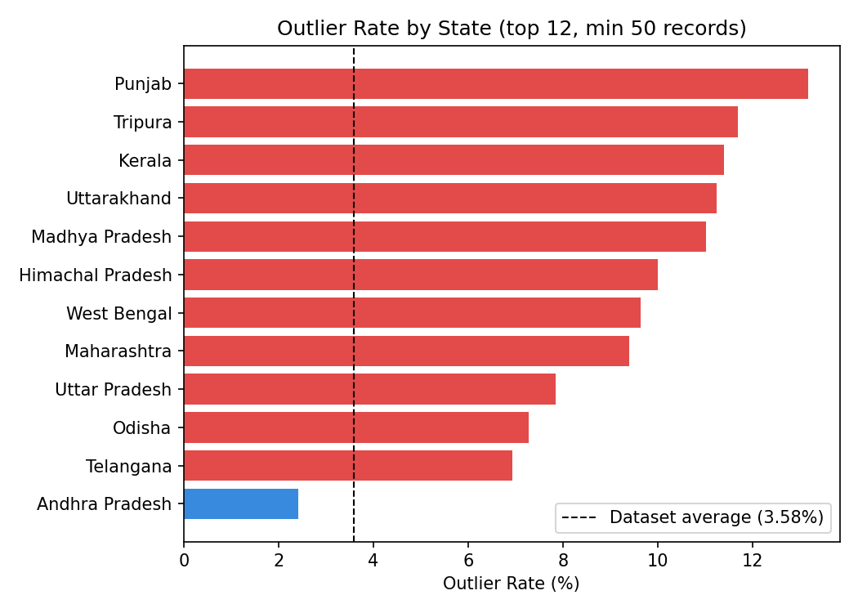
Figure 5. Outlier rate by state, relative to the dataset average (dashed line).
Punjab's outlier rate (13.19%) is roughly 4x the dataset average, and several other states — Tripura, Kerala, Uttarakhand, Madhya Pradesh — all sit above 10%, nearly triple the baseline. By contrast, Tamil Nadu (1.21%) and Haryana (1.49%) sit well below it. This is not evenly distributed noise; it is a concentrated pattern, consistent with the interpretation that certain states' market reporting infrastructure, data entry conventions, or unit standardization differ systematically from others.

5.3 Outlier Rate by Market — Pinpointing the Problem Further
Narrowing from state to individual market sharpens this finding considerably.
Market (highest outlier rate) | Outlier Rate
Piravam Market | 31.25%
Neeleswaram Market | 25%
Angamaly Market | 19.35%
Vadakkenchery Market | 18.75%
Pune(Moshi) APMC | 17.5%
Kanjangadu Market | 17.24%
Chattrapati Sambhajinagar APMC | 15.38%
Chengannur Market | 15.15%
Anchal Market | 14.29%
vadakarapathy Market | 14.29%
Table 3. Markets with the highest price-outlier rates (minimum 20 records). Dataset average: 3.58%.
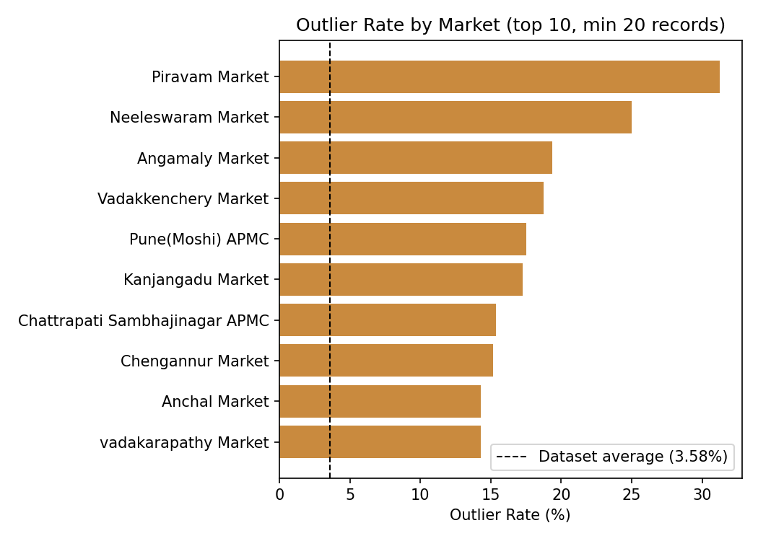
Figure 6. Outlier rate by individual market.
Piravam Market shows an outlier rate of 31.25% — roughly 9x the dataset average — with several other markets, predominantly in Kerala, also showing rates above 15%. This level of granularity moves the finding from a general regional pattern into something directly actionable: a specific, short list of markets that would be the natural starting point for a data-quality audit, rather than a vague instruction to "check the data more carefully" applied uniformly across all 710 markets.

5.4 Outlier Rate by Commodity
For completeness, the same breakdown by commodity was also examined.
Commodity (highest outlier rate) | Outlier Rate
Paddy(Common) | 28.57%
Orange | 13.64%
Green Chilli | 11.88%
Wood | 10.99%
Banana - Green | 10.29%
Green Gram(Moong)(Whole) | 9.68%
Beans | 9.42%
Grapes | 8.7%
Snakeguard | 7.85%
Garlic | 7.84%
Table 4. Commodities with the highest price-outlier rates (minimum 20 records).
Paddy (Common) stands out sharply at 28.57%, well above every other commodity, with Orange and Green Chilli also elevated — the latter consistent with the wide price spread this same commodity showed in the earlier exploratory data analysis. However, the state-level effect (Section 5.2) is larger in magnitude and more consistent across many categories than the commodity-level effect, reinforcing that this is predominantly a geographic and market-infrastructure pattern rather than a commodity-specific one.

6. Business Implications and Recommendations
This analysis reframes what began as a routine outlier-flagging exercise into an operational data-quality diagnostic with direct recommendations.
First, the specific markets identified in Table 3 — led by Piravam Market, Neeleswaram Market, and Angamaly Market — are the most efficient starting point for a targeted data-entry audit, rather than attempting to review the full dataset uniformly. Second, because the effect concentrates by state and market rather than by commodity, the underlying cause is more likely to be procedural (data entry conventions, unit standardization, digitization practices at specific mandis) than agronomic, which should guide where any corrective intervention is directed. Third, this classifier itself has a practical deployment use: run as a screening step on newly ingested Agmarknet data, it would flag roughly 3 in 4 genuine anomalies for human review (per the recall figure in Table 1) at the cost of also surfacing some listings that turn out to be normal — an acceptable tradeoff for a pre-publication quality check, where the cost of missing a genuine error is higher than the cost of one extra manual review.
Finally, this reframes the value of the earlier low-R-squared price-prediction model in a useful way: the two models are not competing attempts at the same goal but complementary lenses on the same data — one modeling the central tendency of price, and the other modeling the reliability of the reporting itself. A mature agribusiness analytics pipeline benefits from both: a price-benchmarking signal for typical value, and a data-quality signal for how much to trust any individual reading.

7. Conclusion
This report built a classifier to predict whether an Agmarknet price listing is a statistical outlier, using the imbalance in the target (3.58% positive class) as a deliberate teaching point about the limits of accuracy as an evaluation metric. A naive model achieved higher accuracy but near-zero recall, while a class-balanced Random Forest traded accuracy for genuinely useful detection (75.4% recall, ROC-AUC 0.8546). More importantly, the exercise surfaced a substantive analytical finding independent of the classifier's raw performance: outlier concentration is driven far more by geography (state and specific market) than by commodity type, pointing toward specific, named markets as priority targets for a data-quality audit rather than treating anomalies as randomly distributed noise across the dataset.

