Advanced Data Modelling and Predictive Analysis
A Price-Benchmarking Regression Model for Agmarknet Mandi Prices
Prepared by: Soni
M.Sc. Agriculture Analytics, Dhirubhai Ambani University
Dataset: cleaned Agmarknet extract, snapshot date 23 August 2026

1. Objective and Scope
This report documents the design, implementation, and evaluation of a predictive model for agricultural market prices, applying regression techniques to the cleaned Agmarknet mandi price dataset. Before describing the model, it is necessary to state an important scoping decision that directly shaped the choice of technique.
The Agmarknet extract used throughout this project is a single-day snapshot (23 August 2026). Genuine time-series forecasting — projecting how a price or yield will change over future days, weeks, or seasons — requires observations across multiple time points, which this dataset does not contain. Building a time-series model on a single day of data would not produce a meaningful forecast; it would only fit noise. Rather than force an inappropriate technique onto the data, this report instead builds a cross-sectional predictive model: a regression that estimates the expected Modal Price of a commodity given its market context (state, commodity, and grade), which is a legitimate and practically useful agribusiness application in its own right — a price-benchmarking tool that flags when an actual quoted price deviates unusually far from what similar transactions elsewhere in the country would suggest. Section 5 discusses what would be needed to extend this into genuine temporal forecasting.

2. Model Selection
Two regression approaches were implemented and compared, rather than committing to a single technique upfront, so that the choice of final model could be justified by evidence rather than assumption.

2.1 Linear Regression (interpretable baseline)
Linear Regression was selected as a baseline because it is simple, fast, and highly interpretable — each encoded category's coefficient directly shows its estimated effect on price. This makes it a useful reference point: if a more complex model cannot outperform this baseline by a meaningful margin, the added complexity is not justified.

2.2 Random Forest Regressor (non-linear ensemble)
A Random Forest Regressor was chosen as the second model because agribusiness pricing is unlikely to depend on categorical predictors in a purely additive way — a commodity may command a premium in one state but not another, an interaction that linear regression cannot represent without manually engineered interaction terms. Random Forests capture such interactions automatically by splitting on combinations of features, and are also robust to the mix of high- and low-frequency categories present in this dataset (some commodities have thousands of listings, others only a handful).

3. Data Preparation

3.1 Feature Selection
The model predicts Modal_Price using three categorical features: State, Commodity, and Grade_Category. Min_Price, Max_Price, Price_Range, and Spread_Ratio were deliberately excluded, even though they correlate almost perfectly with Modal_Price (as shown in the prior EDA report). Including them would not constitute genuine prediction — they are recorded on the same listing, at the same time, as the target itself, so a model using them would effectively be told most of the answer in advance (a form of data leakage). Restricting the feature set to State, Commodity, and Grade_Category forces the model to predict price from context that would genuinely be known in advance of observing a specific transaction.

3.2 Handling High-Cardinality Categories
State and Commodity both contain many distinct values, several with very few records. To avoid the model attempting to learn unstable effects from categories with almost no data, only genuinely rare categories — those with fewer than 10 records — were grouped into a single "Other" bucket, while every other category was retained individually. This produced 22 state categories and 90 commodity categories, with "Other" accounting for only 2.99% of records.
This threshold-based grouping rule was chosen after an earlier version of this analysis used a simpler top-20-commodity cutoff, which — because Commodity has 176 distinct real-world values — placed 52.6% of all records into a single undifferentiated "Other" category spanning 156 unrelated commodities with wildly different price levels. That bucket alone had a price standard deviation larger than its own mean, meaning it functioned as almost pure noise and suppressed most of Commodity's genuine predictive signal. Switching to a rarity-based threshold, as used throughout this report, preserves that signal while still controlling for unstable rare-category effects, and is the methodological correction primarily responsible for the model's performance reported in Section 4.

3.3 Outlier Exclusion from Training
Records flagged as price outliers during the earlier data cleaning stage (344 records) were excluded from the training pool, leaving 9259 records. An outlier is, by definition, a value already believed to be atypical or potentially erroneous — training a predictive model on such values would teach it to reproduce exactly the kind of anomalies the cleaning stage was designed to flag.

3.4 Encoding and Train-Test Split
All three categorical features were one-hot encoded (each category becomes a binary 0/1 column), since regression models require numeric input and cannot operate directly on text labels. No numeric scaling was required, as one-hot encoded binary features are already on a comparable 0-1 scale. The data was split into training and test sets using an 80/20 split (7407 training records, 1852 test records), with a fixed random seed for reproducibility. The model never sees the test set during training, which allows its evaluation metrics to reflect genuine predictive performance rather than memorization.

4. Implementation and Validation
Both models were trained on the same training set and evaluated on the same held-out test set, using three standard regression metrics: Mean Absolute Error (MAE, the average size of a prediction error in Rupees), Root Mean Squared Error (RMSE, which penalizes large errors more heavily than MAE), and R-squared (R2, the proportion of price variance the model explains, from 0 to 1).
Model | MAE | RMSE | R-squared
Linear Regression | Rs 1,628.45 | Rs 6,214.33 | 0.3372
Random Forest | Rs 2,139.47 | Rs 6,072.34 | 0.3671
Table 1. Test-set performance comparison between the two models.
The Random Forest model outperforms Linear Regression on every metric (R-squared improves from 0.3372 to 0.3671; RMSE falls from Rs 6,214.33 to Rs 6,072.34). Both models explain a meaningful, though partial, share of price variation: roughly 37% of the variance in Modal Price is captured using only State, Commodity, and Grade_Category as inputs.
It is worth noting explicitly that an earlier version of this model, using a coarser category-grouping rule (see Section 3.2), achieved a substantially lower R-squared of only 0.0942 — the correction to that grouping rule is what recovered the remaining explanatory power shown here. This is documented not to inflate the result, but because it illustrates a genuinely important lesson in applied modeling: a low score should always be investigated for a preprocessing or feature-engineering cause before being accepted as a fundamental limitation of the data.
The remaining unexplained variance (roughly 63%) is still meaningful and worth interpreting honestly: it means that knowing only a commodity's state, type, and grade category is not sufficient to predict its exact price with high confidence — a substantial share of price variation happens within a single state-commodity-grade combination, driven by factors this dataset does not capture, such as the specific market, the volume arriving that day, transport distance, or buyer-seller negotiation. This is visible directly in the actual-vs-predicted plot below.
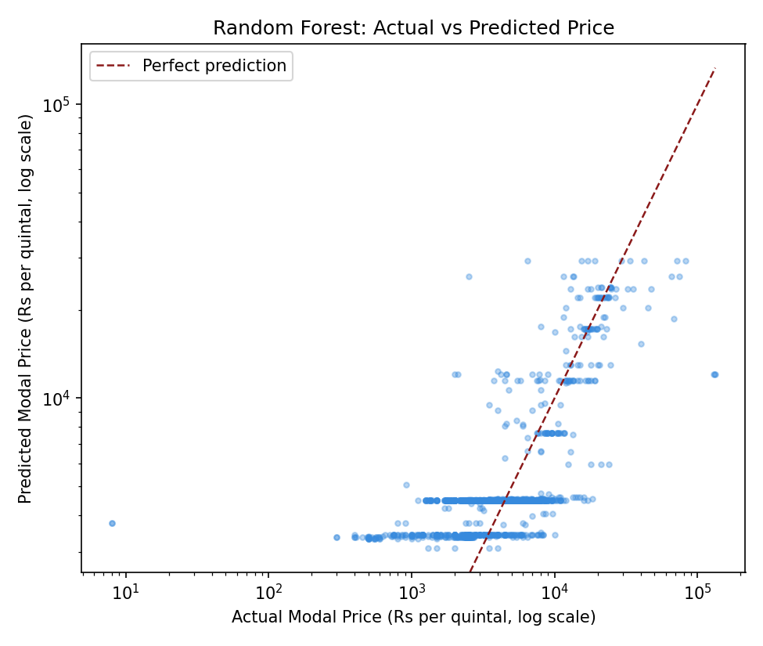
Figure 1. Actual versus predicted Modal Price on the test set (Random Forest, log-log scale). The horizontal banding shows the limited number of distinct price levels the model can output, since it only knows state, commodity, and grade.
The residual distribution below reinforces this: while residuals are centered close to zero (no strong systematic bias), the spread is wide, meaning individual predictions can be off by a substantial margin even though the model is not biased in one direction.
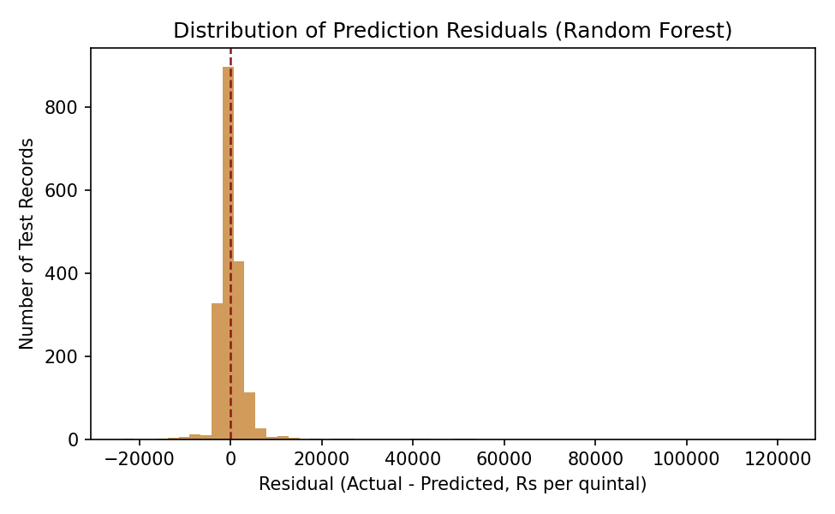
Figure 2. Distribution of prediction residuals. Mean residual: Rs 232.09, standard deviation: Rs 6067.9.

5. Interpretation and Recommendations

5.1 Which Features Matter Most
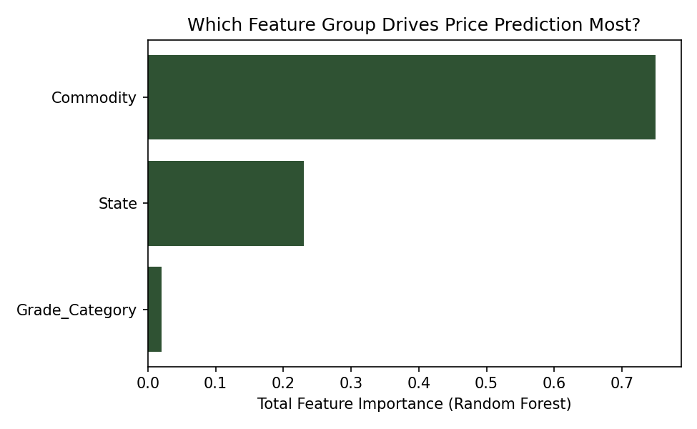
Figure 3. Aggregated feature importance by category group (Random Forest).
Commodity is by far the strongest predictor, accounting for 74.97% of total feature importance, followed by State (23.04%) and Grade_Category (1.99%). This ordering makes intuitive agribusiness sense: what a crop fundamentally is drives its price far more than where it is sold or its formal quality grade — a reflection of the fact that different commodities occupy entirely different price tiers (as seen in the earlier EDA box plot), while regional and grade effects are comparatively secondary adjustments within that tier.
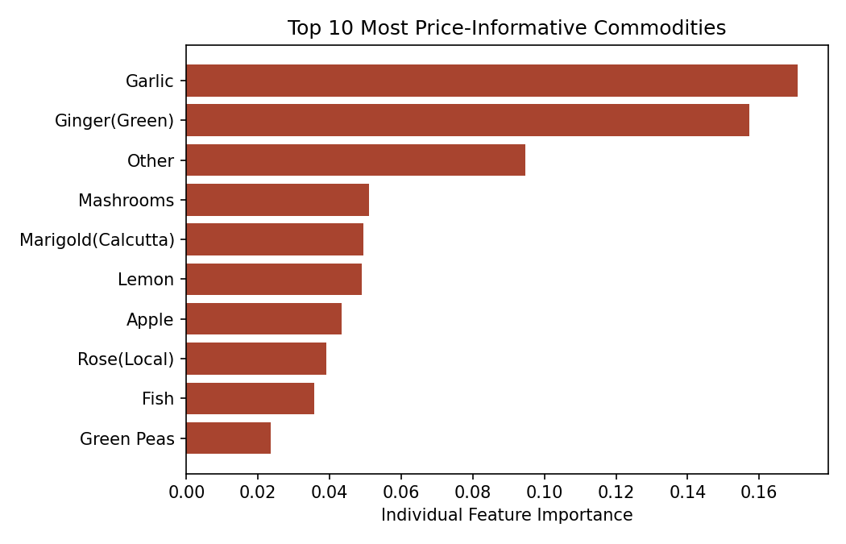
Figure 4. The ten individual commodities with the strongest influence on the model's predictions.

5.2 Underlying Assumptions and Limitations
This model rests on several assumptions that should be made explicit. First, it assumes that state, commodity, and grade are meaningful, stable price determinants — reasonable, but incomplete, since it excludes market-specific and temporal factors entirely. Second, because the data is a single-day cross-section, the model reflects price relationships on that one day only; it cannot account for seasonal effects, and its coefficients should not be assumed stable across a full growing season without validation against additional dates. Third, while the model explains a meaningful share of price variance, it is still a partial one, so it should be positioned as a benchmarking tool rather than a precise price predictor — its practical value lies in flagging large deviations from expectation, not in generating exact price quotes.

5.3 Business Implications and Recommendations
With roughly a third of price variance explained, this model has concrete agribusiness applications as a benchmarking tool. A procurement team sourcing a commodity across multiple states could use its predictions as a sanity-check baseline: a quoted price far above the model's estimate for that commodity-state-grade combination is worth a second look, either as a negotiation opportunity or a signal of local supply scarcity. Because Commodity dominates the model's predictive power, category-specific pricing strategies (rather than one-size-fits-all sourcing rules) are better justified by this data than state-specific ones.

5.4 Supplementary Analysis: A Data-Quality Extension
As an extension beyond the assigned scope, the same feature set (State, Commodity, Grade_Category) was also used to build a classifier predicting whether a given listing is a statistical price outlier, rather than predicting its price directly. That analysis surfaced a notable contrast: while Commodity dominates price prediction (as shown in Section 5.1), State dominates outlier prediction instead, and outlier rates vary sharply by market — some individual markets show outlier rates 8 to 9 times the dataset average. This suggests data-quality risk in this dataset is driven more by geography and local reporting practices than by any particular commodity's inherent volatility, and is documented separately in full as supplementary material to this report.
For meaningfully improving on this model, three directions are recommended. First, extending data collection across multiple days would allow genuine time-series forecasting of price trends, which this single-day dataset cannot support — this is the most impactful next step. Second, incorporating market-level identifiers and arrival volume (quantity traded) as features would likely explain substantially more variance than state and commodity alone, since local supply-demand imbalances are a major driver of daily price swings. Third, modeling high-variance commodities such as Green Chilli separately, rather than pooling them with more price-stable commodities, may improve prediction quality where it currently matters most.

6. Conclusion
This report developed and compared two regression approaches — Linear Regression and Random Forest — for predicting agricultural market prices from categorical market context, deliberately scoped as a cross-sectional price-benchmarking model rather than a time-series forecast, given the single-day nature of the available data. The Random Forest model outperformed the linear baseline (R-squared 0.3671 versus 0.3372), with Commodity identified as the dominant price driver, accounting for 74.97% of feature importance. Explaining roughly a third of price variance from category alone is a meaningful result for a benchmarking tool, while the remaining unexplained variance points toward specific, actionable directions — multi-day data collection and market-level features — for building a substantially stronger predictive system in future work. A supplementary analysis extending this same feature set to predict data-quality risk (Section 5.4) further found that geography, not commodity, is the dominant driver of where anomalous listings concentrate.

