Exploratory Data Analysis
Agmarknet Daily Mandi Price Dataset
Prepared by: Soni
M.Sc. Agriculture Analytics, Dhirubhai Ambani University
Dataset: cleaned Agmarknet extract, snapshot date 23 August 2026

1. Data Overview
This exploratory data analysis is conducted on the cleaned Agmarknet daily mandi price dataset produced in the prior data preparation stage of this project. The dataset contains 9,603 records across 17 columns, covering 23 states, 710 markets, and 176 distinct commodities for a single-day price snapshot.
The variables fall into two broad types. Categorical variables — State, District, Market, Commodity, Variety, Grade, and the derived Grade_Category — describe where and what is being traded. Numeric variables — Min_Price, Max_Price, Modal_Price, Price_Range, and Spread_Ratio, all expressed in Indian Rupees per quintal (100 kg) — describe the price levels and dispersion observed at each market listing. Two additional boolean flag columns (Price_Outlier_Flag, Spread_Anomaly_Flag) carried over from the cleaning stage are used here to contextualize statistical outliers rather than exclude them outright.
Given that agricultural commodity prices are influenced by supply seasonality, transport cost, and local demand, the price variables were expected going in to be right-skewed (a long tail of high-value trades) rather than symmetric, and this expectation is confirmed in Section 2 below.

2. Statistical Analysis

2.1 Univariate Analysis — Numeric Variables
Descriptive statistics for each numeric price variable are summarized below, including measures of central tendency (mean, median), dispersion (standard deviation, interquartile range, coefficient of variation), and shape (skewness).
Variable | Mean | Median | Std Dev | Q1 | Q3 | Skewness
Min_Price | 5098.82 | 4000 | 5838.38 | 2500 | 5800 | 9.67
Max_Price | 5754.82 | 4400 | 6314.97 | 3000 | 6200 | 8.66
Modal_Price | 5428.42 | 4100 | 6048.71 | 2750 | 6000 | 9.22
Price_Range | 656 | 500 | 1249.36 | 0 | 800 | 10.03
Spread_Ratio | 1.2 | 1.11 | 1.34 | 1 | 1.2 | 70.17
Table 1. Descriptive statistics for numeric price variables (Rs per quintal).
All three price variables show a mean noticeably higher than the median (for example, Modal_Price mean of Rs 5,428.42 versus median of Rs 4,100), and skewness values well above zero (Modal_Price skew = 9.22), confirming the expected right-skewed distribution: most trades cluster at moderate prices, with a smaller number of high-value trades pulling the mean upward. The coefficient of variation for Modal_Price (111.43%) indicates the standard deviation exceeds the mean itself, a hallmark of high relative dispersion typical of pooled multi-commodity price data — this is the statistical basis for analyzing price variables separately per commodity rather than in aggregate, as was done in the preprocessing stage.
Spread_Ratio (Max_Price / Min_Price) has a median of just 1.11, meaning most market listings report a narrow, plausible daily price range, but its skewness (70.17) is far higher than the price variables themselves — driven by a small number of listings with extreme max-to-min ratios, consistent with the spread anomalies identified during the earlier data quality assessment.

2.2 Univariate Analysis — Categorical Variables
The State variable has 23 unique values, but is heavily concentrated: the single largest state, Tamil Nadu, accounts for 69.94% of all records. This concentration is an important caveat for any state-level comparison — statistics for less-represented states rest on far smaller samples and are more volatile. The Commodity variable is comparatively well distributed across 176 categories, with the top commodity representing only 3.21% of records, indicating no single crop dominates market activity in this snapshot. The Grade_Category variable (derived during preprocessing) shows 76.28% of records fall under "Market Type" rather than an explicit quality or size grade, meaning most Agmarknet listings do not report a formal quality classification.

2.3 Bivariate Analysis — Correlation Between Price Variables
A Pearson correlation matrix was computed across the five numeric variables to examine relationships between price levels and dispersion measures.
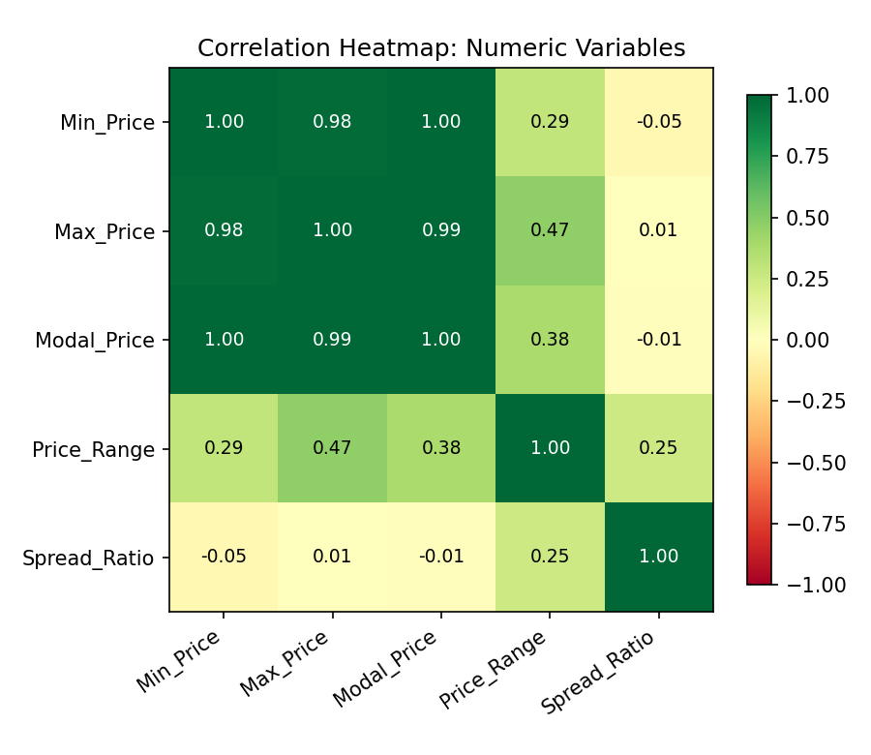
Figure 1. Correlation heatmap of numeric variables.
As expected, Min_Price, Max_Price, and Modal_Price are almost perfectly correlated with one another (r above 0.98 in all pairs), since they are three closely related measurements of the same underlying trade. The more informative finding is that Spread_Ratio is essentially uncorrelated with all three price variables (r between -0.05 and 0.01) — meaning a market's daily price volatility is statistically independent of the price level itself. In other words, expensive commodities are not inherently more or less volatile than cheap ones on a given day; volatility appears to be driven by market-specific or commodity-specific factors rather than price magnitude. Price_Range shows a moderate positive correlation with Max_Price (r = 0.47), which is expected algebraically since Price_Range is derived partly from Max_Price.

2.4 Bivariate Analysis — Price by State and Commodity
Grouping Modal_Price by state and by commodity reveals substantial cross-group variation that a single aggregate statistic would conceal.
State | Mean Modal Price | Median Modal Price | Record Count
Kerala | 6827.46 | 5500 | 684
Madhya Pradesh | 2984.02 | 2000 | 136
Maharashtra | 3416.38 | 2500 | 266
Odisha | 3636.09 | 3200 | 110
Tamil Nadu | 5786.84 | 4500 | 6716
Telangana | 3358.22 | 2600 | 231
Tripura | 6134.73 | 4100 | 94
Uttar Pradesh | 3948.35 | 2410 | 726
Table 2. Modal price statistics by top 8 states (by record volume).
Kerala shows both the highest mean modal price and one of the highest standard deviations among the top states, while Odisha shows a comparatively low standard deviation relative to its mean — suggesting more price-stable market conditions there in this snapshot. Uttar Pradesh's very high standard deviation relative to its mean and median signals a small number of extreme-value records pulling its average upward, consistent with the outlier patterns identified during preprocessing.
Commodity | Mean Modal Price | Median Modal Price | Record Count
Banana | 5563.61 | 5500 | 239
Bhindi(Ladies Finger) | 3848.02 | 3750 | 257
Bitter gourd | 5249.25 | 5500 | 251
Brinjal | 3894.38 | 3800 | 290
Green Chilli | 5212.28 | 5400 | 261
Onion | 4549.99 | 4750 | 278
Potato | 2468.32 | 2600 | 308
Tomato | 2069.25 | 2000 | 300
Table 3. Modal price statistics by top 8 commodities (by record volume).
Tomato and Potato show the lowest mean prices among the top commodities, consistent with their status as high-volume staple vegetables, while Banana and Bitter Gourd command comparatively higher and more variable prices. This kind of commodity-level breakdown is what motivated computing outlier bounds separately per commodity during preprocessing rather than using a single dataset-wide threshold.

3. Visualization
Five visualizations were produced to examine the dataset's distribution, spread, relationships, and categorical patterns from complementary angles.

3.1 Histogram — Modal Price Distribution
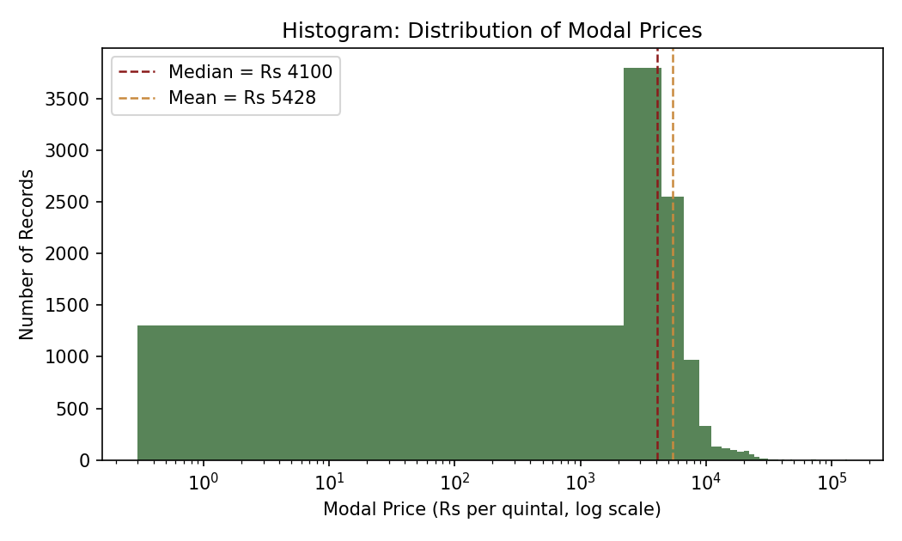
Figure 2. Histogram of modal prices across all commodities (log-scaled x-axis).
The histogram confirms the right-skewed shape suggested by the univariate statistics: the bulk of records cluster between roughly Rs 2,000 and Rs 8,000 per quintal, with a long, thinning tail extending toward six-figure values. The visible gap between the mean and median lines on the chart reinforces that the mean is not a representative measure of a 'typical' price in this dataset — the median is the more reliable central-tendency statistic here.

3.2 Box Plot — Price Spread by Commodity
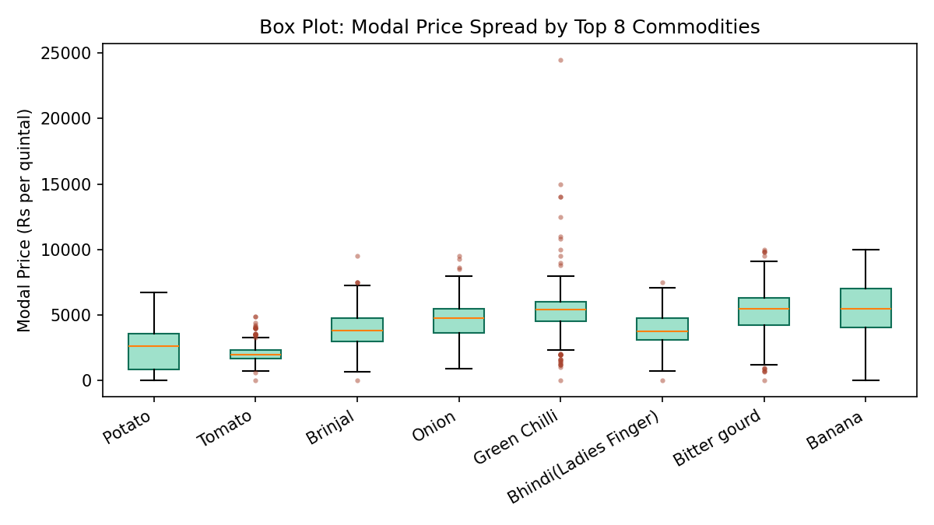
Figure 3. Box plot of modal price by the eight most frequently listed commodities.
The box plot reveals that commodities differ not just in typical price level but in price stability. Tomato and Bhindi show tight, compact boxes with few outlier points, indicating consistent pricing across markets. Green Chilli stands out with the widest box and by far the largest number of outlier points extending well above Rs 15,000 — this single commodity likely accounts for a disproportionate share of the outliers flagged during preprocessing, and would warrant closer investigation (for example, whether these are premium specialty-chilli varieties or data entry issues) before being used in any pricing model.

3.3 Scatter Plot — Min Price vs Max Price
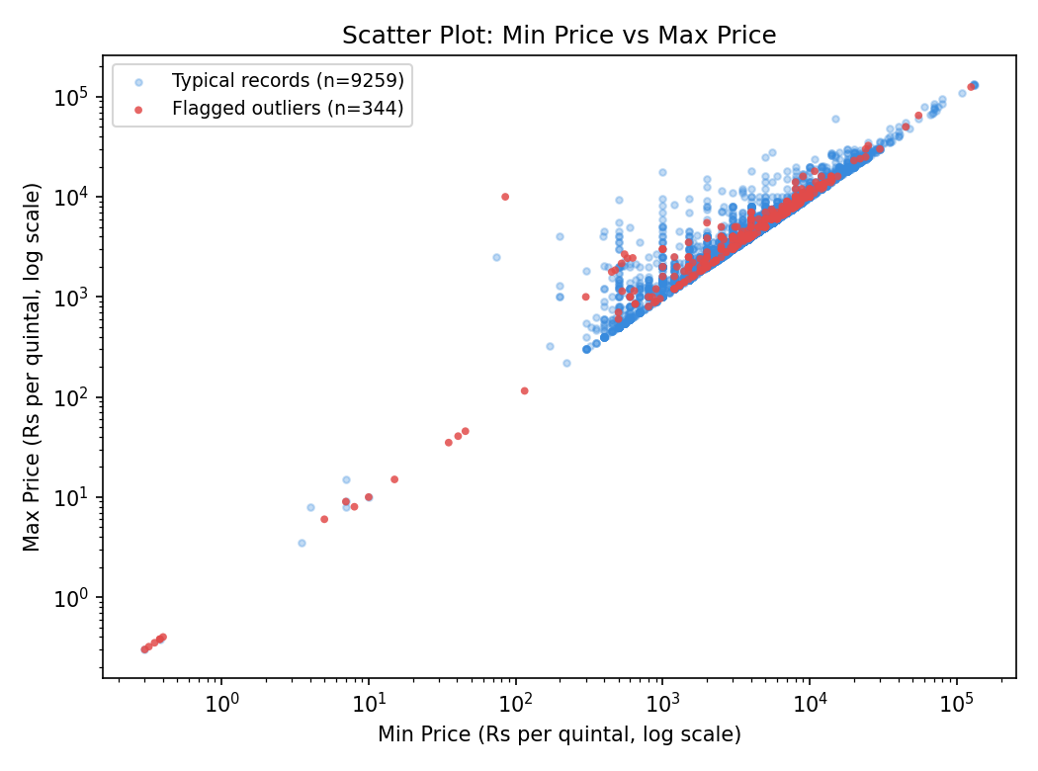
Figure 4. Scatter plot of Min Price against Max Price (log-log scale), colored by outlier status.
The scatter plot shows the expected tight diagonal relationship between minimum and maximum daily prices — most points fall close to the line where Min and Max are proportionally close together. Flagged outlier points (red) are visibly scattered both along the diagonal at extreme values and, in a smaller number of cases, off the diagonal entirely, which corresponds to the spread-ratio anomalies identified earlier. This visualization is a useful sanity check: a healthy dataset should show most points hugging the diagonal, and the degree of scatter away from it is a direct visual measure of data quality.

3.4 Bar Chart — Mean Price by State
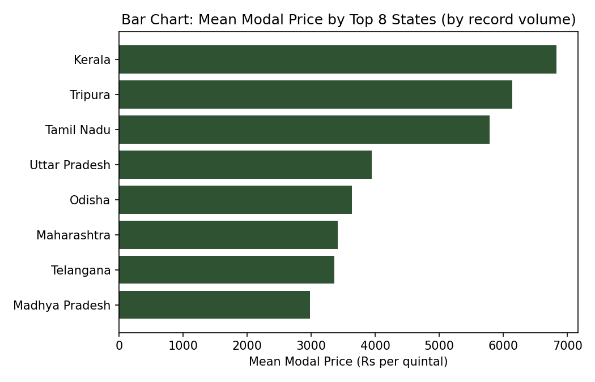
Figure 5. Mean modal price by the top 8 states by record volume.
The bar chart makes the state-level price variation from Table 2 immediately visible: Kerala and Tripura show the highest average prices among high-volume states, while Madhya Pradesh and Telangana sit noticeably lower. Since this reflects a single day's snapshot and an unbalanced sample (Tamil Nadu alone contributes roughly 70% of all records), these differences should be read as indicative rather than definitive without a longer observation window.

4. Insight Generation
Several findings from this analysis carry direct relevance for agribusiness decision-making:
First, the near-zero correlation between price level and Spread_Ratio suggests that price volatility monitoring should be treated as a separate analytical axis from price-level monitoring — a procurement or trading strategy that only tracks average prices would miss volatility risk entirely, since expensive and cheap commodities are equally likely to experience wide daily price swings.
Second, the commodity-level box plot analysis identifies Green Chilli as a candidate for deeper investigation before inclusion in any downstream pricing model — its unusually wide spread and outlier concentration could reflect genuine premium-grade price segmentation, regional supply shocks, or residual data quality issues, and distinguishing between these explanations has direct implications for whether this commodity's price signal can be trusted for forecasting or arbitrage decisions.
Third, the heavy geographic concentration of this snapshot (nearly 70% of records from a single state) is itself an actionable insight for future data collection: any agribusiness analytics pipeline built on Agmarknet data should either collect a longer time window to balance state representation, or explicitly weight/stratify analysis by state to avoid conclusions that are implicitly Tamil Nadu-specific being presented as national patterns.
Fourth, the substantial mean-price gap between states with comparable commodity mixes (for example, Kerala's markedly higher average versus Madhya Pradesh's) points toward a genuine regional price arbitrage signal worth further investigation — if transport and storage costs between these regions are lower than the price gap, this represents a concrete supply-chain optimization opportunity, which is precisely the kind of decision-relevant insight EDA is intended to surface before deeper modeling work begins.

5. Conclusion
This exploratory analysis of the cleaned Agmarknet mandi price dataset combined univariate descriptive statistics, bivariate correlation and group analysis, and five complementary visualizations to surface patterns not visible from the raw data alone. The right-skewed price distributions, the independence of volatility from price level, commodity-specific dispersion differences, and geographic concentration in the sample together form a clear starting point for further agribusiness analysis — whether that is commodity-specific price forecasting, regional arbitrage detection, or volatility-based risk assessment for supply-chain planning.

