Agribusiness Data Acquisition and Preprocessing
A Case Study on Real-Time Agricultural Market Price Data (Agmarknet)
Prepared by: Soni
M.Sc. Agriculture Analytics, Dhirubhai Ambani University
Data snapshot date: 23 August 2026

1. Objective
This report documents the end-to-end process of acquiring, assessing, and preprocessing a real-world agribusiness dataset for downstream analysis. The exercise simulates the data-preparation stage of an applied agricultural analytics pipeline: sourcing an open dataset relevant to agribusiness, identifying realistic data-quality problems within it, designing a justified cleaning strategy, and evaluating how that cleaning affects the data available for analysis. Rather than working with a synthetic or toy dataset, a live extract of government market-price data was used so that the quality issues encountered and the remedies applied are genuine rather than illustrative.

2. Dataset Identification and Acquisition
The dataset used is a daily mandi (wholesale agricultural market) price extract sourced from Agmarknet, the price-dissemination portal operated by India's Directorate of Marketing & Inspection under the Ministry of Agriculture and Farmers Welfare, made available through the open government data platform data.gov.in. Agmarknet aggregates price reports submitted daily by regulated agricultural markets (APMCs and similar market yards) across the country and is one of the most widely used open sources for agricultural market-price and supply-chain-adjacent analytics in India.
The specific extract used in this report is a single-day snapshot dated 23 August 2026, containing 9,603 price records spanning 23 states, 264 districts, 710 markets, and 176 distinct commodities. Each record reports the state, district, market (mandi), commodity, variety, quality grade, arrival date, and the minimum, maximum, and modal (most frequently traded) price for that commodity at that market on that date, expressed in Indian Rupees per quintal (100 kg).
This dataset was selected over alternative options (such as pre-aggregated Kaggle extracts or FAOSTAT global price series) for three reasons. First, it is drawn directly from a government operational system rather than a pre-cleaned third-party copy, so it authentically reflects the kind of entry inconsistencies, naming variation, and outliers that a working analyst would need to handle before analysis, rather than issues invented for illustration. Second, its granularity — market-level, commodity-level, and grade-level pricing — is directly usable for agribusiness applications such as price discovery, arbitrage detection between markets, and supply-chain price-transmission studies. Third, its national scope and commodity diversity (from staple grains such as wheat and paddy to perishables such as tomato, banana, and leafy greens) make it well suited to the M.Sc. Agriculture Analytics coursework this assignment supports.

3. Data Quality Assessment
Before any cleaning was applied, the raw dataset was profiled systematically: checking for missing values, duplicate records, logically inconsistent price fields, extreme outliers, and inconsistent categorical labeling. The table below summarizes the structural profile of the raw extract.
Metric | Value
Total records | 9,603
Missing values (any column) | 0
Exact duplicate rows | 0
Rows with Min > Max or Modal outside [Min, Max] | 0
Rows with zero/negative prices | 0
Distinct States / Districts / Markets / Commodities | 23 / 264 / 710 / 176
Table 1. Structural profile of the raw dataset.
The absence of missing values and schema-level violations (no Min > Max, no modal price outside the min–max band) indicates that the portal's own entry validation is reasonably strict at the point of submission. However, deeper profiling surfaced five categories of quality issues that are common in operational agricultural price data and that materially affect downstream analysis if left unaddressed.

3.1 Extreme Price Outliers and Suspected Unit Errors
Modal prices in the raw data range from ₹0.30 to ₹133,089 per quintal — a span of over five orders of magnitude within a single column. Some of this spread is genuine (garlic and coriander leaves trade at naturally higher per-quintal prices than potato or cabbage), but part of it is not. For example, one Punjab market (Patti APMC) reports Green Chilli, Potato, and Tomato all at modal prices near ₹0.30–₹0.40, and Garlic at ₹40.6, while the same commodities elsewhere in the dataset trade in the ₹500–₹24,000 range. This pattern is consistent with a unit-of-entry error — most plausibly a per-kilogram figure entered into a per-quintal field, or a misplaced decimal — rather than a real market price. Because such errors are commodity-specific and location-specific, a single global outlier threshold cannot separate them from genuinely low-priced markets.

3.2 Inconsistent Categorical Labeling
State names are not uniformly spelled across records: Kerala appears as "Keralam," and Chhattisgarh appears as "Chattisgarh." Left uncorrected, this fragments what should be single-state aggregates into separate groups during any groupby or join operation — for instance, against census, weather, or MSP (Minimum Support Price) reference tables that use standard state names.

3.3 Inconsistent Commodity and Variety Taxonomy
The Commodity and Variety fields do not follow a single controlled vocabulary. The same crop is sometimes split across multiple Commodity labels (e.g., "Banana" and "Banana - Green" recorded as distinct commodities rather than one commodity with a variety attribute), and casing/spelling is inconsistent (e.g., "Bitter gourd" as a Commodity label but "Bitter Gourd" as a Variety label for the same crop). Across the full extract, 176 distinct commodity strings were found, some of which represent the same underlying crop under different labels. This affects any commodity-level aggregation, such as computing a national average price per crop.

3.4 High Min–Max Spread Anomalies
For a small number of records, the maximum reported price is more than ten times the minimum reported price at the same market on the same day for the same commodity — an implausibly wide range for a single day's trading unless the market handles multiple sub-grades under one listing. 8 records exceeded a 10× max-to-min ratio. These are not necessarily errors, but they warrant flagging rather than blind inclusion, since they can distort volatility-based analysis if treated as typical.

3.5 Mixed-Semantics Grade Field
The Grade column mixes three different underlying concepts under one label: produce-quality grades (Grade A, Grade B, Grade C, FAQ, Non-FAQ), size grades (Small, Medium, Large), and market-type indicators (Local). Twelve distinct values were found in total. Treating this as a single flat category understates its analytical value; quality grade and size grade are different axes that should be modeled separately where the downstream analysis calls for it.

3.6 Duplicate Assessment
No exact duplicate rows exist in the raw extract. However, 26 records share the same State, District, Market, Commodity, and Variety but differ in Grade — for example, the same market listing Brinjal at both "Grade A" and "Medium" size on the same day. These are legitimate multi-grade listings (a market can trade the same crop at multiple quality tiers simultaneously) rather than data-entry duplicates, and were therefore retained rather than removed. Removing them would understate the price dispersion a buyer or supply-chain analyst would actually observe in that market.

4. Preprocessing Strategy
Each cleaning step below was chosen to address a specific issue identified in Section 3, with a deliberate preference for flagging over silent deletion wherever the correct interpretation of an anomalous value was ambiguous. Silent deletion of unusual-but-possibly-genuine records would bias the cleaned dataset toward "typical" markets and understate real price volatility, which is itself an important signal for supply-chain risk analysis.

4.1 Categorical Standardization
State names were mapped to a single canonical spelling ("Keralam" → "Kerala"; "Chattisgarh" → "Chhattisgarh"; "NCT of Delhi" → "Delhi") using an explicit lookup table, and all text fields were stripped of leading/trailing whitespace. This is a low-risk, high-value step: it does not alter any price information, but it is a precondition for any correct state-level aggregation or join against external reference data.

4.2 Grade Taxonomy Normalization
The Grade field was mapped into three explicit categories — Quality Grade, Size Grade, and Market Type — via a controlled lookup table, producing a new Grade_Category column alongside the original Grade value (which was retained rather than overwritten, so no information is lost). This was chosen over collapsing Grade into a single cleaned category because the three concepts are not comparable on the same scale, and an analyst filtering for "quality grade" records should not have size-only or market-type-only records silently mixed in.

4.3 Logical Validity Filtering
Records with Min_Price > Max_Price, Modal_Price outside the [Min_Price, Max_Price] interval, or any non-positive price were checked and would have been removed as structurally invalid. No such records were found in this extract (0 ordering violations, 0 non-positive prices), which was itself a useful confirmation that the portal enforces basic validation at submission time.

4.4 Outlier Detection via Per-Commodity IQR Fencing
Rather than applying a single global outlier threshold — which would be meaningless across commodities whose natural price scales differ by two or three orders of magnitude — outlier bounds were computed separately for each commodity using the interquartile range (IQR) method: values more than 1.5×IQR below the first quartile or above the third quartile, computed within that commodity's own price distribution, were flagged. This method was chosen over a z-score approach because agricultural commodity prices are typically right-skewed rather than normally distributed, and IQR fencing is more robust to that skew. Applying this per-commodity, 344 records (3.58% of the dataset) were flagged as statistical outliers. These were flagged in a Price_Outlier_Flag column rather than deleted, so that analyses can be run either including or excluding them depending on whether the goal is central-tendency estimation (exclude) or volatility/risk analysis (include).

4.5 Spread-Ratio and Suspected Unit-Error Flags
A Spread_Ratio field (Max_Price ÷ Min_Price) was computed for every record, and records exceeding a 10× ratio were flagged as Spread_Anomaly_Flag (8 records). Separately, records were flagged as Suspected_Unit_Error when their modal price fell below 2% of that commodity's median modal price across the dataset, restricted to commodities with a median price above ₹100 — a heuristic aimed specifically at catching the per-kg-vs-per-quintal pattern described in Section 3.1 without misclassifying commodities that are legitimately cheap. 22 records were flagged under this rule. These were not auto-corrected (e.g., by multiplying by 100), because a wrong automatic correction is worse than a visible flag: the flag preserves the original value while making the anomaly visible for manual review or exclusion.

4.6 Duplicate Handling
Exact full-row duplicates would have been dropped (0 found). Records sharing Market/Commodity/Variety but differing only in Grade (26 records) were deliberately retained, per the reasoning in Section 3.6.

4.7 Derived Fields for Analysis
Two derived fields were added to support downstream analysis: Price_Range (Max_Price − Min_Price), capturing intra-day price dispersion at each market, and Modal_Price_Normalized, a min–max normalization of modal price computed within each commodity group (scaling each commodity's own price range to [0, 1]). Normalizing within-commodity rather than globally was a deliberate choice: a global min–max scale would compress cheap staple commodities (e.g., potato) into a near-zero band once compared against high-value commodities (e.g., garlic, saffron-adjacent spices), destroying any meaningful price variation among the staples themselves.

5. Impact of Cleaning on the Dataset
No records were physically removed from this extract, since no missing values, exact duplicates, or structurally invalid price rows were present. The cleaning strategy's impact is therefore concentrated in (a) making the dataset analysis-ready through standardization, and (b) making its remaining irregularities explicit and actionable through flags, rather than either hiding them or deleting data that may still carry real signal.
Cleaning Outcome | Result
Records retained | 9,603 of 9,603 (100%)
Price outliers flagged (IQR method) | 344 (3.58%)
Spread anomalies flagged (>10x Max/Min) | 8
Suspected unit-entry errors flagged | 22
State name variants standardized | 3 (Kerala, Chhattisgarh, Delhi)
Grade values mapped to controlled taxonomy | 12 → 3 categories
Table 2. Summary of cleaning actions and their measured effect.
Excluding the flagged outliers shifts the modal price distribution only modestly at the aggregate level — the median falls from ₹4,100 to ₹4,000 per quintal, and the mean from ₹5,428 to ₹5,398 — because outliers are a small share (3.58%) of the total. The more important impact is at the commodity level: for any single commodity or market analysed in isolation, an unflagged unit-entry error (such as the ₹0.30 Green Chilli listing) would severely distort that commodity's summary statistics even though its effect on the dataset as a whole is negligible. This is the core justification for per-commodity flagging over global filtering — the damage from these errors is local, so the correction must be local too.
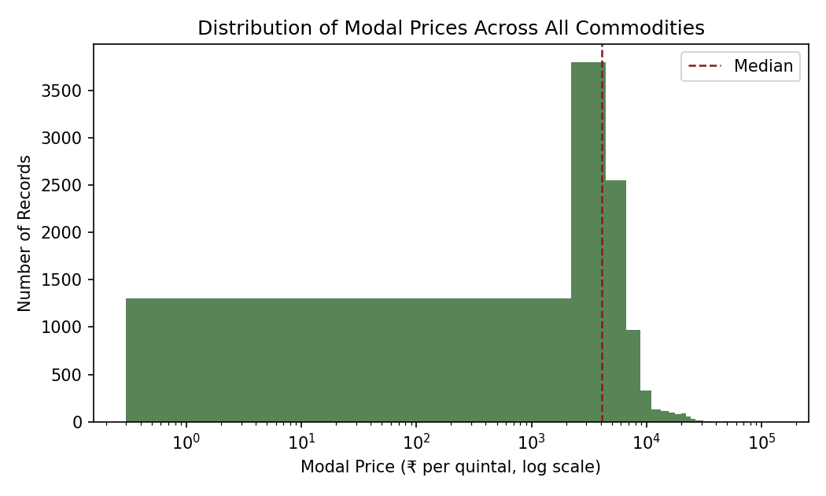
Figure 1. Distribution of modal prices across all commodities (log scale). The heavy right tail motivates per-commodity rather than global outlier fencing.
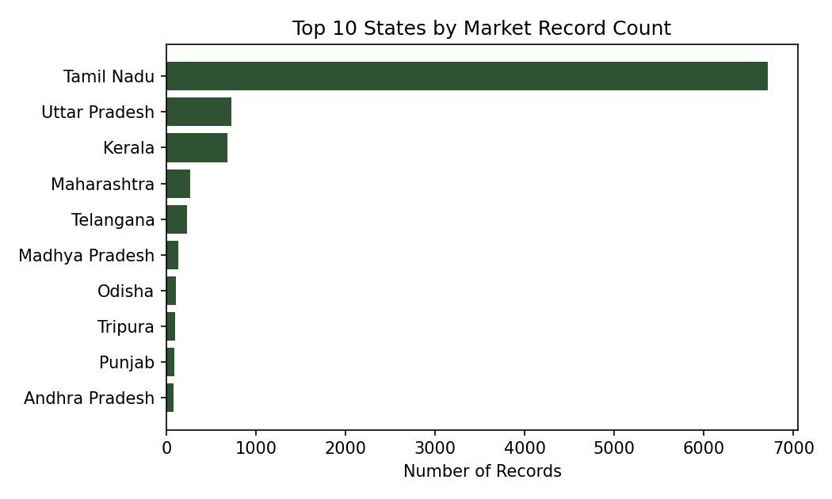
Figure 2. Record volume is heavily concentrated in a small number of states, which should be accounted for as a sampling bias in any state-comparison analysis.
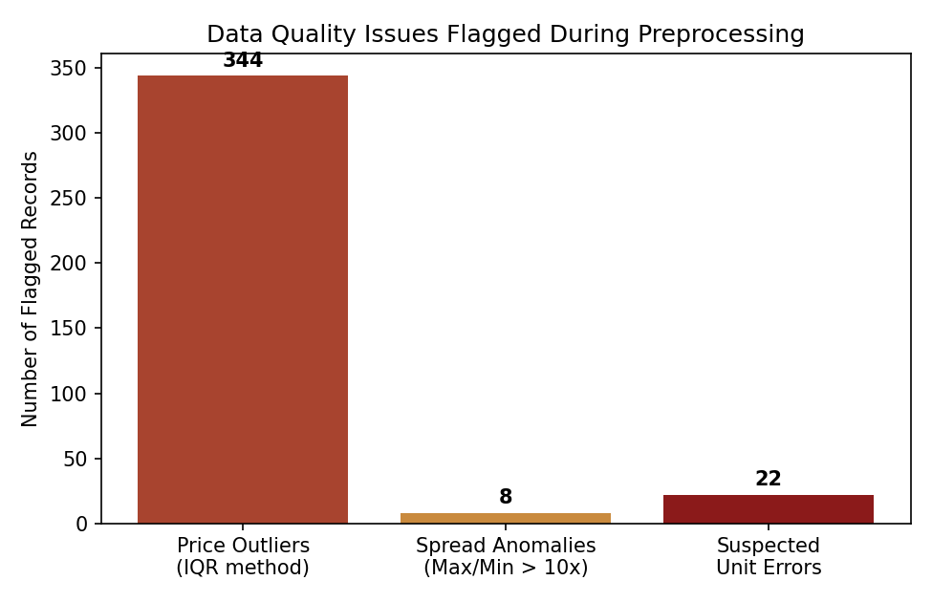
Figure 3. Count of records flagged under each quality-issue category.
For subsequent analysis, this cleaned and flagged dataset supports several agribusiness-relevant use cases without further preprocessing: cross-market price comparison for a given commodity (using standardized state/commodity labels), volatility analysis using Price_Range and Spread_Ratio, and cross-commodity comparison using Modal_Price_Normalized. Analyses sensitive to extreme values (e.g., mean price benchmarking) should filter on Price_Outlier_Flag and Suspected_Unit_Error, while analyses interested in market-level risk or arbitrage opportunities should retain them, since the anomalies themselves may be informative rather than purely erroneous.

6. Conclusion
This exercise sourced a live, government-published agribusiness dataset — Agmarknet daily mandi prices — rather than a simulated one, which surfaced authentic data-quality issues: unit-of-entry inconsistencies, non-standard categorical labels, a mixed-semantics grading field, and commodity-specific price outliers. The preprocessing strategy applied favored transparent flagging and controlled-vocabulary standardization over aggressive deletion, preserving the dataset's full informational content while making its irregularities explicit for whichever downstream analysis a user chooses to run. The resulting cleaned dataset (agmarknet_cleaned.csv) is ready for exploratory and comparative price analysis across India's agricultural markets.

