
Department of Computer Engineering and Technology
MINI PROJECT REPORT
Computer Networks Laboratory
(CSE20110)
Laboratory Continuous Assessment 3

Branch Office Network with Centralized Services

Submitted by
Sr. No. | Student Name | PRN
1. | KANAK SINGHAL | 1262242069
2. | JOYDEEP CHAKRABARTY | 1262243624
3. | DHRUV YELBHAR | 1262252246
4. | Tanishq Awale | 1262242428
5. | Paloma | 1262242596

Panel: J Batch: J1
Third Year B.Tech. Computer Engineering and Technology
Under the guidance of
UMA PUJERI MAM
Academic Year 2026–2027
Submission Date 26 October 2026

Department of Computer Engineering and Technology
CERTIFICATE

This is to certify that the mini-project entitled “Branch Office Network with Centralized Services” has been carried out by the following students of Third Year B.Tech. Computer Science and Engineering, Panel [Enter panel], Batch [Enter batch], Group No. [Enter group number], under my guidance during the academic year 2026–2027.
Student Name | PRN
KANAK SINGHAL | 1262242069
JOYDEEP CHAKRABARTY | 1262243624
DHRUV YELBHAR | 1262252246
Tanishq Awale | 1262242428
Paloma | 1262242596

The report is submitted towards the mini-project component of Laboratory Continuous Assessment 3 for the Computer Networks Laboratory course.

Faculty Signature __________________________
[Enter faculty name]
Project Guide and Course Faculty
Date ____________________
Place: Pune

GITHUB LINK: - https://github.com/k9agrawal98-web/CN-MIni-DNS-Server.git

VIDEO LINK: - https://drive.google.com/file/d/17lGyJS0EP-cvbpHilFR_Ebb0eZxWGvBg/view?usp=drivesdk

Acknowledgement
The project team acknowledges the Computer Networks Laboratory course and the academic resources provided by the Department of Computer Engineering and Technology. The project was developed and documented using Cisco Packet Tracer as the network simulation environment. The presentation materials supplied for this report describe the topology, addressing plan, centralized services, implementation steps, troubleshooting, and reported verification outcomes. The team also acknowledges the role of course guidance in structuring the mini-project and its evaluation. Team, faculty, and group details should be completed before submission.

Abstract
This mini-project presents a simulated branch-office network in which a Head Office and two geographically separate branches communicate over routed WAN links and use centralized network services. The design uses three IPv4 LANs: 192.168.10.0/24 at the Head Office, 192.168.20.0/24 at Branch 1, and 192.168.30.0/24 at Branch 2. The Head Office server, Server0 at 192.168.10.10, provides DHCP, DNS, and HTTP services. OSPF process 1 in Area 0 provides dynamic routing between the routers, while R2 and R3 relay branch DHCP requests to the central server using the ip helper-address function. The network was designed and tested in Cisco Packet Tracer. The presentation reports successful OSPF neighbor formation, DHCP assignment at the Head Office and branches, and access to the website through the name www.company.local from both branch PCs. A branch DHCP issue was resolved by configuring the relay on the branch routers. The project demonstrates how centralizing basic services can simplify administration across a small multi-office organization. The solution remains a simulation and has a single central-server dependency.
Keywords: Computer Networks, OSPF, DHCP Relay, DNS, HTTP, Cisco Packet Tracer
Replace every bracketed placeholder with project-specific content and delete the instructional text before submission. Keep only the rows needed for your group. Update the contents and page numbers after completing the report. Remove this section from the submitted report.

Table of Contents

1 Introduction and Project Objectives
1.1 Introduction and Background
1.2 Problem Statement
1.3 Scope
1.4 Objectives
2 Proposed Design and Requirements
2.1 Architecture and Network Topology
2.2 Tools and System Requirements
2.3 Addressing and Protocol Selection
3 Implementation and Technical Working
3.1 Methodology
3.2 Configuration or Code Implementation
3.3 Protocols and Technical Working
3.4 Execution Procedure
4 Testing and Results
4.1 Test Plan
4.2 Results and Execution Evidence
4.3 Objective Achievement
5 Discussion and Conclusion
5.1 Discussion and Comparative Analysis
5.2 Advantages and Applications
5.3 Limitations
5.4 Challenges and Troubleshooting
5.5 Future Scope
5.6 Conclusion
References
AI Usage Declaration
Appendices

List of Figures
Figure 2.1 Branch-office network architecture and addressing plan
Figure 3.1 Implementation workflow
Figure 4.1 Summary of reported verification outcomes

List of Tables
Table 1.1 Project objectives and verification methods
Table 2.1 Tools and system requirements
Table 2.2 IPv4 addressing plan
Table 4.1 Test plan and reported outcomes
Table 4.2 Objective achievement matrix
Table 5.1 Troubleshooting summary
Use A4 paper, Times New Roman 12 pt, 1.5 line spacing and 1-inch margins. Justify body text. Keep code left-aligned in a monospace font. Number all figures and tables and cite them in the text. Use IEEE-style numbered references. Aim for 10–20 pages of main content, excluding preliminary pages and appendices. Submit the completed report as a PDF. Remove this guidance section before submission.

1 Introduction and Project Objectives

1.1 Introduction and Background
Organizations with multiple offices need connectivity between separate local area networks (LANs), while still controlling address allocation and common services. A router forwards traffic between IP networks; a dynamic routing protocol allows routers to learn reachable networks without requiring every route to be entered manually. This project uses Open Shortest Path First (OSPF), a link-state routing protocol, to exchange routing information between the Head Office router and the two branch routers [1].
The project also centralizes Dynamic Host Configuration Protocol (DHCP), Domain Name System (DNS), and Hypertext Transfer Protocol (HTTP) services at the Head Office. DHCP automates assignment of host configuration such as IP address, default gateway, and DNS server [2]. Because DHCP discovery from a branch PC is broadcast within its local network, a router must relay the request to a server in another subnet; Cisco IOS provides the ip helper-address interface command for this purpose [3]. DNS maps the human-readable name www.company.local to the server address, and HTTP transfers the web page to the browser [4], [5]. The supplied presentation identifies Cisco Packet Tracer as the simulation environment.

1.2 Problem Statement
The project addresses the problem of connecting three geographically separate offices while maintaining consistent IP configuration and shared services. If each branch is configured independently, address settings and service records can become inconsistent, and administration requires repeating the same work at multiple locations. The target design connects the Head Office and two branches using routed WAN links, provides dynamic routing, and hosts DHCP, DNS, and HTTP centrally at Server0. The scope is a lab simulation; it does not claim to measure production-network availability or performance.

1.3 Scope
The simulated users are desktop PCs located in the Head Office, Branch 1, and Branch 2. The network contains three LANs, three routers (R1, R2, and R3), switches, client PCs, and one central server. The Head Office LAN is 192.168.10.0/24, Branch 1 is 192.168.20.0/24, and Branch 2 is 192.168.30.0/24. The WAN subnets are 10.0.0.0/30 between R1 and R2 and 10.0.0.4/30 between R1 and R3. The server address is 192.168.10.10. The project covers OSPF reachability, DHCP allocation and relay, DNS name resolution, and HTTP page access. The presentation does not specify all router interface addresses, exact software version, or detailed device configurations; those values should be confirmed from the original Packet Tracer file before final submission.

1.4 Objectives
The objectives are written so each can be checked using the evidence described in the presentation. The objective table below connects the intended function to an observable verification method.
Objective ID | Objective | Verification Method
O1 | Connect the three office LANs over WAN links using dynamic OSPF routing. | Check OSPF neighbor state with show ip ospf neighbor; verify routed reachability.
O2 | Provide centralized DHCP, DNS and HTTP services from the Head Office. | Inspect DHCP leases and Server0 service settings; resolve www.company.local.
O3 | Verify branch connectivity and name-based web access. | Obtain branch DHCP leases and open http://www.company.local from PC1 and PC3.

2 Proposed Design and Requirements

2.1 Architecture and Network Topology
Figure 2.1 summarizes the logical topology. R1 is the Head Office router. R2 and R3 connect the branch LANs to the Head Office through the two /30 WAN networks. OSPF process 1 operates in Area 0. Server0 (192.168.10.10) provides the three shared services. Branch routers act as DHCP relays so branch client broadcasts can reach the server across the routed network.
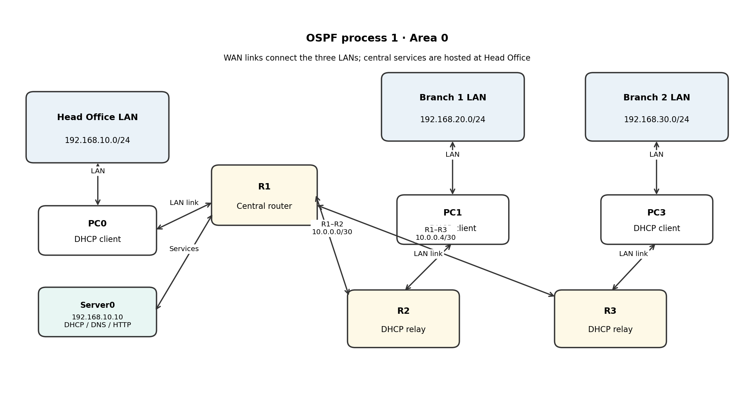
Figure 2.1 Proposed architecture or topology

2.2 Tools and System Requirements
Cisco Packet Tracer is the simulation tool explicitly identified in the project presentation. The topology uses routers, switches, PCs, and Server0. The exact Packet Tracer release and host operating system are not specified in the supplied material and should be filled in only after checking the project environment.
Tool or Resource | Version or Specification | Purpose
Cisco Packet Tracer | Version not stated in supplied presentation | Simulate routers, switches, PCs, server, routing and services.
Routers R1, R2, R3 | Cisco Packet Tracer devices; exact models not stated | Route between the LANs and WAN links; R2/R3 relay DHCP.
Switches and client PCs | Packet Tracer devices | Connect office endpoints within each LAN.
Server0 | 192.168.10.10 | Central DHCP, DNS and HTTP services.

2.3 Addressing and Protocol Selection
Table 2.2 records the subnets and known server/client settings reported in the presentation. Individual router interface addresses are not shown in the supplied slides, so they are not invented here. Use the original Packet Tracer file to confirm interface-level addressing before submission.
Device / Interface | IP / Prefix | Gateway | Role
Head Office LAN | 192.168.10.0/24 | Not applicable (network prefix) | Head Office subnet
Server0 | 192.168.10.10/24 (server IP reported; prefix follows LAN) | 192.168.10.1 (reported for Head Office PC; confirm server setting) | Central DHCP, DNS and HTTP
Head Office PC0 | 192.168.10.100 (reported) | 192.168.10.1 | DHCP client
Branch 1 LAN | 192.168.20.0/24 | Not applicable (network prefix) | Branch 1 subnet
Branch 1 PC1 | 192.168.20.x (exact lease not reported) | Branch gateway (exact address not stated) | DHCP client
Branch 2 LAN | 192.168.30.0/24 | Not applicable (network prefix) | Branch 2 subnet
Branch 2 PC3 | 192.168.30.x (exact lease not reported) | Branch gateway (exact address not stated) | DHCP client
R1–R2 WAN | 10.0.0.0/30 | Not applicable (point-to-point link) | Router-to-router connection
R1–R3 WAN | 10.0.0.4/30 | Not applicable (point-to-point link) | Router-to-router connection

OSPF was selected for dynamic routing between the three routers. A single Area 0 keeps the lab design straightforward. The /24 LAN prefixes provide separate address spaces for each office, while /30 prefixes are used for point-to-point WAN links. DHCP reduces manual client configuration; DHCP relay makes a centralized DHCP server usable across routed subnets. DNS lets users access the HTTP service by name rather than remembering the server IP address. HTTP is used for the browser-based welcome page. The server is centralized for ease of management, but this creates a single point of failure.
Important addressing note: the supplied presentation names the LAN and WAN prefixes and reports the Head Office client lease and gateway/DNS values, but it does not provide the complete interface-by-interface configuration. The branch client addresses are therefore recorded as subnet patterns rather than fabricated exact leases.

3 Implementation and Technical Working

3.1 Methodology
The implementation followed a staged workflow: create the three LANs and WAN links; assign IP addresses to router interfaces and hosts as required; configure OSPF process 1 in Area 0; configure the central DHCP pools, DNS record, and HTTP page on Server0; add DHCP relay configuration on R2 and R3; and verify routing, address allocation, and name-based web access. Figure 3.1 shows this sequence at a high level.

3.2 Configuration or Code Implementation
The project is a network simulation rather than a standalone software application, so its implementation consists of device configuration and service settings. The presentation confirms OSPF process 1 in Area 0 and the use of ip helper-address on both branch routers. A representative relay command is shown below; the interface name must match the interface facing the branch LAN in the actual Packet Tracer configuration.
interface <branch-LAN-interface>
ip helper-address 192.168.10.10
The angle-bracket interface label is a placeholder, not a literal Cisco IOS command. The presentation does not provide the actual interface names or complete router configurations. The central DHCP pools and DNS/HTTP service settings are configured through Server0 in Packet Tracer.

3.3 Protocols and Technical Working
Routing: R1, R2, and R3 exchange OSPF information so the routers can reach the LANs behind one another. The reported verification was that R2 and R3 each showed R1 as a FULL OSPF neighbor. DHCP: a client broadcasts a DHCP request on its LAN. The branch router relays the request to 192.168.10.10, and the server returns configuration from the matching subnet pool. DNS and HTTP: the browser queries DNS for www.company.local, receives 192.168.10.10, and then sends an HTTP request to that address. The server returns the configured welcome page.

3.4 Execution Procedure
Open the project in Cisco Packet Tracer and ensure the devices are powered on. First inspect the router interfaces and verify OSPF adjacency using show ip ospf neighbor on R2 and R3. On a Head Office PC and the branch PCs, select Desktop > IP Configuration and choose DHCP. Confirm that each client receives an address from its own LAN subnet, along with the appropriate default gateway and DNS server. On Server0, verify that DHCP pools match the three LANs, the DNS service contains the www.company.local record pointing to 192.168.10.10, and HTTP is enabled with a welcome page. Finally, use Desktop > Web Browser on PC1 and PC3 and visit http://www.company.local. Exact file name and interface identifiers were not supplied in the presentation.
The source presentation does not contain a standalone Packet Tracer screenshot in the extracted content. Figure 3.1 is therefore an implementation workflow diagram, not a screenshot or substitute for live configuration evidence. Before submission, add a screenshot of the actual Packet Tracer topology and, if possible, the router OSPF output and browser result.
Figure 3.1 Implementation evidence

4 Testing and Results

4.1 Test Plan
Testing was reported in Cisco Packet Tracer. The success criteria were: OSPF neighbors reach FULL state; the Head Office PC receives a valid DHCP lease; branch PCs receive addresses from their own subnets after relay configuration; and the website loads from both branch PCs using its DNS name. A separate negative-input or outage test is not reported in the presentation, so it is listed as a recommended additional test rather than a completed test.
Test ID | Test and Input | Expected Result | Observed Result | Status
T1 | Run show ip ospf neighbor on R2 and R3. | R1 appears as a FULL neighbor on both branch routers. | Presentation reports R2 and R3 each show R1 as FULL. | PASS
T2 | Set Head Office PC0 to DHCP. | Address in 192.168.10.0/24, gateway 192.168.10.1, DNS 192.168.10.10. | 192.168.10.100, gateway 192.168.10.1 and DNS 192.168.10.10 reported. | PASS
T3 | Set PC1 and PC3 to DHCP after configuring relay. | PC1 receives 192.168.20.x and PC3 receives 192.168.30.x with correct gateway/DNS. | Presentation reports branch PCs obtained addresses from their own subnets after relay was configured. | PASS after fix
T4 | Open http://www.company.local from PC1 and PC3. | DNS resolves the name and the HTTP welcome page loads. | Presentation reports the page loaded from both branch PCs. | PASS
T5 | Disconnect Server0 or disable a service (recommended extra test). | Service failure should be observable; document which functions fail and recovery steps. | Not reported as performed in the supplied presentation. | NOT TESTED

4.2 Results and Execution Evidence
The presentation reports PASS for the OSPF neighbor check, Head Office DHCP, branch DHCP after adding the relay, and web access by name from both branch PCs. Figure 4.1 summarizes those reported outcomes. It is a summary based on the presentation, not a screenshot of Packet Tracer output. Attach the original screenshots or command output as evidence if available.
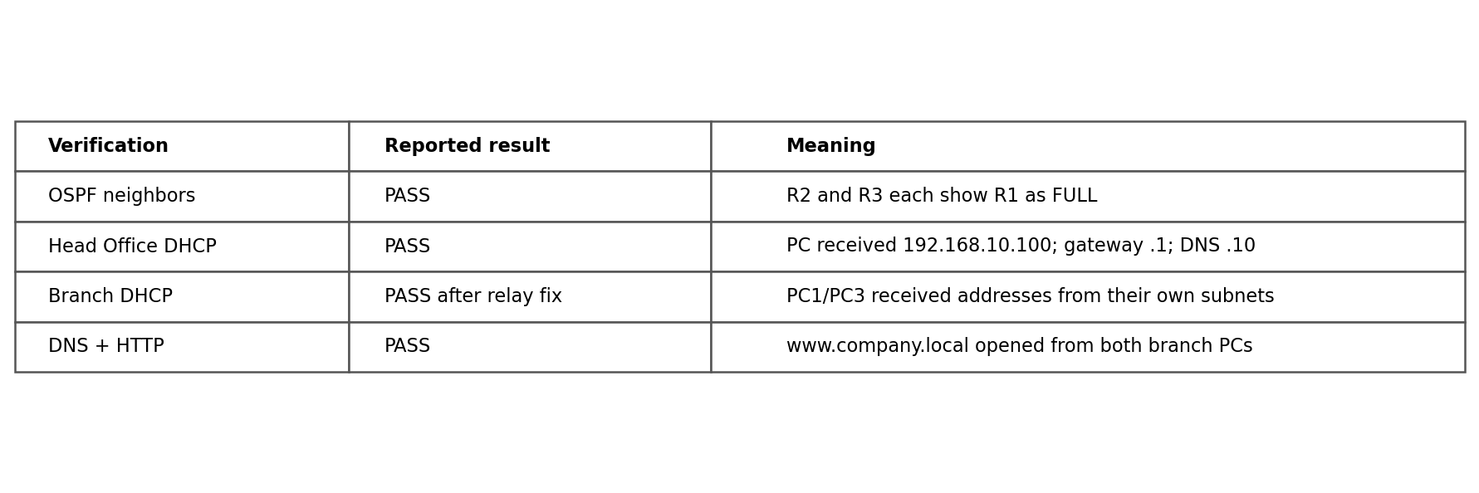
Figure 4.1 Test execution result

4.3 Objective Achievement
The reported outcomes support all three objectives within the simulated environment. The branch DHCP objective was achieved only after the relay configuration was corrected. The evidence is based on the outcomes documented in the supplied presentation; independent performance measurements were not provided.
Objective ID | Evidence or Test ID | Outcome
O1 | T1; OSPF neighbor verification | Achieved in the reported Packet Tracer test.
O2 | T2, T3, T4; DHCP/DNS/HTTP checks | Achieved in the reported simulation; branch DHCP required relay configuration.
O3 | T3, T4; branch leases and browser access | Achieved in the reported simulation.

5 Discussion and Conclusion

5.1 Discussion and Comparative Analysis
The design demonstrates the functional difference between manually configuring every client and using a centralized DHCP service: clients can obtain their network settings from the appropriate pool, while the administrator maintains pools at the Head Office. OSPF avoids relying exclusively on manually maintained static routes for the three-router topology. The DNS record supports name-based access to the HTTP server. The results are functional checks, not a benchmark; no latency, throughput, convergence-time, or scalability measurements were supplied, so no numerical performance comparison is claimed.

5.2 Advantages and Applications
Centralized services reduce duplicated administration and can make address allocation and name records more consistent across offices. OSPF supports automatic route exchange as the topology changes. DHCP relay extends the central DHCP service to remote subnets without placing a separate DHCP server at each branch. The design is relevant as a learning model for a small organization with a Head Office and two branches.

5.3 Limitations
The central server is a single point of failure: if Server0 becomes unavailable, the centralized DHCP, DNS, and HTTP services may be affected. The topology is a Cisco Packet Tracer simulation and does not establish production behavior under real link failures, high traffic, security attacks, or large numbers of clients. The supplied presentation does not specify all interface IP addresses, the Packet Tracer version, or measured performance. Security controls such as access-control lists, authenticated administration, and redundant services are not reported as implemented.

5.4 Challenges and Troubleshooting
The documented troubleshooting issue was branch DHCP failure. DHCP discovery uses a local broadcast, which is not forwarded by a router by default. The branch routers were configured with ip helper-address pointing to 192.168.10.10. The presentation reports that branch clients then obtained addresses from their own subnets, and branch web access succeeded. No other actual fault is documented in the supplied slides.
Issue | Cause or Diagnosis | Solution and Verification
Branch PCs did not initially obtain DHCP settings | DHCP discovery is broadcast traffic and does not automatically cross a router to the central server. | Configured ip helper-address 192.168.10.10 on R2 and R3. The presentation reports that branch PCs then received addresses from their respective subnets.

5.5 Future Scope
Future improvements include adding a redundant DHCP/DNS/HTTP server or a documented recovery plan; implementing access-control lists and restricting management access; adding monitoring for router adjacency and server availability; testing link failure and recovery; capturing packet traces to explain DHCP and DNS exchanges; and measuring convergence time or service response under controlled conditions. These are recommendations and are not claimed as completed work.

5.6 Conclusion
The mini-project designed and simulated a three-office IPv4 network with a Head Office and two branches. OSPF process 1 in Area 0 provided dynamic routing, while Server0 at 192.168.10.10 hosted centralized DHCP, DNS, and HTTP services. DHCP relay configuration on R2 and R3 resolved the reported branch address-allocation problem. The presentation records successful OSPF adjacency, DHCP assignment in all three LANs, and access to www.company.local from both branch PCs. The project meets its stated functional objectives in Packet Tracer, while remaining limited by its simulated environment and single central server.

References
References are listed in IEEE style. The project presentation identifies Cisco Packet Tracer and the listed networking standards/documentation as reference areas; the following official sources support the protocol descriptions used in this report.
[1] J. Moy, “OSPF Version 2,” RFC 2328, Internet Engineering Task Force, Apr. 1998. [Online]. Available: https://www.rfc-editor.org/rfc/rfc2328
[2] R. Droms, “Dynamic Host Configuration Protocol,” RFC 2131, Internet Engineering Task Force, Mar. 1997. [Online]. Available: https://www.rfc-editor.org/rfc/rfc2131
[3] Cisco, “ip helper-address,” Cisco IOS IP Addressing Services Command Reference. [Online]. Available: https://www.cisco.com/ (search for the IOS ip helper-address command reference).
[4] P. Mockapetris, “Domain Names—Concepts and Facilities,” RFC 1034, Internet Engineering Task Force, Nov. 1987. [Online]. Available: https://www.rfc-editor.org/rfc/rfc1034
[5] R. Fielding, M. Nottingham, and J. Reschke, “HTTP Semantics,” RFC 9110, Internet Engineering Task Force, Jun. 2022. [Online]. Available: https://www.rfc-editor.org/rfc/rfc9110
[6] Cisco Networking Academy, “Cisco Packet Tracer,” network simulation environment. [Online]. Available: https://www.netacad.com/cisco-packet-tracer

AI Usage Declaration
AI tools were used to assist with report organization, language drafting, and diagram preparation based on the supplied project presentation. The topology, addressing plan, commands, and reported results in this report are derived from the provided presentation. The report does not claim that additional Packet Tracer tests were performed during report preparation. The project team should compare all configuration details with the original Packet Tracer file and update missing group, faculty, PRN, screenshot, and version details before submission.
Declaration: We take responsibility for the accuracy of this report and understand the submitted implementation and results. Sources and assistance used have been acknowledged.
Student Name | PRN | Signature
KANAK SINGHAL | 1262242069
JOYDEEP CHAKRABARTY | 1262243624
DHRUV YELBHAR | 1262252246

Appendices

Appendix A Code and Configuration
The supplied presentation does not include complete router running-config files or the Packet Tracer project file. The following snippets are representative verification/configuration references, not a claim that every line matches the saved project. Confirm interface names and addresses against the actual .pkt file.
Branch router DHCP relay (apply on the interface facing the branch LAN):
interface <branch-LAN-interface>
ip helper-address 192.168.10.10
OSPF verification command (reported in the presentation):
show ip ospf neighbor
Server0 service checklist: enable DHCP and create pools for 192.168.10.0/24, 192.168.20.0/24, and 192.168.30.0/24; configure DNS name www.company.local to resolve to 192.168.10.10; enable HTTP and configure the welcome page. Pool names, lease ranges, and exact gateway settings must be confirmed in the original simulation.

Appendix B Additional Evidence
No standalone screenshots, packet captures, or raw router logs were included in the supplied presentation text. The reported verification outcomes are summarized in Table 4.1 and Figure 4.1. Add actual screenshots from Packet Tracer before final submission, particularly: (1) the full topology, (2) show ip ospf neighbor output on R2 and R3, (3) DHCP leases on PC0, PC1 and PC3, and (4) the website open at http://www.company.local on a branch PC.

