**Debugging:-**

**Q1:-**1>C:\Users\agarwadu\Desktop\Week2Exercise2Broken\Week2Exercise2Broken\ExploreCalifornia.Monolith\Domain\Tour.cs(7,46,7,47): error CS8180: { or ; or => expected

**Ans:-**

1. public string Description { get; set; }

**Q2:-**1>C:\Users\agarwadu\Desktop\Week2Exercise2Broken\Week2Exercise2Broken\ExploreCalifornia.Monolith\DataAccess\ToursRepository.cs(39,2,39,2): error CS1513: } expected

**Ans:-**

}

}

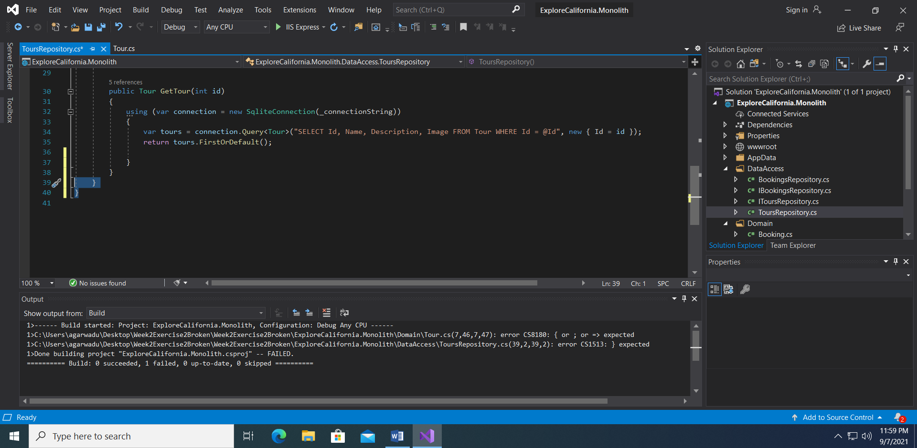

**Q3:-**

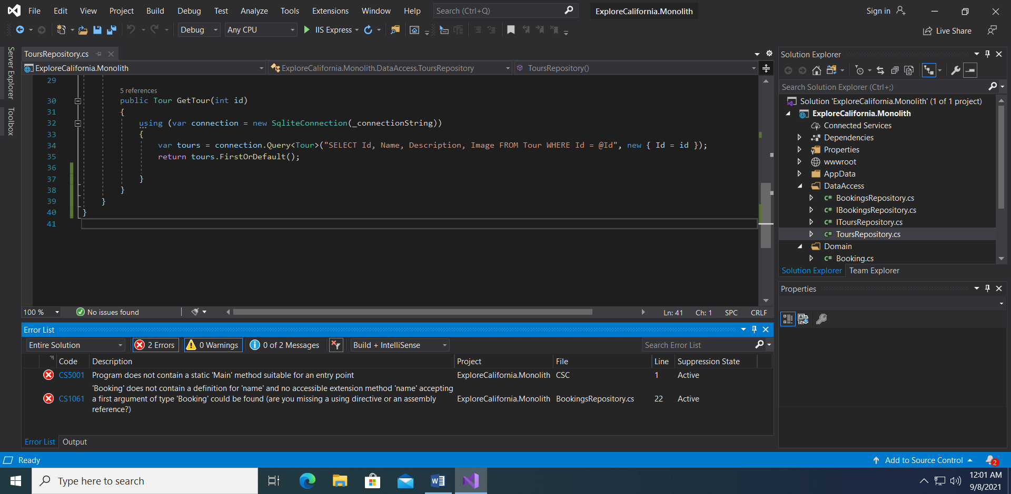

**Ans:-**

1. public static void Main(string[] args)
2. connection.Execute(
3. "INSERT INTO Booking (TourId, Name, Email, Transport) VALUES (@TourId, @Name, @Email, @Transport)",

new { TourId = booking.TourId, Name = booking.Name, Email = booking.Email, Transport = booking.Transport });

**Q4:-** Application not running after build success

**Ans:-** uncomment index.cshtml

1. @page

@model IndexModel

1. </article>

Successfully running application

