AGRIWISE AI
An Intelligent Crop Lifecycle
Decision Support System for Sustainable Agriculture
Research Dossier
Research foundation, evidence and limitations
Version 1.0 | 15 October 2026
Student name: [FILL IN] Roll number: [FILL IN]
Institution / Department: [FILL IN]
Project supervisor: [FILL IN]
Submission term / academic year: [FILL IN]
Evidence-grounded edition — implementation claims are qualified by verification status.

Contents
Open this document in Word and update the table of contents.
The contents field is updateable in Microsoft Word: select the contents and choose Update Field → Update entire table. Headings are real Word heading styles.

Executive summary
AgriWise AI is a Flask/Jinja and SQLite software prototype that brings farm records, crop classification, weather-aware workflows, rule-based advisories, lifecycle tracking, optional disease-image screening, and financial/market pages into one application. Its purpose is decision support and record organization, not autonomous agronomy.
Repository evidence establishes that the crop classifier is trained on a balanced 2,200-row, 22-label CSV with seven numeric features and that the checked-in metrics artifact reports Random Forest held-out accuracy and macro-F1 of 0.9955. The source provider, license, geography, and collection period are not established. The held-out split is used to select the candidate model, so these numbers are development-benchmark evidence rather than independent field accuracy.
A MobileNetV3 Small checkpoint and 38 disease classes are present. The app can produce a crop-matched, unverified closest-class suggestion; disease accuracy, training lineage, calibration, and field robustness are unknown. Other outputs are a mixture of deterministic rules, statistical calculations, provider data, and farmer records.
The full project test run recorded on 15 October 2026 was 183 passed, one Windows joblib warning, and zero failures. That verifies covered software behavior only. The project has not established improved yields, farmer outcomes, disease accuracy, operational live market history, or field efficacy.

Problem statement and motivation
Agricultural decisions are coupled: soil and climate conditions influence crop choice, weather changes the timing of operations, crop stage shapes monitoring needs, and farmers need a durable record of what was planned and completed. Disconnected applications can force users to repeat data entry and make it difficult to trace why a suggestion appeared.
AgriWise AI addresses this information-coordination problem for a prototype user workflow. It stores a farm profile and soil readings, exposes model and rule outputs, tracks an active crop cycle and activities, and presents supporting weather and market pages. It does not measure whether a recommendation improves a farm outcome. The distinction is important because an integrated interface is not itself evidence of agronomic validity [6], [7].
The intended user is a farmer or demonstrator who can enter or obtain soil and farm data and interpret decision-support outputs. Deployment with real users requires local agronomic review, user research, consent and privacy practices, accessibility evaluation, and field validation.

Research objectives and questions
Completed engineering objective: implement a web application that connects farmer/farm records with crop classification, lifecycle workflows, rules, and selected external data adapters. Evidence is in routes, services, templates, database schema and tests.
Completed engineering objective: maintain crop recommendation and disease screening as distinct workflows with explicit caveats. Disease reports and transient image screening have separate persistence and interaction paths.
Partially completed objective: provide reusable English/Marathi/Hindi translation infrastructure and translated screens. Locale resources, selection persistence and fallback exist, but complete page-by-page and dynamic-message coverage is not certified.
Research questions for an empirical follow-up are: (RQ1) How does crop classification generalize under geographically and temporally independent evaluation? (RQ2) What is the accuracy and calibration of disease screening on independent field images? (RQ3) Does coordinated lifecycle/weather/task display reduce missed operations or improve decision traceability? These questions are not answered by the available benchmark or software tests.

Literature review
Plant disease image classification has been explored using deep convolutional networks on curated image repositories. Mohanty, Hughes and Salathé evaluated deep learning on PlantVillage-style images and made a dataset-driven case for image diagnosis research [1], [2]. Their work also reports a sharp performance reduction on images captured under different conditions, which cautions against transferring curated-image results to field use.
Crop recommendation using soil and weather-related inputs is represented in prior work; Chauhan and Chaudhary describe Random Forest and Decision Tree approaches [3]. Ertaza and Hossain report soil/climate features and SHAP/LIME explanations in an abstract-level record [9]. Neither paper validates AgriWise's classifier.
Weather-and-irrigation decision support is represented by Sexton's Opticane work, which discusses forecast scale and local-climate fit [10]. India-specific price forecasting examples include onion/potato market forecasting and anomaly detection [11] and daily NCDEX commodity price comparisons among ARIMA, TDNN and LSTM models [12]. These are research precedents, not evidence that AgriWise's provider or price forecast is operational.
Tan et al. review agricultural expert systems across crop, water and soil management categories [13]. Rajkhowa and Qaim report associations between personalized digital extension and agricultural performance for Indian smallholders, using matching methods to address selection concerns [14]. This does not establish causal impact or local-language performance for AgriWise.
Machine-learning evaluation metrics are conditional on sampling and protocol. Accuracy and macro-F1 are summaries; they do not alone establish calibration, distributional robustness, utility or causal impact [16]. FAO and the World Bank provide digital-agriculture and economic context [6], [7], not validation of this prototype.

Literature comparison matrix
The table summarizes the role of selected publications and documentation. Research findings are attributed to those works; AgriWise-specific statements are separately identified as repository evidence.
Source | Problem | Method / data | Evaluation / reported scope | Finding supported | Relevance / limit
Mohanty et al. (2016) [1] | Plant disease; CNNs on 54,306 PlantVillage images / 38 classes | Reported 99.35% best dataset accuracy; just above 31% on different-condition images | Demonstrates domain sensitivity in that experiment; not AgriWise performance
Hughes & Salathé (2015) [2] | Open plant-health image repository | Describes over 50,000 curated images and diagnostic research motivation | Dataset context only; does not identify AgriWise checkpoint provenance
Chauhan & Chaudhary (2021) [3] | Crop recommendation; soil/weather inputs; RF/DT | Conference abstract/DOI metadata checked; detailed evaluation not verified | Method precedent; no same-data comparison
McKinion & Lemmon (1985) [4] | Agricultural expert systems | Title and bibliographic record verified; full text not reviewed | Historical research anchor; no specific findings attributed
Ertaza & Hossain (2024) [9] | Crop recommendation; soil/climate features; SHAP/LIME | Abstract-level evidence; no verified evaluation details in this audit | Feature explanations differ from calibrated uncertainty; no AgriWise comparison
Sexton (2023) [10] | Weather + irrigation decision support (Opticane) | Conference abstract describes sugarcane tool and local forecast-scale concern | Supports design precedent only; not transferable outcome evidence
Madaan et al. (2019) [11] | India onion/potato prices and anomaly detection | Abstract describes wholesale arrivals and retail prices; anomaly events include hoarding | Related Indian market research; not evidence of AgriWise live data
Manogna & Mishra (2021) [12] | Indian NCDEX commodity price forecasting | Deposited abstract compares ARIMA, TDNN and LSTM on five commodities | Abstract reports directional-price performance; not an AgriWise comparison
Tan et al. (2022) [13] | Oil-palm precision-agriculture expert systems | Abstract reports review of 108 papers from 2011–2020; crop/water/soil categories | Review context; does not validate AgriWise rules
Rajkhowa & Qaim (2021) [14] | Personalized digital extension in India | Full PLOS ONE article/abstract; association analysis with propensity-score matching | Relevant user-context evidence; not proof of causality or AgriWise impact

Table 1. Selected literature and evidence boundaries.

Existing-system analysis and research gap
Existing research addresses focused tasks such as image classification, prediction, sensing, and automation. AgriWise's engineering contribution is an integrated prototype workflow: user-owned farm records connect to a crop recommendation page, lifecycle planning, deterministic rules, a separate disease screen, and supporting data pages.
The defensible gap for this project is not that earlier work lacks these components. Rather, the prototype demonstrates how such workflows are wired together while making evidence boundaries visible. Whether that integration is novel, more usable, more accurate, or beneficial has not been established by comparative research.
Unresolved research gaps include external validation of the crop classifier, disease model provenance/evaluation, calibrated uncertainty, a validated all-14-crop recommendation dataset, farmer-centered usability and accessibility, a measured effect on decision quality, and successful live market-history acquisition.

Proposed contributions and evidence
Contribution A — implemented software integration: Flask routes and services coordinate farm inputs, model inference, rules, records, and browser pages. Evidence: source inspection and the recorded automated test suite. Not proven: production scalability or improved agricultural outcomes.
Contribution B — separate safety boundaries: image screening returns only a crop-matched suggestion; problem reports store farmer-reported symptoms separately. Evidence: route/service separation and regression tests. Not proven: diagnostic accuracy.
Contribution C — reusable localization: UTF-8 JSON resources, supported language validation, session persistence, and English fallback. Evidence: service and selected rendered-route tests. Not proven: total translation coverage or native-speaker acceptance.
Contribution D — measured crop model benchmark: stored comparison of four classifiers on a balanced CSV. Evidence: model_metrics.json and training procedure. Not proven: independent generalization because the held-out set selects the winner and dataset provenance is unresolved.

Dataset analysis
The primary recommendation dataset is data/Crop_recommendation.csv. It contains 2,200 rows: 100 for each of 22 labels. Predictors are N, P, K, temperature, humidity, ph, and rainfall; label is the crop class. recommendationData.csv is byte-identical in the audited checkout and must not be counted as extra evidence. Repository evidence does not establish the original author/provider, license, collection protocol, period, units documentation, or geography.
The class balance is exact in the saved artifact. A stratified 80/20 split with random_state=42 yields 1,760 training and 440 held-out records; five-fold stratified cross-validation is applied to the training partition. Invalid and exact duplicate rows are filtered by the training utility.
The disease model uses a 38-label mapping associated with a MobileNetV3 Small checkpoint. The full PlantVillage image collection is external, not bundled. The precise checkpoint training subset, labels-to-image mapping, train/validation/test partitions, deduplication, training code and metrics are unknown.
The recommendation benchmark and disease model crop identities are not identical. After common-name normalization, their overlap is four crop identities (apple, maize/corn, grape/grapes and orange); an approved, traceable data source covering all 14 disease-model crops has not been established. Do not synthesize rows to make class coverage appear complete.
Validity risks include source/near-duplicate leakage, non-independent rows, unknown geography and measurement units, label construction, selection on the held-out test set, and differences between benchmark features and actual farm constraints. An external, grouped geographic/temporal split and prospective field data are required.
Item | Verified evidence | Limitation
Recommendation data | 2,200 rows; 22 labels; 7 predictors; 100 rows/class | Provider, license, geography, period and units unresolved
Duplicate copy | recommendationData.csv has identical SHA-256 | Not an independent sample
Disease model | 38 output classes; 14 crop identities; MobileNetV3 Small artifact | Training lineage and independent evaluation unknown
Crop-name overlap | 4 normalized identities across tasks | No verified all-14 recommendation set

Table 2. Dataset inventory based on repository evidence.

Methodology
The software-development methodology is evidence-first source inspection followed by test execution and bounded claims. The crop training path loads and validates tabular data, coerces numerical features, filters invalid records, splits stratified data, evaluates candidate classifiers, compares held-out macro-F1, and writes artifacts. K-nearest neighbors uses a StandardScaler pipeline. Metric definitions and averaging behavior follow the scikit-learn evaluation reference [16].
At application inference, the crop route validates seven input fields and calls the saved model through the crop service, then builds an explanation and persists the recommendation. Disease inference validates the uploaded image, converts it to RGB, resizes to 224×224, normalizes using ImageNet channel statistics, calls the checkpoint, and conditionally presents a top class when its crop matches the selected/lifecycle crop.
The broader application composes weather adapters, deterministic rules, lifecycle calculations, user records, and conditional market analysis. Open-Meteo documents weather-model forecasts, not sensor readings [5]. These methods are not interchangeable: a rule engine is not a trained predictor; external weather is not a sensor; a price forecast is not a guaranteed offer.
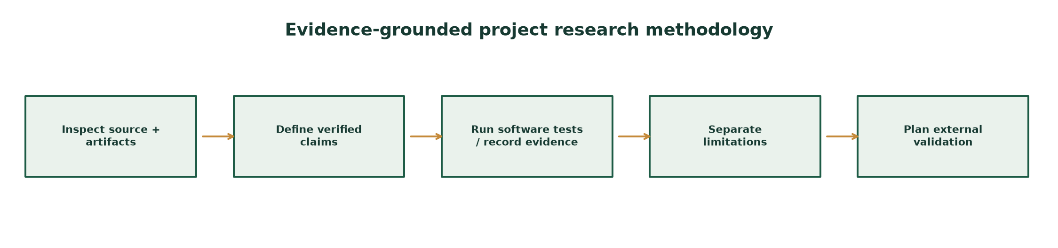
Figure 1. Evidence-oriented research and software audit workflow.

Experimental results
The stored crop metrics artifact reports Random Forest as selected with accuracy 0.9955, macro precision 0.9957, macro recall 0.9955 and macro-F1 0.9955. Its training-fold five-fold CV accuracy is 0.9943 ± 0.0051. Decision Tree reports 0.9818 accuracy / 0.9817 macro-F1; KNN 0.9795 / 0.9793; Gradient Boosting 0.9886 / 0.9886.
These values are artifact-reported, not regenerated in this documentation task. The model-selection procedure uses held-out macro-F1, so the held-out score is optimistic as a final unbiased estimate. It must not be described as field accuracy, regional accuracy, or expected harvest success.
The disease checkpoint has no verified independent metric in the repository evidence. No current live market-data record set, market-forecast accuracy, field trial, inference-latency benchmark, coverage estimate, or user study was established. Software tests recorded 183 passed, one environment warning, zero failures.
Model | Accuracy | Macro-P | Macro-R | Macro-F1 | 5-fold CV accuracy
Decision Tree | 0.9818 | 0.9830 | 0.9818 | 0.9817 | 0.9841 ± 0.0073
Random Forest | 0.9955 | 0.9957 | 0.9955 | 0.9955 | 0.9943 ± 0.0051
KNN | 0.9795 | 0.9804 | 0.9795 | 0.9793 | 0.9653 ± 0.0121
Gradient Boosting | 0.9886 | 0.9896 | 0.9886 | 0.9886 | 0.9926 ± 0.0043

Table 1. Reported crop-model metrics from ml/model_metrics.json; not independently reproduced here.
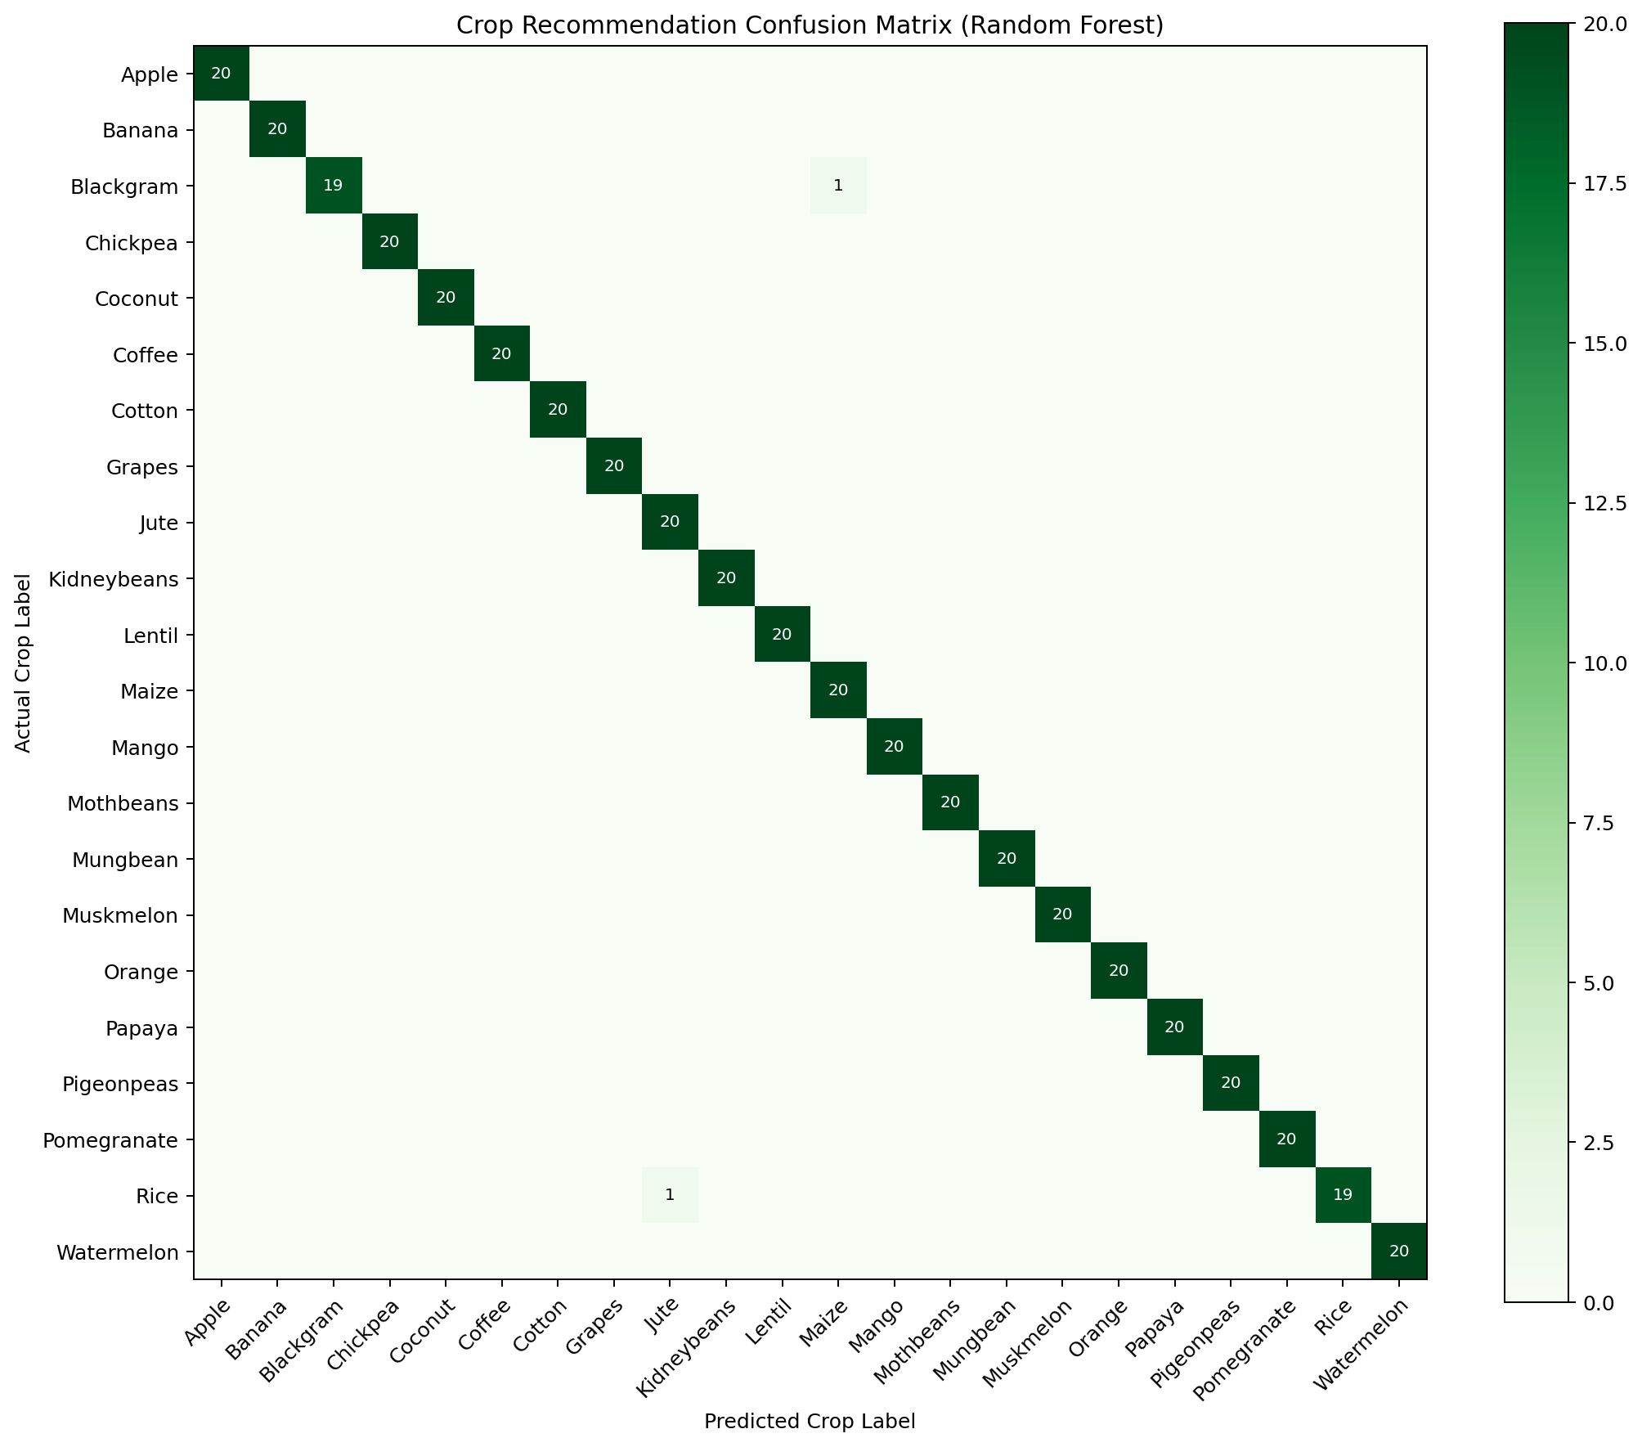
Figure 2. Repository confusion matrix artifact. It is included as a reported artifact, not newly reproduced.

Discussion
The evidence demonstrates a functioning software prototype with a measurable crop benchmark and test-covered workflows. It demonstrates engineering feasibility and selected interface/service contracts. It does not establish that the crop model is suitable for Maharashtra, that disease screening is accurate, or that users benefit.
A 99.55% score on a balanced, provenance-limited random split can coexist with poor real-world generalization. Field measurements may differ in scale, season, instrumentation, crop variety and management. Likewise, high softmax scores are not calibrated probabilities, and a closed-set image model may confidently assign an unsupported image to a known class.
The integrated presentation can improve traceability if the user can see input, source and caveat. That usability proposition must be tested with farmers and agricultural experts.

Threats to validity
Construct validity: benchmark crop labels may encode a synthetic/curated recommendation task rather than field outcomes; disease labels and confidence do not equal confirmed diagnoses.
Internal validity: selection on the held-out test set and potential source-level duplication may bias reported crop performance; the disease model's training lineage is unknown.
External validity: no independent location, season, cultivar, device, field, or farmer evaluation exists. API reliability and market histories vary with network, key and provider conditions.
Reproducibility: training code exists, but original dataset provenance is unresolved; model artifacts and recorded metrics were not retrained in the latest audit. The full test suite's module-level import may initialize the configured database, so the recorded test run cannot be called database-side-effect-free.
Operational validity: browser visual auditing, accessibility, load testing, penetration testing, deployment smoke testing and user studies were not performed in the audit represented here.

Future research
Priority 1: identify and license a traceable agronomic dataset covering the intended crop classes and define feature units/collection contexts before any retraining.
Priority 2: use nested model selection or a sealed independent test set; split by source, site, time or farm where identifiers permit; report confidence intervals and per-class metrics.
Priority 3: obtain an independently labeled disease image set with field photographs, plant-part metadata and expert adjudication; report calibration, sensitivity, specificity, abstention and OOD behavior.
Priority 4: conduct farmer-centered usability and accessibility studies with consent, a prespecified protocol, local-language review and appropriate ethics approval.
Priority 5: verify external API contracts with bounded live tests; monitor freshness, provenance and failure behavior; add independent audit logs and operational metrics without exposing secrets.

References
[1] S. P. Mohanty, D. P. Hughes, and M. Salathé, “Using Deep Learning for Image-Based Plant Disease Detection,” Frontiers in Plant Science, vol. 7, art. 1419, 2016, doi: 10.3389/fpls.2016.01419.
[2] D. P. Hughes and M. Salathé, “An open access repository of images on plant health to enable the development of mobile disease diagnostics,” arXiv:1511.08060 [cs.CY], 2015. [Online]. Available: https://arxiv.org/abs/1511.08060
[3] G. Chauhan and A. Chaudhary, “Crop Recommendation System using Machine Learning Algorithms,” in 2021 10th International Conference on System Modeling & Advancement in Research Trends (SMART), 2021, pp. 109–112, doi: 10.1109/SMART52563.2021.9676210.
[4] J. M. McKinion and H. E. Lemmon, “Expert systems for agriculture,” Computers and Electronics in Agriculture, vol. 1, no. 1, pp. 31–40, 1985, doi: 10.1016/0168-1699(85)90004-3.
[5] Open-Meteo, “Weather Forecast API,” official documentation, accessed 15 Oct. 2026. [Online]. Available: https://open-meteo.com/en/docs
[6] Food and Agriculture Organization of the United Nations, “e-Agriculture,” accessed 15 Oct. 2026. [Online]. Available: https://www.fao.org/e-agriculture/
[7] World Bank, World Development Indicators, “Agriculture, forestry, and fishing, value added (% of GDP),” indicator NV.AGR.TOTL.ZS, accessed 15 Oct. 2026. [Online]. Available: https://data.worldbank.org/indicator/NV.AGR.TOTL.ZS
[8] World Wide Web Consortium (W3C), Web Content Accessibility Guidelines (WCAG) 2.2, W3C Recommendation, 5 Oct. 2023, Success Criterion 3.1.1. [Online]. Available: https://www.w3.org/TR/WCAG22/#language-of-page
[9] S. I. Ertaza and S. K. A. Hossain, “Smart Crop Recommendation System Using Machine Learning and Explainable AI,” in 2024 27th International Conference on Computer and Information Technology (ICCIT), 2024, doi: 10.1109/ICCiT64611.2024.11021774. Abstract-level evidence accessed.
[10] J. Sexton, “Development of an online weather and irrigation forecast decision support tool using an action learning process,” in MODSIM2023, 25th International Congress on Modelling and Simulation, 2023, doi: 10.36334/modsim.2023.sexton.
[11] L. Madaan, A. Sharma, P. Khandelwal, S. Goel, P. Singla, and A. Seth, “Price forecasting & anomaly detection for agricultural commodities in India,” in Proceedings of the 2nd ACM SIGCAS Conference on Computing and Sustainable Societies (COMPASS ’19), 2019, pp. 52–64, doi: 10.1145/3314344.3332488. Abstract-level evidence accessed.
[12] R. L. Manogna and A. K. Mishra, “Forecasting spot prices of agricultural commodities in India: Application of deep-learning models,” Intelligent Systems in Accounting, Finance and Management, vol. 28, no. 1, pp. 72–83, 2021, doi: 10.1002/isaf.1487. Deposited-abstract evidence accessed.
[13] X. J. Tan, W. L. Cheor, K. S. Yeo, and W. Z. Leow, “Expert systems in oil palm precision agriculture: A decade systematic review,” Journal of King Saud University – Computer and Information Sciences, vol. 34, no. 4, pp. 1569–1594, 2022, doi: 10.1016/j.jksuci.2022.02.006. Abstract-level evidence accessed.
[14] P. Rajkhowa and M. Qaim, “Personalized digital extension services and agricultural performance: Evidence from smallholder farmers in India,” PLOS ONE, vol. 16, no. 10, e0259319, 2021, doi: 10.1371/journal.pone.0259319.
[15] Pallets Projects, Flask Documentation, “Application Factories” and “The Request Context.” [Online]. Available: https://flask.palletsprojects.com/en/stable/patterns/appfactories/
[16] scikit-learn developers, “Model evaluation: quantifying the quality of predictions,” official documentation. [Online]. Available: https://scikit-learn.org/stable/modules/model_evaluation.html
[17] SQLite Consortium, “SQLite Foreign Key Support,” official documentation. [Online]. Available: https://www.sqlite.org/foreignkeys.html

Evidence register and academic completion checklist
Claim area | Evidence state | What would strengthen it
Crop classifier benchmark | Artifact-reported; selection split caveat | Sealed geographic/time holdout; repeated reproduction
Disease classifier | Checkpoint integrated; performance unknown | Labeled independent field set, calibration, subgroup analysis
Weather | Adapter and mocked tests; historical single live observation | Current controlled integration checks and freshness logging
Market | Adapter configured; live usable data unverified | Verified key/resource response, complete series and forecast evaluation
Localization | Infrastructure and selected-screen tests | Complete per-template/dynamic audit and native reviewer acceptance
Farm benefit | No user/field study | Prospective controlled study with consent/ethics and outcome measures

Table 3. Evidence gaps that constrain conclusions.

