AGRIWISE AI
An Intelligent Crop Lifecycle
Decision Support System for Sustainable Agriculture
Technical and Product Manual
Architecture, operations and developer handover
Version 1.0 | 15 October 2026
Student name: [FILL IN] Roll number: [FILL IN]
Institution / Department: [FILL IN]
Project supervisor: [FILL IN]
Submission term / academic year: [FILL IN]
Evidence-grounded edition — implementation claims are qualified by verification status.

Contents
Open this document in Word and update the table of contents.
The contents field is updateable in Microsoft Word: select the contents and choose Update Field → Update entire table. Headings are real Word heading styles.

Product overview and boundaries
AgriWise AI is a local-first Flask application with a server-rendered Jinja interface and SQLite persistence. It is intended to organize farm information and present crop-classifier outputs, lifecycle estimates, weather context, configurable rule-based advice, and records. It is a prototype; it is not a certified agronomic, diagnostic, financial, or emergency service.
The app contains multiple machine and decision-support approaches. Crop recommendation is a supervised tabular classifier. Disease screening is a deep image classifier with unverified evaluation. Lifecycle and expert-system features use configured profiles and rules. Weather and geocoding depend on external providers. Market retrieval is conditional and live usable responses remain unverified.

Technology stack
Verified runtime dependencies include Python 3.12.4 in the project environment, Flask 3.0.3, SQLite, pandas 2.2.2, NumPy 2.0.2, scikit-learn 1.5.1, joblib 1.4.2, requests 2.32.3, Pillow 11.3.0, and python-dotenv. The optional disease stack includes PyTorch/torchvision in the inspected environment. HTML is rendered with Jinja; Bootstrap and icon/chart/map assets may be loaded from CDNs. Render configuration uses Gunicorn.
The dependency manifest is the authoritative installation source; the exact runtime inventory may vary by environment. The project `.venv` is not required to be committed or copied to production.
Layer | Technology | Evidence | Status
Web/backend | Python 3.12.4; Flask 3.0.3; Jinja templates | Current environment/requirements | Source exists; route tests pass
Database | SQLite via sqlite3; 23 tables | db.py DDL | Local persistence; production concurrency constrained
Crop ML | pandas, NumPy, scikit-learn, joblib; Random Forest artifact | ml/ and services/ | Stored benchmark metrics; no field validation
Disease ML | PyTorch/torchvision; MobileNetV3 Small checkpoint | disease model package | Inference integrated; accuracy unknown
Weather | Open-Meteo HTTP adapter, requests | services/weather_service.py | Historical single live observation; mocked tests
Market | data.gov.in adapter; optional API key | services/official_market_service.py | Live usable records unverified
Deployment | Gunicorn; Render blueprint | render.yaml | Configuration inspected, not deployed

Table 1. Technologies observed in source and project environment.

Architecture and request flow
The application factory in app.py configures Flask, middleware-like request hooks, CSRF behavior, session settings and routes. Flask's factory pattern allows differently configured instances for tests and applications [9]. Routes perform request validation and call domain services. Services contain classification, lifecycle, weather, market, risk, rules, reporting, resources and finance logic. Templates display results. SQLite stores user and operational records. Model artifacts are loaded from local paths. External calls are made through provider adapters.
The database has 23 tables. Core declared relationships include users→farms; farms→soil, recommendations, cycles, weather, advisories, notifications, activities, disease reports, fertilizer records, expenses, sales, what-if runs and risk snapshots; cycles→stages, activities, advisories, disease reports, expenses and sales; reports→predictions; resources→resource prices. Market prices, forecasts and mandis are standalone in the declared FK graph.
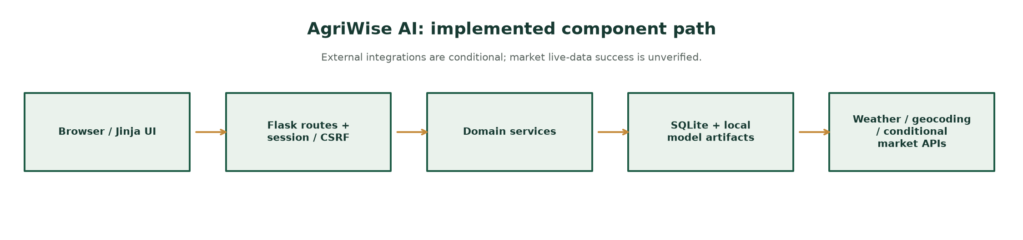
Figure 1. Implemented component chain. Provider connectivity is not guaranteed.
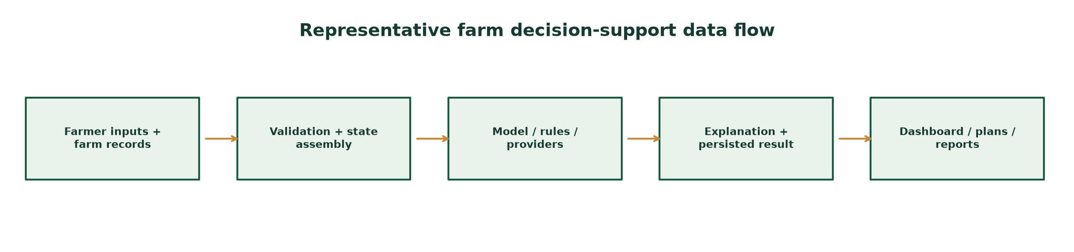
Figure 2. Representative end-to-end data flow.
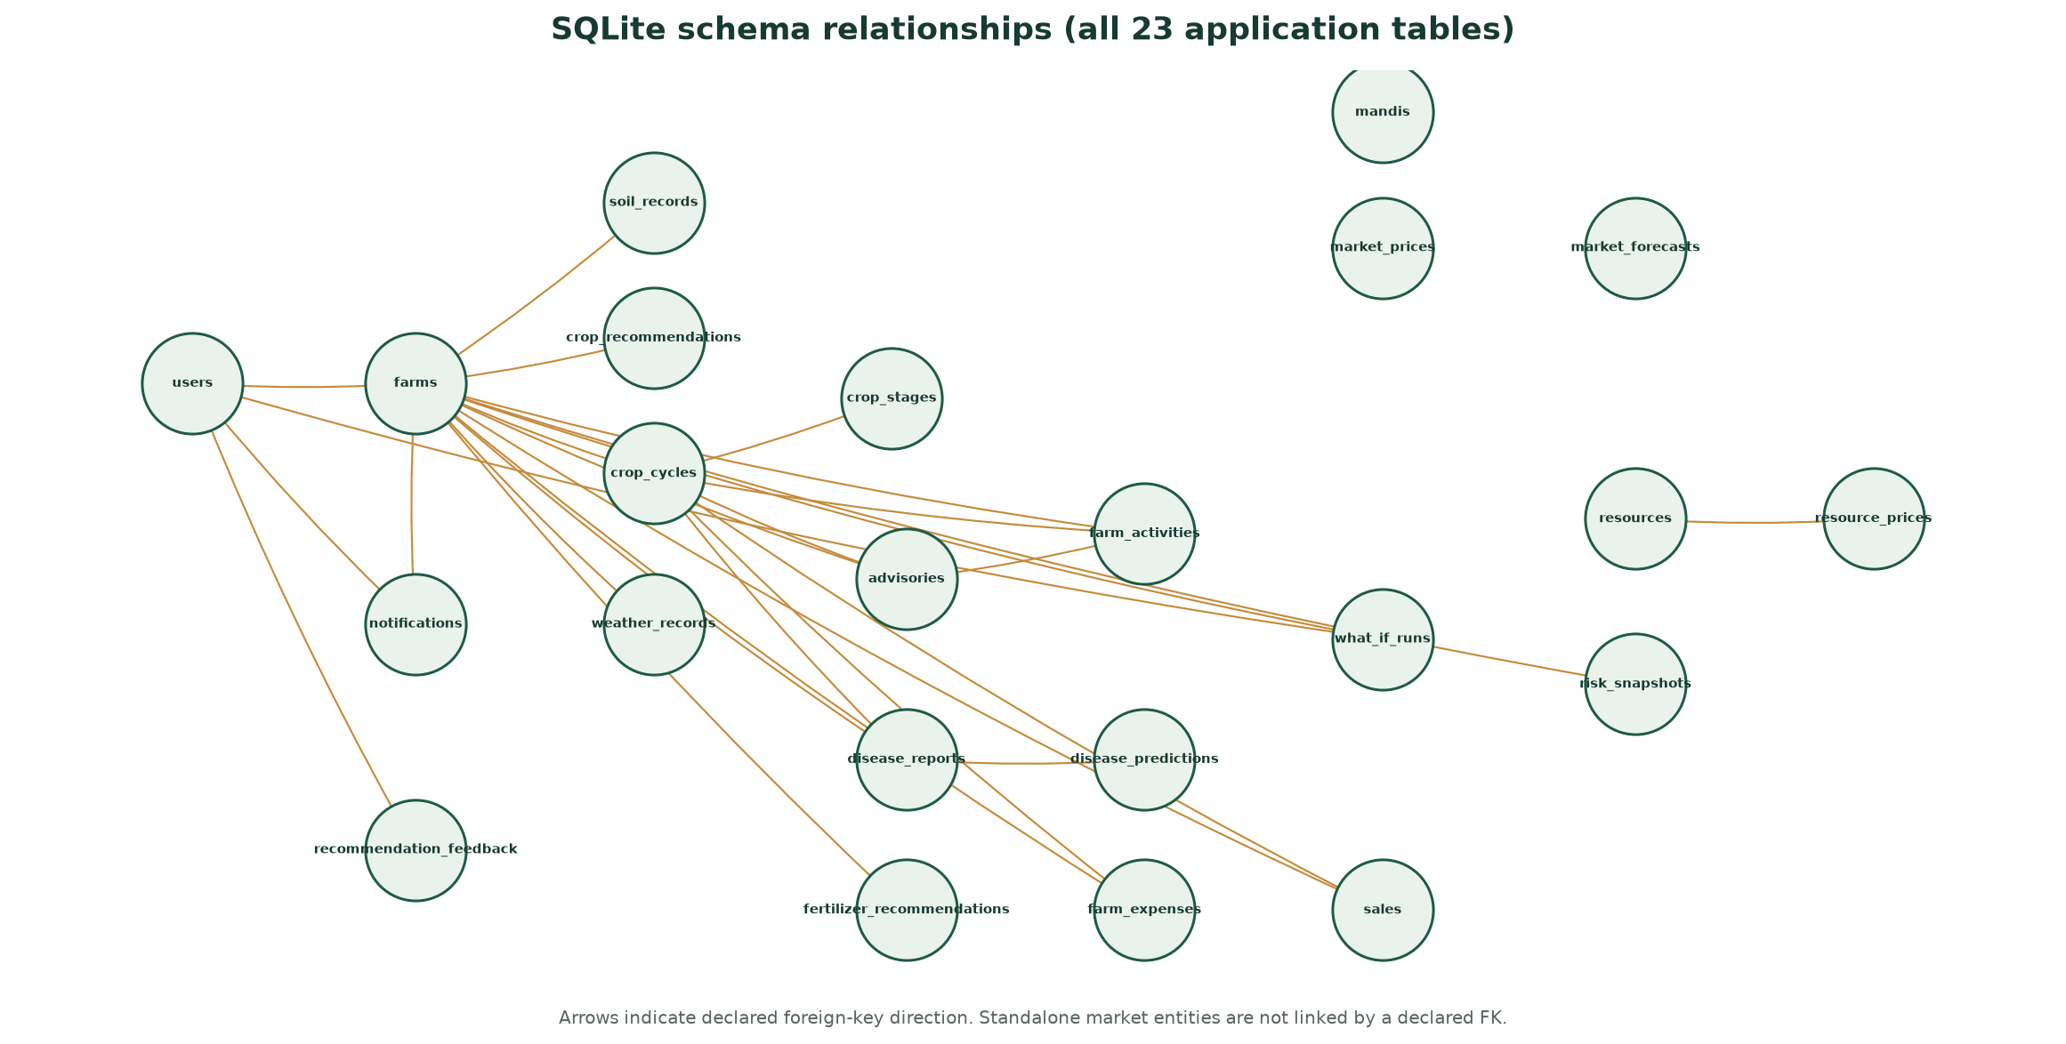
Figure 3. Declared foreign-key relationships across all application tables.
Entity group | Tables | Relationship note
Identity and farm | users, farms | Each farm references a user.
Agronomic observations | soil_records, weather_records | Each record references a farm.
Crop planning | crop_recommendations, crop_cycles, crop_stages | Cycles belong to farms; stages belong to cycles.
Operations | advisories, notifications, farm_activities | Activities may reference farm, cycle and advisory.
Disease | disease_reports, disease_predictions | Predictions reference a report; reports can reference farm/cycle.
Finance | farm_expenses, sales | Records may reference farm/cycle; expenses may link activity.
Market and resources | market_prices, market_forecasts, mandis, resources, resource_prices | Resource prices reference resources; market entities have no declared FK in current DDL.
Decision outputs | fertilizer_recommendations, what_if_runs, risk_snapshots, recommendation_feedback | Farm/user scope follows declared DDL; see db.py for exact columns.

Table 2. Database entity groups; consult db.py for authoritative columns and constraints.

Crop recommendation implementation
The route accepts seven numeric features: N, P, K, temperature, humidity, pH and rainfall. It validates input, invokes services/crop_service.py to load the saved ml/crop_model.pkl artifact, generates a class suggestion and explanation, and persists the result and submitted context. ml/train_model.py calls the active candidate evaluation path in services/crop_ml_service.py.
The dataset contains 2,200 balanced rows and 22 labels. The artifact's best candidate is Random Forest; recorded held-out accuracy and macro-F1 are both 0.9955. Candidate selection itself uses that held-out score, so these values are development results. No regional holdout or field outcome is present. Model probabilities are not calibrated field confidence.
Do not run the training command casually: it writes model, metric and confusion-matrix artifacts. Preserve a copy and use explicit temporary output paths for experiments.
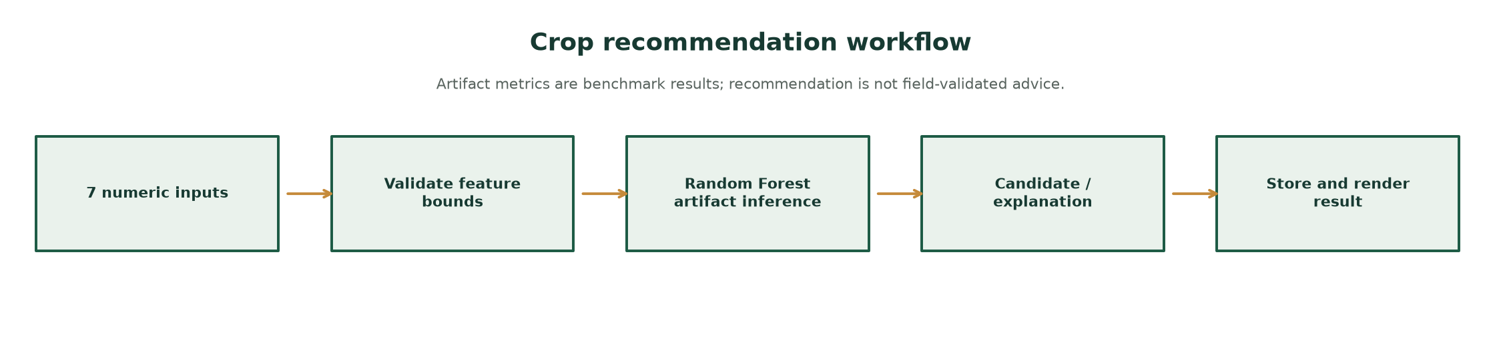
Figure 4. Crop recommendation inference path.
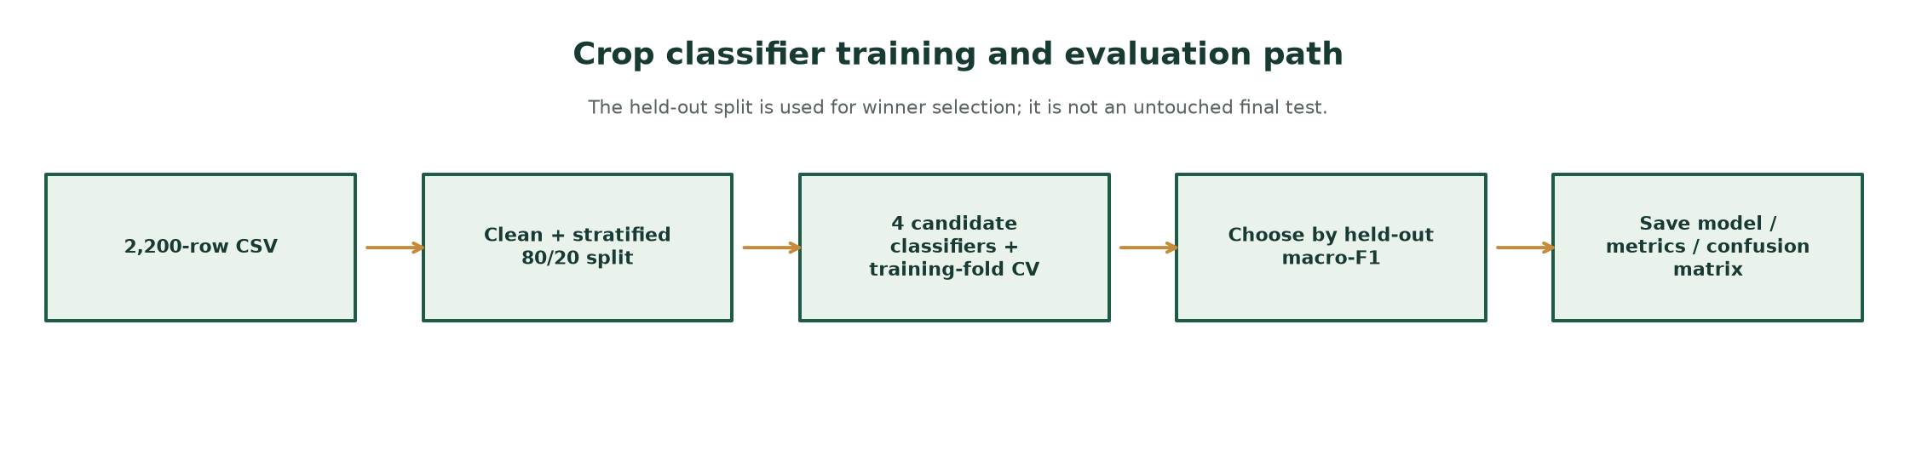
Figure 5. Training and candidate selection path.
Model | Accuracy | Macro-P | Macro-R | Macro-F1 | 5-fold CV accuracy
Decision Tree | 0.9818 | 0.9830 | 0.9818 | 0.9817 | 0.9841 ± 0.0073
Random Forest | 0.9955 | 0.9957 | 0.9955 | 0.9955 | 0.9943 ± 0.0051
KNN | 0.9795 | 0.9804 | 0.9795 | 0.9793 | 0.9653 ± 0.0121
Gradient Boosting | 0.9886 | 0.9896 | 0.9886 | 0.9886 | 0.9926 ± 0.0043

Table 1. Reported crop-model metrics from ml/model_metrics.json; not independently reproduced here.

Disease image screening
The repository contains a MobileNetV3 Small 38-class checkpoint and class_names.json. The predictor converts to RGB, resizes to 224×224 and applies ImageNet mean/standard-deviation normalization before inference. The app validates image type, decoded format, size (5 MiB maximum) and pixel dimensions (24 million maximum).
The route uses the active lifecycle crop when available and prevents an uploaded crop string from overriding that crop. If there is no active lifecycle crop, the user may specify one. A top-class result is presented only as an unverified suggestion when the crop matches; this is not a diagnosis. Confidence is an uncalibrated softmax score. Training lineage and independent performance are unknown.
Problem Report is a separate workflow for farmer-described symptoms and an optional private reference image. It does not run the standalone image classifier; the disease result page clearly communicates that no confirmed diagnosis exists. No pesticide prescription should be inferred from either workflow.
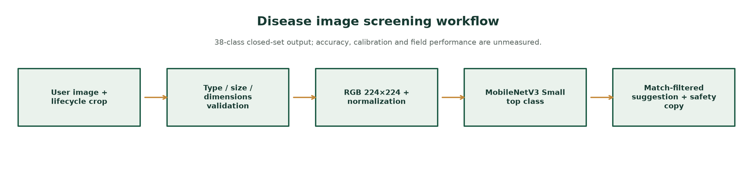
Figure 6. Disease-screening path and its evidence boundary.

Lifecycle, activities and rules
Crop cycles, stages and activities are persisted with farm ownership and status. Lifecycle dates/stages are computed from configured crop profiles and calendar rules, not observed plant phenology. Activity tasks may be suggested or manually entered; completion is a farmer-confirmed event.
The expert system uses deterministic IF/THEN production rules over a working set of farm, soil, weather, crop-stage and confirmed-action facts. Conflict resolution and safety priorities are code logic. It is not a trained AI model and its rule base requires local agricultural validation.

Weather and geocoding
Weather calls Open-Meteo using farm coordinates, an 8-second request timeout and a 30-minute in-memory cache; a prior cached result can be surfaced as stale when refresh fails. The provider documentation describes forecast time series assembled from weather-model sources; this output is not an on-farm sensor [5]. A prior successful request is historical evidence only, not a current uptime guarantee. Weather-aware irrigation research likewise emphasizes local forecast context [10].
Reverse geocoding attempts Nominatim with a five-second timeout and a 24-hour in-memory cache, then BigDataCloud, then coordinate text. Both providers receive coordinates. Network failure or rate limits can reduce location detail.

Market, sales and finance
The official market adapter targets data.gov.in/Agmarknet resource 9ef84268-d588-465a-a308-a864a43d0070 and reads DATA_GOV_IN_API_KEY from the environment. It validates records, uses bounded retries/cooldowns/cache and requests at most ten records per query. Historical diagnostics do not establish a current successful response, key acceptance or usable price history.
Market forecast code requires at least 20 distinct daily observations from one market/variety series. It uses a simple time regression and a chronological holdout, bounds point movement, and labels its range as heuristic rather than a confidence interval. No live usable series or measured forecast error is established.
Profit and expense screens combine estimates and user-entered transactions. They are not yield guarantees, verified offers, or investment advice.

Fertilizer, resources and safe agronomy
Fertilizer and resource services present configured reference logic, nutrient status and directory information. Their existence does not prove that underlying rates, products, local availability, or efficacy are validated. Community-listed resource entries may be stale or inaccurate.
The interface must not convert an unverified image class or generic nutrient range into a chemical prescription. Any fertilizer/pesticide dosage requires crop-, stage-, soil-, product-label- and region-specific evidence and qualified local review.

Multilingual support
English is the default/fallback; Marathi and Hindi are supported by UTF-8 JSON resources in locales/en.json, mr.json and hi.json. Jinja translation helpers resolve dotted keys and missing strings fall back to English. The language POST route validates codes and stores the choice in the Flask session; its return path is constrained to a local destination.
Translations are applied to selected templates, not guaranteed throughout every static phrase or dynamic advisory. Crop/model identifiers and user-entered text remain machine-readable/original. Rendered page tests cover selected screens only; this should not be described as complete app-wide localization. WCAG's page-language criterion supports exposing the predominant language to assistive technologies; it does not assess translation accuracy [8].
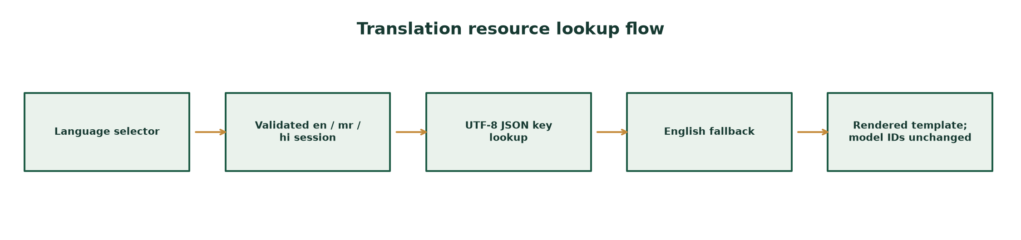
Figure 7. Language selection and resource fallback.

Database and persistence
SQLite is initialized through db.py with foreign-key enforcement, table creation, indexes, and compatibility migrations. Operational records are associated with users/farms where the schema declares ownership. SQLite foreign keys enforce declared parent-child relationships only when enabled for each connection [17]. SQLite is convenient for a single-instance educational prototype but writes and file locking require care under concurrent production traffic. Render's blueprint specifies one instance/worker and persistent disk.
Use a backed-up copy for schema experiments. The test suite imports app.py, which constructs a module-level application and initializes the configured database; the audited full test run did not establish that the configured database was untouched. Isolate AGRIWISE_DATA_DIR before Python imports for future test execution.

Security and privacy
Source inspection finds Werkzeug password hashing, user/session auth tokens, session rotation on password change, HttpOnly/SameSite cookie settings, Secure cookies for production when configured, a session CSRF token checked with constant-time comparison, selected security headers, parameterized SQLite calls in inspected paths, and authenticated private image access. These are observed controls, not security certification.
Uploads are allowlisted and decoded, size/pixel limited, named with a secure filename plus UUID, and served through an ownership-checked route. API keys are environment variables and .env is ignored; never include secret values in deliverables. A comprehensive penetration test, dependency audit, rate-limit review and full access-control proof were not performed.

Installation and local run (Windows)
From the repository root in PowerShell, create/use the project Python 3.12 environment, install the runtime requirements, and start the Flask application. Commands below match repository paths; consult README.md and deployment docs if manifests change. This project also constructs a module-level app at import time.
py -3.12 -m venv .venv
.\.venv\Scripts\Activate.ps1
python -m pip install --upgrade pip
python -m pip install -r requirements.txt
Copy-Item .env.example .env # optional local provider settings; do not commit secrets
python app.py
Start-Process http://127.0.0.1:5000/

Testing and verification record
Recorded command: .\.venv\Scripts\python.exe -m pytest -q --no-header -p no:cacheprovider. Observed result on 2026-10-15: 183 passed, one joblib Windows physical-core discovery warning, zero failures, in 117.80 seconds.
Tests cover routes, core workflow, model contracts, disease input validation, lifecycle, rules, weather/market parsing with mocks, security regressions and selected localization. They do not measure field agronomic performance, disease accuracy, live provider uptime, performance under load, accessibility, or all translation strings.
The full suite imported app.py and triggered module-level app/database initialization. Because no pre-run database metadata or contents were collected, the run cannot be described as guaranteed not to touch existing local database state. The generator does not execute application tests.
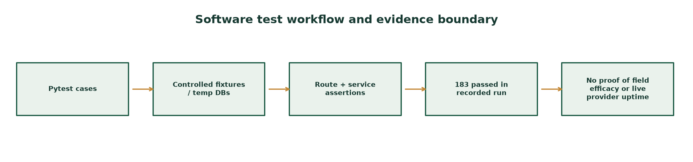
Figure 8. Software test evidence and what it does not establish.

Deployment and troubleshooting
render.yaml specifies a paid Starter web instance, one instance, Gunicorn one worker/four threads, a 120-second timeout, /healthz, a 1 GB persistent disk mounted at /var/data, production environment settings, generated secret and optional market API key. This is configuration only; no deployed service or live deployment check was verified.
Vercel documentation describes ephemeral /tmp storage; SQLite and uploads in an ephemeral or multi-instance environment can be lost or inconsistent. The app's in-memory provider cache/lock is process-local. Do not claim serverless persistence without a durable shared database/storage design.
If crop prediction fails, verify the saved artifact path and seven numeric inputs. If disease model loading fails, verify the optional ML dependencies/checkpoint and report the unavailable state; do not imply image results. For weather, inspect coordinates/network and whether a cached result is stale. For market, verify secret configuration privately, provider response status and record count. Never print or paste an API key.
Symptom | Likely cause | Diagnostic / action
Crop prediction unavailable | Artifact missing, invalid inputs or import/runtime issue | Check artifact path and server logs; verify all seven finite numeric fields.
Disease screen unavailable | Optional dependency/checkpoint not loadable | Check package/artifact presence; state unavailable rather than guessing.
Weather stale/unavailable | Provider timeout, connectivity, coordinates | Check farm coordinates and freshness label; do not relabel stale data as live.
No market prices | Key/resource/provider response unverified or no usable records | Check sanitized diagnostic privately; never expose key or fabricate rows.
Language partly English | Missing key or hard-coded/dynamic content | Check locale key lookup and template; English fallback is expected for missing keys.
Data disappears after deploy | Ephemeral storage or wrong mount path | Use a configured durable disk/database and test restart/restore behavior.

Table 3. Troubleshooting based on observed architecture and known limitations.

Developer handover and priorities
Key files: app.py (factory, routes, request/session flow); db.py (SQLite schema and migrations); services/crop_service.py and crop_ml_service.py (prediction/training paths); services/disease_service.py and agriwise_disease_model/disease_predictor.py (screening); services/weather_service.py, official_market_service.py, decision_orchestrator.py, expert_system.py, lifecycle_service.py and i18n_service.py; locales/*.json; templates/*.html; tests/*.py; render.yaml.
Priority sequence: establish dataset provenance/license and all-target crop coverage; make model selection unbiased and evaluate geographically; independently evaluate/calibrate disease screening; complete localization and native review; isolate test databases; verify APIs and deployment; then conduct accessibility, security, load and farmer field studies.

Operational feature verification matrix
Feature | Status | Evidence / boundary
Registration/login | Implemented; route/security tests | Source and tests; not a full security audit
Crop recommendation | Implemented; artifact benchmark | Split selection caveat; no field validity
Disease image screen | Integrated; performance unknown | 38-class checkpoint; no independent evaluation
Lifecycle and activities | Implemented; tests cover core behavior | Stage timings are configured estimates
Weather | Implemented adapter; mocked tests | Historical single live response only
Market prices | Adapter implemented; live data unverified | At most 10 records/query
Multilingual | Partial app coverage | Selected screens tested; do not claim whole-app completeness

Table 4. Feature status as supported by current source/test evidence.

