AgriWise AI: An Intelligent Crop Lifecycle
Decision Support System for Sustainable Agriculture
[Author Name], [Department], [Institution], [City, Country]
[Email / ORCID — fill in]

Abstract
This paper describes AgriWise AI, a Flask-based agricultural decision-support prototype integrating farm records, crop classification, lifecycle tracking, deterministic rules, weather context and optional plant-image screening. The crop classifier uses seven numeric features from a 2,200-row, 22-class CSV. The checked-in metrics artifact reports a Random Forest held-out accuracy and macro-F1 of 0.9955 under a stratified 80/20 split. Because the held-out score is used to select the winning candidate and dataset provenance is unresolved, this result is a development benchmark rather than independent or field accuracy. A MobileNetV3 Small disease-screening checkpoint with 38 outputs is integrated, but its training lineage, calibration and independent performance are unknown. Automated software tests recorded 183 passes, one environment warning and zero failures; these tests do not establish agronomic efficacy. The work demonstrates a connected software prototype and identifies the independent data, safety and user studies required before field claims.
Index Terms—agricultural decision support, crop classification, plant disease screening, lifecycle management, model evaluation, multilingual interface.

I. INTRODUCTION
Farm decision support often spans data entry, crop choice, crop-stage tracking, weather context and operational records. AgriWise AI is a Flask-based prototype designed to connect these workflows while presenting distinct ML, rule-based and provider-derived outputs. Digital agriculture is a broad and context-sensitive area; ICT for sustainable agriculture is discussed by FAO, while the World Bank indicator supplies economic context rather than an impact measure [6], [7].
This paper reports the implementation and evidence boundaries of the prototype. It does not claim a novel classifier, field efficacy, diagnostic accuracy or farmer outcome improvement. Its concrete engineering contribution is an integrated workflow with explicit separation of supervised crop recommendation, optional disease-image screening, deterministic rules, external weather/market adapters and farm records.

II. RELATED WORK
Plant disease classification research demonstrates that convolutional networks can classify curated leaf-image datasets [1], [2]. Mohanty et al. report 99.35% best accuracy on a 54,306-image, 38-class PlantVillage dataset and a drop to just above 31% on images captured under different conditions [1]. This motivates but does not validate AgriWise's disease checkpoint, whose exact training set and evaluation split are unknown. Crop recommendation using soil and weather-related inputs has also been studied with machine-learning algorithms [3], while agricultural expert systems have a documented history [4].
Explainable crop recommendation with SHAP/LIME features is described in an abstract-level publication [9]. Weather-and-irrigation decision support [10], Indian commodity price forecasting [11], [12], and agricultural expert-system reviews [13] provide further component-level context. A personalized extension study in India reports associations, not direct evidence about this prototype [14].
Evaluation must be interpreted against sampling, target definition and split design. Standard metrics such as accuracy, precision, recall and F1 are summaries of a defined sample; they cannot by themselves demonstrate calibration, regional generalization or user utility [16].

III. RESEARCH GAP AND CONTRIBUTIONS
The study addresses an engineering question: how can a web prototype connect crop classification, farm records, lifecycle tasks and contextual decision support while preserving distinct evidence and safety boundaries? The repository demonstrates an implementation of this integration. It does not establish scientific novelty or superiority over a comparator.
Contributions are (1) a source-auditable, multi-workflow implementation; (2) a crop-classifier benchmark reporting its selection caveat; (3) a separated, crop-matched disease suggestion path with a separate farmer symptom-report route; and (4) a reusable multilingual resource layer with selected-page testing. The last contribution is partial because not every page/dynamic message is verified in all languages.

IV. SYSTEM AND METHODS
The application uses Flask routes and Jinja templates, domain services, SQLite and local artifacts [15], [17]. Crop recommendation consumes seven numeric fields (N, P, K, temperature, humidity, pH and rainfall) and calls the saved Random Forest model. Explanatory text and records are generated/stored in the application. Weather calls the Open-Meteo forecast adapter [5]; market data uses a bounded official-data adapter but live usable records are unverified.
The crop training utility reads a balanced 2,200-row CSV with 22 labels, applies data cleaning, uses a stratified 80/20 split (random_state=42), compares four classifiers, computes five-fold stratified accuracy on the training portion, and selects by held-out macro-F1. This split is consequently part of model selection, not an independent untouched test.
Disease screening uses a MobileNetV3 Small model with 38 outputs. Uploaded images are decoded, converted to RGB, resized to 224×224 and normalized using ImageNet statistics. The interface shows a suggestion only when the predicted class crop matches the lifecycle/selected crop. Softmax is uncalibrated and the checkpoint evaluation is unknown.
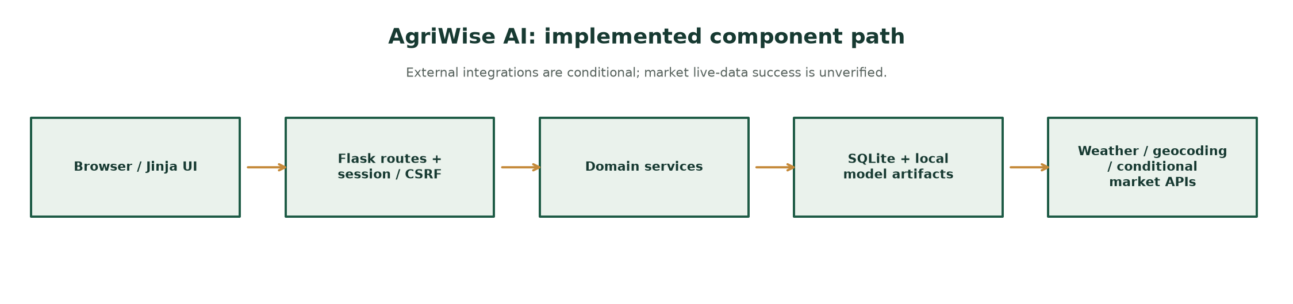
Fig. 1. Implemented component path.

V. DATASET AND EXPERIMENTAL SETUP
The crop CSV has 2,200 rows, 22 balanced classes and seven numeric features. The duplicate recommendationData.csv has the same SHA-256 in the audited checkout and is not an independent dataset. Dataset publisher, license, collection geography, period, units and collection protocol are not established. A random row split cannot exclude source-level leakage or prove geographic/temporal independence.
The checked-in metrics artifact reports 1,760 training and 440 test examples. Candidate values are: Decision Tree 98.18% accuracy, 98.17% macro-F1; Random Forest 99.55%, 99.55%; KNN 97.95%, 97.93%; Gradient Boosting 98.86%, 98.86%. Random Forest five-fold training-split CV accuracy is 99.43% ± 0.51%. Values are recorded artifacts and were not reproduced in this documentation run.
No disease accuracy, calibration, field image evaluation, inference latency, live market forecast error, field trial or usability study is available. The project test suite passed 183 tests with one environment warning in a recorded run; software tests do not measure agronomic efficacy. WCAG's page-language guidance is relevant to assistive technology but does not verify translation quality [8].
Model | Acc. | Macro-F1 | CV μ±σ
Decision Tree | 0.9818 | 0.9817 | 0.9841±0.0073
Random Forest | 0.9955 | 0.9955 | 0.9943±0.0051
KNN | 0.9795 | 0.9793 | 0.9653±0.0121
Gradient Boosting | 0.9886 | 0.9886 | 0.9926±0.0043

Table I. Recorded crop benchmark metrics; winner selection uses the held-out set.
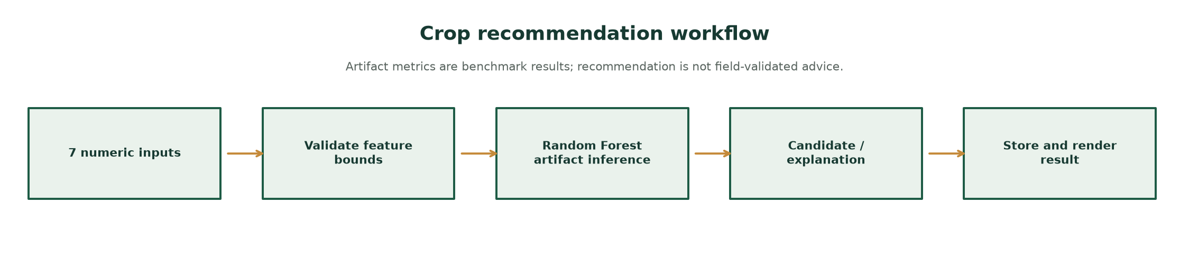
Fig. 2. Crop recommendation pipeline.

VI. RESULTS AND DISCUSSION
The tabular benchmark shows strong separability under its recorded random-split protocol. Because the held-out score selects the winning candidate, an independent test set is needed to estimate final performance. Unknown dataset provenance also prevents confident claims about target-population fit. The result should be treated as a software/model-development benchmark only.
The disease route proves integration and input-validation behavior, not model validity. Its 38-class mapping and checkpoint do not reveal training lineage. Field deployment would require externally labeled images, class-level performance, calibration, robustness testing, and a safe abstention policy.
The application test record supports covered route/service behavior. The market adapter's existence does not prove API success; the current usable-data state remains unverified. Therefore the paper reports an implemented prototype rather than a validated farm decision system.

VII. LIMITATIONS AND FUTURE WORK
Threats include undocumented dataset provenance, selection bias in the crop test protocol, possible source-level data dependence, no external regional data, no calibrated confidence, unknown disease model lineage, unverified market data, network dependency, and no farmer-outcome study. Multilingual rendering is tested on selected screens but not certified across the whole application; page language metadata supports assistive technology but does not assure translation quality [8].
Future work should establish licensed representative data, use nested or sealed geographic/time holdouts, independently evaluate and calibrate both ML tasks, test safety/abstention, conduct local-language review, and perform a prespecified farmer study with ethics and consent. API and deployment claims need reproducible live tests.

VIII. CONCLUSION
AgriWise AI is an integrated agricultural decision-support prototype whose source and tests show multiple connected workflows. Its crop classifier has a recorded high benchmark score under a development split, but no independent field validation. Disease performance and market-provider success remain unmeasured or unverified. The defensible conclusion is software integration feasibility and a clear research agenda—not proven agronomic impact.

REFERENCES
[1] S. P. Mohanty, D. P. Hughes, and M. Salathé, “Using Deep Learning for Image-Based Plant Disease Detection,” Frontiers in Plant Science, vol. 7, art. 1419, 2016, doi: 10.3389/fpls.2016.01419.
[2] D. P. Hughes and M. Salathé, “An open access repository of images on plant health to enable the development of mobile disease diagnostics,” arXiv:1511.08060 [cs.CY], 2015. [Online]. Available: https://arxiv.org/abs/1511.08060
[3] G. Chauhan and A. Chaudhary, “Crop Recommendation System using Machine Learning Algorithms,” in 2021 10th International Conference on System Modeling & Advancement in Research Trends (SMART), 2021, pp. 109–112, doi: 10.1109/SMART52563.2021.9676210.
[4] J. M. McKinion and H. E. Lemmon, “Expert systems for agriculture,” Computers and Electronics in Agriculture, vol. 1, no. 1, pp. 31–40, 1985, doi: 10.1016/0168-1699(85)90004-3.
[5] Open-Meteo, “Weather Forecast API,” official documentation, accessed 15 Oct. 2026. [Online]. Available: https://open-meteo.com/en/docs
[6] Food and Agriculture Organization of the United Nations, “e-Agriculture,” accessed 15 Oct. 2026. [Online]. Available: https://www.fao.org/e-agriculture/
[7] World Bank, World Development Indicators, “Agriculture, forestry, and fishing, value added (% of GDP),” indicator NV.AGR.TOTL.ZS, accessed 15 Oct. 2026. [Online]. Available: https://data.worldbank.org/indicator/NV.AGR.TOTL.ZS
[8] World Wide Web Consortium (W3C), Web Content Accessibility Guidelines (WCAG) 2.2, W3C Recommendation, 5 Oct. 2023, Success Criterion 3.1.1. [Online]. Available: https://www.w3.org/TR/WCAG22/#language-of-page
[9] S. I. Ertaza and S. K. A. Hossain, “Smart Crop Recommendation System Using Machine Learning and Explainable AI,” in 2024 27th International Conference on Computer and Information Technology (ICCIT), 2024, doi: 10.1109/ICCiT64611.2024.11021774. Abstract-level evidence accessed.
[10] J. Sexton, “Development of an online weather and irrigation forecast decision support tool using an action learning process,” in MODSIM2023, 25th International Congress on Modelling and Simulation, 2023, doi: 10.36334/modsim.2023.sexton.
[11] L. Madaan, A. Sharma, P. Khandelwal, S. Goel, P. Singla, and A. Seth, “Price forecasting & anomaly detection for agricultural commodities in India,” in Proceedings of the 2nd ACM SIGCAS Conference on Computing and Sustainable Societies (COMPASS ’19), 2019, pp. 52–64, doi: 10.1145/3314344.3332488. Abstract-level evidence accessed.
[12] R. L. Manogna and A. K. Mishra, “Forecasting spot prices of agricultural commodities in India: Application of deep-learning models,” Intelligent Systems in Accounting, Finance and Management, vol. 28, no. 1, pp. 72–83, 2021, doi: 10.1002/isaf.1487. Deposited-abstract evidence accessed.
[13] X. J. Tan, W. L. Cheor, K. S. Yeo, and W. Z. Leow, “Expert systems in oil palm precision agriculture: A decade systematic review,” Journal of King Saud University – Computer and Information Sciences, vol. 34, no. 4, pp. 1569–1594, 2022, doi: 10.1016/j.jksuci.2022.02.006. Abstract-level evidence accessed.
[14] P. Rajkhowa and M. Qaim, “Personalized digital extension services and agricultural performance: Evidence from smallholder farmers in India,” PLOS ONE, vol. 16, no. 10, e0259319, 2021, doi: 10.1371/journal.pone.0259319.
[15] Pallets Projects, Flask Documentation, “Application Factories” and “The Request Context.” [Online]. Available: https://flask.palletsprojects.com/en/stable/patterns/appfactories/
[16] scikit-learn developers, “Model evaluation: quantifying the quality of predictions,” official documentation. [Online]. Available: https://scikit-learn.org/stable/modules/model_evaluation.html
[17] SQLite Consortium, “SQLite Foreign Key Support,” official documentation. [Online]. Available: https://www.sqlite.org/foreignkeys.html
Manuscript status: IEEE-style conference layout for further review, not an official template, acceptance, certification or publication guarantee. Adapt to the chosen venue's current author instructions.

