Document Title Here [Title]

Author(s) and Institution(s) Here [Subtitle]

|  |  |
| --- | --- |
| **Contents** | |
| Page 1 | Section Title |
| Page 3 | Section Title |

# Summary (or Abstract) [Heading 1]

Suggested 200 words maximum.Lorem ipsum dolor sit amet, consectetur adipisicing elit, sed do eiusmod tempor incididunt ut labore et dolore magna aliqua. Ut enim ad minim veniam, quis nostrud exercitation ullamco laboris nisi ut aliquip ex ea commodo consequat. Duis aute irure dolor in reprehenderit in voluptate velit esse cillum dolore eu fugiat nulla pariatur.

# Method [Heading 1]

Lorem ipsum dolor sit amet, consectetur adipisicing elit, sed do eiusmod tempor incididunt ut labore et dolore magna aliqua. Ut enim ad minim veniam, quis nostrud exercitation ullamco laboris nisi ut aliquip ex ea commodo consequat.

## Heading [Heading 2]

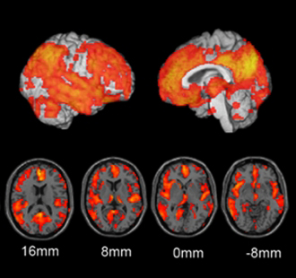

Figure : Comparison of neural decline indicated by areas in orange between patients with AD and MCI.

Describe your image processing steps here including the names and versions of software used. Sed ut perspiciatis unde omnis iste natus error sit voluptatem accusantium doloremque laudantium, totam rem aperiam, eaque ipsa quae ab illo inventore veritatis et quasi architecto beatae vitae dicta sunt explicabo. Nemo enim ipsam voluptatem quia voluptas sit aspernatur aut odit aut fugit, sed quia consequuntur magni dolores eos qui ratione voluptatem sequi nesciunt. Neque porro quisquam est, qui dolorem ipsum quia dolor sit amet, consectetur, adipisci velit, sed quia non numquam eius modi tempora incidunt ut labore et dolore magnam aliquam quaerat voluptatem.

# Version Information [Heading 1]

This document supersedes our previous document dated [date]. Specific changes in our methods are summarized in this section. Lorem ipsum dolor sit amet, consectetur adipisicing elit, sed do eiusmod tempor incididunt ut labore et dolore magna aliqua. Ut enim ad minim veniam, quis nostrud exercitation ullamco laboris nisi ut aliquip ex ea commodo consequat.

Dataset Information

This methods document applies to the following dataset(s) available from the ADNI repository:

|  |  |
| --- | --- |
| **Dataset Name** | **Date Submitted** |
| Smith Lab – Foo Method ROI Analysis Version 3.2 | 22 February 2012 |

# References­

1. Standard Citation Format

# About the Authors

This document was prepared by <**insert** **people, institution, department>**. For more information please contact <**insert** **name>** at <**insert phone** **(999) 999-9999>** or by email at <**insert** [**email@school.edu**](mailto:email@school.edu)**>**.

*Notice: This document is presented by the author(s) as a service to ADNI data users.  However, users should be aware that no formal review process has vetted this document and that ADNI cannot guarantee the accuracy or utility of this document.*