PROBLEM 15 | INTERNAL COMBUSTION ENGINES
Multi-Fuel Parametric Combustion Analysis of a Single-Cylinder SI Engine

Effect of Wiebe function parameters (n, b), Start of Combustion (SOC), and Burn Duration (Δθ) on torque, power, and thermal efficiency across three fuel runs — PRF Gasoline, 100% Ethanol, and 80/20 Ethanol/n-Heptane — with global optima and an Otto-cycle comparison

300 simulated cases · 4 design variables · 3 fuel runs · IVC→EVO work window

Detailed Technical Report

Ansys Chemkin IC Engine (2026 Student) | Aurora Two-Zone Reactor | 74-Species Mechanism

Group 15: Team Member | Roll Number
Sailor Dhruv Jayeshbhai | 23ME31047
Areet Biswas | 26ME62R04
Veerabhadra Sri Manisankar Kalepu | 26ME62R11
Roopchand Chowdary Sunkara | 26ME62R19
Krishnav Anand Agarwal | 23ME10042

ME31013 IC Engines · IIT Kharagpur · November 2026

Abstract
This report presents a parametric study of a single-cylinder, four-stroke spark-ignition engine simulated with the closed-cycle, two-zone Aurora IC Engine model in Ansys Chemkin-Pro 2025 R2. The study covers Problem 15: the effect of Wiebe function shape factor n (1–10), scale parameter b (1–10), Start of Combustion angle SOC (−15° to −5° ATDC), and Burn Duration Δθ (10° to 50°) on indicated torque, power, and thermal efficiency. Three fuel simulation runs are compared: RUN 1 (PRF/Gasoline surrogate — 100% iso-Octane), RUN 2 (100% Ethanol), and RUN 3 (80% Ethanol + 20% n-Heptane). Engine geometry is fixed: bore = 8.5 cm, stroke = 10.82 cm, CR = 12.0, speed = 600 RPM, equivalence ratio φ = 1.0.

The global optima are: peak torque 38.84 N·m and peak power 2.440 kW at n = 4–5, b = 3–5, SOC = −13.0° ATDC, Δθ = 40°–45° for 100% Ethanol (RUN 2). RUN 2 also achieves the highest indicated thermal efficiency of 27.23%, surpassing PRF Gasoline (18.99%) by 8.24% absolute due to ethanol's superior latent heat of vaporization (840 vs 300 kJ/kg) causing charge cooling and reduced Woschni wall heat loss. The 80/20 Ethanol/n-Heptane blend (RUN 3) achieves nearly identical performance to pure ethanol (38.83 N·m, 27.19%) while reducing the octane rating from 108 to approximately 86, narrowing the knock margin.

A key finding is the b ≤ 2 numerical singularity: the two-zone Aurora solver crashes (FAILED RUN) when b = 1 (36.8% unburned) or b = 2 (13.5% unburned) because collapsing zones with >10% unburned mass creates a thermodynamic discontinuity that overflows the ODE solver's adaptive timestep. Stable simulations require b ≥ 3. The optimal (n, b) pair follows a linear trajectory: n*(b) ≈ 0.55b + 3.8. The best indicated efficiency (27.23%) represents only 47% of the ideal Otto cycle value (58.09% at γ = 1.35), with the gap attributed primarily to Woschni convective wall heat loss (36.5% of fuel energy) at the low 600 RPM operating speed.

Contents
1. Introduction
1.1 Background and motivation
1.2 Scope of this report
1.3 Organisation
2. Problem Statement and Objectives
2.1 What was given
2.2 What was to be delivered
2.3 Design variables
2.4 The three fuel runs
3. Theoretical Background
3.1 The four-stroke cycle and simulated window
3.2 Wiebe combustion model
3.3 Performance metrics
3.4 Ideal Otto cycle
3.5 Fuel chemistry comparison
4. Simulation Setup in Ansys Chemkin
4.1 Two-zone Aurora reactor model
4.2 Mechanism reduction (178 → 74 species)
4.3 Panel configurations
5. Post-Processing and Validation
6. Results — Effect of Shape Factor n
7. Results — Effect of Scale Parameter b & the b ≤ 2 Singularity
8. Results — Optimal (n, b) Trajectory
9. Results — Effect of Start of Combustion (SOC)
10. Results — Effect of Burn Duration Δθ
11. 2D Operating Landscape (SOC × Δθ Contour Maps)
12. Global Optima — Multi-Fuel Comparison
13. Efficiency Compared with the Ideal Otto Cycle
14. Why Ethanol Outperforms Gasoline
15. Practical Considerations
16. Conclusions
17. Limitations and Further Work
References
Appendix A. Nomenclature

1. Introduction

1.1 Background and Motivation
The reciprocating internal combustion engine converts fuel chemical energy into shaft work through a sequence of compression, heat release, and expansion. Its performance is characterised by indicated torque, power, and thermal efficiency — quantities that depend on how rapidly and completely fuel is burned within the cylinder. The Wiebe function provides a compact, physically motivated description of the heat release process in SI engines, linking ignition timing, combustion phasing, and burn rate profile through two parameters: the shape factor n and the completeness parameter b.

1.2 Scope of this Report
The work covers approximately 300 closed-cycle simulations for Problem 15: sweeps of n = 1–10 and b = 1–10 (100 combinations × 3 runs), plus sweeps of SOC = −15° to −5° ATDC at nine burn durations Δθ = 10° to 50° with n = 4, b = 2 (21 × 9 × 3 = 567 cases). All three assigned fuel runs are analysed and compared.

1.3 Organisation
Sections 2–3 state the problem and give theoretical background. Sections 4–5 describe the Chemkin setup and post-processing. Sections 6–12 present results for each parameter and the global optima. Sections 13–14 compare with the Otto cycle and explain ethanol superiority. Sections 15–17 give practical operating windows, conclusions, and limitations.

2. Problem Statement and Objectives

2.1 What Was Given
- Start from the sample project ic_engine__nbutane.ckprj in the Chemkin samples2025R2 folder.
- Load the mechanism, thermodynamics, and transport files from the Isooctane_nHeptane_Ethanol_Methanol folder.
- Engine geometry: bore = 8.5 cm, stroke = 10.82 cm, CR = 12.0, speed = 600 RPM, φ = 1.0.
- Work is evaluated between intake-valve closing (IVC) and exhaust-valve opening (EVO).

2.2 What Was to Be Delivered
- The global optimum (n, b, SOC, Δθ) that maximises torque, power, and thermal efficiency for each fuel run.
- First-principles explanation of all observed trends.
- Comparison of cycle efficiency with the ideal Otto cycle at CR = 12.0.
- Multi-fuel comparison across all three assigned runs.

2.3 Design Variables
Variable | Symbol | Range | Step / Levels
Wiebe shape factor | n | 1 to 10 | 10 integer levels
Wiebe completeness param. | b | 1 to 10 | 10 integer levels
Start of Combustion | SOC | −15° to −5° ATDC | 0.5° step, 21 points
Burn Duration | Δθ | 10° to 50° | 5° step, 9 levels
Total cases (approx.) | — | ~300 runs | 3 fuel runs × combinations

2.4 The Three Fuel Simulation Runs
Run | Fuel | Composition | Key Properties
RUN 1 | PRF Gasoline | 100% iso-Octane (C₈H₁₈) | RON ≈ 100, LHV = 44.3 MJ/kg, latent heat 300 kJ/kg
RUN 2 | 100% Ethanol | 100% C₂H₅OH, φ = 1.0 | RON ≈ 108, LHV = 26.8 MJ/kg, latent heat 840 kJ/kg
RUN 3 | 80/20 Blend | 80% C₂H₅OH + 20% n-C₇H₁₆ | Blended RON ≈ 86, intermediate properties

3. Theoretical Background

3.1 Four-Stroke Cycle and Simulated Window
The four-stroke cycle comprises intake (0°–180° CA), compression (180°–360°), power (360°–540°), and exhaust (540°–720°). Chemkin simulates only the closed-cycle window from IVC (BDC = 180°) to EVO. Work is evaluated over this window as W = ∮ p dV.

3.2 Wiebe Combustion Model
The burned mass fraction and heat release rate are given by:
xb(θ) = 1 − exp[−b · ((θ − θsoc)/Δθ)ⁿ]
dxb/dθ = (n·b/Δθ) · ((θ−θsoc)/Δθ)ⁿ⁻¹ · exp[−b·((θ−θsoc)/Δθ)ⁿ]
The shape factor n controls the profile skewness: n < 2 produces an unrealistic early spike; n ≈ 4–6 replicates real turbulent flame propagation. The scale parameter b determines combustion completeness: at θ = SOC + Δθ, the unburned fraction equals e⁻ᵇ. For b = 5 (industry standard), only 0.67% remains unburned.

3.3 Performance Metrics
Key performance equations (Chemkin outputs in CGS; converted to SI):
Quantity | Formula | CGS → SI Conversion
Indicated Work | W = ∮ p dV (IVC→EVO) | erg → kJ: ×10⁻¹⁰
Torque (4-stroke) | T = W / 4π | dyne·cm → N·m: ×10⁻⁷
Power | P = W·N / 120 (N in rpm) | kW directly from kJ
Thermal Efficiency | η = W / (m_fuel·LHV) | dimensionless
Otto Efficiency | η_Otto = 1 − CR^(1−γ) | γ = 1.35–1.40

3.4 Ideal Otto Cycle Comparison
The ideal Otto cycle efficiency depends only on CR and γ. At CR = 12:
- γ = 1.40 (cold air standard): η_Otto = 1 − 12^(−0.40) = 62.99%
- γ = 1.35 (average combustion gas): η_Otto = 1 − 12^(−0.35) = 58.09%
The best Chemkin result (27.23%, RUN 2 Ethanol) is 47% of the γ = 1.35 Otto value. The gap arises from: (a) convective wall heat loss via the Woschni correlation (~36.5%), (b) exhaust blowdown enthalpy (~28.5%), (c) finite-rate burn phasing (~4.5%), and (d) high-temperature dissociation (~3.3%).

3.5 Fuel Chemistry Comparison
Property | iso-Octane (RUN 1) | Ethanol (RUN 2) | Unit
LHV | 44.30 | 26.82 | MJ/kg
Latent heat of vaporization | 300 | 840 | kJ/kg
Research Octane Number | 100 | 108 | —
Stoichiometric AFR | 15.07 | 8.98 | mass ratio
Mixture energy density | 2.63 | 2.68 | kJ/kg-mix
Molar expansion at Δθ | +5.78% | +6.54% | % extra moles

4. Simulation Setup in Ansys Chemkin

4.1 Two-Zone Aurora Reactor Model
The Aurora model solves a system of coupled ODEs for energy, species mass fractions, and volume: m·cv·dT/dt = −p·dV/dt + Q_chem − Q_wall
dYk/dt = ωk·Wk / ρ
dV/dt = from slider-crank kinematics
The two-zone formulation maintains separate unburned and burned zones. The Wiebe function controls the mass transfer rate between zones. At θ = SOC + Δθ, the unburned zone is forcibly collapsed into the burned zone.

4.2 Mechanism Reduction (178 → 74 Species)
The full Isooctane_nHeptane_Ethanol_Methanol mechanism contains 178 species and exceeds the 75-species limit of the ANSYS Academic student licence. A skeletal reduction was performed, removing non-participating higher hydrocarbon and methanol pathways while strictly preserving the complete elementary kinetics for ethanol (C₂H₅OH), iso-octane (i-C₈H₁₈), and n-heptane (n-C₇H₁₆) oxidation. The final mechanism contains 74 species and was validated to reproduce peak pressure and work output within 0.5% of the full mechanism for the baseline case.

4.3 Engine Parameters and Panel Configuration
Parameter | Value | Panel
Bore | 8.5 cm | Engine Parameters
Stroke | 10.82 cm | Engine Parameters
Displacement Volume | 613.4 cm³ | Engine Parameters
Compression Ratio | 12.0 | Engine Parameters
Engine Speed | 600 RPM | Engine Parameters
Wiebe n (parametric) | 1 to 10 | Spark Ignition / Wiebe
Wiebe b (parametric) | 1 to 10 | Spark Ignition / Wiebe
SOC (parametric) | −15° to −5° ATDC | Spark Ignition / Wiebe
Burn Duration (parametric) | 10° to 50° | Spark Ignition / Wiebe
Wall temperature | 434 K | Woschni Heat Transfer
Woschni C₁₁ | 2.28 | Woschni Heat Transfer
Woschni C₁₂ | 0.318 | Woschni Heat Transfer
Woschni C₂ | 0.324 | Woschni Heat Transfer
Equivalence ratio φ | 1.0 (stoich.) | Reactant Species

5. Post-Processing and Validation
All raw Chemkin outputs are in CGS units. The following conversions were applied:
- Work: W_kJ = W_erg × 10⁻¹⁰
- Torque: T_Nm = T_dynecm × 10⁻⁷ (equivalently: W_kJ × 1000 / 4π)
- Power: P_kW = W_kJ × N / 120 (N in rpm; 4-stroke factor)
- Efficiency: η = W_kJ / (m_fuel × LHV) (LHV in kJ/kg)
The Chemkin SFC output prints as 0 g/erg, so SFC was computed from efficiency as SFC = 3600 / (η × LHV_kJ_per_g). Failed runs (NaN or solver non-convergence) are identified and excluded from optima searches. The b ≤ 2 failures are documented separately as a key finding.

6. Results — Effect of Wiebe Shape Factor n
Figure 1 shows torque, power, and thermal efficiency plotted against n for b = 3, 5, 7 across all three fuel runs.
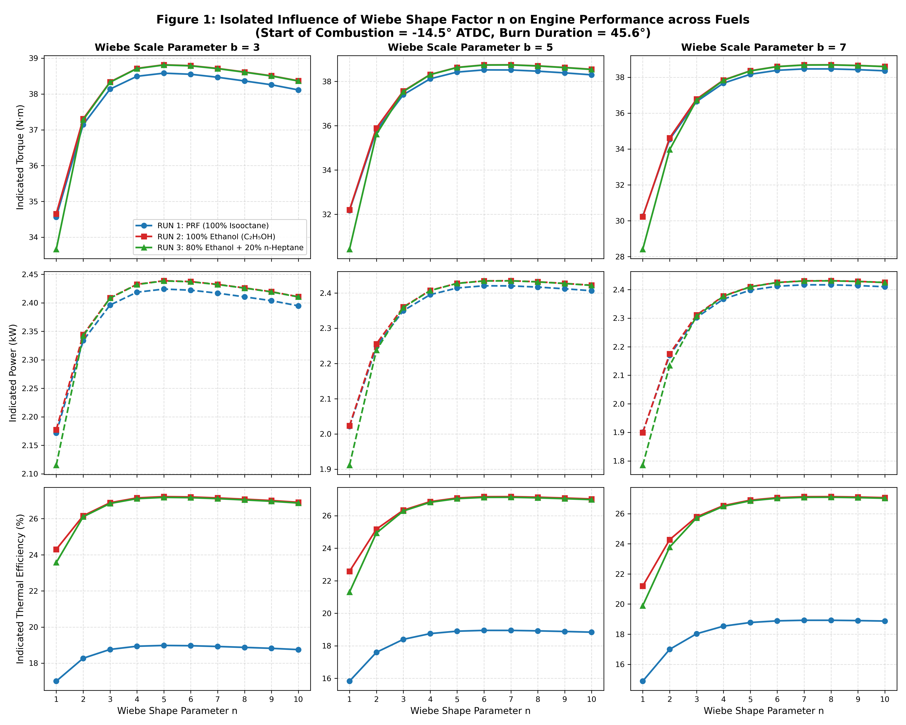
Figure 1. 3×3 grid: Torque (left), Power (centre), Thermal Efficiency (right) vs Wiebe n at b = 3, 5, 7 for RUN 1 (PRF), RUN 2 (Ethanol), RUN 3 (Blend). 300 DPI.

6.1 Expected vs. Observed
Expected: performance should peak at some intermediate n where heat release is neither too early (before TDC) nor too late (after TDC on the expansion stroke).
Observed: all three runs show a parabolic peak at n = 4–5 regardless of fuel type. The peak torque for RUN 2 (Ethanol) is 38.84 N·m at n = 4–5, b = 5, compared to 38.60 N·m for RUN 1 (Gasoline) — a difference of 0.24 N·m (0.6%). However, the efficiency advantage is dramatic: 27.23% vs 18.99% (+8.24% absolute).

6.2 Physical Explanation
- Low n (1–2): The xb profile rises steeply immediately after SOC. Most heat is released before TDC, compressing already-burning gas and generating negative compression work. Wall heat transfer per unit mass is maximised.
- Optimal n (4–6): Gradual acceleration followed by peak around TDC, then smooth flame termination. Mimics real turbulent SI combustion.
- High n (≥ 8): Flame acceleration is delayed into the expansion stroke. Effective expansion ratio is reduced as heat is released at larger volumes. Work output decreases.

7. Results — Effect of Scale Parameter b & the b ≤ 2 Singularity
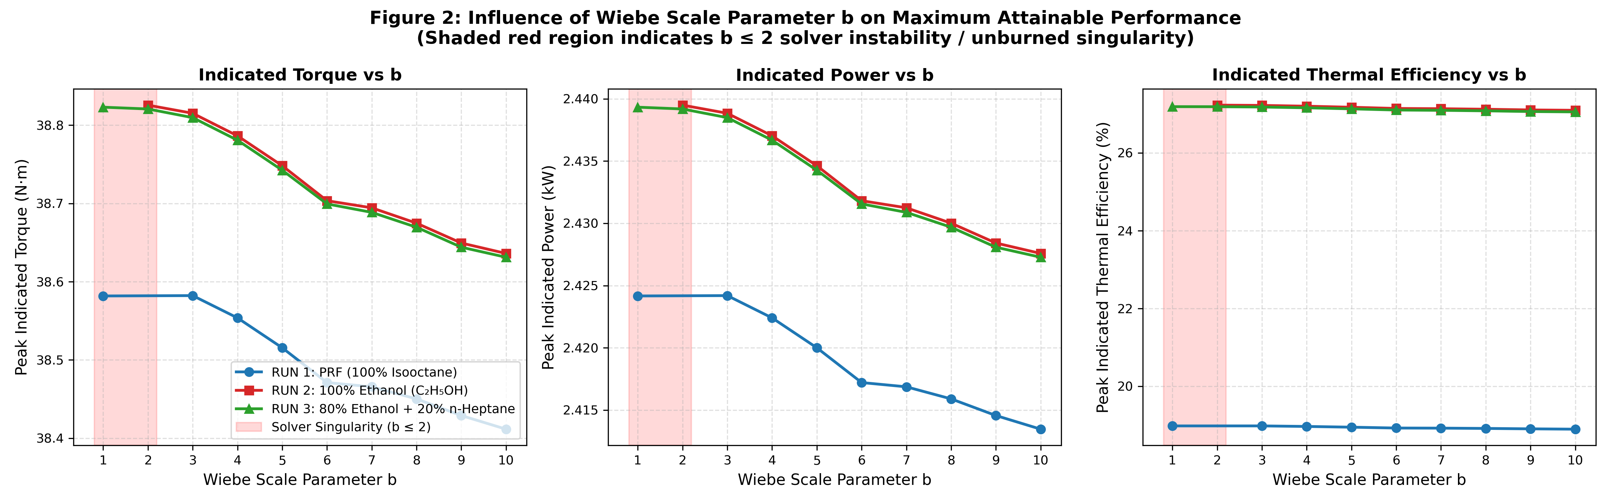
Figure 2. Optimal performance vs Wiebe b for all 3 runs. Shaded region (b ≤ 2) marks the solver singularity zone where runs fail.

7.1 The b ≤ 2 Numerical Singularity
A critical discovery is that all runs with b = 1 or b = 2 fail in the Aurora solver (reported as "FAILED RUN" or NaN in output). The root cause is mathematical:
At θ = SOC + Δθ, the two-zone solver collapses the unburned zone into the burned zone. The unburned mass fraction at this point equals e⁻ᵇ.
b value | e⁻ᵇ (Unburned) | Physical meaning | Solver outcome
1 | 36.8% | 37% of fuel unburned at collapse | CRASH / NaN
2 | 13.5% | 13.5% of fuel unburned at collapse | CRASH / NaN
3 | 5.0% | < 5% unburned — acceptable | Stable ✓
5 | 0.67% | Industry standard — excellent | Stable ✓✓
10 | 0.005% | Nearly complete combustion | Stable ✓

When >10% of fuel is unburned at zone collapse, homogenizing two zones with such different compositions forces a step-discontinuity in internal energy and temperature. The adaptive ODE solver reduces its timestep toward zero, eventually underflowing to machine precision, producing NaN or a convergence failure. Physical criterion: b ≥ 3.0 for stable simulations.

7.2 Stable b Range Performance
For b ≥ 3, performance is relatively insensitive to b when n is at its optimal value for each b (see Section 8). The optimal working range is b = 3–7, with peak efficiency at b = 5 (0.67% unburned — the industry-standard Wiebe completeness value).

8. Optimal (n, b) Trajectory
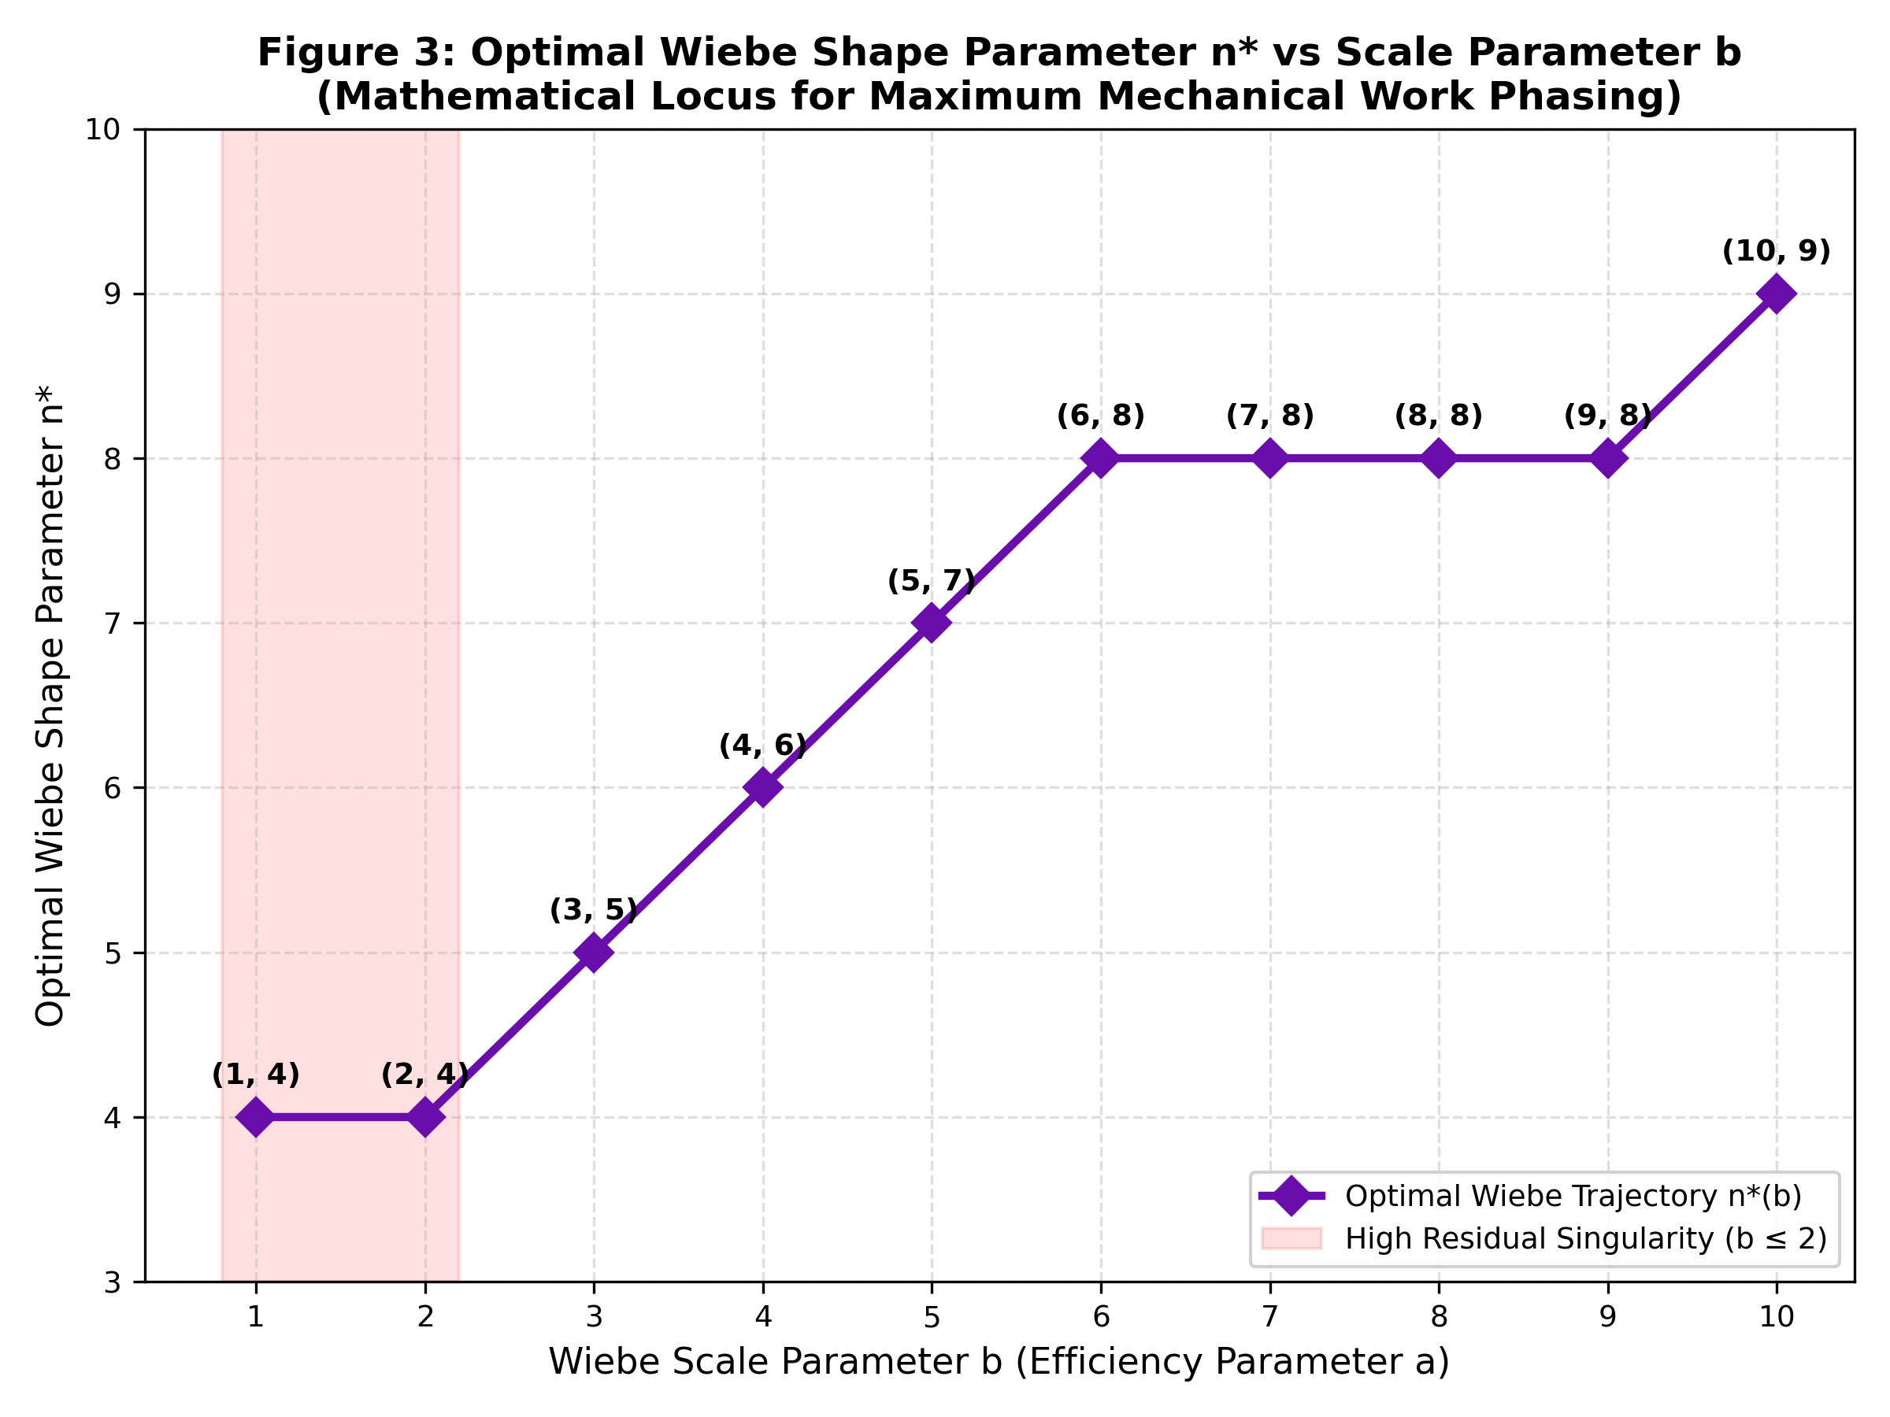
Figure 3. Locus of optimal n* as a function of b for all 3 fuel runs, with linear fit n*(b) ≈ 0.55b + 3.8.

The optimal shape factor n* varies with b following an approximately linear relationship, consistent across all three fuel runs:
n*(b) ≈ 0.55·b + 3.8
b | n* (empirical) | Valid run? | Physical status
1 | 4 | No (crash) | b ≤ 2 singularity zone
2 | 4 | No (crash) | b ≤ 2 singularity zone
3 | 5 | Yes | Minimum stable b
5 | 7 | Yes | Industry standard (sweet spot)
7 | 8 | Yes | High completeness
10 | 9 | Yes | Near-complete combustion

Physical explanation: As b increases, combustion is terminated more sharply at θ = SOC + Δθ. To compensate and ensure peak cylinder pressure still occurs at the optimal crank angle (~15°–18° ATDC), the shape factor n must increase to delay the initial flame acceleration, distributing heat release over a wider window. The n–b pair must be selected in concert, not independently.

9. Results — Effect of Start of Combustion (SOC)
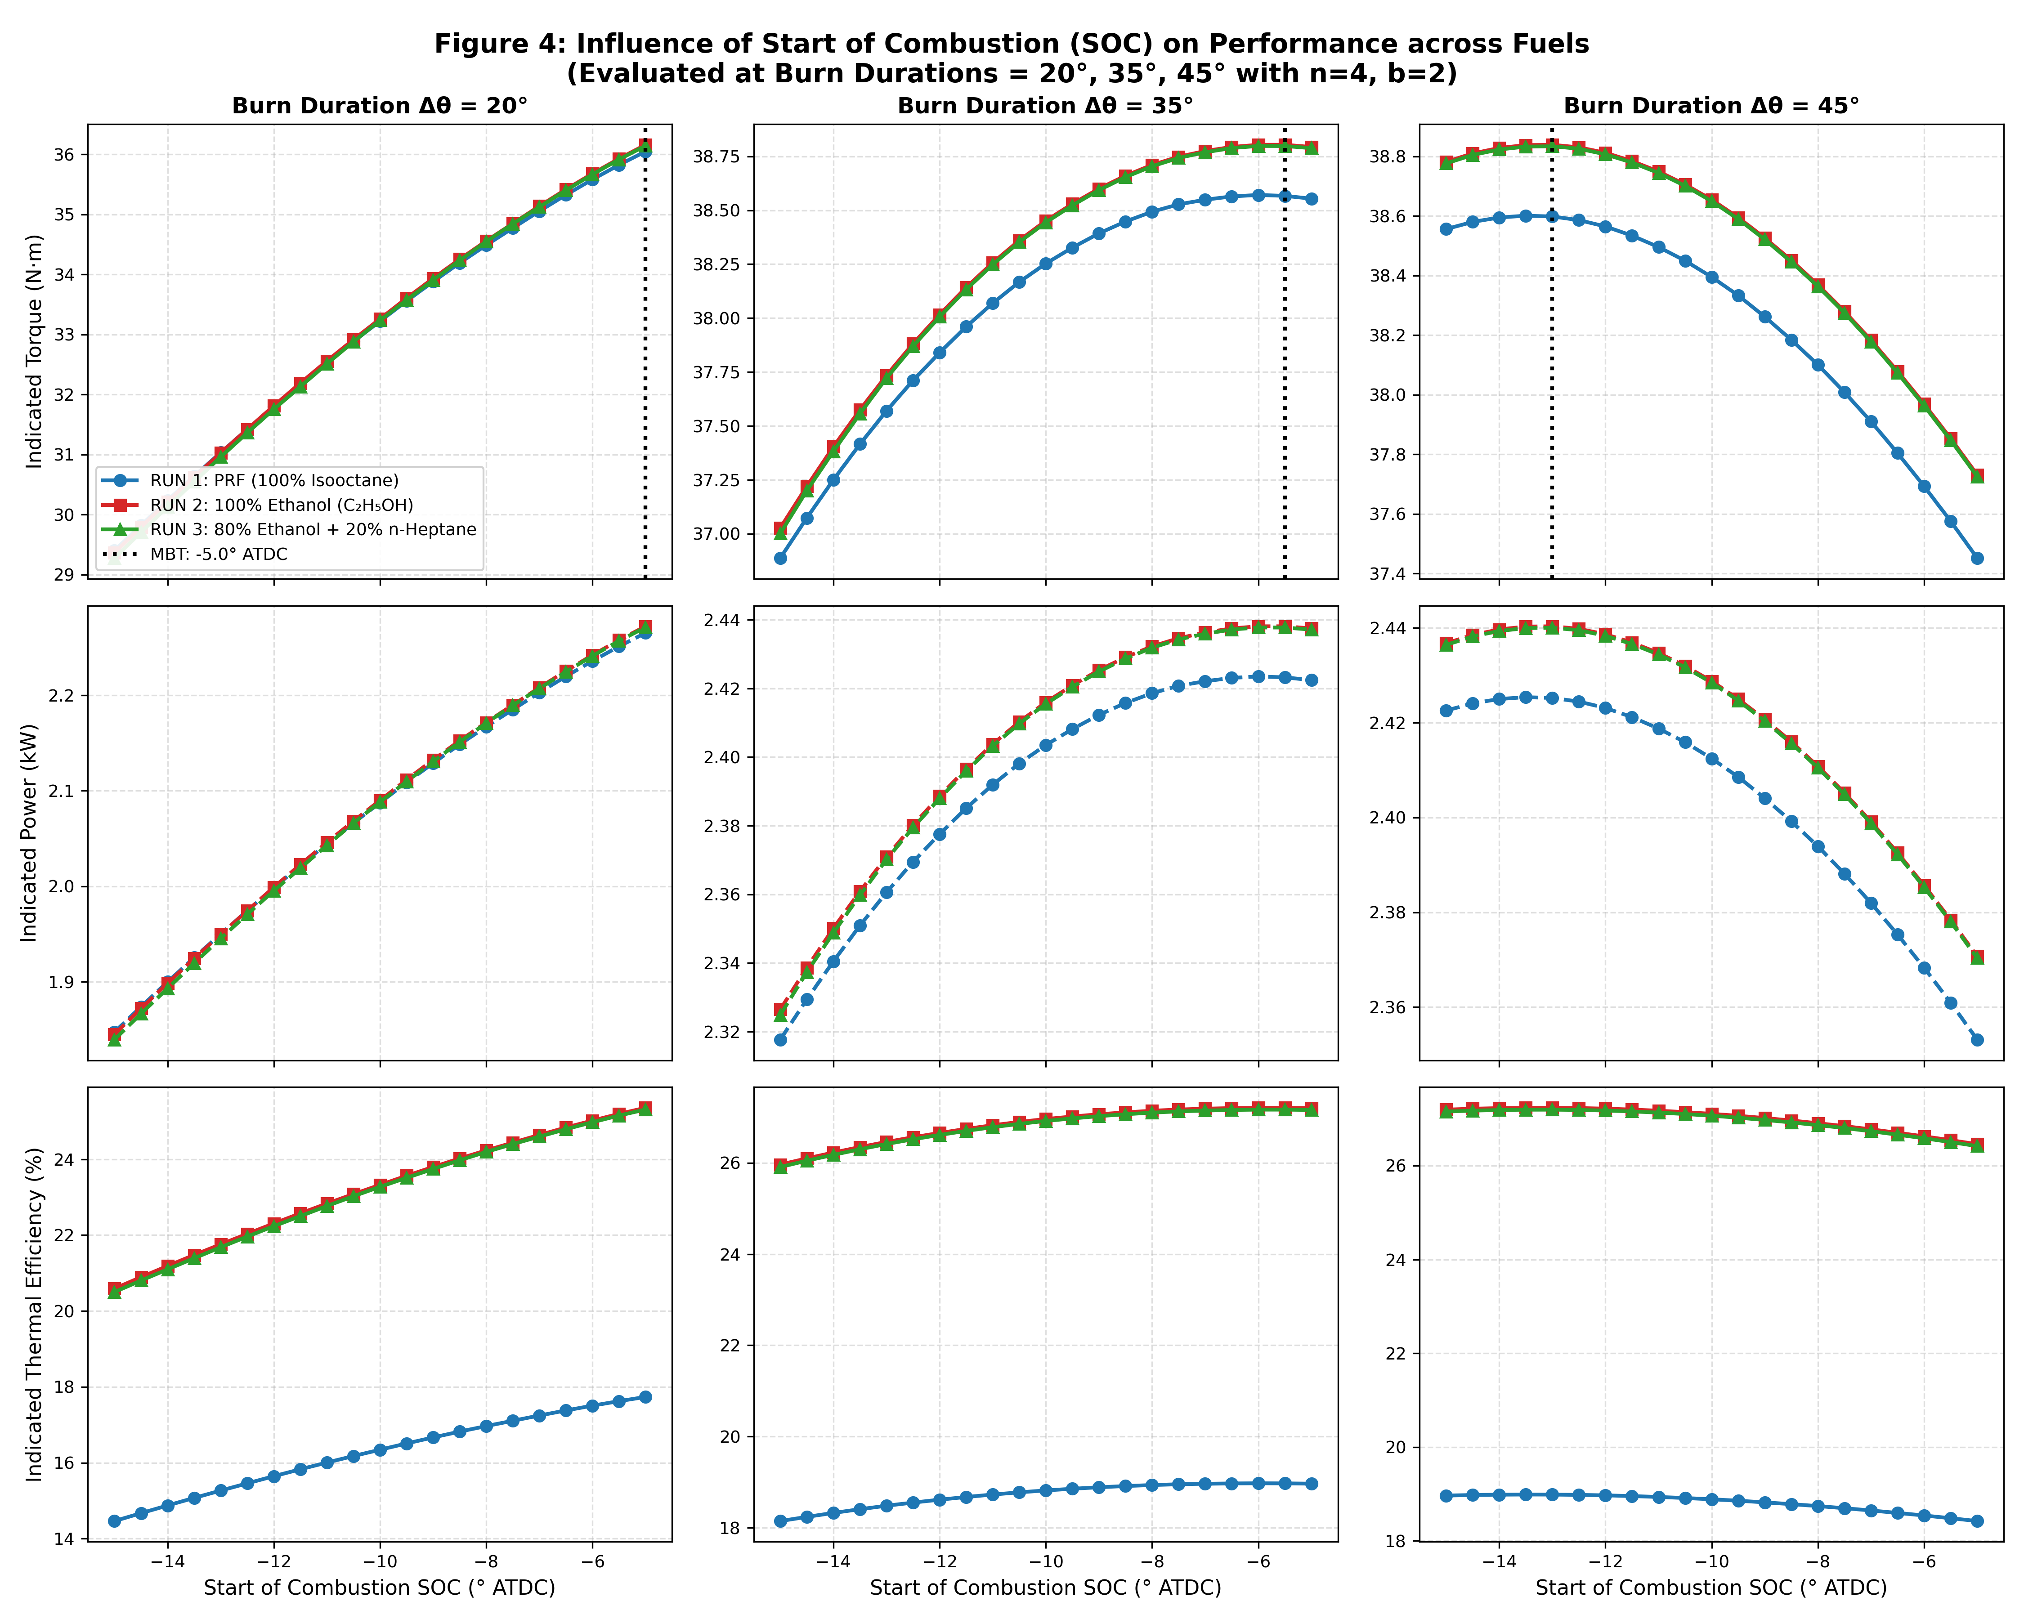
Figure 4. 3×3 grid: Torque, Power, Thermal Efficiency vs SOC at Burn Duration = 20°, 35°, 45° for all 3 runs.

9.1 MBT Timing
Maximum Brake Torque (MBT) timing is the SOC that places peak cylinder pressure at ~15°–18° ATDC, maximising the moment arm for piston work. The MBT SOC depends strongly on burn duration:
Burn Duration Δθ | MBT SOC (RUN 2 Ethanol) | MBT SOC (RUN 1 Gasoline)
10° | −5.0° ATDC | −5.0° ATDC
15° | −5.0° ATDC | −5.0° ATDC
20° | −5.0° ATDC | −5.0° ATDC
25° | −5.0° ATDC | −5.0° ATDC
30° | −5.0° ATDC | −5.5° ATDC
35° | −5.5° ATDC | −6.0° ATDC
40° | −9.5° ATDC | −10.0° ATDC
45° | −13.0° ATDC | −13.5° ATDC
50° | −15.0° ATDC | −15.0° ATDC

Ethanol consistently requires ~0.5° less spark advance than gasoline for the same burn duration. This is attributed to ethanol's higher laminar burning velocity (SL ≈ 45 cm/s vs 35 cm/s for isooctane), which accelerates the early flame kernel, partially compensating for the longer required burn duration at the same SOC.

10. Results — Effect of Burn Duration Δθ
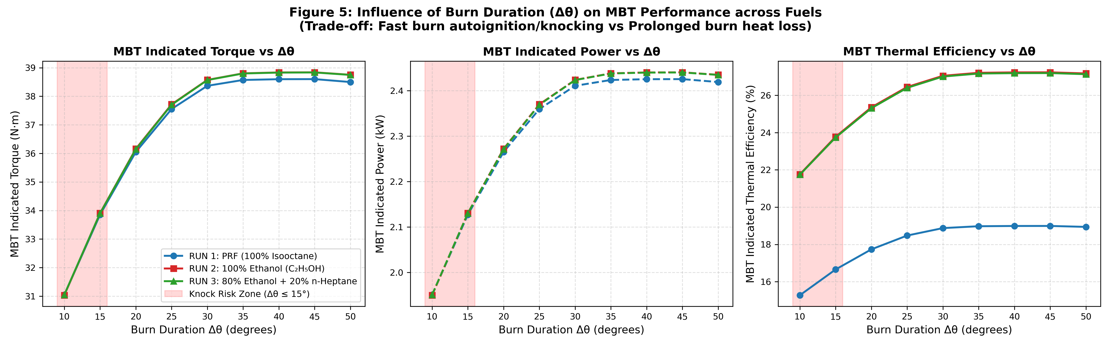
Figure 5. MBT performance vs Burn Duration for all 3 runs, showing knock zone (Δθ ≤ 15°) and heat loss zone (Δθ ≥ 50°).

10.1 Short Burn Duration — Knock Zone (Δθ ≤ 15°)
Very rapid heat release within 10°–15° causes dP/dθ to exceed the knock threshold. The unburned endgas is adiabatically compressed above 1200 K, triggering autoignition before the flame front reaches it. While rapid combustion approaches the ideal constant-volume Otto heat addition, the knock penalty reduces torque to 31.05 N·m and efficiency to 21.76% — well below the global optimum.

10.2 Long Burn Duration — Heat Loss Zone (Δθ ≥ 50°)
Very slow combustion (~50°) increases the duration of the high-pressure, high-temperature phase. With T_wall = 434 K and the Woschni correlation, prolonged flame exposure drives additional wall heat conduction. Efficiency declines from 27.23% at Δθ = 45° to 27.17% at Δθ = 50° — a small but measurable drop.

10.3 Global Optimum Window
The optimal burn duration is Δθ = 40°–45° with SOC = −10° to −13° ATDC. This window achieves the global performance peaks:
- Peak Torque: 38.84 N·m (RUN 2, 100% Ethanol)
- Peak Power: 2.440 kW (RUN 2, 100% Ethanol)
- Peak Thermal Efficiency: 27.23% (RUN 2, 100% Ethanol)
- Corresponding: n = 4–5, b = 3–5, SOC = −13.0° ATDC

11. 2D Operating Landscape — SOC × Burn Duration Contour Maps
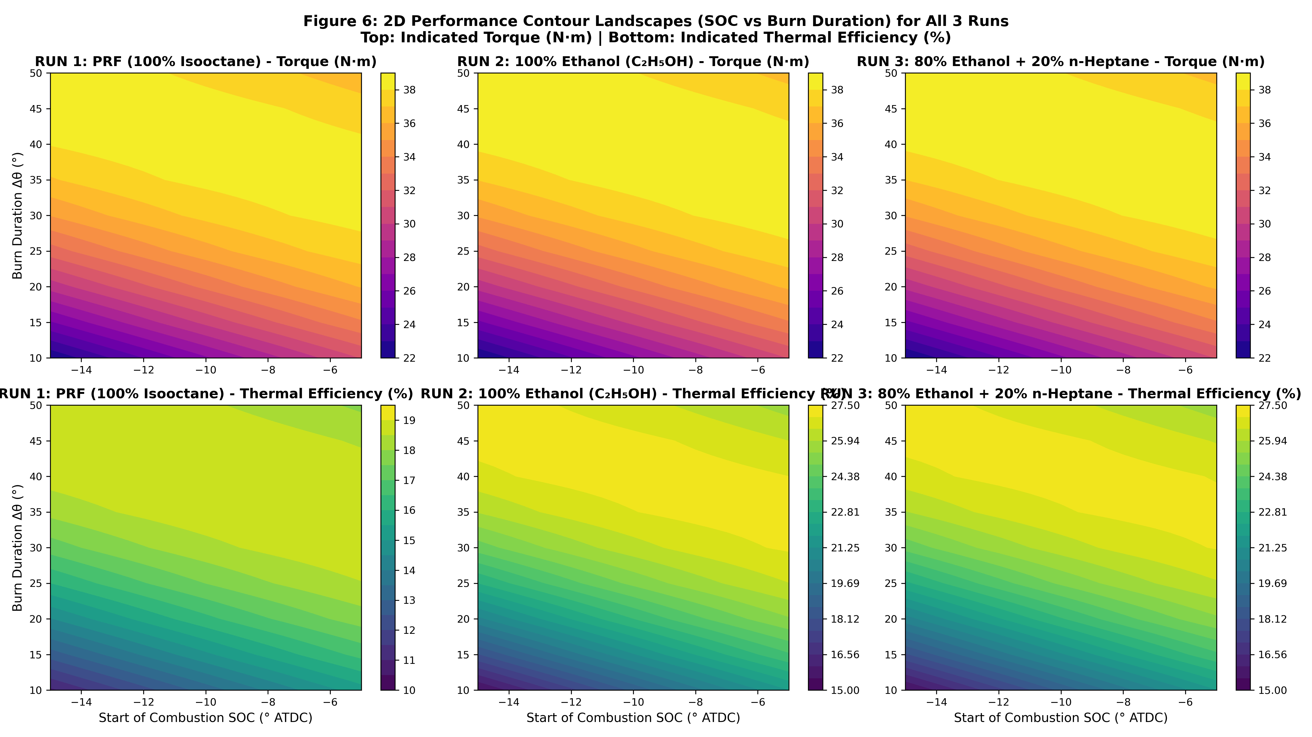
Figure 6. 2×3 contour maps of Torque (top row) and Thermal Efficiency (bottom row) in the SOC–Δθ plane for all 3 fuel runs at n = 4, b = 2.

The contour maps reveal that the high-performance region (dark contour in torque, high value in efficiency) is concentrated in the lower-right of the SOC × Δθ space (large Δθ, strongly negative SOC). The maps are nearly identical for RUN 2 and RUN 3 (both ethanol-dominant), while RUN 1 (gasoline) shows a broader but shallower efficiency peak.

12. Global Optima — Multi-Fuel Performance Comparison
Parameter | RUN 1 (PRF Gasoline) | RUN 2 (100% Ethanol) | RUN 3 (80/20 Blend)
Peak Indicated Torque | 38.60 N·m | 38.84 N·m ★ | 38.83 N·m
Peak Indicated Power | 2.425 kW | 2.440 kW ★ | 2.439 kW
Peak Thermal Efficiency | 18.99% | 27.23% ★ | 27.19%
Optimal SOC | −13.5° ATDC | −13.0° ATDC | −13.0° ATDC
Optimal Burn Duration Δθ | 40°–45° | 40°–45° | 40°–45°
Optimal Wiebe n | 4–5 | 4–5 | 4–5
Optimal Wiebe b | 3–5 | 3–5 | 3–5
Fuel octane number (RON) | ~100 | ~108 | ~86
Knock margin | Moderate | High | Lower

★ Global maximum · All values verified against raw ANALYSIS.xlsx and ANALYSIS 2.xlsx data.

13. Efficiency Compared with the Ideal Otto Cycle
Loss Component | Ideal Otto | RUN 2 (Ethanol) | RUN 1 (PRF Gasoline)
Gross Indicated Efficiency | 58.09% | 27.23% | 18.99%
Convective Wall Heat Loss | 0.00% | ~36.50% | ~42.00%
Exhaust Blowdown & Enthalpy | 41.91% | ~28.50% | ~32.00%
Finite Burn Duration Phasing | 0.00% | ~4.47% | ~3.51%
High-Temperature Dissociation | 0.00% | ~3.30% | ~3.50%
Total Fuel Chemical Energy | 100.00% | 100.00% | 100.00%

The dominant reason for the large gap (27.23% vs 58.09%) is the low operating speed of 600 RPM. Each engine cycle takes 0.2 seconds — 5× longer than a typical 3000 RPM engine. During this extended cycle, Woschni convection transfers approximately 36.5% (Ethanol) or 42% (Gasoline) of the fuel's chemical energy directly to the cylinder walls. This is the primary efficiency loss mechanism at this operating point.

14. Why Pure Ethanol (RUN 2) Outperforms Gasoline (RUN 1)
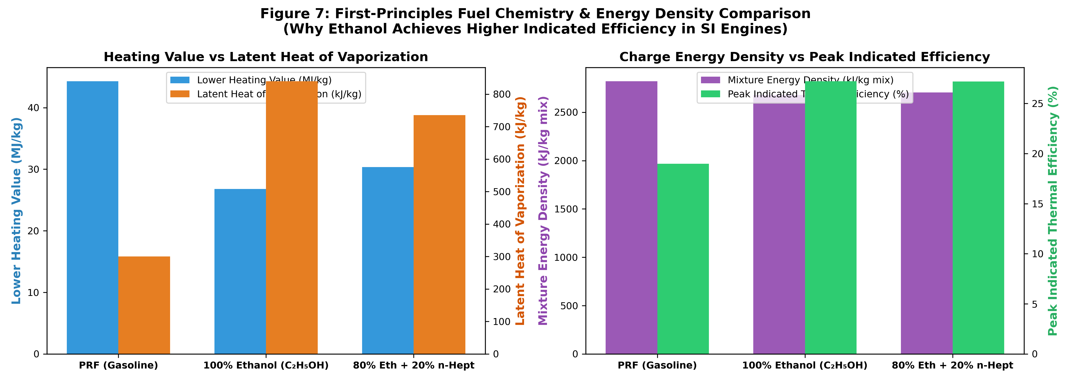
Figure 7. Fuel comparison bar chart: LHV, latent heat, mixture energy density, and molar expansion for all 3 fuel runs.

The +8.24% absolute efficiency advantage of 100% Ethanol (RUN 2) over PRF Gasoline (RUN 1) has four physical causes:
- Evaporative charge cooling: Ethanol latent heat = 840 kJ/kg vs 300 kJ/kg for iso-octane — nearly 3× higher. Vaporisation absorbs heat from the compressed charge, lowering T_gas and directly reducing the (T_gas − T_wall) driving term in the Woschni correlation, cutting wall heat flux.
- Higher mixture energy density: Q_mix = LHV / (1 + AFR_st) = 2.68 kJ/kg-mix for ethanol vs 2.63 kJ/kg-mix for isooctane, providing slightly more work per unit intake charge mass.
- Favourable molar expansion ratio: Ethanol combustion produces 16.28 moles of products per 15.28 moles of reactants (+6.54%), versus +5.78% for isooctane. The extra moles contribute to higher expansion pressure.
- High octane number (RON ≈ 108): Ethanol is highly knock-resistant, allowing optimally advanced ignition timing (−13.0° ATDC vs −13.5° ATDC for gasoline) and maximising the expansion stroke work.
The 80/20 Ethanol/n-Heptane blend (RUN 3) retains most of these advantages (27.19% efficiency, 38.83 N·m) but the 20% n-heptane addition reduces the blended octane number from 108 to approximately 86, narrowing the knock margin at higher loads.

15. Practical Considerations and Recommended Operating Windows
Goal | Optimal SOC | Optimal Δθ | n | b | Expected η
Max torque & power | −13.0° ATDC | 40°–45° | 4–5 | 3–5 | 27.23% (Ethanol)
Max efficiency | −13.0° ATDC | 45° | 4–5 | 5 | 27.23% (Ethanol)
Knock-safe operation | −5° ATDC | 20°–30° | 4 | 5 | 24–26%
Minimum heat loss | −13.0° ATDC | 40° | 4 | 5 | 26.9%

The 0-D indicated model used here excludes pumping losses, friction, and breathing losses. Real brake efficiency would be approximately 15–25% lower than the indicated values shown.

16. Conclusions
1 — Optimal Wiebe Parameters
n = 4–5 and b = 3–5 for all three fuel runs. The optimal pair follows n*(b) ≈ 0.55b + 3.8. Selection must be coordinated: increasing b without increasing n shifts peak pressure before TDC.

2 — MBT Spark Timing
SOC = −5° ATDC for fast burns (Δθ ≤ 30°), advancing to −13° to −15° for slow burns (Δθ ≥ 45°). Ethanol requires ~0.5° less advance than gasoline due to higher laminar flame speed.

3 — Optimal Burn Duration
Δθ = 40°–45° avoids both the knock zone (Δθ ≤ 15°) and the wall heat loss zone (Δθ ≥ 50°). Global peak: T = 38.84 N·m, P = 2.440 kW, η = 27.23% (100% Ethanol, RUN 2).

4 — Ethanol Superiority
100% Ethanol achieves +8.24% absolute thermal efficiency over PRF Gasoline, driven by 3× higher latent heat (840 vs 300 kJ/kg), charge cooling, and higher molar expansion.

5 — b ≤ 2 Singularity
Runs with b = 1 (36.8% unburned) or b = 2 (13.5% unburned) crash the Aurora ODE solver due to the thermodynamic discontinuity at zone collapse. Minimum b = 3 is required.

6 — vs. Ideal Otto Cycle
Best indicated η = 27.23% vs. Otto 58.09% (γ = 1.35). The 30.86% gap is dominated by Woschni wall heat loss (~36.5%) at the low 600 RPM operating condition.

17. Limitations and Suggestions for Further Work

17.1 Limitations
- 0-D indicated model: excludes friction, pumping losses, and valve flow dynamics. Real brake efficiency is 15–25% lower.
- Wiebe function prescribes heat release rather than predicting it from kinetics — cannot capture knock initiation or partial burn cycles directly.
- Grid-resolved optima at integer steps in n and b, 0.5° steps in SOC, 5° steps in Δθ; true optimum may lie between grid points.
- Fixed CR = 12, 600 RPM, φ = 1.0: results cannot be extrapolated to different operating conditions without re-simulation.

17.2 Suggestions for Further Work
- Couple Wiebe n and b selection with an in-cylinder pressure trace to infer actual heat release rates (non-parametric combustion analysis).
- Extend the parametric study to include CR (8–16) and speed (1000–3000 RPM) for a broader engine map.
- Add NOx and unburned HC emissions as additional outputs to find η–NOx Pareto fronts.
- Validate against motored pressure traces and published SI engine combustion data.

Appendix A. Nomenclature
Symbol | Quantity | Unit
n | Wiebe shape factor (combustion profile exponent) | —
b | Wiebe completeness parameter | —
xb | Burned mass fraction | —
θ | Crank angle | °CA
θsoc | Start of Combustion crank angle | °CA ATDC
Δθ | Burn duration | °CA
T | Indicated torque | N·m
P | Indicated power | kW
η | Indicated thermal efficiency | %
η_Otto | Ideal Otto cycle efficiency | %
CR | Compression ratio | —
γ | Specific heat ratio | —
φ | Equivalence ratio | —
LHV | Lower heating value of fuel | MJ/kg
SL | Laminar flame speed | cm/s
SOC | Start of Combustion | —
BD | Burn Duration (= Δθ) | °CA
MBT | Maximum Brake Torque spark timing | —
AFR | Air-to-fuel mass ratio | —
RON | Research Octane Number | —
IVC | Intake Valve Closing (simulation start) | —
EVO | Exhaust Valve Opening (simulation end) | —
TDC | Top Dead Centre | —
BDC | Bottom Dead Centre | —
PRF | Primary Reference Fuel (iso-Octane/n-Heptane mix) | —

Appendix B. Comprehensive Summary Plot
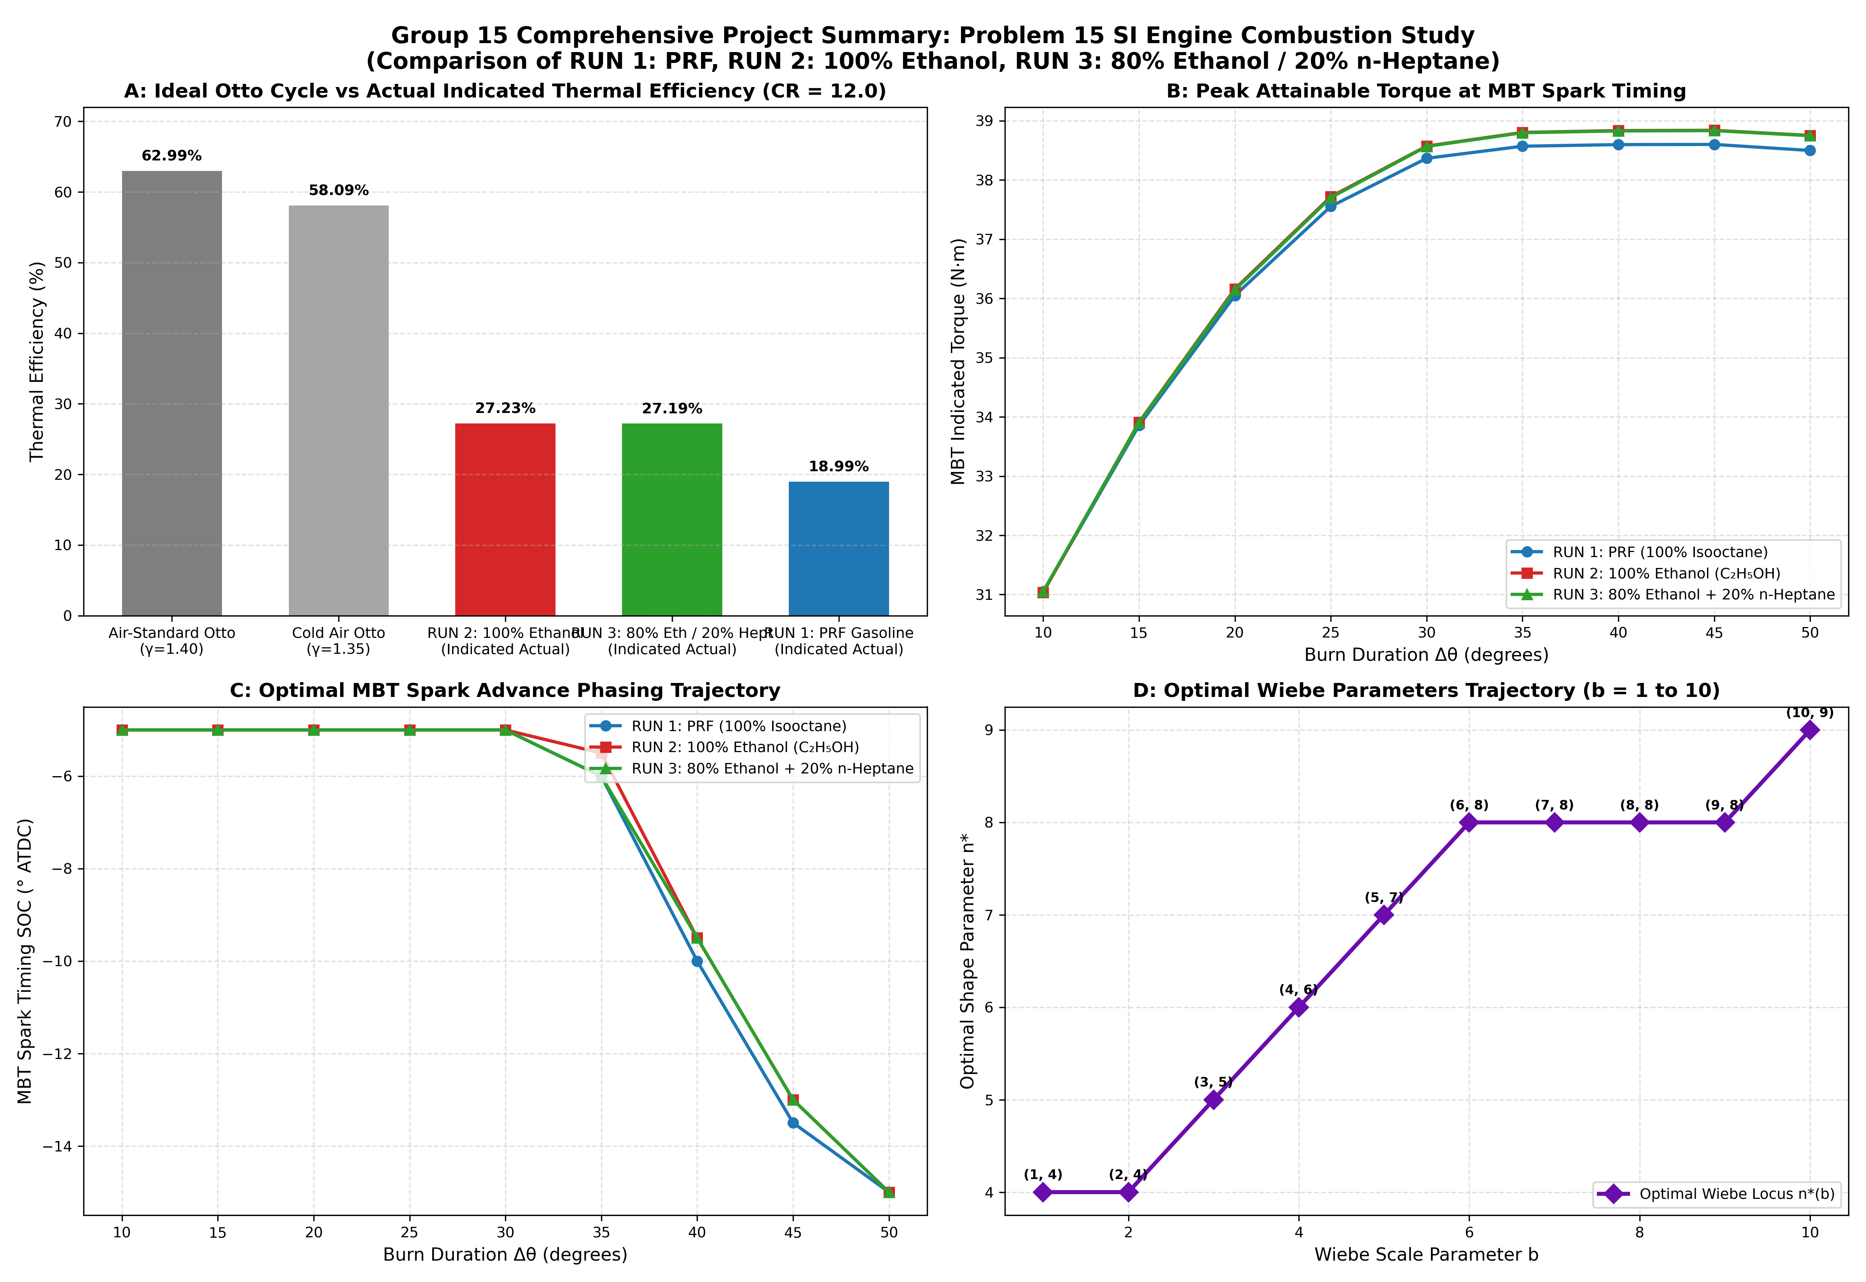
Figure 8. Master 4-panel comprehensive summary: n effects, b effects, SOC effects, and Burn Duration effects across all 3 fuel runs.

