Batch: Roll No.:

Experiment / assignment / tutorial No.

Grade: AA / AB / BB / BC / CC / CD /DD

Signature of the Staff In-charge with date

TITLE: Decision Making Statements

AIM: 1) Write a program to count the number of prime numbers and composite numbers entered by the user.
2) Write a program to check whether a given number is Armstrong or not.
______________________________________________________________________

Expected OUTCOME of Experiment: Use different Decision Making statements in Python.
______________________________________________________________________
Resource Needed: Python IDE
______________________________________________________________________
Theory:

Decision Control Statements
1) Selection/Conditional branching statements
a) if statement
b) if-else statement
c) if-elif-else statement
2)Basic loop Structures/Iterative statement
a) while loop
b) for loop

If statement:
In Python if statement is used for decision-making operations. It contains a body of code which runs only when the condition given in the if statement is true.

Syntax:
if condition:
statement(s)
If flowchart:
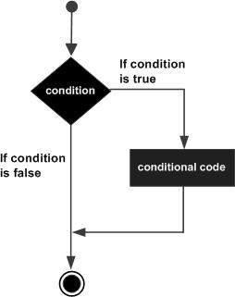

If-else Statement:
An else statement can be combined with an if statement. An else statement contains the block of code that executes if the conditional expression in the if statement resolves to 0 or a FALSE value.
The else statement is an optional statement and there could be at most only one else statement following if.

Syntax:

if expression:
statement(s)
else:
statement(s)

If-else flowchart:
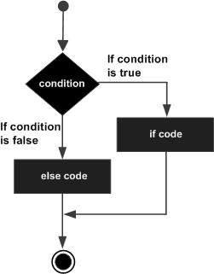

If-elif-else Statement:
The elif statement allows you to check multiple expressions for TRUE and execute a block of code as soon as one of the conditions evaluates to TRUE.
Similar to the else, the elif statement is optional. However, unlike else, for which there can be at most one statement, there can be an arbitrary number of elif statements following an if.

Syntax:
if expression1:
statement(s)
elif expression2:
statement(s)
elif expression3:
statement(s)
else:
statement(s)

While loop:
A while loop statement in Python programming language repeatedly executes a target statement as long as a given condition is true.

Syntax:
while expression:
statement(s)

While loop flowchart:
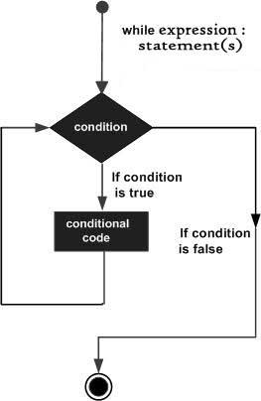

For Loop:
The for statement in Python differs a bit from what you may be used to in C. Rather than giving the user the ability to define both the iteration step and halting condition (as C), Python’s for statement iterates over the items of any sequence (a list or a string), in the order that they appear in the sequence.

Syntax:

for iterating_var in sequence:
statements(s)

For loop flowchart:
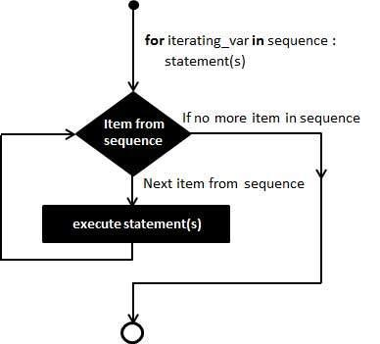

Problem Definition:
1) Write a program to read the numbers until -1 is encountered. Also, count the number of prime numbers and composite numbers entered by the user

2) Write a program to check whether a number is Armstrong or not.

(Armstrong number is a number that is equal to the sum of cubes of its digits for example: 153 = 1^3 + 5^3 + 3^3.)

Books/ Journals/ Websites referred:

- Reema Thareja, Python Programming: Using Problem Solving Approach, Oxford University Press, First Edition 2017, India
- Sheetal Taneja and Naveen Kumar, Python Programming: A modular Approach, Pearson India, Second Edition 2018,India
- https://docs.python.org/3/tutorial/controlflow.html#for-statements

Implementation details:

Output(s):

Conclusion:

Post Lab Questions:
1) When should we use nested if statements? Illustrate your answer with the help of an example.
2) Explain the utility of break and continue statements with the help of an example.
3) Write a program that accepts a string from user and calculate the number of digits and letters in string.

Date: _____________ Signature of faculty in-charge

