CN Homework 2

Group 31

Q1. Exploring Network Interfaces with ifconfig (5 Marks)
Run the ifconfig command on your machine.
• Identify all available network interfaces (wired, wireless, loopback, etc.).
Answer:
- lo → Loopback interface
- virbr0 → Virtual bridge
- wlp1s0 → Wireless LAN interface.

• For your active interface, report:
– IP address (IPv4 and IPv6 if available)
– MAC address (if available)
– RX/TX packet counts and errors
Answer:
The active interface is wlp1s0 (Wi-Fi), since it has a valid IP address and shows traffic.
- IPv4 Address: 192.168.43.247
- IPv6 Address: fe80::c863:a4f0:daa7:7728
- MAC Address: c4:9d:ed:04:cb:31
- RX Packets: 21511 packets received (23.3 MB)
- TX Packets: 5881 packets received (961.5 KB)
- RX Errors/Dropped: 0 errors, 0 dropped
- TX Errors/Dropped: 0 errors, 0 dropped

• Add a screenshot of ifconfig’s output.
Answer:
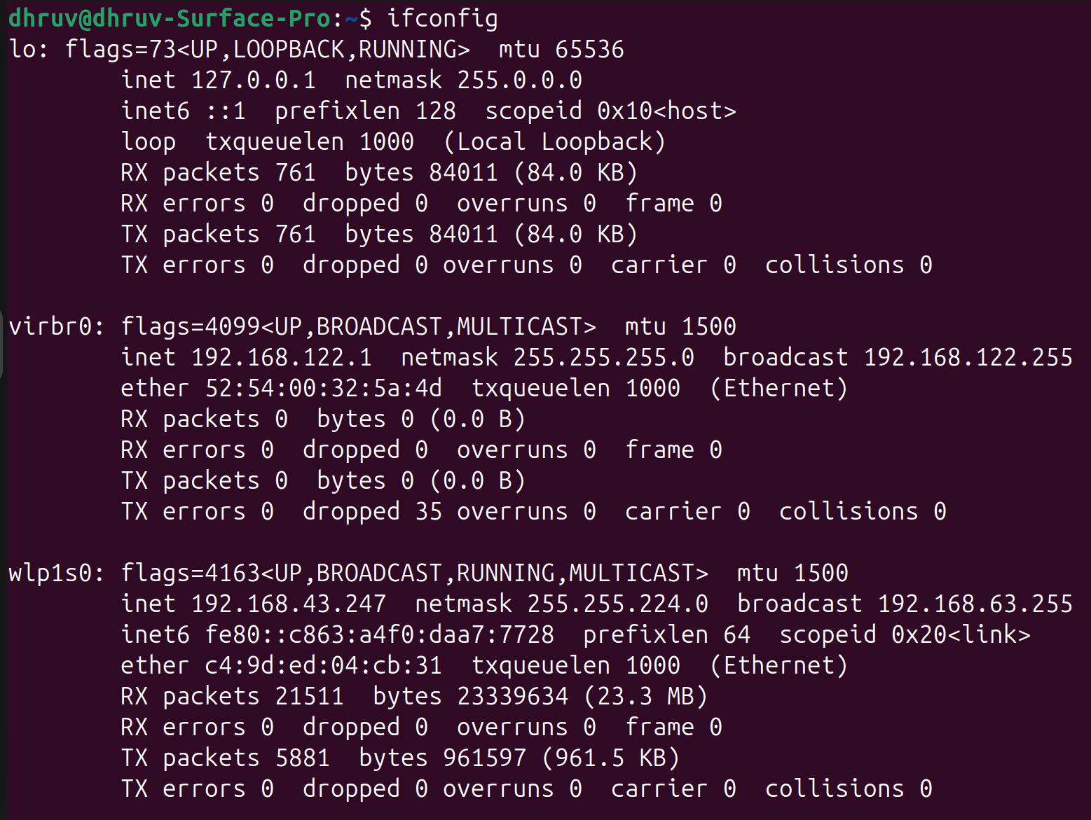

Q2. Tracing Routes with traceroute and mtr (5 Marks)
Use both traceroute and mtr command to trace the route to google.co.in.
• Add a screenshot to report for both commands.
Answer:
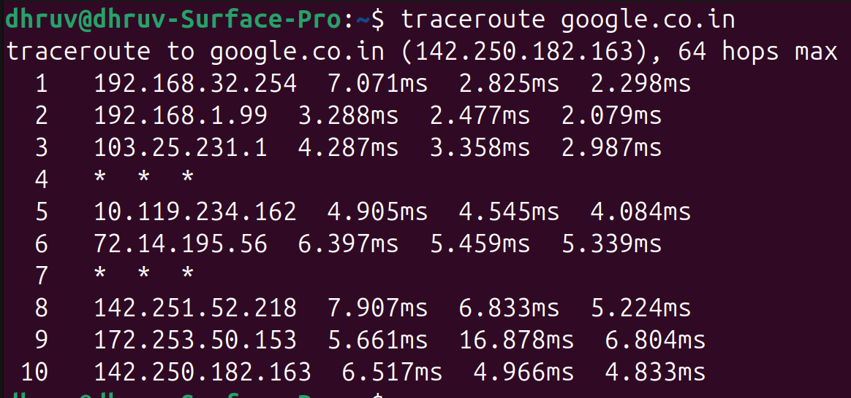
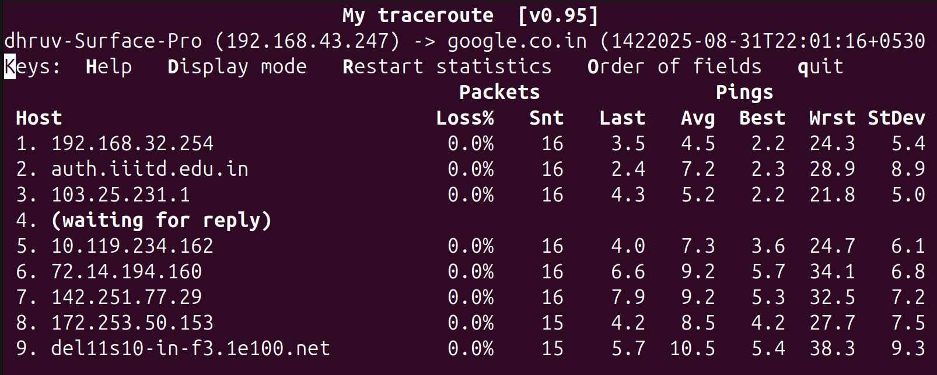

• How many hops or intermediate IP addresses do you observe in each command ?
Answer:
traceroute google.co.in (to 142.250.182.163)
Output hops shown: 10 (including destination).
Responding IPs seen (excluding “* * *” rows):

192.168.32.254, 2) 192.168.1.99, 3) 103.25.231.1, 5) 10.119.234.162, 6) 72.14.195.56, 8) 142.251.52.218, 9) 172.253.50.153, 10) 142.250.182.163 → 8 responding hops total.
“Intermediate routers” (responding, excluding the final destination): 7

mtr google.co.in
Hosts listed:
192.168.32.254, 2) auth.iiitd.edu.in, 3) 103.25.231.1, 4) (waiting for reply), 5) 10.119.234.162, 6) 72.14.194.160, 7) 142.251.77.29, 8) 172.253.50.153, 9) del11s10-in-f3.1e100.net → 9 hops shown (including destination).
Responding IPs including destination: 8.
Responding intermediates (excluding destination): 7.

• If you observe “* * *” in a hop in traceroute’s output, then research and report a few possible reasons for it?
Answer:
- The router drops or rate-limits ICMP Time-Exceeded / UDP replies used by traceroute.
- Firewall/ACL blocks returning probes.
- Asymmetric routing: reply takes a different path and is filtered en route.
- Per-flow load-balancing sends your probes to a device/interface that doesn’t respond.
- Timeout too short for that hop to answer.
- Router may choose not to reveal its details, but still forwards.
• Lookup your IP address and geolocation using www.whatismyip.com
website and report it.
Answer:
Public IPv4: 103.25.231.126
Geolocation (city/region, country): Noida, Uttar Pradesh, India
• If there are any non-local IP addresses in the traceroute or mtr, i.e. IP addresses not in ranges 10.0.0.0 to 10.255.255.255, 172.16.0.0 to 172.31.255.255, 192.168.0.0 to 192.168.255.255, then report their geolocation using “checkhost.net” website, and the netname, descr attributes using whois shell command. In case traceroute doesn’t show any non-local IP address or geolocation isn’t available then mention that in the report.
Answer:
IP / Hostname | Geo (check-host.net) | netname (whois) | descr/org (whois)
103.25.231.1 | Noida, Uttar Pradesh, India | IIITD | Indraprastha Institute of Information Technology
72.14.195.56 | Mountain View, California, US | GOOGLE | GOOGLE
72.14.194.160 | Mountain View, California, US | GOOGLE | GOOGLE
142.251.52.218 | Mountain View, California, US | GOOGLE | GOOGLE
142.251.77.29 | Mountain View, California, US | GOOGLE | GOOGLE
172.253.50.153 | Mountain View, California, US | GOOGLE | GOOGLE
142.250.182.163 / del11s10-in-f3.1e100.net | Delhi, Delhi, India | GOOGLE | GOOGLE

Q3. DNS Analysis with nslookup and dig (5 Marks)
Use nslookup and dig to query the IP addresses of google.com.
• Compare the outputs of both tools. Do they report the same IP address?
Answer:
- nslookup google.com
Returned:
  - IPv4: 172.217.26.110
  - IPv6: 2404:6800:4002:831::200e
- dig google.com
Returned:
  - IPv4: 172.217.26.110
Both tools reported valid Google IP addresses. The IPv4 result matched in both (172.217.26.110).
The only difference: nslookup also displayed an IPv6 address.

When you use this IP address as URL in browser, does it open Google’s homePage?
Answer:
Yes

• Find IP address of an Authoritative Nameserver of “google.com” using command “nslookup -type=NS google.com”. Then query the authority name server using command “nslookup google.com - 〈IP address of authoritative
name server 〉”. Attach screenshot of this step in the report.
Answer:
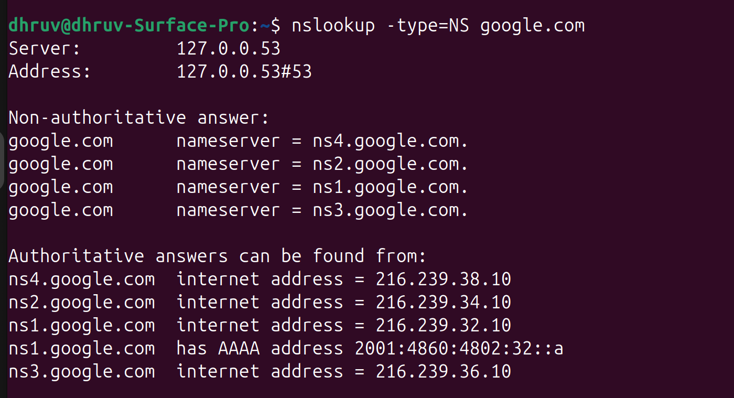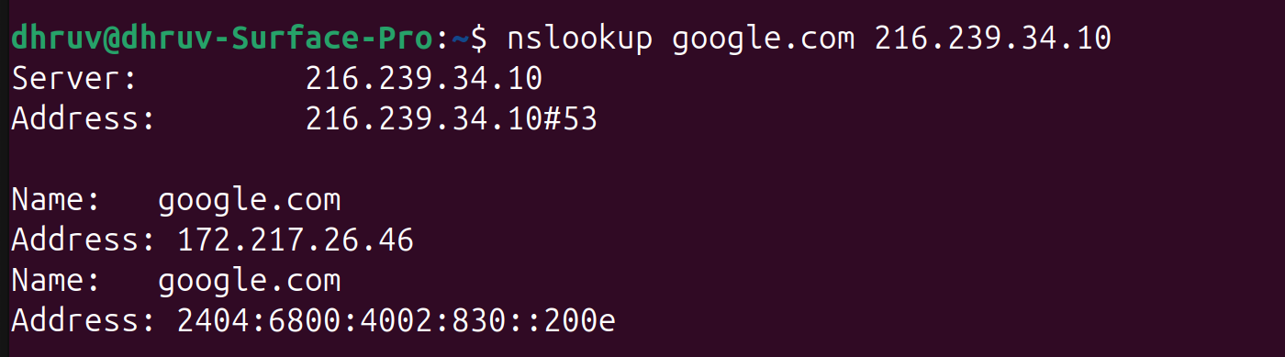

Q4. Measuring Traffic with iftop (5 Marks)
Run iftop while browsing or streaming content on your browser.
• Add a screenshot of the top 3 connections consuming bandwidth to the report.
Answer:
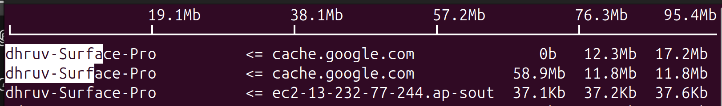

• Report the source/destination IPs and bandwidth usage.
Answer:
dhruv-Surface-Pro ⇔ cache.google.com (flow 1) → 0 b / 12.3 Mb / 17.2 Mb
dhruv-Surface-Pro ⇔ cache.google.com (flow 2) → 58.9 Mb / 11.8 Mb / 11.8 Mb
dhruv-Surface-Pro ⇔ ec2-13-232-77-244.ap-south-1.amazonaws.com → 37.1 Kb / 37.2 Kb / 37.6 Kb

Overall
TX (sent): 10.1 MB
RX (received): 662 MB
TOTAL traffic: 672 MB
Peak rate observed: 1.10 Mb/s
Current total rate: 9.85 Mb/s

• What type of applications might be generating this traffic?
Answer:
Google cache servers (cache.google.com)
The majority of the traffic is between the local machine and Google cache servers. This indicates YouTube streaming, Google search, or Chrome updates.
AWS EC2 instance (ec2-13-232-77-244.ap-south-1.amazonaws.com)
Represents cloud service traffic, likely API calls or background synchronization with a service hosted on Amazon Web Services.
Traffic distribution
Received traffic (RX ~662 MB) is far larger than sent traffic (TX ~10 MB), which is typical of video streaming or web browsing workloads.

