Cover page

- Project Title: Scientific Calculator python project
- Author: Dhruv singh
- Reg num:- 25BAI11453
- Date: 24 november 2025
- COURSE:-CSE1021
- INSTRUCTOR:Mrs.Monika Vyas

2. Introduction
- Python-based scientific calculator
- Supports arithmetic, scientific, and matrix operations
- Interactive CLI interface
- Designed for flexibility and ease of use

3. Problem Statement
- Need for a calculator that performs:
  - Basic arithmetic
  - Complex number calculations
  - Trigonometric functions
  - Matrix operations
- Goal: Build an accurate, user-friendly scientific calculator

4. Functional Requirements

- Perform:
  - Addition, subtraction, multiplication, division, modulus
  - Trigonometric operations: sin, cos, tan
  - Complex number operations
  - Matrix addition
  - Matrix multiplication
- Input validation
- Display output clearly

5. Non-functional Requirements
- Easy to use
- Reliable and handles errors
- Fast performance
- Portable (runs anywhere Python is available)

6. System Architecture
- Input Module → collects numbers/matrices
- Validator → checks input correctness
- Computation Engine → performs all calculations
- Output Handler → prints results
8. Design Decisions & Rationale
- Use Python’s built-in complex type
- Use lists for matrix operations
- Use CLI for simplicity and portability
- Keep code modular using functions

9. Implementation Details
- Input is taken as either numeric or matrix
- Matrix input taken row-wise
- Matrix operations implemented manually
- Scientific functions based on cmath module

- RESULTS

- 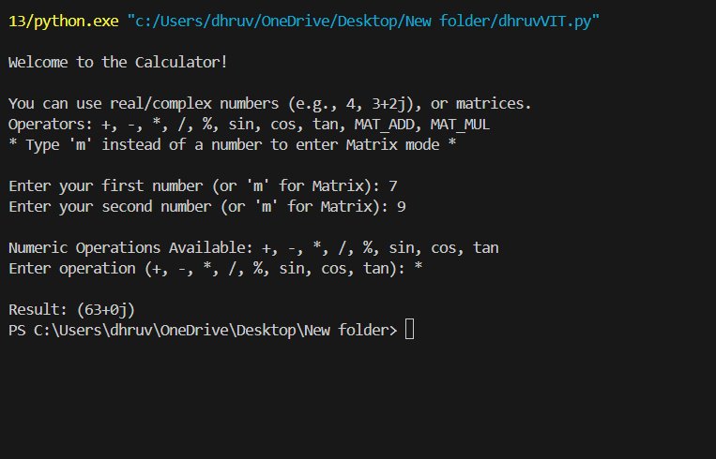
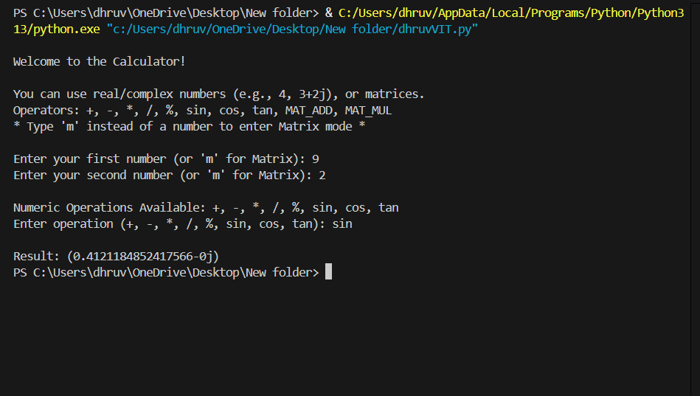
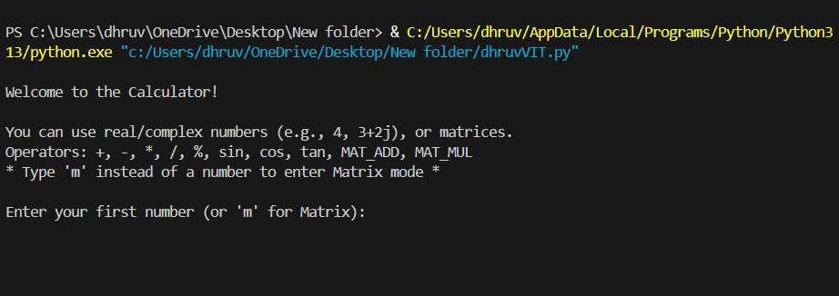
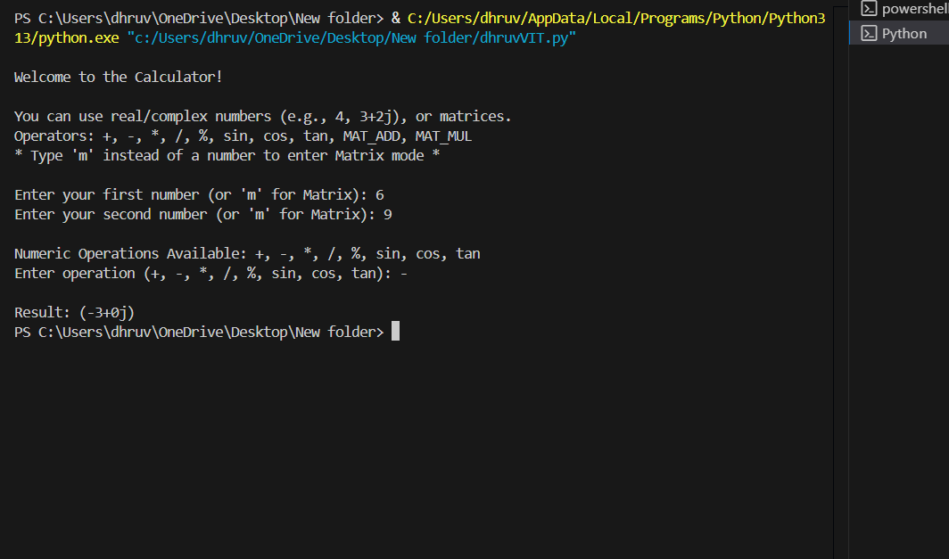
9. Implementation Details
- Input is taken as either numeric or matrix
- Matrix input taken row-wise
- Matrix operations implemented manually
- Scientific functions based on cmath module
11. Testing Approach
- Unit testing for arithmetic functions
- Validation testing for incorrect inputs
- Boundary testing (divide by zero, invalid matrices, etc.)

12. Challenges Faced
- Parsing complex numbers
- Handling incompatible matrix sizes
- Preventing input errors

13. Learnings & Key Takeaways
- Better understanding of complex numbers
- Improved knowledge of matrix operations
- Importance of input validation
- Modular coding improves clarity

14. Future Enhancements
- GUI version using Tkinter or PyQt
- Add more scientific functions (log, sqrt, exponent)
- Add graph plotting
- Add history storage (database/JSON)
15. References
- Python Official Documentation
- cmath module documentation
- Mathematical reference materials

