**(42027)** REPORT ON DEVELOPED OPENFLOW-BASED NETWORK FOR AN ENTERPRISE ENVIRONMENT

**Open SDN architecture,** this architecture enables developing a network, it provides a programmable network that is centralized. The architecture consists of: a controller that allow for centralized management of the individual networks. APIs that ensure passage of messages between controllers and network components like hosts. The API consists of Southbound and Northbound, which makes SDN behave like a single network.

SDN makes it easy to troubleshoot network problems, reduce network build time, improves network security and revolutionize existing network infrastructure.

The simulation of the Open SDN network is done with assistance of **Mininet,** that provides a simple, fast virtual environment for creating virtual network. The Mininet provides virtual kernels, switches, application code, machines among other network components.

**Part A: Network Topology Creation in Mininet**

The figure below is a mininet python script for a six host, four switches and a controller for mininet network.

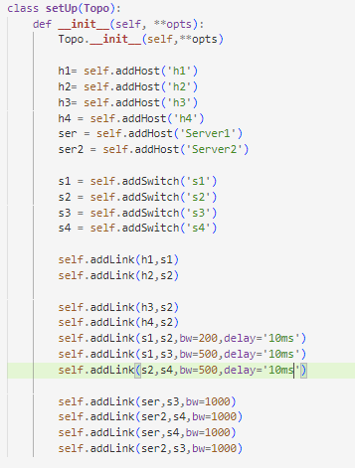

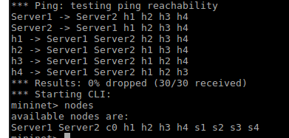

The setup() function defines a Topology, that consist of 11 nodes as indicated above, those are 10 devices and one controller.

The function after initialization, creates hosts, *self.addHost(),* switches, and links them up to define the network.

The links are each controlled by set bandwidth set in *bw=1000,*  that makes the link speed to be one gigabyte. The switches each have a delay of ten millisecond.

**Part B: Network Configuration and Application Development**

In the main method, opo object is created, defined in Part A, a log level is set and finally a Mininet object is created, a switch o f type OVSKernelSwitch is specified along with a default Controller.

The autoSetMacs defined is used to format host mac addresses of type 00:00:00:00:01.

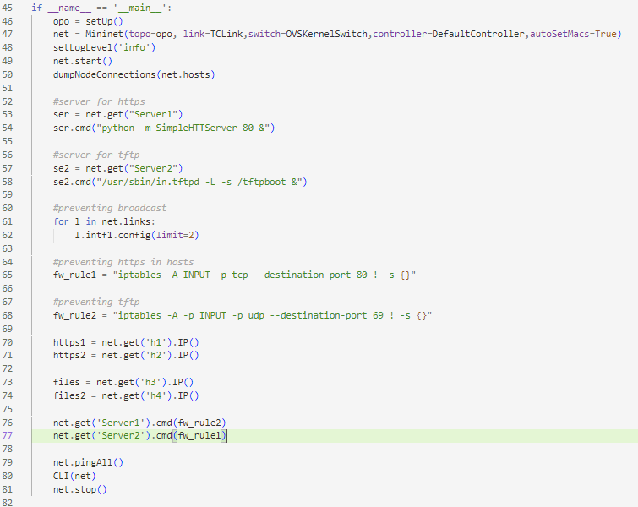The next bit is used to display node connections.

The controller control commands follows in closely, a control for server1 to only serve webpages, first the node is acquired by net.get() function and the control message is supplied in the cmd().

Server2 controls is also of the nature of the first to only server files request.

To prevent broadcast the nodes are limited to number of hosts to receive broadcast.

At the end a Mininet CLI is started to provide a platform for interacting with the network, after it exits, the emulation is stopped.

