PROJECT REPORT

On

Research Paper

Submitted To

DEPARTMENT OF COMPUTER SCIENCE AND ENGINEERING
FOR

CO-OP PROJECT AT INDUSTRY (MODULE-2)



Submitted By: Submitted To:
Name: Ananya Gupta, Diya Goyal, Dhruv Gupta, Jaskirat Singh Mr. Lalit`
University Roll No:2210991258, 2210991544, 2210991507, 2210990446
Semester: VIII
Session: 2025-2026



Index

S. No. | Topic | Page No.
1 | Introduction | 1
2 | Problem Statement | 1
3 | Title of Project | 2
4 | Objective | 2
5 | Options Available to Execute the Project | 3
6 | Similarity and AI Score | 3
7 | Future Scope | 4
8 | Conclusion | 4
9 | References | 5



Introduction

A lot of the time, modern web apps have to choose between quickly adding new features and keeping the best performance. As applications grow, bad dependency management, big bundle sizes, and slow data handling make them less efficient and add to their technical debt.

These problems have a big effect on user experience and system scalability in big Single Page Applications (SPAs). There are many ways to optimise, but most of the time they are only used after performance problems show up.

This research suggests a systematic, multi-tiered methodology to enhance performance in monolithic web applications without necessitating a total architectural transformation. The research seeks to embed performance as a continuous and enforceable component of the development process through the integration of observability, structural optimisation, automated governance, and an AppShell-based architecture.

Problem Statement

Big Single Page Applications (SPAs) often have performance problems because their bundles are too big, they don't manage dependencies well, and they fetch data in order. These problems make pages load slowly, use more network bandwidth, and make the user experience worse.

Most current solutions are reactive and don't enforce rules at the system level, which means that performance problems can happen again. To find, fix, and stop performance problems in a way that lasts, we need to take a proactive and organised approach.

1



Title of Project
Title: “Engineering Scalable Applications with Optimized Web Performance”
- The title “Engineering Scalable Applications with Optimized Web Performance” clearly represents the core idea of the project. The main goal of this research is to make large-scale web applications work better by using a structured and scalable method. This title reflects that. It stresses improving system architecture, managing dependencies, and making sure that performance stays high without having to switch to microservices completely.

Objectives:

The primary objective of this study is to improve the performance and scalability of large-scale monolithic Single Page Applications (SPAs) through a structured and proactive approach. The research focuses on identifying core performance bottlenecks, implementing architectural improvements, and ensuring that performance remains consistent through automated enforcement mechanisms:

- To analyze performance challenges in large-scale monolithic SPAs..
- To establish accurate performance measurement using high-fidelity observability techniques.
- To identify and eliminate structural causes of performance bottlenecks such as inefficient data fetching and dependency management.
- To implement automated governance using static analysis and CI pipelines to prevent performance regressions.
- To design a decoupled AppShell architecture for improved scalability and load performance.
- To evaluate the effectiveness of the proposed framework through measurable performance improvements.

2



5. Options Available to Execute the Project:

- Development Environment: Visual Studio Code
- Language Used: JavaScript / TypeScript
- Frameworks&Tools: React, Vite, Webpack
- Observability Tool: Datadog RUM (Real User Monitoring)
- Analysis Tool: Statoscope (for bundle analysis and visualization)
- Custom Tools: Import Tree Analyzer, Chrome Debug Extension
- Automation & Governance: ESLint, CI/CD pipelines

Similarity and AI Score

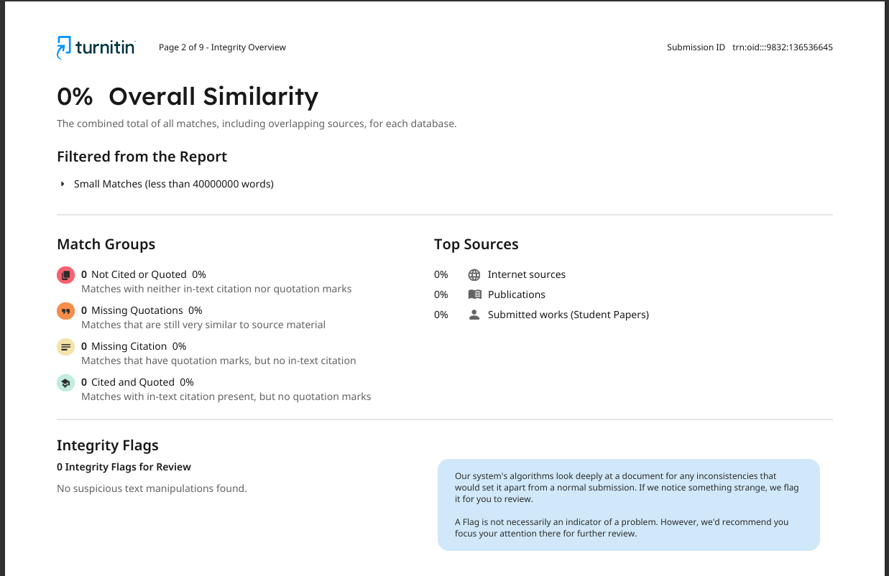

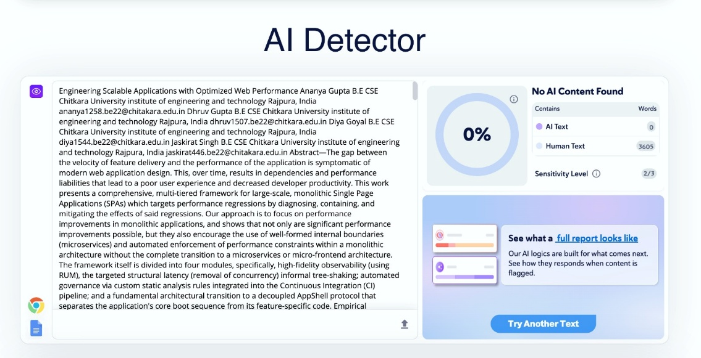

3


7. Future Scope

The future scope of this research is broad, with significant potential for further enhancement and real-world application. The proposed framework can be improved even more by adding advanced methods like machine learning to predict performance drops and give real-time suggestions for how to improve performance. You can also add support for different architectures, such as micro-frontends and server-side rendering (SSR). Better tools, like real-time IDE integration for dependency analysis and smarter prefetching strategies based on how users act, can make performance even better. In general, this method could help with scalable system design, making things easier for developers, and software engineering practices that focus on performance.

8. Conclusion

This study offers a systematic and anticipatory methodology for enhancing performance in extensive monolithic Single Page Applications (SPAs). The study shows that you can get big performance gains without completely switching to microservices by using high-fidelity observability, structural optimization, automated governance, and an AppShell-based architecture.

The results show that performance isn't just a result of optimization methods; it's also a result of clear architectural choices and ongoing enforcement. The framework makes sure that performance limits are built into the development lifecycle, which keeps things going for a long time and stops regressions. In general, this work stresses that treating performance as a core system property is important for making web apps that can grow, work well, and be easy to maintain.

4



9. References

- Datadog, Inc., “Real User Monitoring (RUM) – Browser Performance Tracking,” Datadog Documentation, 2024. Available: https://docs.datadoghq.com/real_user_monitoring/ (Accessed: 2026)
- Webpack Contributors, “Tree Shaking,” Webpack Documentation, 2024. Available: https://webpack.js.org/guides/tree-shaking/ (Accessed: 2026)
- Statoscope Contributors, “Toolkit for Webpack Bundle Analysis and Validation,” 2023. Available: https://statoscope.tech/ (Accessed: 2026)
- Addy Osmani, “JavaScript Start-up Performance,” Google Web Fundamentals, 2018. Available: https://developers.google.com/web/fundamentals/performance/optimizing-content-efficiency/javascript-startup-optimization (Accessed: 2026)
- Paul Irish, “The Cost of JavaScript in 2019,” Chrome Dev Summit, 2019. Available: https://v8.dev/blog/cost-of-javascript-2019
- Google Web.dev Team, “Core Web Vitals,” Google Developers, 2021. Available: https://web.dev/vitals/ (Accessed: 2026)
- Rollup Contributors, “Tree-Shaking and ES Module Bundling,” Rollup Documentation, 2024. Available: https://rollupjs.org/introduction/ (Accessed: 2026)
- Ilya Grigorik, High Performance Browser Networking, O'Reilly Media, 2013.
- Mozilla Contributors, “Page Visibility API,” MDN Web Docs, 2023. Available: https://developer.mozilla.org/en-US/docs/Web/API/Page_Visibility_API (Accessed: 2026)
- Google Chrome Team, “Service Workers: An Introduction,” Google Web Fundamentals, 2020. Available: https://developers.google.com/web/fundamentals/primers/service-workers (Accessed: 2026)
- ESLint Team, “Working with Rules,” ESLint Documentation, 2024. Available: https://eslint.org/docs/developer-guide/working-with-rules (Accessed: 2026)
- Mark Seemann, “Dependency Injection Principles, Practices, and Patterns,” Manning Publications, 2019.
- “Analyzing and Testing Web Application Performance,” Academia.edu, 2020 (approx.).
- Sourav Mondal, “Enhancing React Application Performance: Proven Strategies and Best Practices,” ResearchGate, 2021.
- “Optimising Performance in React Apps,” Theseus.fi, 2020.
- V. Veeri, “Performance Optimization Techniques in React Applications: A Comprehensive Analysis,” ResearchGate, 2022.

5

