Exercise 3:

Q1.

Status code: 200

Phrase: OK

Q2.

Date: Tue, 23 Sep 2003 05:29:50 GMT

Last Modified: Tue, 23 Sep 2003 05:29:00 GMT

Date is when the message is generated the first time, while the last modified time is the last time the server believes that the resource is modified.

Q3.

Connection is persistent by default as it is of type HTTP/1.1. Simply refer to under “connection length” tab, “Connection: Keep Alive”. Non persistent connection will be displayed as “Connection: close”.

Q4.

From picture 1 (below), the content length displayed as 73 bytes is the size of HTTP response in bytes.

**PIC 1**

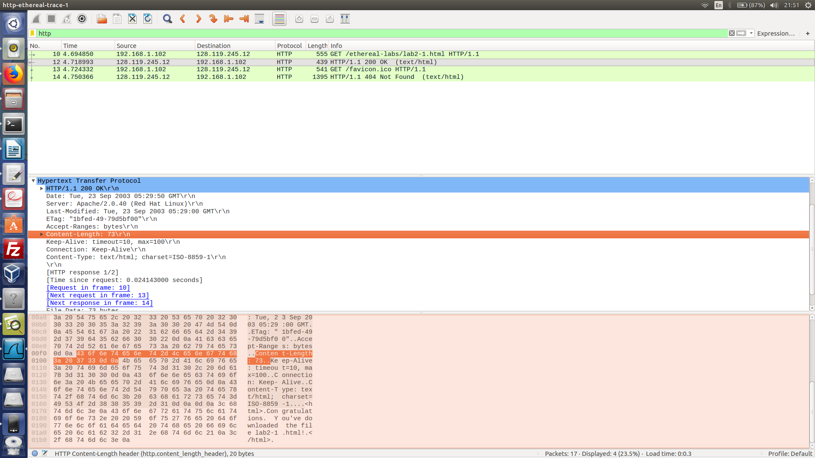

Q5. Data contained inside the HTTP response packet is the line based text data displayed is the response packet in picture 2:

**PIC 2**

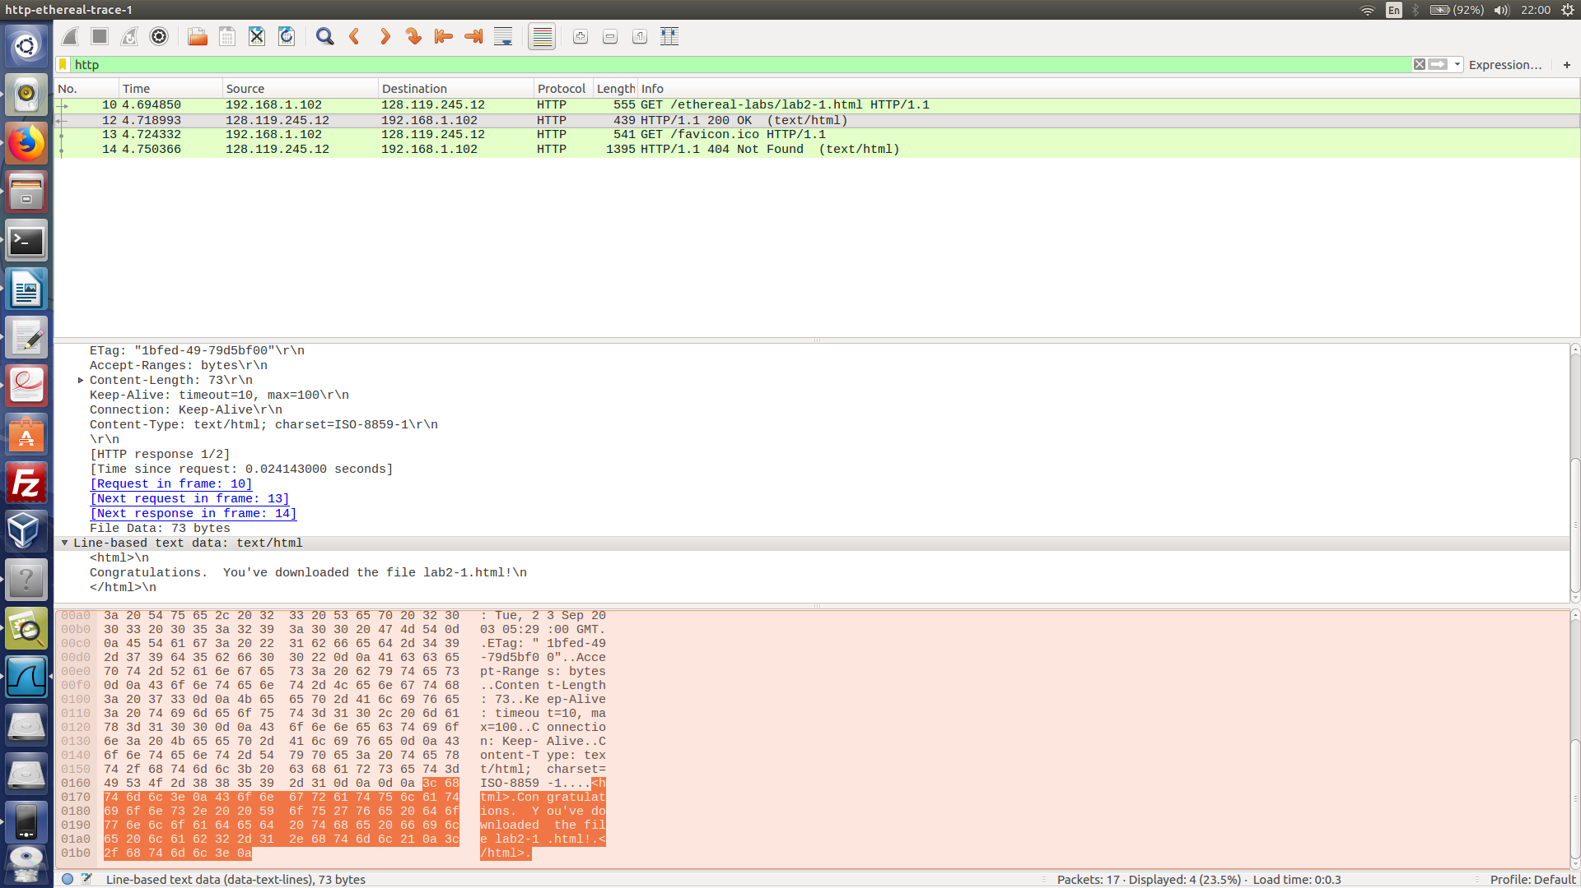

Exercise 4:

Q1.

**PIC 3**

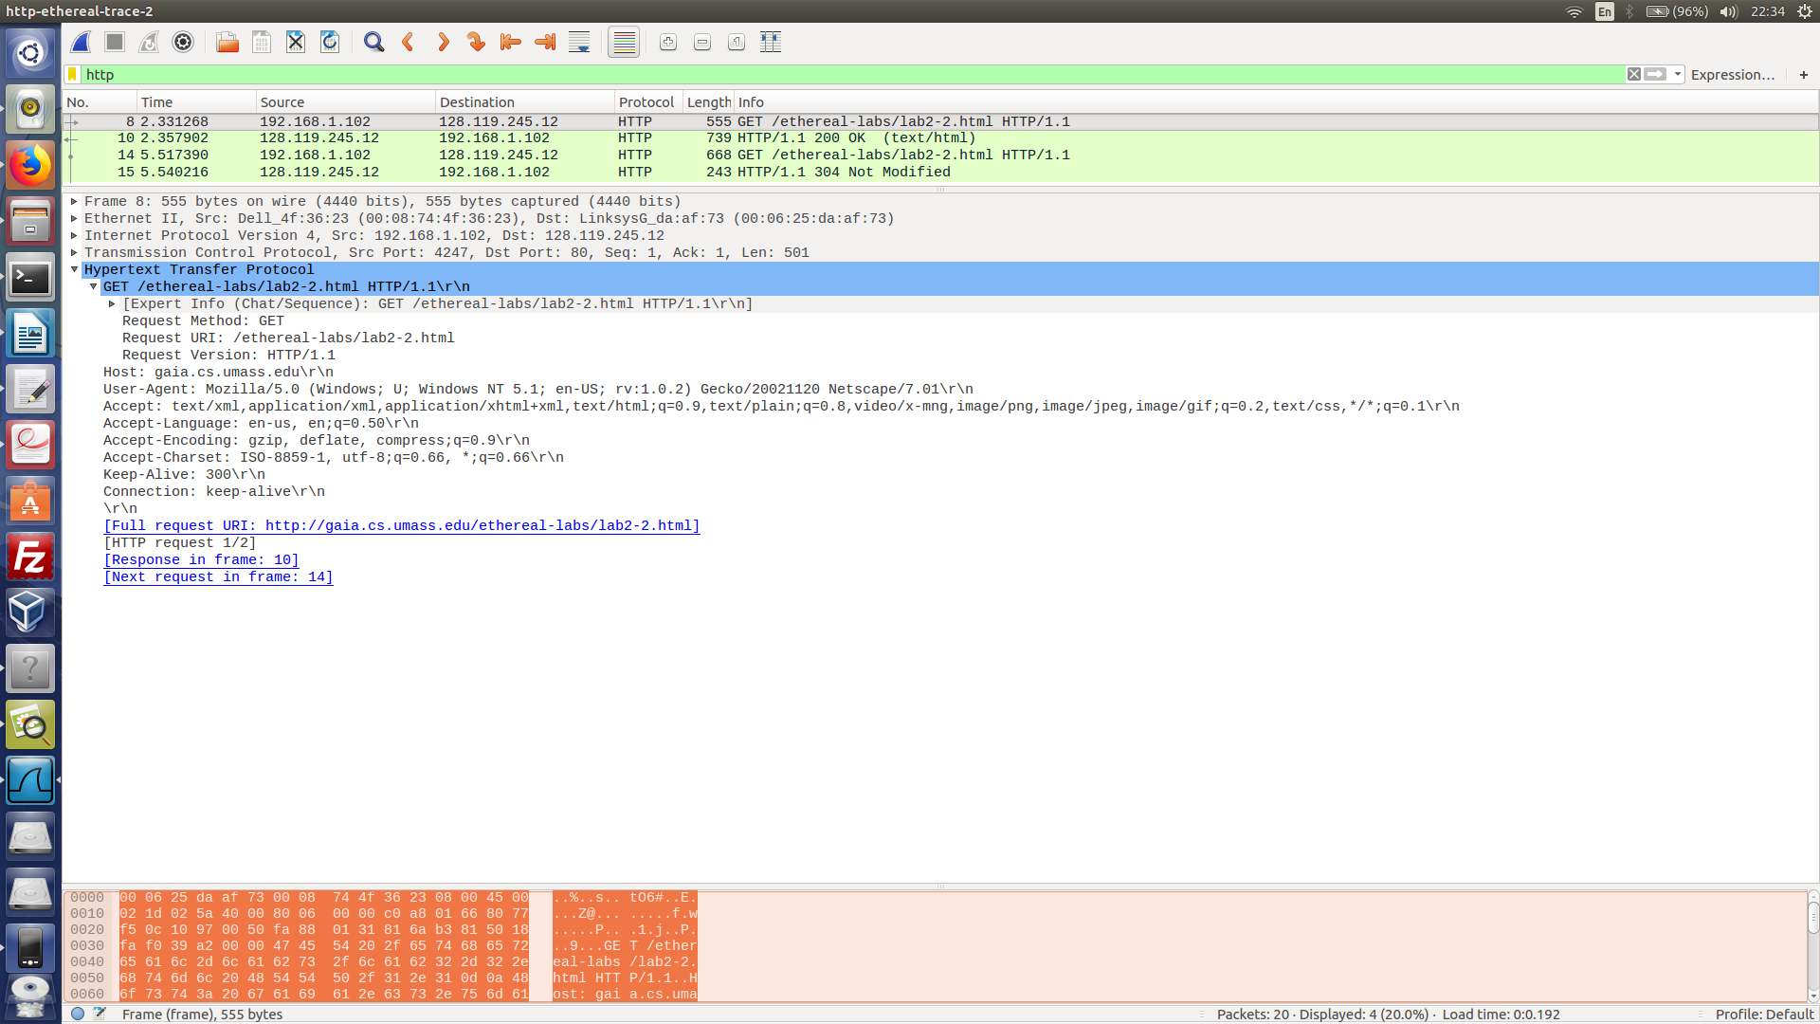**PIC 4**

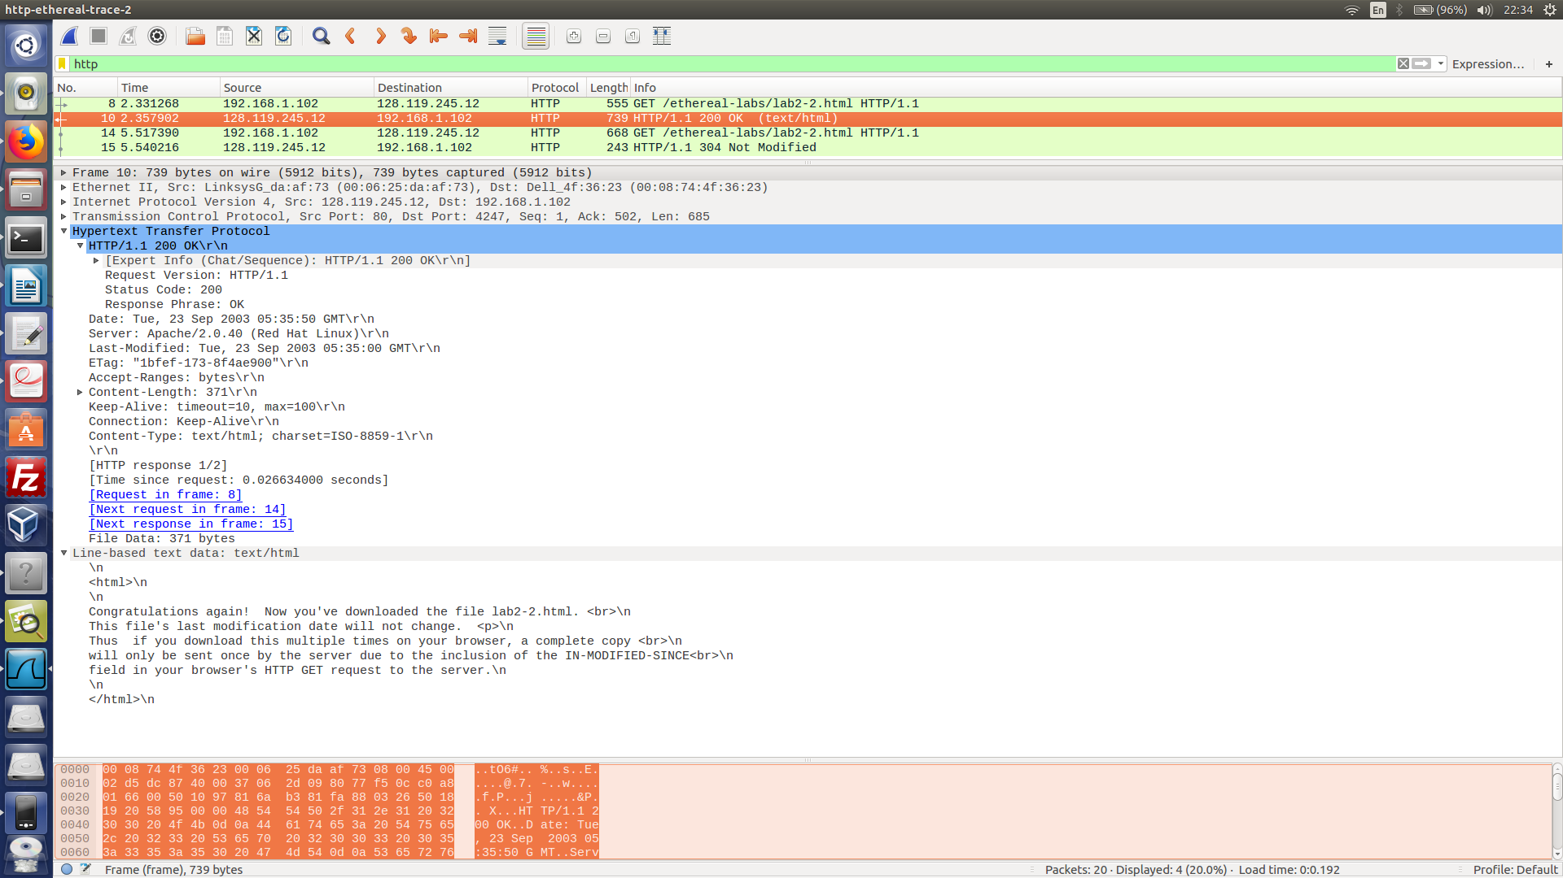

No. According to both pictures above.

Q2.

Yes. From above picture 4, the file is last modified Tue, 23 Sep 2003 05:35:50

**PIC 5**

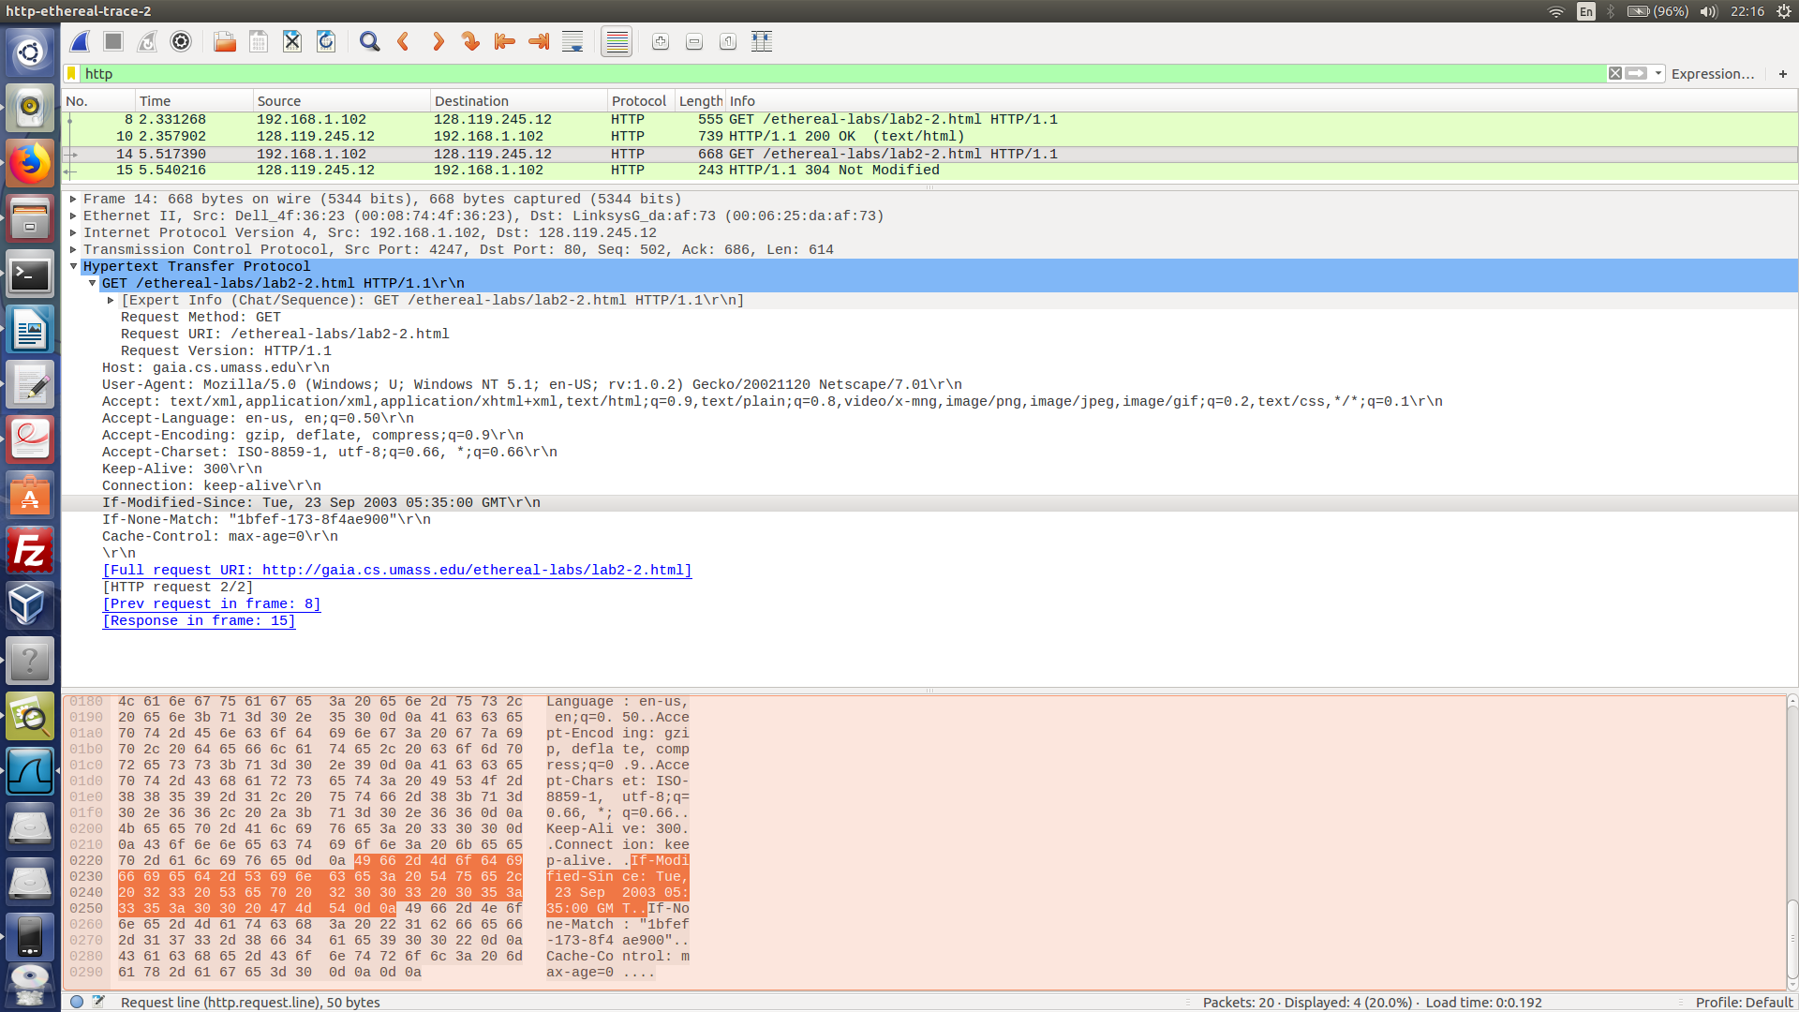

**PIC 6**

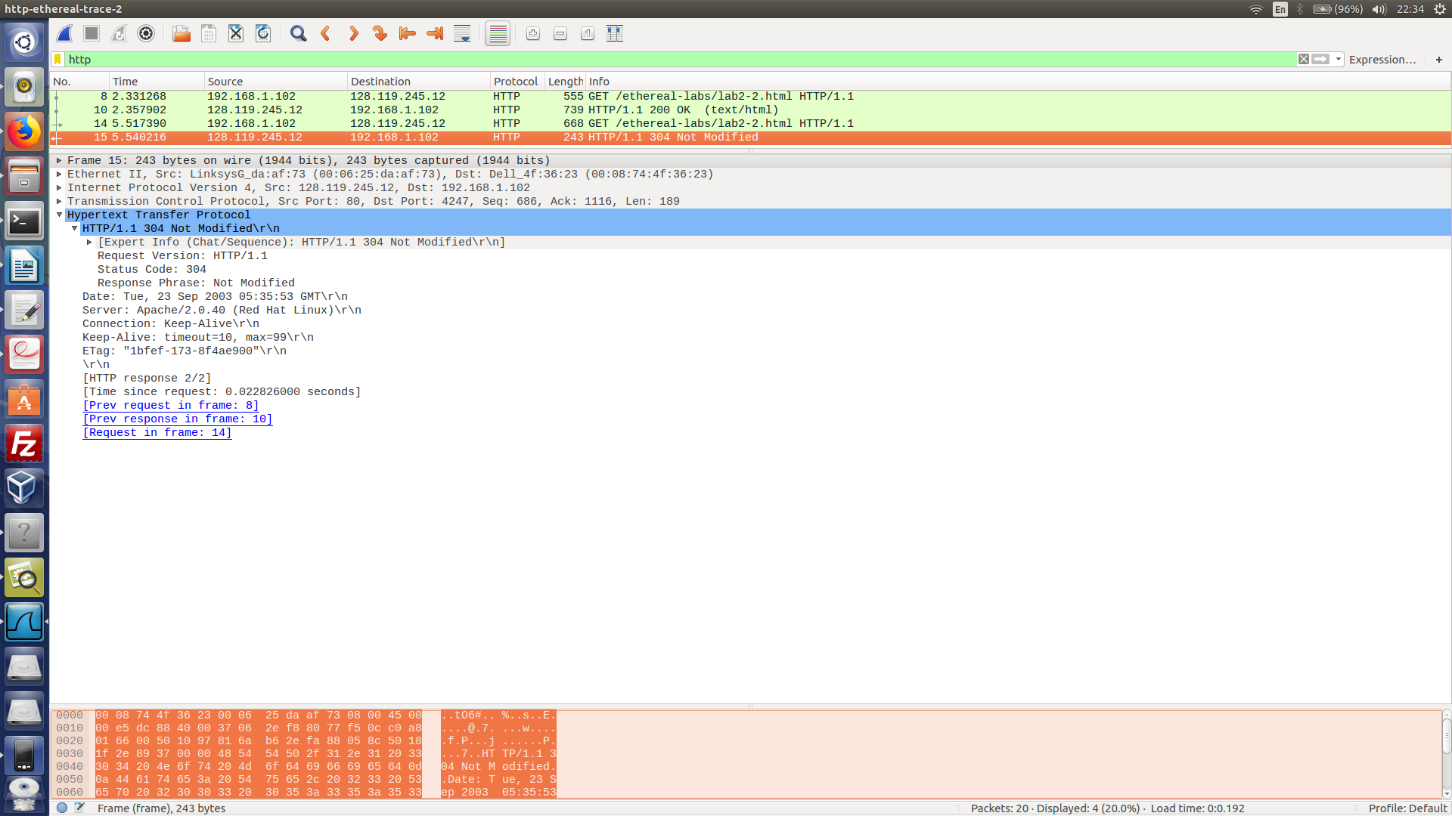

Q3, Q4.

Yes. IF-MODIFIED-SINCE displays the date of the last modification did on the file from a past GET request. IF-NONE-MATCH displays the ETAG value. The value shown depends on whether it is the same ETAG as the server’s, if true, status code 304 and empty body is returned back. In this case, code 304 and the phrase “Not Modified” is returned. The server did not explicitly return the contents as code 304 infer that an empty body is returned.

Q3, Q4.

“ETAG” has not changed from 1st to 2nd response. “ETAG” of the 1st  response (server side) is compared with the one received in request header. It is compared through server-side logic that checks whether a new copy of resource is needed judging if “ETAG” in both responses are the same. The result of the comparison is displayed through IF-NONE-MATCH header as a “ETAG” value in 2nd response. This “ETAG” value helps to infer whether the requested resources needed to be updated or not.