Exercise 3:

Q1.
IP: 150.203.161.98
Class IN, Type A query is made according to dig output.

Q2.
The canonical name is rproxy.cecs.anu.edu.au with IP 150.203.161.98.
Aliases are used as internet hosts can be identified in different ways. They are useful for humans to identify the location of the host within internet. Plus, some aliases’ length varies and can be hard to processed by routers, hence IP address is used instead.

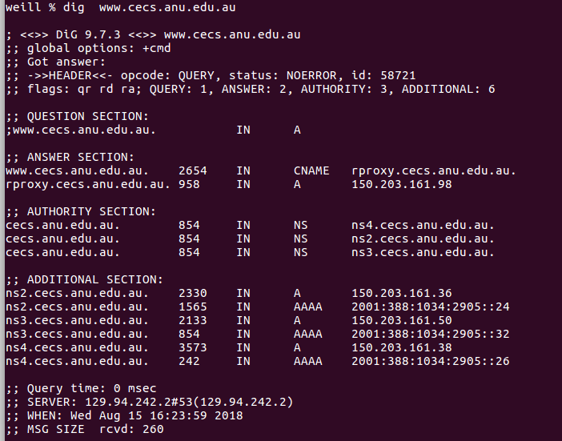

Q3.
The rest of the response:
i) Question Section: shows query being made to find host IP (or the A record for www.cecs.anu.edu.au)

ii) Authority section: Dig receives query answers through some authoritative name servers list under this section.

iii). Additional section: extra info provided that maybe wanted but not requested by dig command.

Q4.
(In the 1st picture)
IP of local name server : “;; SERVER: 129.94.242.2#53(129.94.242.2)”

Q5.
DNS name servers: (In the 1st picture)
- ns3.cecs.anu.edu.au. (IP: 150.203.161.50)
- ns2.cecs.anu.edu.au. (IP: 150.203.161.36)
- ns4.cecs.anu.edu.au. (IP: 150.203.161.38)
Type NS query is made.

Q6.
DNS name associated to this IP:
engplws008.ad.unsw.edu.au.
engplws008.eng.unsw.edu.au.
www.engineering.unsw.edu.au.

DNS query: PTR

Q7.
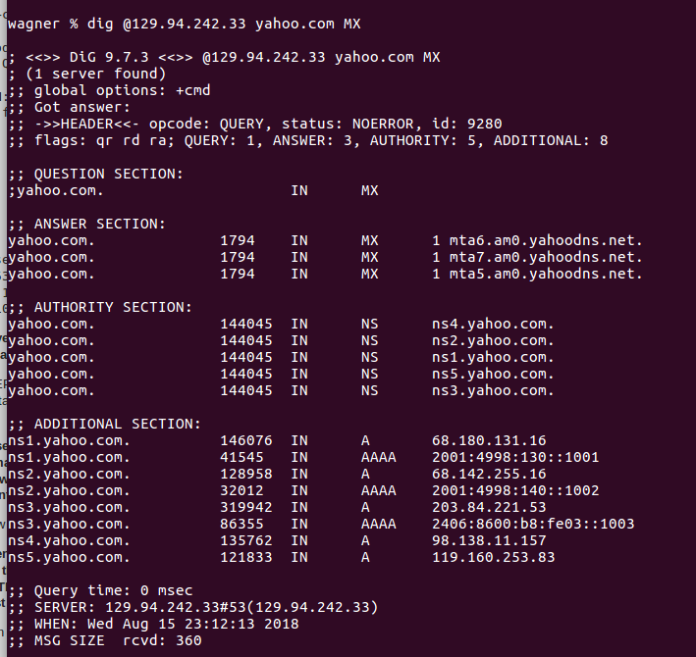
Judging by the flags with aa, the mail server did not give an authoritative answer. This is mostly due to its authority within EPFL domain.

Q8.
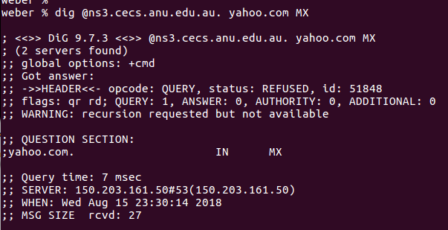

No reply is received from the mail server.
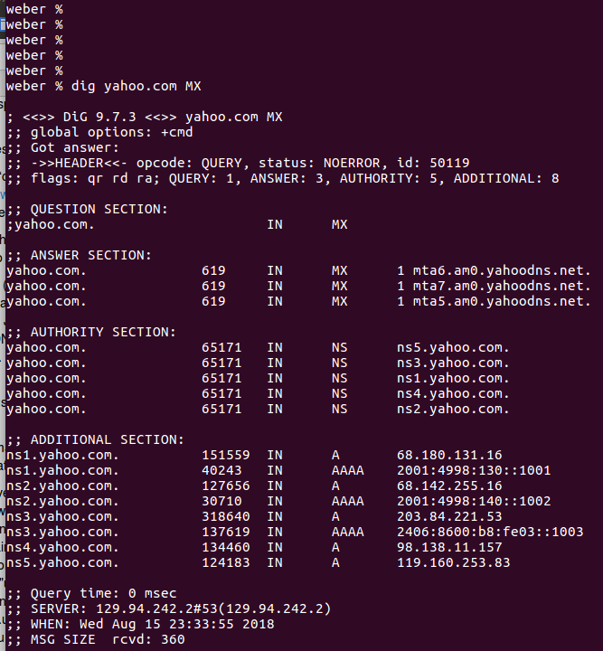
Q9.
A NS query is made to obtain authoritative answers from yahoo.com mail servers. The authoritative answers are listed under authority section.
Q10.
1. First, find the name server (query type NS) of the "." domain (root domain).

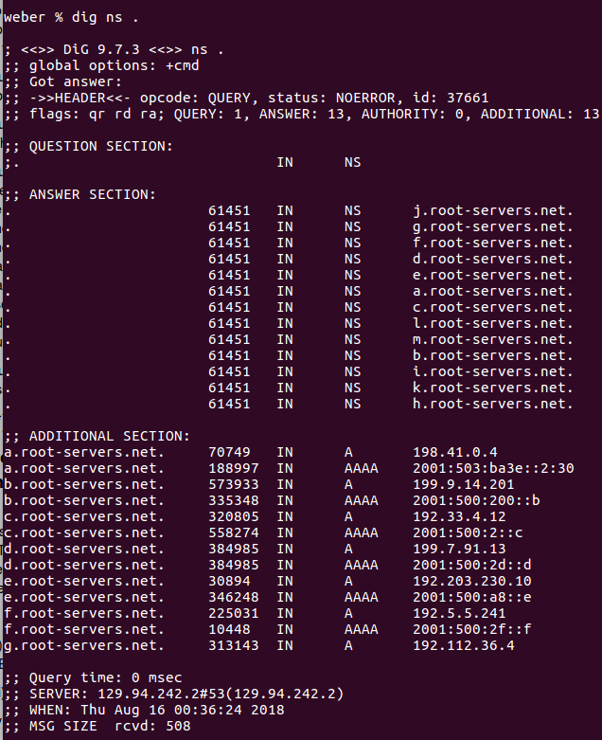

2. Query this nameserver to find the authoritative name server for the "au." domain.
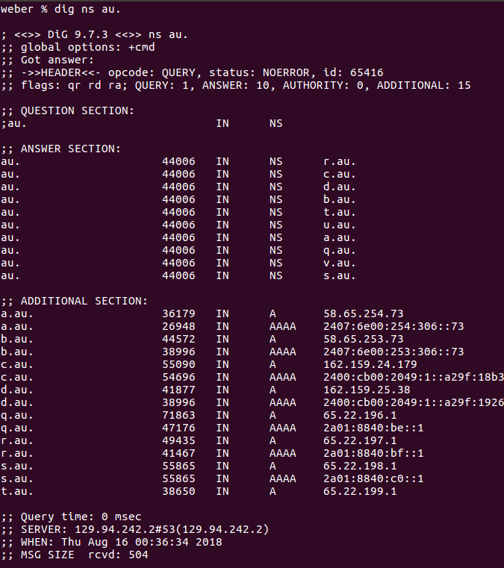

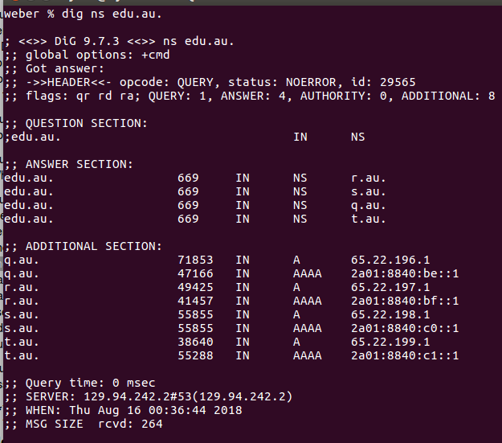
3. Query this second server to find the authoritative nameserver for the "edu.au." domain.

4. Now query this nameserver to find the authoritative nameserver for "unsw.edu.au".
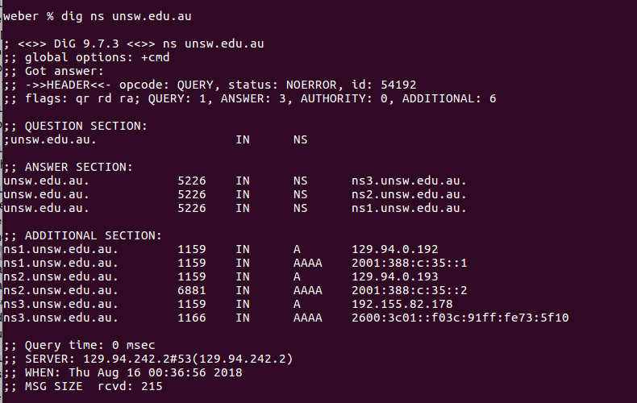

5 & 6. Next query the nameserver of unsw.edu.au to find the authoritative name server of cse.unsw.edu.au. Now query the nameserver of cse.unsw.edu.au to find the IP address of your host.
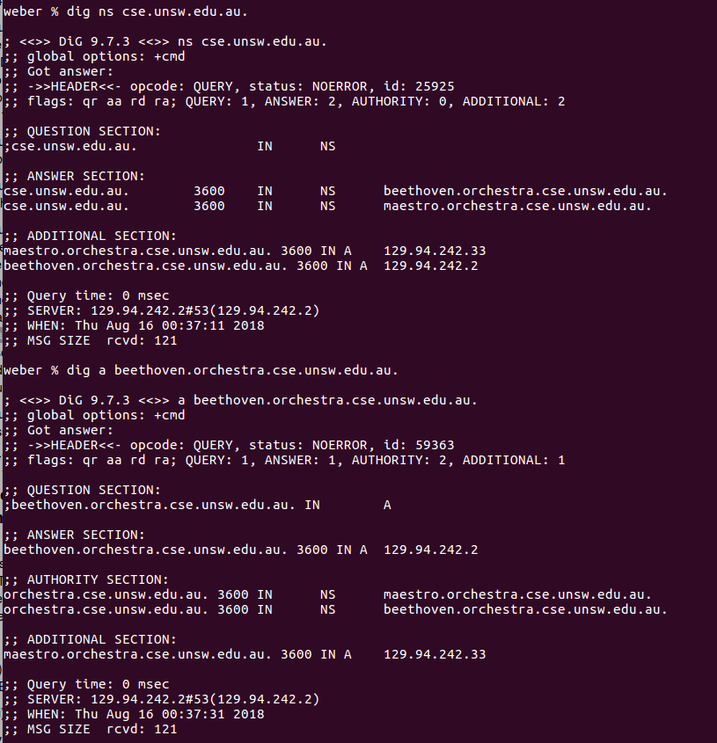

Hence around 6 DNS servers goes through query to get an authoritative answer.
Q11.
Most machines have multiple interfaces in network, in turn an interface can be associated with multiple IP addresses at the same time. Also an IP can have several aliases as well, hence while “dig”, query type cname is needed to find the canonical name of the machine.

