Exercise 1
Q1.
Maximum size of congestion window: 100 packets during slow start phase. (2 sec in slow-start)
When triple dupACKs is received congestion is detected, the transmit window size is recorded. TCP will now start with slow start thereshold that window size is reset to the recorded’s value halved (100 → 50). When window size is increased to around recorded value which is the congestion avoidance phase, it will increase more discreetly.

Q2.
From the graph:
- Avg Packet/sec throughput: 190
- IP & TCP headers = 20+20 = 40 bytes
- Packet payload: 500 bytes
- Ttl size transmitted: 540 bytes
- Bits/sec throughput = 540 * 8 bits (1 byte) *190 = 820800 bps

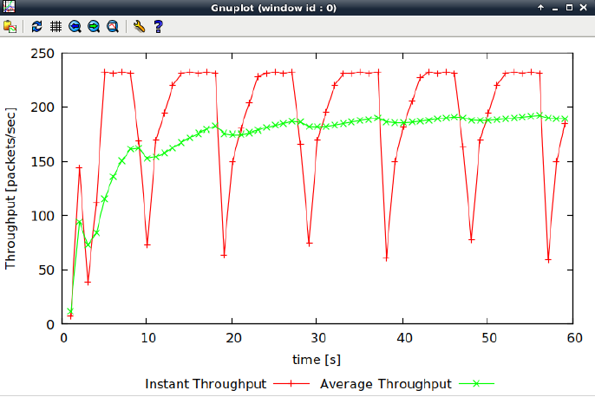

Q3.
Graph shows that TCP response stops oscillating when windows size if 66 packets.
Avg throughput: 231 packets/sec
Bps throughput: 540 * 8 bits (1 byte) * 231: 997920 bps (less than 1Mbps)

Q4.
TCP Reno has a fast recovery phase which keep the transmit window full, this can be observed from how congestion window does not become zero at all. The slow start threshold is instead set to new congestion window in the fast recovery phase. TCP throughput is observed to be around 200 packets per second as Bps throughput is 864000 (540bytes*8*200). TCP Reno performs slightly better as there is small increase in throughput compared to TCP Tahoe.
Exercise 2.
Q1.
Judging by how all lines lies on similar throughput value in the graph with only some minimal fluctuations, the capacity of the link is distributed equally.
Q2.
TCP congestion control plays a good role in balancing all flows, it will decrease the capacity previously distributed to release the resource for new incoming flow resulting in a fair distribution. The throughput is affected during these periods until a new balance is reach maintaining all flows.

Exercise 3.
Q1.
The Nam simulator shows a continuous flow of packets being sent at a higher throughput than the blue line underneath. Hence UDP is said to be faster than TCP.
Q2.
UDP has looser restrictions on congestion control (restricted window size etc) and processing protocol (handshakes during connection establish, headers and checksums etc) compared to TCP.
Q3.
Types | Advantages | Disadvantages
UDP | - Fast transmission | - The packets sent might not remain intact and arrives in proper order.  - Unreliable as recovery is not possible if a data packet is lost.
TCP | - Efficient and secure transmission of data. | - Slow transmission

The type of connection used is largely dependent on the importance of data integrity. UDP is generally preferred when speed is valued for performance.

