# NoSQL Use Cases

## 1. Introduction

NoSQL (Not Only SQL) databases are designed to handle unstructured, semi-structured, and structured data with scalability and flexibility. Unlike traditional relational databases, NoSQL systems support dynamic schema design, distributed storage, and high availability, making them ideal for modern data-intensive applications.

## 2. Key Characteristics of NoSQL Databases

• Schema-less data model

• Horizontal scalability

• High performance and low latency

• Support for large-scale distributed systems

• Flexibility for different data types (key-value, document, column, graph)

## 3. General NoSQL Data Flow

The following diagram represents a generic flow of data in a NoSQL-based system:

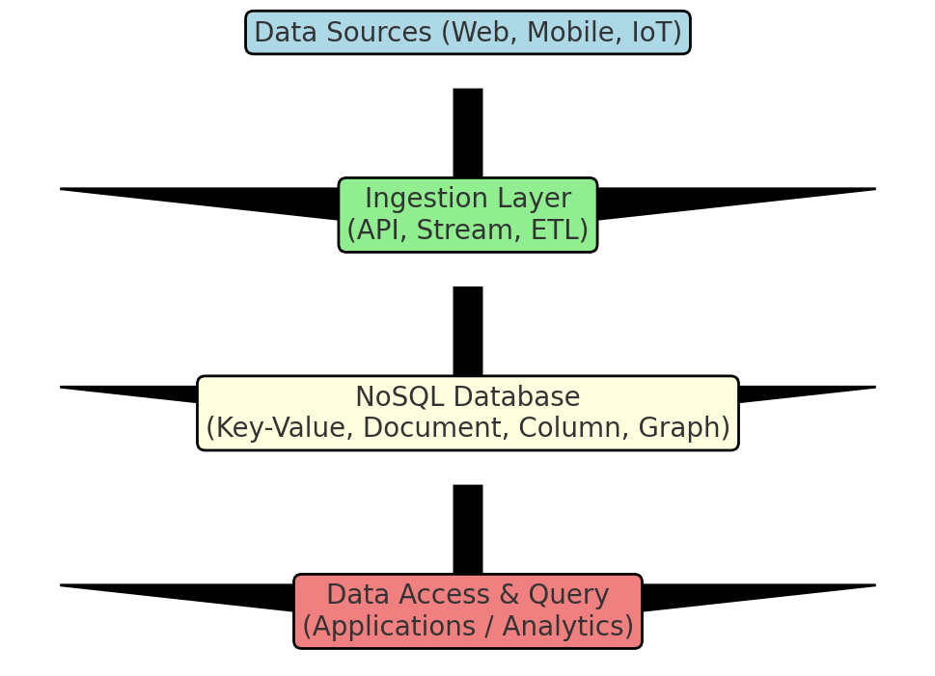

## 4. Common Use Cases of NoSQL Databases

### 4.1 Social Media Platforms

NoSQL databases are widely used in social media applications to store user profiles, posts, relationships, and real-time feeds. Graph databases like Neo4j or key-value stores like Redis help manage relationships and provide fast query responses.

### 4.2 E-Commerce

E-commerce platforms leverage NoSQL to manage product catalogs, customer sessions, recommendations, and cart data. Document stores like MongoDB are popular for their ability to handle dynamic product data structures.

### 4.3 IoT Applications

NoSQL databases are well-suited for IoT use cases that generate massive, time-series data. Column-family stores like Cassandra efficiently handle continuous data ingestion and real-time analysis.

## 5. Example Use Case: E-commerce System Flow

This flowchart shows how data moves through a NoSQL-based e-commerce system:

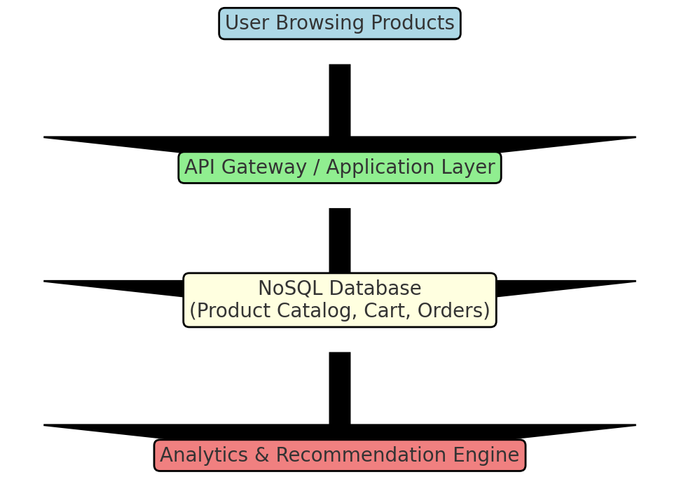

## 6. Conclusion

NoSQL databases provide the flexibility and scalability required for modern applications. They enable organizations to efficiently store and process large, diverse datasets while maintaining performance and adaptability. Choosing the right NoSQL type—key-value, document, column-family, or graph—depends on the specific use case and data model.