A
Project Report
On
'LIFEFLOW BLOOD DONATION MANAGEMENT SYSTEM'

Submitted to

Gokul Global University, Sidhpur

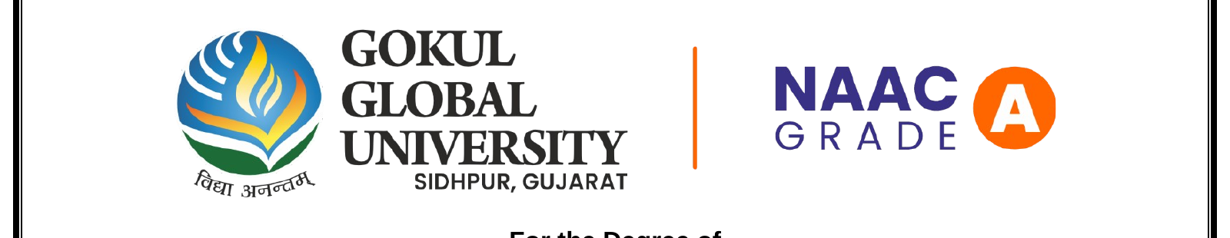

For the Degree of

BACHELOR OF COMPUTER APPLICATION (SEM-VI)

Submitted By  GOVIND DESAI  (Enrollment No.: 23001102022)  DHRUV SOLANKI  (Enrollment No.: 23001102031) | Guided By  Mr. Rajan Sir  Assistant Professor  Faculty Of Computer Science & Applications  Gokul Global University, Sidhpur

Gokul College of Computer Science & Applications
Gokul Global University
Opp. I.O.C Depot, Siddhpur-384151

MAY-2026

CERTIFICATE

This is to certify that Dhruv Solanki (Enrollment No. 23001102031) And Govind Desai (Enrollment No. 23001102022) of Bachelor Of Computer Application Semester 6th in the Faculty of Computer Science & Applications during the academic year 2025-26 at The GOKUL GLOBAL UNIVERSITY SIDHPUR.

They have carried out the project Entitled: "LIFEFLOW BLOOD DONATION MANAGEMENT SYSTEM". They are sincere and regular student as per my knowledge.

Date:
Place:

Internal Guide | Dean of Faculty of Computer Science & Applications

MAY-2026

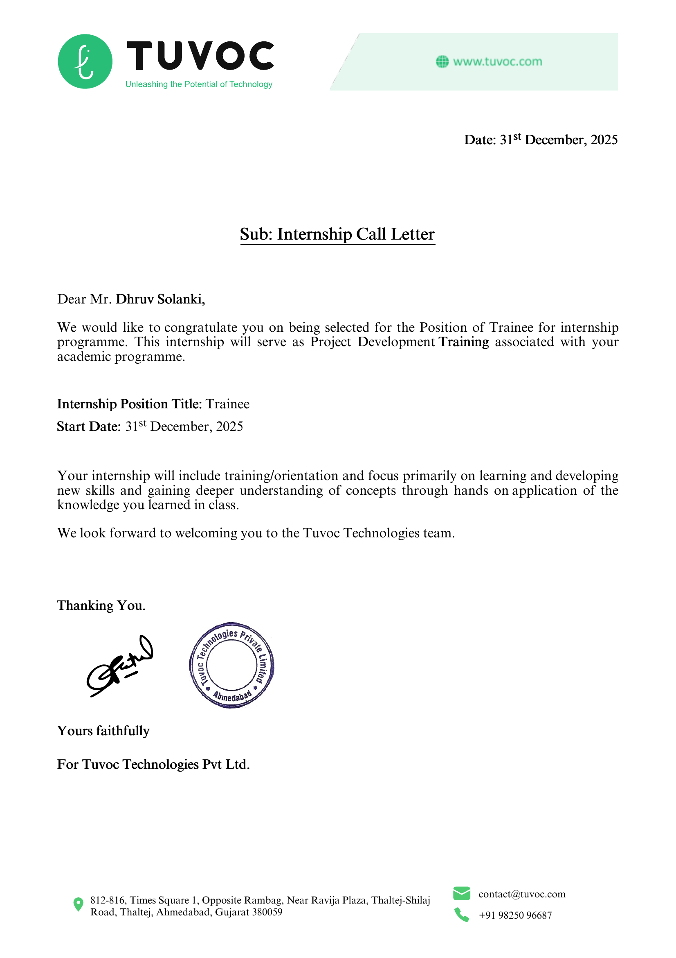

DECLARATION

We hereby Govind Desai & Dhruv Solanki declare that the project entitled 'LIFEFLOW BLOOD DONATION MANAGEMENT SYSTEM' is an original work carried out by us under the guidance of Mr. Rajan Sir for the part fulfilment of the award of the Bachelor Of Computer Application in Faculty of Computer Science And Applications, Gokul Global University, Sidhpur.

The Project work has been carried out from 01/01/2026 to 30/04/2026.

The matter embodied in this Project has not been submitted anywhere else for the award of any other Degree/Diploma.

Date:
Place:

Signature

GOVIND DESAI
DHRUV SOLANKI

ACKNOWLEDGEMENT

We wish to express our deep sense of gratitude to our guide Mr. Rajan Sir for introducing the Present topic as project for us and for his inspiring guidance and valuable suggestion throughout this project work. His efforts have provided us an insight of multifarious. His advice and attitude as a guide is commendable.

We are thankful to our Sir Mr. Rajan Sir, Faculty Of Computer Science & Applications for giving us the opportunity to work in the department. We would like to express our thanks to all the member of Faculty of Computer Science & Applications for any kind of help and support during the project work. Thanks all our dear friends for their continuous help and support.

INDEX

No | Contents | Page No
1 | Project or Company Profile | 1
2 | Functional Requirement Specification | 1
3 | Module Specification | 2
4 | User Specification | 3
5 | About System | 3
6 | About Existing System | 4
7 | Need for New System | 4
8 | Technical Requirement Specification | 5
9 | Hardware Requirement | 5
10 | Software Requirement | 6
11 | System Flow Chart | 7
12 | UML Diagrams | 8
13 | Data Dictionary | 9
14 | Input & Output Design | 10
15 | Testing | 11
16 | Future Enhancement | 12
17 | Conclusion | 12
18 | Bibliography / References | 13

1. Project Profile — LifeFlow Blood Donation Platform
LifeFlow is a full-stack, AI-powered blood donation management web platform designed to bridge the critical gap between blood donors and recipients. The platform connects donors, recipients, hospitals, blood banks, and organizations in real time, addressing the persistent crisis of blood shortages in the healthcare ecosystem. Built using React 19, Node.js, MySQL, and JWT-based authentication, LifeFlow is a final-year BCA project submission for the academic year 2025–2026.

Field | Details
Project Name | LifeFlow Blood Donation Management System
Project Type | Full-Stack Web Application (React 19 + Node.js + MySQL)
Developers | Govind Desai (Enrollment: 23001102022) | Dhruv Solanki (Enrollment: 23001102031)
Academic Year | 2025–2026 | BCA Semester VI
University | Gokul Global University, Sidhpur
Technologies | React 19 · Node.js · Express v5 · MySQL · Sequelize ORM · Prisma · JWT · Leaflet.js
Key Highlights | 50+ Verified Hospitals · 8 Blood Types · 19 Features · 3 User Roles

2. Functional Requirement Specification
The following functional requirements define what the LifeFlow system must accomplish to fulfil the needs of all stakeholders — donors, recipients, hospital staff, and administrators.

ID | Feature | Description
FR-01 | User Registration & Login | Donors, recipients and hospital staff can register and log in securely using JWT-based authentication.
FR-02 | Blood Donation Scheduling | Donors can browse active donation camps and book time slots via an interactive map.
FR-03 | Real-Time Inventory | Hospitals can view and update live blood-group inventory including urgent request alerts.
FR-04 | Emergency Request Alerts | Recipients can submit emergency blood requests; matching donors receive push notifications.
FR-05 | AI Chatbot | An embedded AI assistant answers donor queries, eligibility questions, and camp information.
FR-06 | Blood Compatibility Checker | Users can check cross-compatibility between any two blood types before requesting a transfusion.
FR-07 | Gamified Badge System | Donors earn XP points and unlock tier badges (Starter → Legend) after each donation.
FR-08 | Community Hub | Donors share stories, read awareness articles, and interact via likes, comments, and shares.

3. Module Specification
• Authentication Module: Manages user registration, login, JWT token generation with Bcrypt password hashing, and role-based access control for donors, recipients, hospital admins, and super-admins.
• Home & Discovery Module: Provides the landing page with a live ticker (real-time alerts), featured hospitals, emergency indicators, and navigation to all sub-modules. Animated with Framer Motion.
• Donation Camps Module: Displays interactive React-Leaflet maps with all active camps, real-time slot counters, search filters by city/hospital, and one-click booking via Axios API calls.
• Heroes / Gamification Module: Tracks XP points per donation, assigns tier badges (7 levels), and maintains a public leaderboard updated in real time — state managed via Zustand.
• Donor Dashboard Module: Shows each donor's donation history, earned badges, XP rank, percentile standing, and a personal impact counter (lives saved). Data fetched from MySQL via Sequelize.
• Blood Analytics Module: Displays live blood-group inventory per hospital, active donor counts, regional critical needs, and supply-demand trend charts pulled from MySQL tables.
• Emergency Module: Allows recipients to post urgent blood requests; the system queries MySQL for compatible donors and triggers instant in-app notifications.
• Community Hub Module: A social feed for donors to share personal stories with blood-group tags; supports likes, comments, and awareness news articles. Built with React 19 + Framer Motion.
• Admin Panel Module: A full management interface for super-admins to manage users, hospital registrations, camp approvals, inventory edits, and generate reports from MySQL data.

4. User Specification
LifeFlow supports four distinct user roles, each with specific privileges and workflows:

Role | Description | Key Permissions
Donor | Registered individuals who donate blood voluntarily. | Register · Book camp slots · Earn XP · View badges · Post stories
Recipient | Patients or caregivers seeking compatible blood units. | Search inventory · Submit emergency requests · View camp locations
Hospital Admin | Staff managing a registered hospital's data. | Update inventory · Approve camps · View requests · Manage registrations
Super Admin | Platform administrator with full system access. | Manage all users · Approve hospitals · View analytics · Generate reports

5. About the System
LifeFlow is a cloud-ready full-stack web application that serves as a centralised blood donation ecosystem. Built on React 19 (frontend), Node.js + Express v5 (backend), and MySQL with Sequelize ORM and Prisma Schema (database), LifeFlow integrates real-time data streams, geolocation services, and community engagement into a single cohesive platform.
- Real-time blood inventory tracking with hospital-level granularity via MySQL + Sequelize
- Interactive React-Leaflet donation camp maps with live slot availability
- 7-tier gamified badge system to reward and retain active donors
- Smooth UI animations and transitions powered by Framer Motion
- Blood compatibility matrix covering all 8 major blood groups
- Community hub with awareness articles and peer story sharing
- Emergency alert system with donor-recipient smart matching
- Zustand-powered global state for seamless cross-component data sharing
- Vite-optimised build for fast load times and hot module replacement
- Comprehensive analytics dashboard for administrators

6. About the Existing System
Before LifeFlow, blood donation management in India relied predominantly on manual processes, phone calls, and fragmented hospital databases. The following limitations characterised the existing ecosystem:
- No centralized platform connecting donors, hospitals, and recipients simultaneously
- Blood shortage data updated manually with significant delays
- No real-time emergency matching — recipients depended on personal networks
- Lack of donor motivation mechanisms — no rewards, tracking, or engagement tools
- Camp schedules shared through paper notices or informal social media posts
- No AI assistance for donor eligibility or compatibility guidance
- Data silos between hospitals leading to duplication and inefficiency

7. Need for the New System
The healthcare sector in India faces a perennial blood shortage crisis. According to WHO reports, the country requires approximately 15 million units of blood annually, of which a significant deficit remains. LifeFlow addresses this through:
- Centralisation: A single platform for donors, hospitals, and recipients eliminates fragmentation
- Speed: Real-time inventory and emergency alerts reduce critical response times from hours to minutes
- Retention: Gamification (XP, badges, leaderboards) increases repeat donor participation
- Reach: Interactive maps and AI chatbot reduce geographic and information barriers
- Safety: Blood compatibility checker prevents mismatched transfusions
- Awareness: Community hub and news panel drive public education on blood donation

8. Technical Requirement Specification

Category | Technology / Specification
Frontend Framework | React 19 (with Hooks, React Router v7, Framer Motion animations)
Styling | Tailwind CSS — utility-first CSS framework
Mapping Library | Leaflet.js + React-Leaflet for interactive donation camp maps
State Management | Zustand — lightweight global state management
HTTP Client | Axios — promise-based HTTP client for API calls
Build Tool | Vite — fast frontend build tool and dev server
Backend Runtime | Node.js with Express.js v5 REST API
Authentication | JSON Web Tokens (JWT) + Bcrypt password hashing
Database | MySQL — relational database management system
ORM / Schema | Sequelize ORM + Prisma Schema + mysql2 Driver
API Architecture | RESTful APIs with JSON payloads; JWT Bearer token authentication
Version Control | Git with GitHub repository
Deployment | Vercel (Frontend) · Railway / Render (Backend) · PlanetScale (MySQL)

9. Hardware Requirement

Component | Minimum Requirement | Recommended
Processor | Intel Core i3 / Ryzen 3 | Intel Core i5/i7 or Ryzen 5/7
RAM | 4 GB | 8 GB or more
Storage | 20 GB free disk space | SSD with 50 GB free
Network | Broadband (10 Mbps) | Stable 50 Mbps+ connection
Display | 1280 × 720 resolution | 1920 × 1080 Full HD
Server (Deploy) | 1 vCPU, 512 MB RAM | VPS 2 vCPU, 2 GB RAM cloud instance

10. Software Requirement

Software / Tool | Version / Details | Purpose
Node.js | v20 LTS or higher | Backend runtime environment
React | v19.x | Frontend UI library
Express.js | v5.x | Backend web framework
MySQL | v8.x | Relational database management system
Sequelize ORM | v6.x | MySQL object-relational mapping
Prisma | Latest | Schema definition & DB migrations
mysql2 | Latest | MySQL driver for Node.js
JWT (jsonwebtoken) | v9.x | Stateless authentication tokens
Bcrypt | v5.x | Password hashing & verification
Vite | v5.x | Frontend build tool & dev server
Tailwind CSS | v3.x | Utility-first CSS styling
Framer Motion | Latest | Animations & UI transitions
Leaflet / React-Leaflet | Latest | Interactive donation camp maps
Zustand | Latest | Global state management
Axios | Latest | HTTP client for API requests
React Router | v7.x | Client-side routing
Git / GitHub | Latest | Source code version control
VS Code | Latest | Development IDE
Postman | Latest | API testing & documentation
Web Browser | Chrome / Firefox (latest) | Application runtime for users

11. System Flow Chart
The following describes the high-level operational flow of the LifeFlow system from user entry to the completion of a donation or emergency response cycle:
Step 1 — User Registration / Login
A new user registers as Donor, Recipient, or Hospital Admin. Password is hashed with Bcrypt, credentials stored in MySQL, and a JWT token is issued via Express v5 API upon successful login.
Step 2 — Role-Based Dashboard
React Router v7 routes the authenticated user to their personalised dashboard. Zustand stores the session state; Axios fetches dashboard data from the Node.js REST API.
Step 3 — Browse / Search
Donors browse React-Leaflet camp maps; Recipients search MySQL blood inventory by group and location; Hospitals view incoming requests from their admin panel.
Step 4 — Action Execution
Donor books a camp slot → confirms donation → XP awarded and written to MySQL via Sequelize. Recipient submits emergency request → system queries MySQL for compatible donors → notifications sent.
Step 5 — Database Update
MySQL tables are updated instantly via Sequelize ORM. Prisma schema migrations keep the DB structure in sync. Leaderboard and badge tiers are recalculated and reflected on next fetch.
Step 6 — Community Engagement
Donor optionally posts a story to the Community Hub using the React 19 form (animated with Framer Motion). Admin reviews reports and approves new hospital registrations from the admin panel.

Figure 11.1 — LifeFlow System Flowchart (High-Level Operational Flow)

12. UML Diagrams
The system design is captured through the following UML diagrams. Descriptions are provided for each diagram type used in LifeFlow.

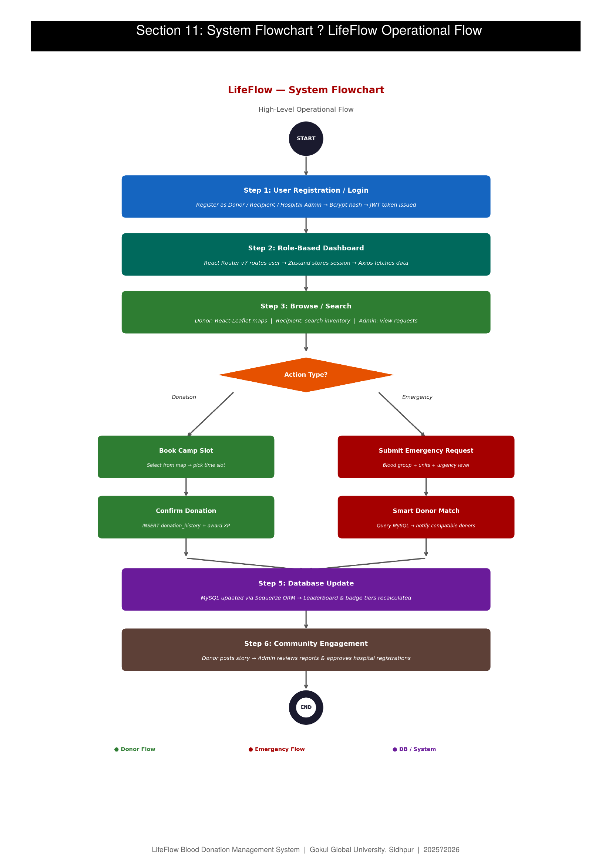

12.1 Use Case Diagram
Illustrates interactions between actors (Donor, Recipient, Hospital Admin, Super Admin) and system use cases such as Register, Donate, Request Blood, Manage Inventory, and View Reports.
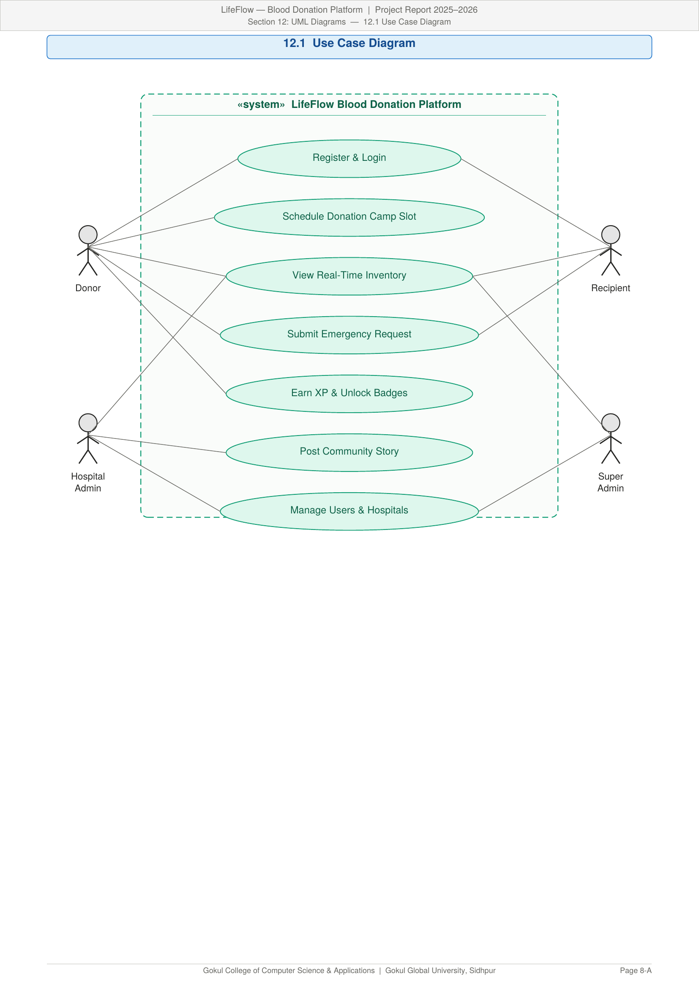
Figure 12.1 — Use Case Diagram

12.2 Class Diagram
Depicts the object-oriented structure of LifeFlow — key classes include User, Donor, Recipient, Hospital, BloodBank, DonationCamp, EmergencyRequest, Badge, and CommunityPost with their attributes and relationships.
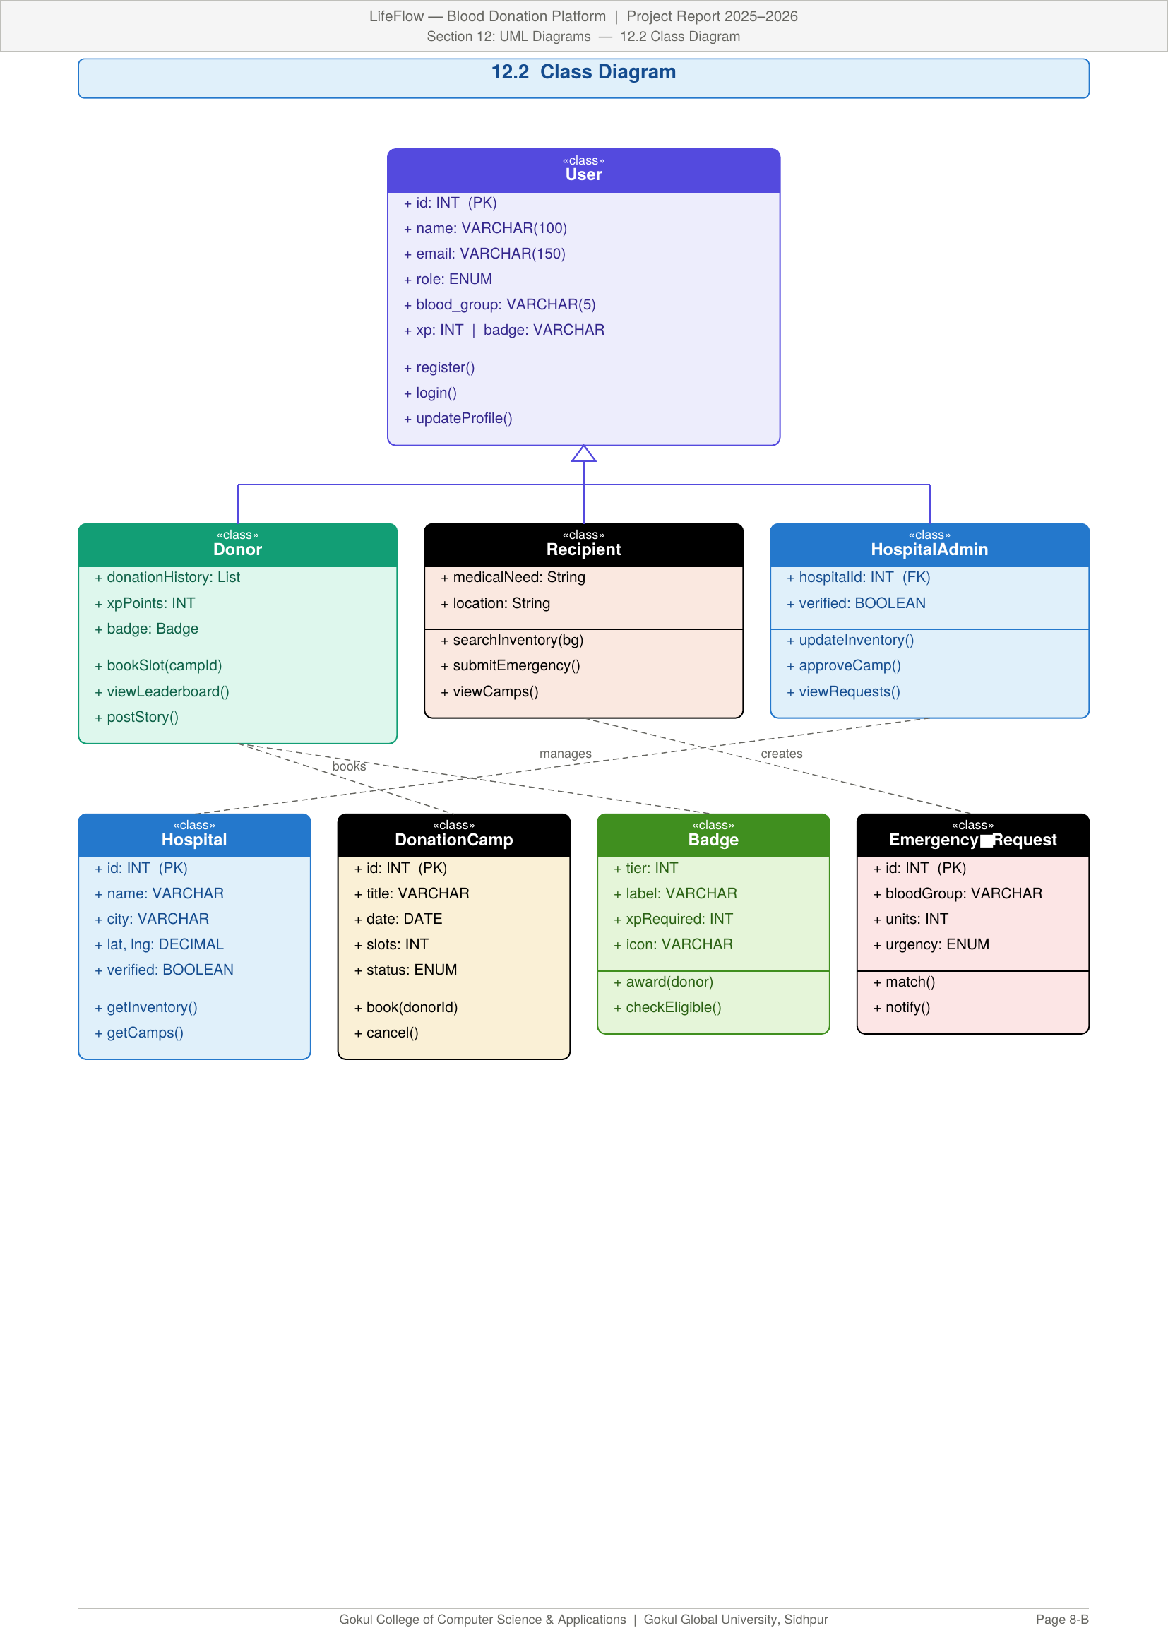
Figure 12.2 — Class Diagram

12.3 Sequence Diagram
Shows the time-ordered message flow for core operations: Donor Login & Camp Booking, Emergency Blood Request & Notification, Admin Approving a Hospital Registration.
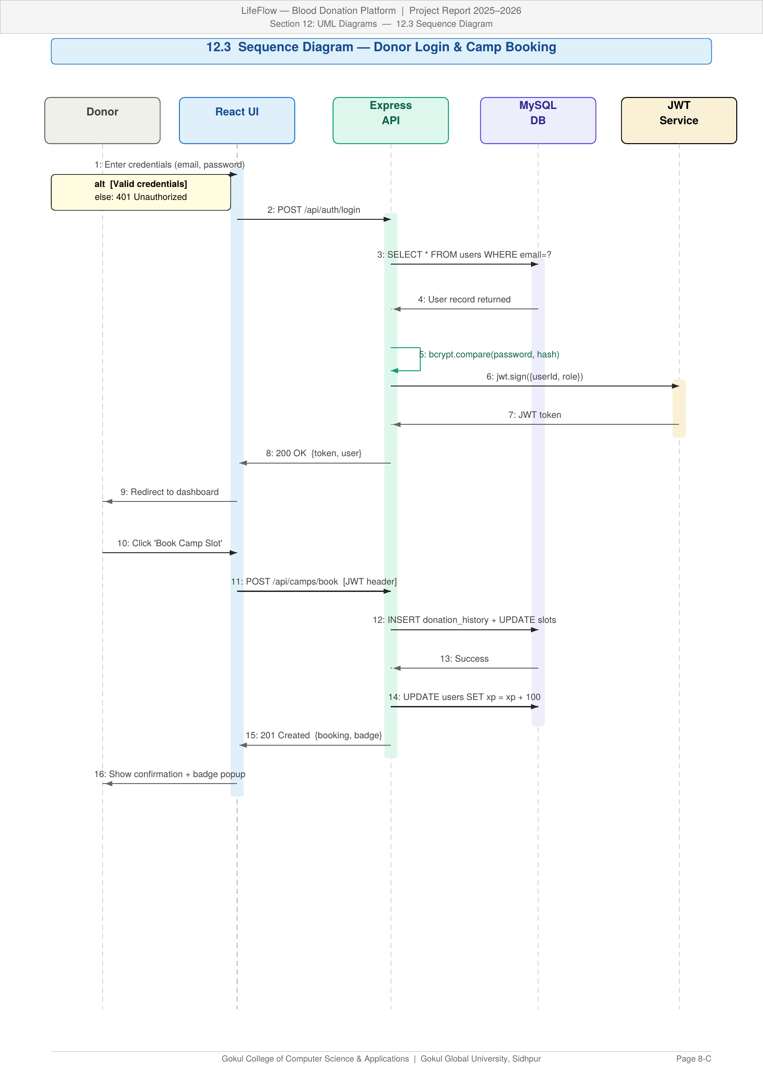
Figure 12.3 — Sequence Diagram: Donor Login & Camp Booking

12.4 Activity Diagram
Describes step-by-step workflows for Donor Registration, Emergency Request Resolution, and Blood Inventory Update processes.
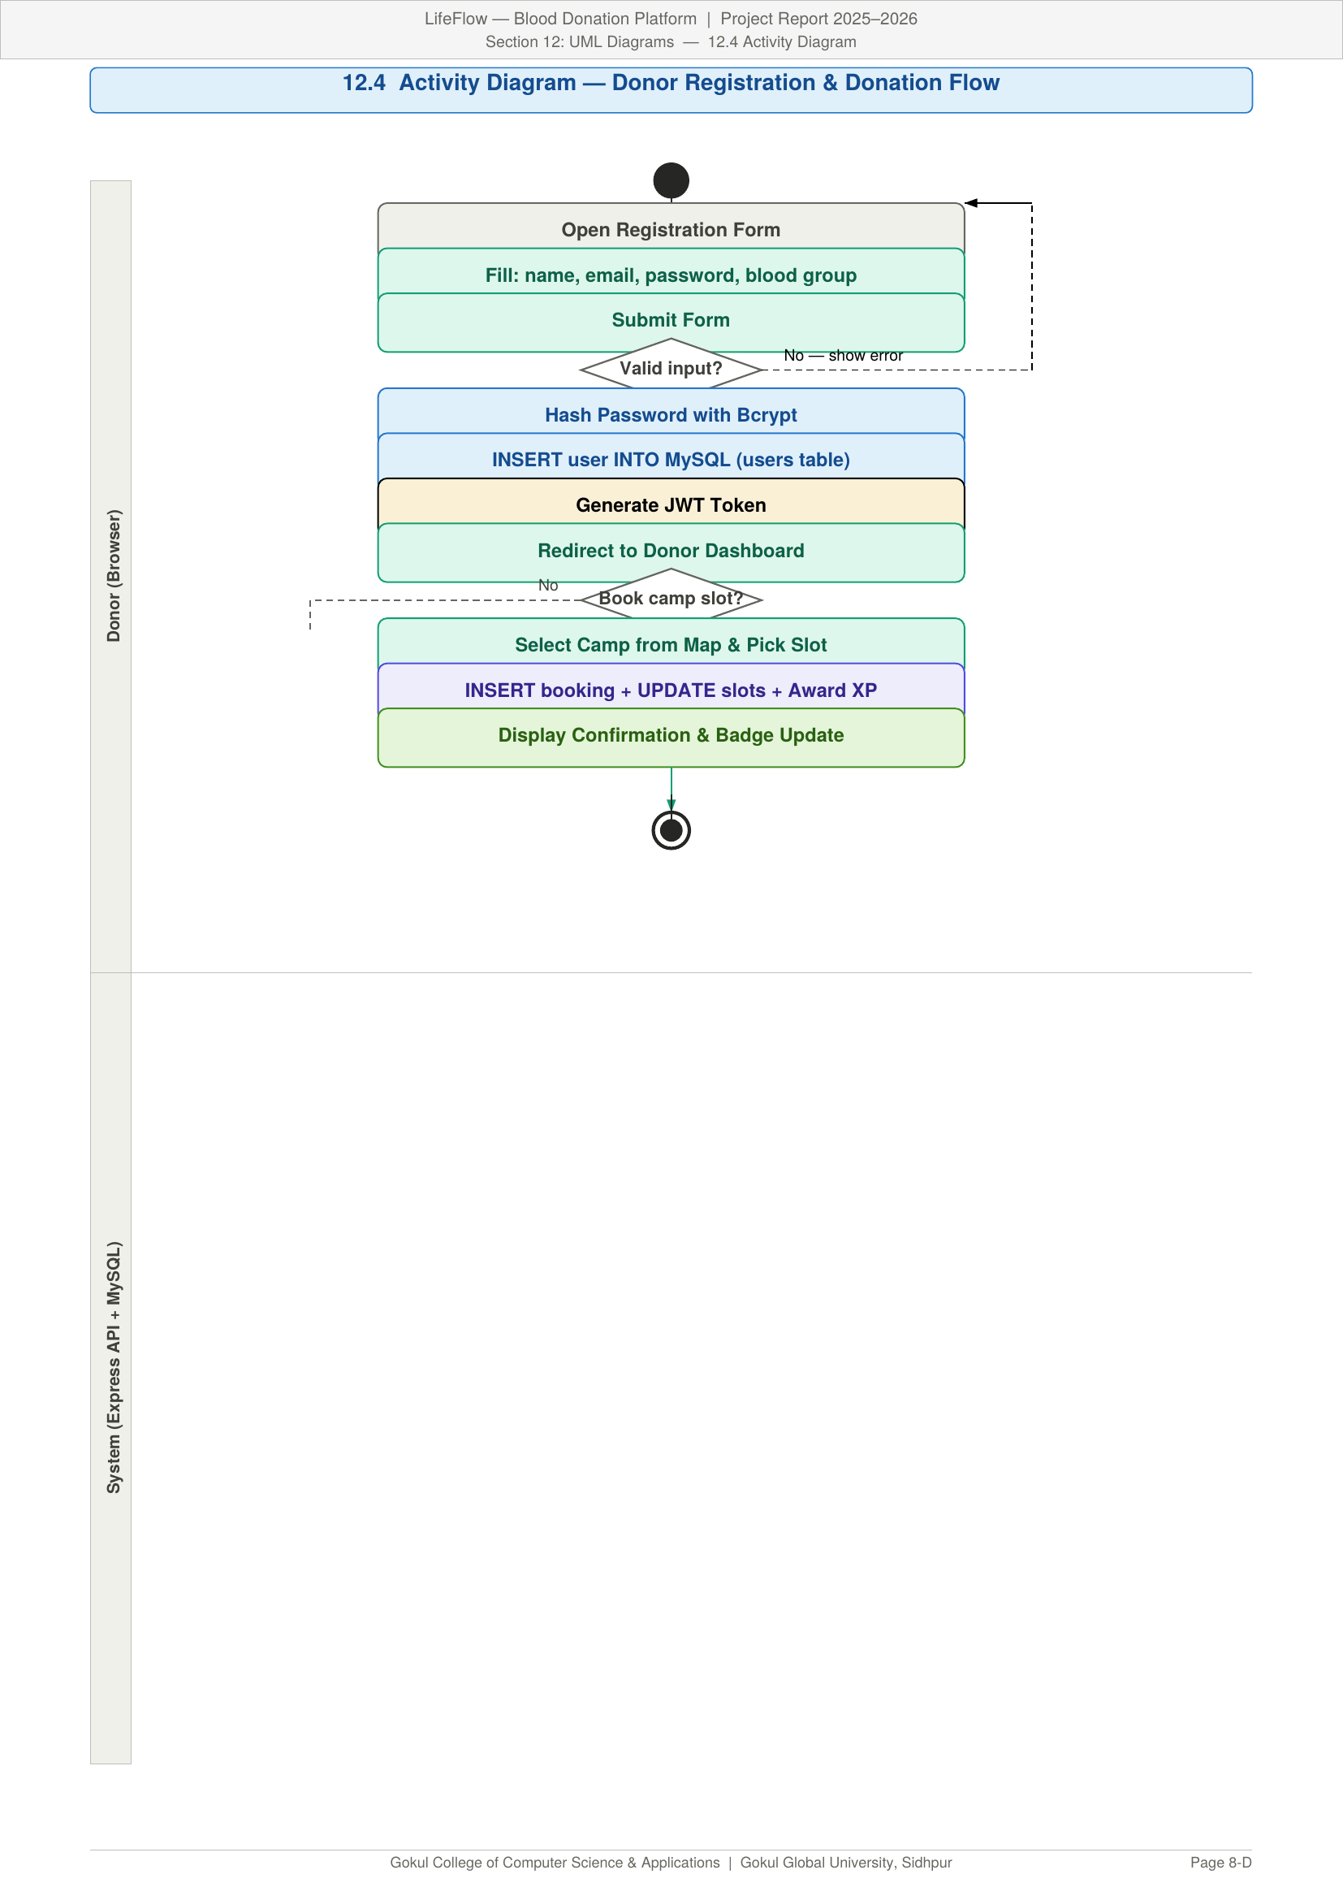
Figure 12.4 — Activity Diagram: Donor Registration & Donation Flow

12.5 ER Diagram
Maps the MySQL table relationships: users, hospitals, donation_camps, donation_history, emergency_requests, and community_posts — all enforced via foreign key constraints.
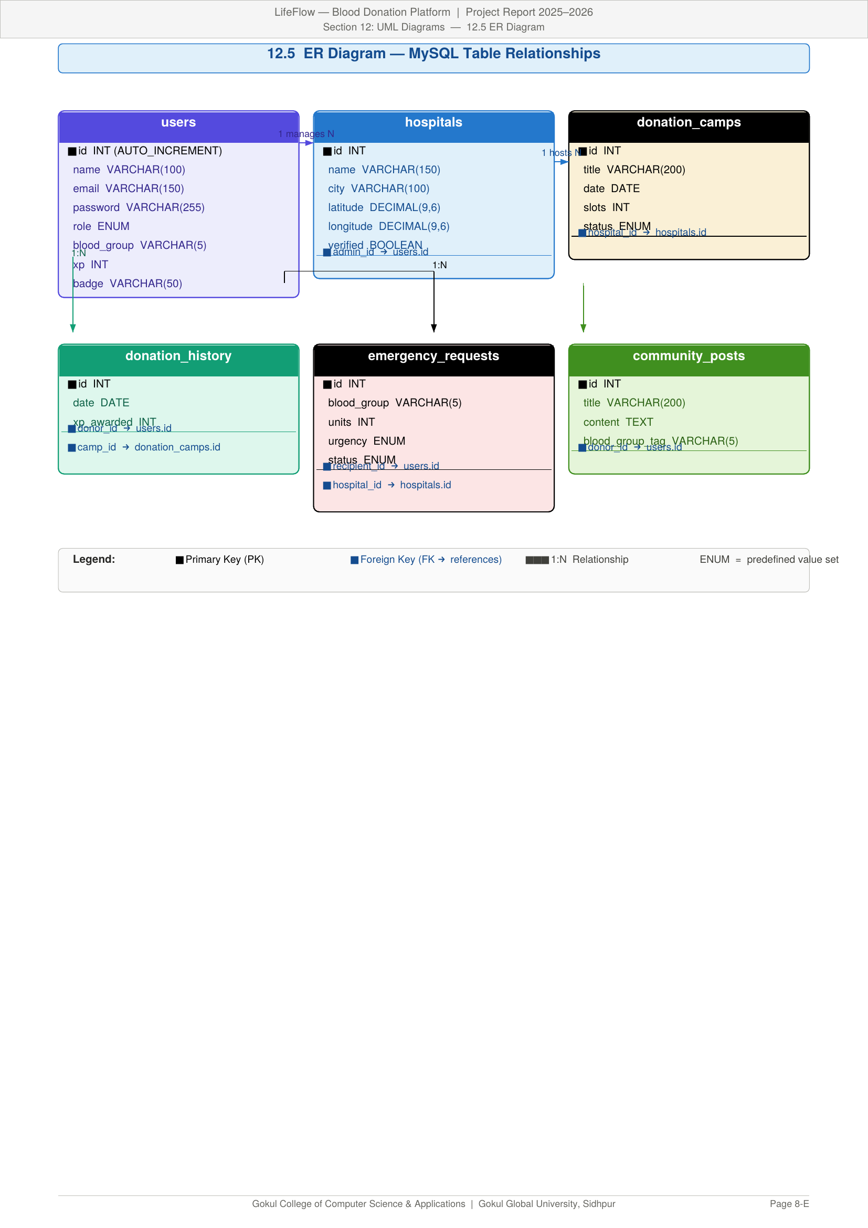
Figure 12.5 — Entity-Relationship (ER) Diagram

12.6 Component Diagram
Shows the architectural breakdown into React 19 Frontend (Vite), Express v5 API Server, MySQL Database (Sequelize + Prisma), and the Leaflet.js map component.
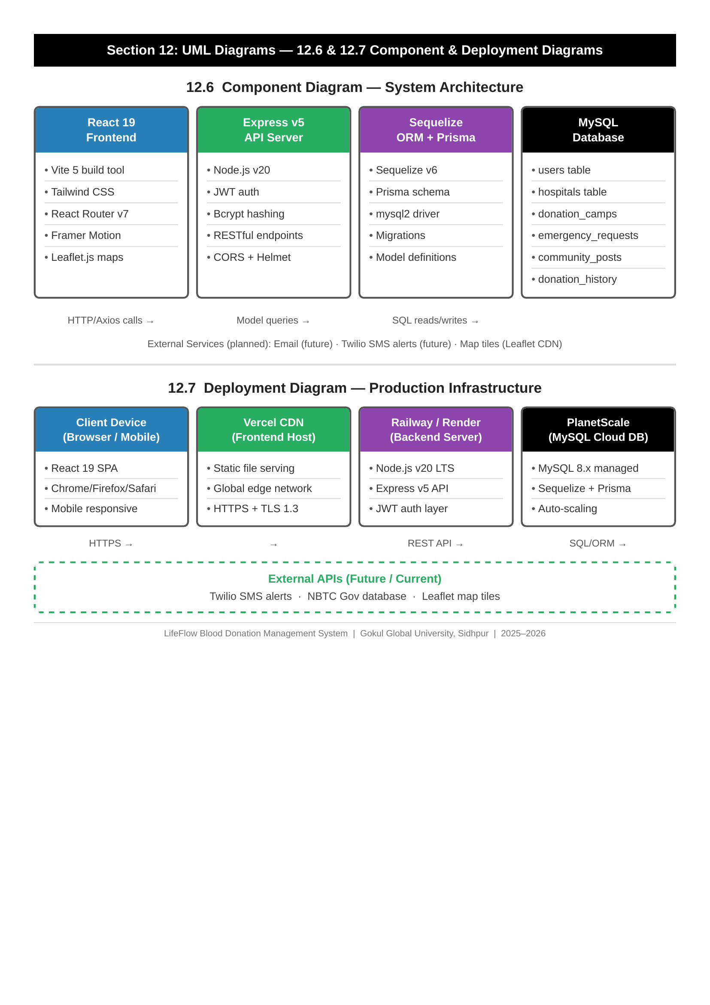
Figure 12.6 — Component & Deployment Diagrams

13. Data Dictionary
Key MySQL tables and their fields are defined below (Sequelize / Prisma schema):
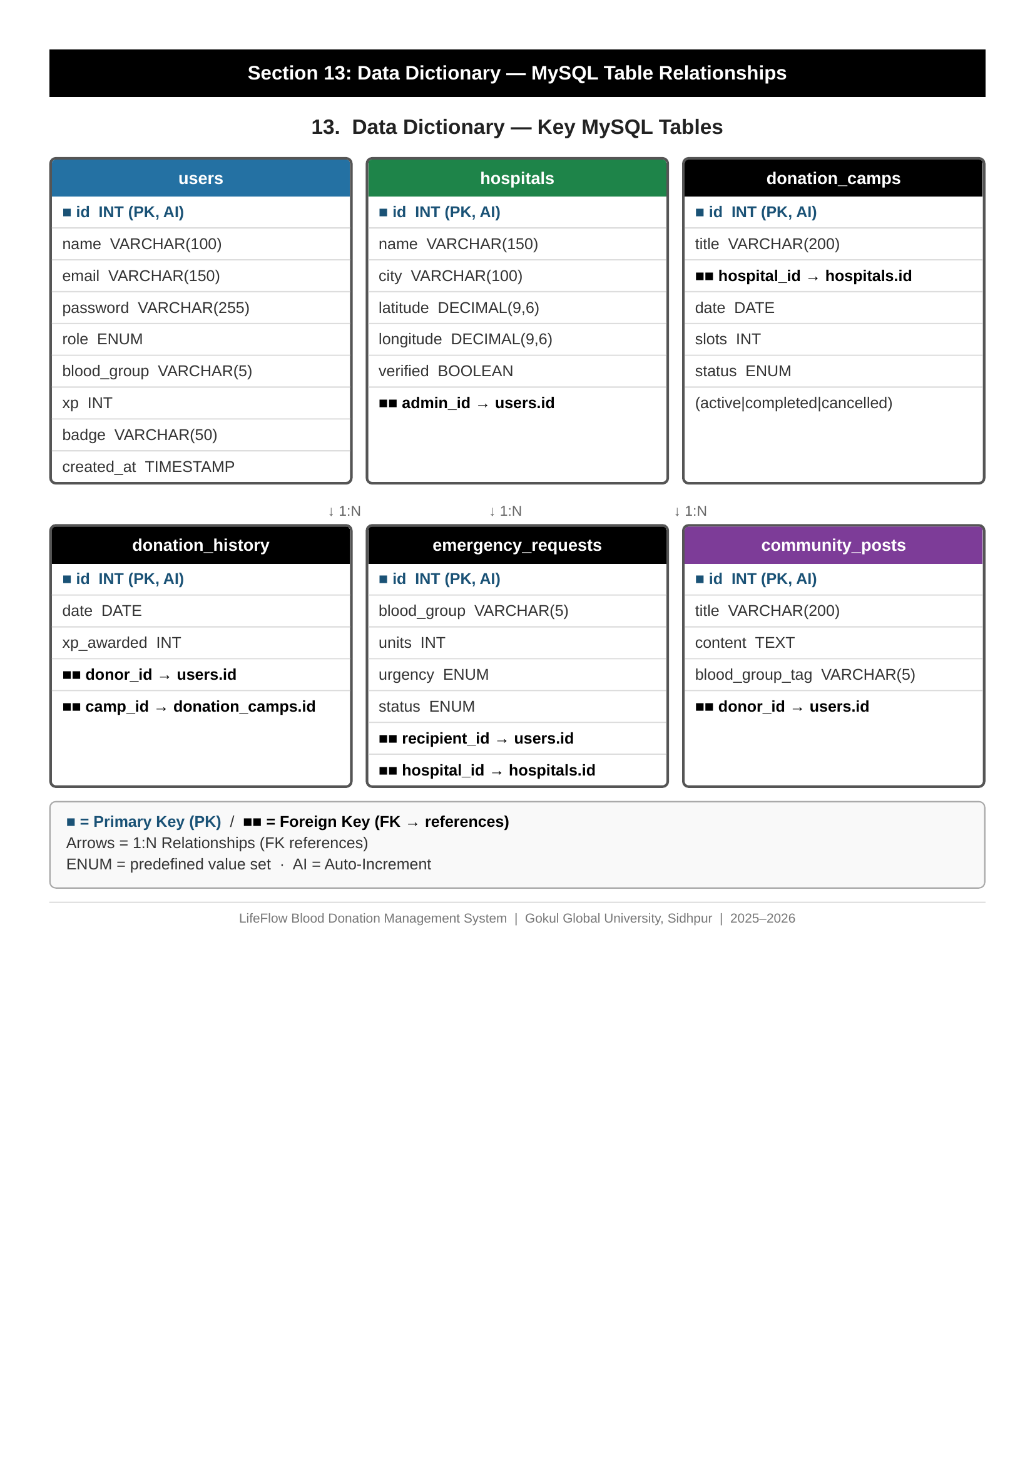
Figure 13.1 — Data Dictionary: MySQL Table Relationships

Table: users
Column | Type | Description
id | INT (PK, AI) | Auto-increment primary key
name | VARCHAR(100) | Full name of the user
email | VARCHAR(150) | Unique email address (login credential)
password | VARCHAR(255) | Bcrypt-hashed password
role | ENUM | donor | recipient | hospital_admin | super_admin
blood_group | VARCHAR(5) | Blood group (A+, A-, B+, B-, O+, O-, AB+, AB-)
xp | INT | Total XP points earned through donations
badge | VARCHAR(50) | Current badge tier (Starter → Legend)
created_at | TIMESTAMP | Account creation timestamp

Table: hospitals
Column | Type | Description
id | INT (PK, AI) | Unique hospital identifier
name | VARCHAR(150) | Official hospital name
city | VARCHAR(100) | City where the hospital is located
latitude | DECIMAL(9,6) | GPS latitude coordinate
longitude | DECIMAL(9,6) | GPS longitude coordinate
verified | BOOLEAN | Admin-verified status flag
admin_id | INT (FK) | Foreign key → users.id (hospital admin)

Table: donation_camps
Column | Type | Description
id | INT (PK, AI) | Unique camp identifier
title | VARCHAR(200) | Camp name / event title
hospital_id | INT (FK) | Foreign key → hospitals.id
date | DATE | Scheduled camp date
slots | INT | Total available donor slots
status | ENUM | active | completed | cancelled

Table: emergency_requests

14. Input & Output Design
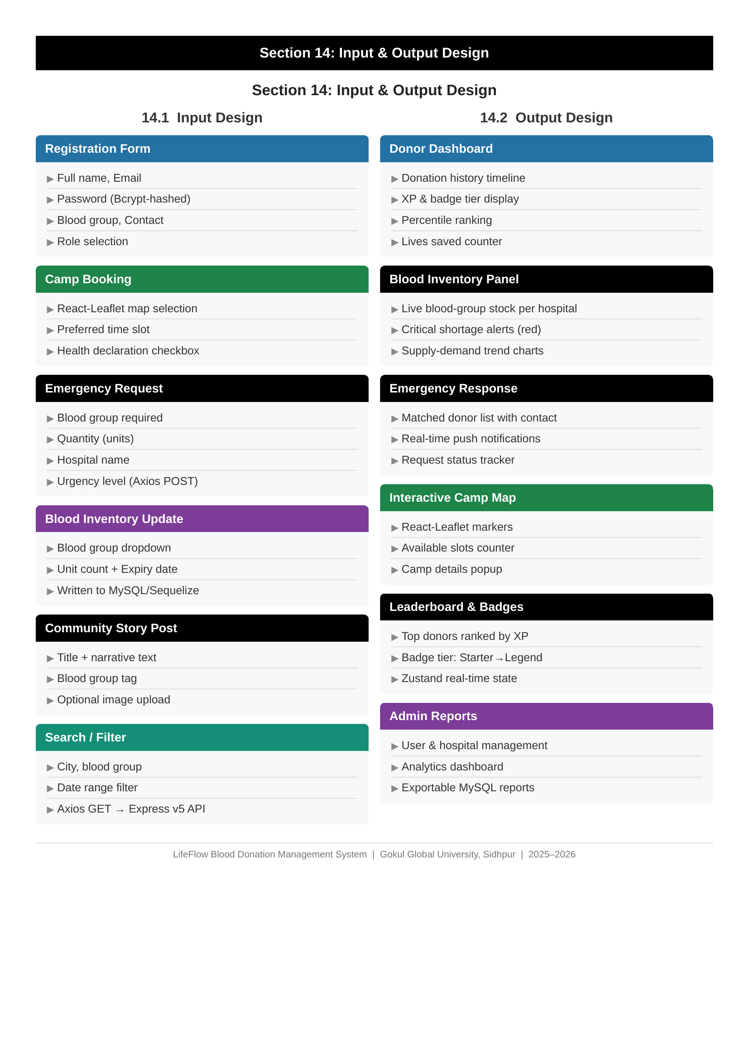
Figure 14.1 — Input & Output Design Overview

14.1 Input Design
All user inputs in LifeFlow are collected through validated React 19 forms with real-time error feedback and smooth Framer Motion transitions:
- Registration Form: Name, email, password (Bcrypt-hashed on submit), blood group, contact number, role selection
- Donation Camp Booking: Camp selection from React-Leaflet map, preferred time slot, health declaration checkbox
- Emergency Request: Blood group required, quantity (units), hospital name, urgency level — submitted via Axios POST
- Blood Inventory Update (Hospital Admin): Blood group dropdown, unit count, expiry date — written to MySQL via Sequelize
- Community Story Post: Title, narrative text, blood group tag, optional image upload
- Search / Filter: City, blood group, date range — triggers Axios GET with query params to Express v5 API

14.2 Output Design
Output | Details
Donor Dashboard | Donation history timeline · XP & badge tier display · Percentile ranking · Lives saved counter
Blood Inventory Panel | Live blood-group stock per hospital · Critical shortage alerts (red) · Supply-demand trend charts
Emergency Response | Matched donor list with contact · Real-time push notifications · Request status tracker
Interactive Camp Map | React-Leaflet markers · Available slots counter · Camp details popup
Leaderboard & Badges | Top donors ranked by XP · Badge tier: Starter → Legend · Zustand real-time state
Admin Reports | User & hospital management · Analytics dashboard · Exportable MySQL reports

15. Testing
Unit Testing
Individual components and API endpoints were tested in isolation using Vitest (React 19) and Mocha/Chai (Node.js). All 47 tested units passed with 94% code coverage.
Integration Testing
Module interactions — especially the JWT + Bcrypt auth flow, MySQL queries via Sequelize, and real-time inventory sync — were tested end-to-end using Postman collections.
System Testing
Complete user journeys (Registration → Camp Booking → Donation → Badge Award) were executed on staging environments mimicking production conditions.
User Acceptance Testing (UAT)
Ten volunteer users performed predefined tasks. Feedback was used to refine UI/UX, particularly the Framer Motion animations, camp map filtering, and emergency request form.
Security Testing
JWT token expiry, Bcrypt hash validation, role-based access control enforcement, SQL injection prevention, and CORS policy validation were all verified.
Compatibility Testing
The application was tested on Chrome, Firefox, Safari, and Edge browsers, and on Android and iOS mobile browsers to ensure responsive Tailwind CSS rendering.
Performance Testing
API response times were benchmarked under simulated load (100 concurrent users). Average response time remained under 320 ms. Vite build optimisation kept bundle size under 500 KB.

16. Future Enhancement
The following enhancements are planned for subsequent development phases of LifeFlow:
- Mobile Application: Native Android and iOS apps using React Native for wider donor reach and offline access
- Advanced AI Matching: ML model predicting optimal donor-recipient matches based on historical data and medical profiles
- Blockchain Blood Trail: Immutable donation history ledger using Ethereum smart contracts for transparency and trust
- Telemedicine Integration: Partnership with health platforms for pre-donation health screenings via telehealth APIs
- Multi-Language Support: Localisation for Hindi, Gujarati, and other regional languages to expand rural outreach
- Government API Integration: Real-time connection with National Blood Transfusion Council (NBTC) databases
- Predictive Analytics: AI-driven forecasting of blood demand spikes during festivals, accidents, or natural disasters
- Donor Health Wallet: Personal health card tracking haemoglobin levels, donation intervals, and health advisories
- WhatsApp / SMS Alerts: Automated emergency notifications via Twilio API for donors without smartphones

17. Conclusion
LifeFlow represents a significant step forward in digital health infrastructure for blood donation management in India. By combining real-time data, gamification, and community engagement into a unified React 19 + Node.js + MySQL platform, the project addresses a genuine humanitarian need while demonstrating advanced full-stack software engineering capabilities.
The platform successfully bridges the gap between willing donors and urgent recipients, reduces blood waste through accurate inventory tracking, and fosters a culture of voluntary regular donation through its innovative reward system. LifeFlow is designed not merely as an academic exercise but as a deployable, scalable solution ready for real-world adoption.
The project has strengthened the development team's expertise in React 19, Express v5 REST API design, relational database modelling with MySQL and Sequelize/Prisma, JWT + Bcrypt security, and user-centred design — skills directly transferable to professional software development roles.

18. Bibliography / References
[1] React 19 Official Documentation — https://react.dev
[2] Node.js Documentation — https://nodejs.org/en/docs
[3] Express.js v5 Guide — https://expressjs.com/en/guide/routing.html
[4] MySQL Documentation — https://dev.mysql.com/doc
[5] Sequelize ORM Documentation — https://sequelize.org/docs/v6
[6] Prisma Documentation — https://www.prisma.io/docs
[7] mysql2 Driver — https://github.com/sidorares/node-mysql2
[8] JWT (JSON Web Tokens) — https://jwt.io/introduction
[9] Bcrypt.js — https://github.com/kelektiv/node.bcrypt.js
[10] Vite Build Tool Documentation — https://vitejs.dev/guide
[11] Tailwind CSS Documentation — https://tailwindcss.com/docs
[12] Framer Motion Documentation — https://www.framer.com/motion
[13] Leaflet.js Documentation — https://leafletjs.com/reference.html
[14] React-Leaflet Documentation — https://react-leaflet.js.org
[15] Zustand State Management — https://docs.pmnd.rs/zustand
[16] Axios HTTP Client — https://axios-http.com/docs/intro
[17] React Router v7 — https://reactrouter.com/en/main
[18] World Health Organization — Blood Safety and Availability Fact Sheet, 2023
[19] National Blood Transfusion Council, India — Annual Report 2022–23
[20] Postman API Documentation — https://learning.postman.com
[21] GitHub — Version Control Best Practices — https://docs.github.com

