**1. Use the IF function to evaluate whether each product met its sales**

**target.**

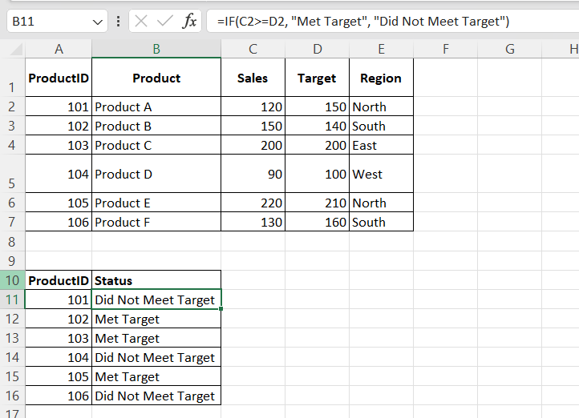

**2. Use the IF function to determine if a product is eligible for a regional**

**bonus. Products in the "North" region with sales over 200 are eligible.**

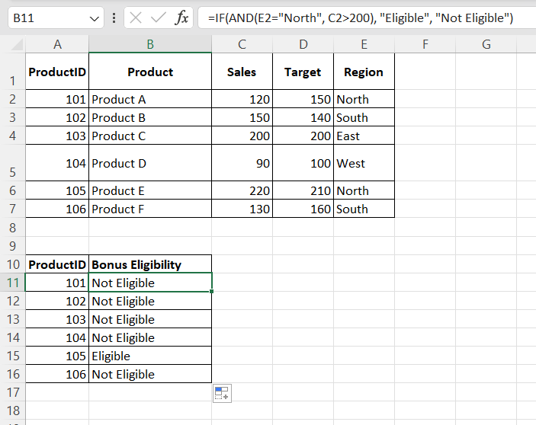

**3. Use nested IF functions to assign a commission rate based on sales.**

**Sales >= 200 get a 10% commission, sales >= 150 get a 7%**

**commission, and others get a 5% commission.**

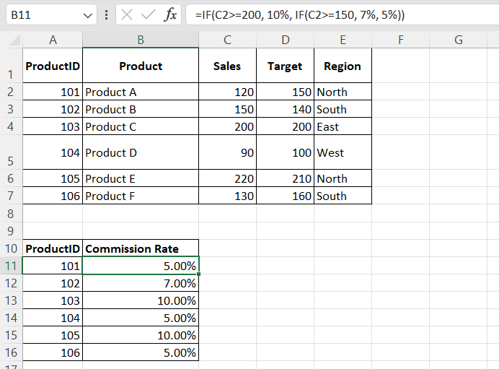

**4. Use the IF function to calculate a bonus amount. If sales met or**

**exceeded the target, the bonus is 10% of the sales; otherwise, it's**

**5%.**

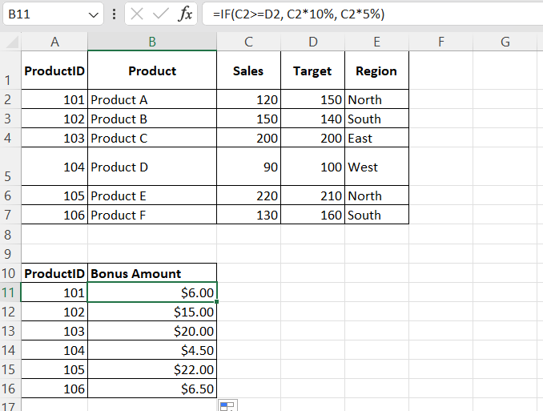

**5. Use the IF function to categorize sales performance as "Excellent"**

**(>=200), "Good" (>=150), or "Needs Improvement" (<150).**

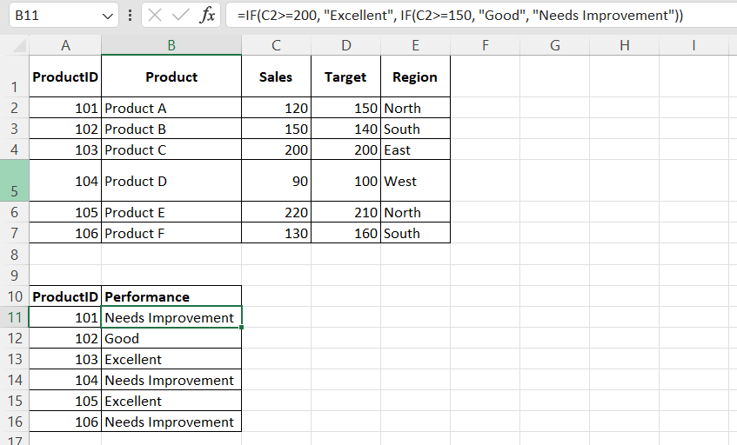

**6. Use the IF function to assign a price tier based on the sales value.**

**"High" for sales > 200, "Medium" for sales between 100 and 200, and**

**"Low" for sales < 100.**

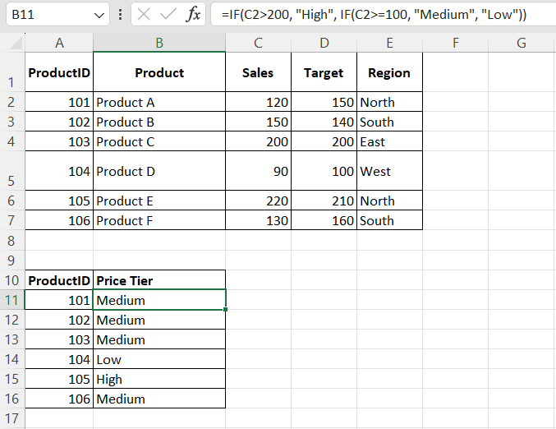

**7. Use the IF function to calculate the year-end bonus. If sales >= 150**

**and region is "North", the bonus is $500, otherwise, it's $300.**

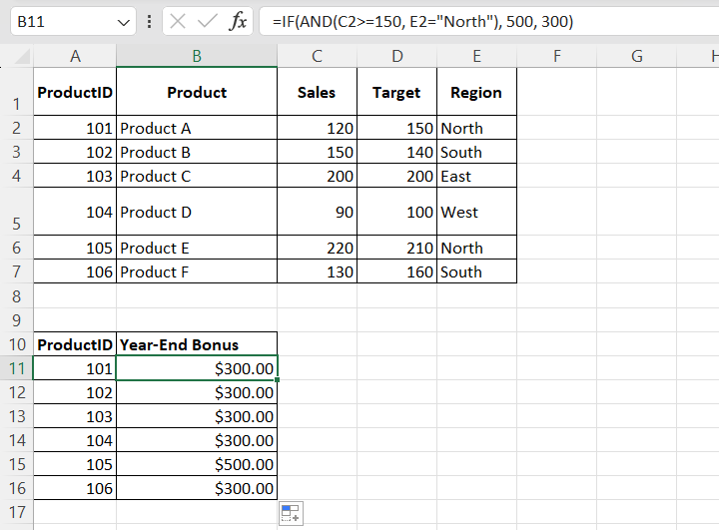

**8. Use the IF function to mark high performers. A product is a high**

**performer if its sales are in the top 25% of all sales.**

