Speech Recognition using Recurrent Neural
Networks(RNN)

Dhruv Patel,
Devang Patel Institute of Advance Technology and Research
dhruvmpatel096@gmail.com

Namra Patel,
Devang Patel Institute of Advance Technology and Research
142002namrapatel@gmail.com
Hitarth Shah,
Devang Patel Institute of Advance Technology and Research
Hitarthshah189@gmail.com

Abstract— We have seen many changes in field of artificial intelligence since 2012. One of the key change is use of AI is for marketing.
After many years of research and development today we have very good algorithm of NLP (natural language processing). Today NLP has many uses like auto correct, prediction of word, Text processing etc. With the use of NLP and some other Machine Learning algorithm, big companies like google, amazon filter a lot of data and do analysis of data. By using Sentimental analysis of data you can point out defects in a product, it also helps launching a product according to market trend. This paper presents study of NLP and AI for Sentimental Analysis on Twitter.

Keywords—Artificial intelligence, Recurrent neural networks, Speech recognition system , Speech to text .

I.INTRODUCTION

Speech Recognition is a growing field in world. It means to make a computer understand what we speak. In todays world Alexa, google ,Siri all use speech recognition. By “understand” we mean it would convert our voice into appropriate format for e.g. Text. Thus speech recognition is also called as Speech to Text conversion process .It consists of microphone for humans to speak, recognition of speech software and a computer to perform task. The basic recognition of speech system is shown in fig. 1 [1].
Speech to text engine
We have to import sound waves in computer for converting it into text. As sound waves are continuous (analog) signal the we need to perform sampling of signal using Nyquist theorem. This sampled signal is send directly to our neural network but pre-processing of signal is done in order to get better result and accurate predictions of spoken words.Steps for Pre-processing include grouping of a large sampled signal into 20-milliseconds small chunks. Pre - processed sampled data which is in digital format is now send to our Recurrent Neural Network (RNN) which is our main speech recognition model used for prediction. Models used in STT Engine are discussed in below sections.

Sampling and pre-processing of speech
Sampling and pre-processing of data is vital step while designing Speech To Text (STT) Engine .This step decide the performance and time consumed by the engine. Sound waves are one-dimensional(1D). At each moment in time, they have a single value based on the magnitude of the wave. To turn this sound wave into number we have to just record the
magnitude of the wave at equally-spaced points. This is
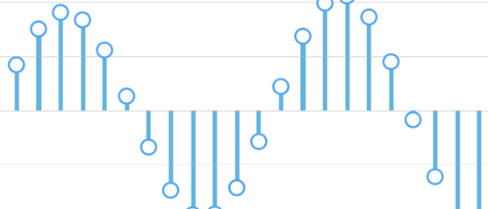
called as Sampling , as shown in fig. 2. [1]

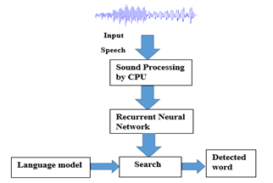

Fig. 2 Sampling of speech signal

Fig. 1 Speech Recognition system
Sampling rate is decided using Nyquist theorem and it is mostly 1/16000th seconds interval [2].Math is used to perfectly reconstruct the original sound wave from the spaced-out samples with sampling frequency equal to or two times more than of the highest frequency at which it is recorded. This sampled data directly fed to our recurrent neural network but for simple and better results data is pre- processed before applying to the network. Pre-processing

is segmentation of the sampled data into groups of data. Generally grouping the sound wave with in some interval of time mostly for 20-25 milliseconds. Sampling and pre- processing together can be also termed as conversion of sound into numbers (bits) which is shown in fig. 3. [3]

Fig. 3 Sampled and pre-processed data
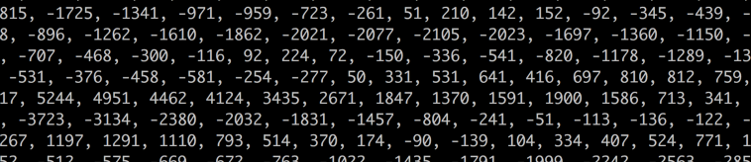

III.RECURRENT NEURAL NETWORK

Fig. 4 shows speech recognition using RNN. Now audio which is given at input will be easy to process, it will be feed into a deep neural network. After feeding of small audio chunks of around 20ms to our model it will figure out letter which matches the spoken sound [1,3]

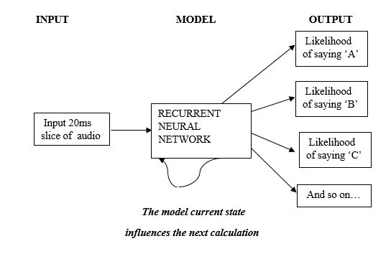
Fig. 4 Speech Recognition Model

RNN is a network which has a memory and algorithm that decides the future predictions. This is because as it predicts one letter that is going to affect the likelihood of the upcoming letter which it will predict too. Consider an example, if we have said “MUM” so far, then it‟s obvious one will say “BAI” next to complete the word “MUMBAI”. There is much less probability that one will say something which is unpronounceable “ENEMY” after saying the word “MUM”. Hence having a memory of previous predictions boosts our network to make more accurate predictions going forward. [1,2]

If X=VANILLA-{1 0 0} Y=CHOCOLATE-{0 1 0} Z=BUTTERSCOTCH-{0 0 1}
Fig. 5 RNN ice-cream example

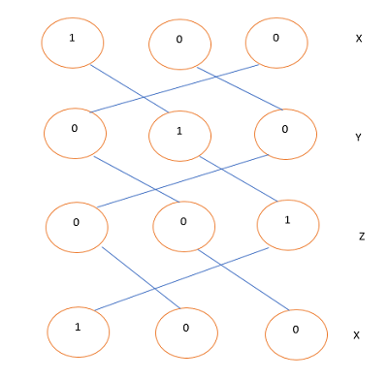
A simple recurrent neural network works like the above model. E.g. a person eats vanilla ice-cream on day one,chocolate on day two and butterscotch on other after that he eats vanilla and chocolate and so on repeats. Here, it means that the input is dependent on the past output and it repeats itself after some time. Hence, the name recurrent neural network. [1,5]
RNN uses the idea of sequential information. RNN, a neural network that has a memory and algorithm that influences future predictions Sequential information which is stored in memory of RNNs is used for predictions. Idea to use RNN instead of traditional neural network is that in traditional neural network it is assumed that every input & every output are does not depends on each other. Hence using of traditional neural network is bad idea in speech processing.[3] Prediction of any words in a sentence requires the information about the word which is used before i.e. past word which is processed. Having a memory which predicts upcoming word is one of the speciality of RNN which makes it unique than other networks .There are various neural networks available among them the Recurrent Neural network [RNN] is used because it is more efficient than the others for speech recognition. [1,4]
Algorithm
Steps involved in the RNN algorithm [1] are :
Xt is input at time t , Xt-1 is past input and Xt+1 is the future input (sampled sound)
II. St is the hidden state. It is the hidden memory. St is calculated as: St = f(U*Xt + W*Xt-1).
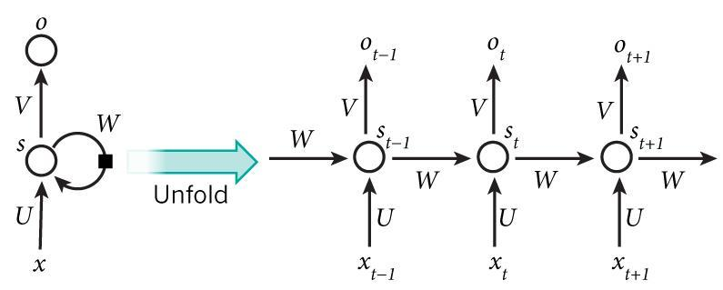
Ot is output for the step t .For example if we want to predict the next word in a sentence it Would be a vector of probabilities across our vocabulary , Ot=soft max(V*St)

Fig. 6. RNN algorithm

Few things to note here are :
State St is the memory of the recurrent neural network that can be hidden., St stores the data of what things took place in all the previous steps. Output at step Ot is calculated exclusively based on the memory at time „t‟. As mentioned above, it’s a little more complex in practice and practical implementation because St normally can’t capture data from too many time steps ago.

• For implementation traditional neural network which are deep uses various parameters at each and every layer while the same parameters are shared by RNN.
• It uses (U,V,W) parameters which are shown by all steps above. This shows us about that we are doing the same task at each and every single step , by passing various inputs at different step. By this there is a decrease in the numbers of parameters in all which need to be learned.

Diagram shown has outputs at each time step, but depending on the task to perform it is not necessary
.Consider an example, where we have to predict the sentiment of a sentence here we may only care about the final outcome or output, not the sentiment or the output which is given after each word. Same case for inputs too , we do not need inputs at each time step. Important feature of a RNN is its abstract state, which stores some data about a sequence.

A. LSTM
The most commonly used RNN’s are Long short term memory (LSTM) shown in fig.7. Long short term memory (LSTM) are the building units for multiple layers of RNN.As you know, RNN faces problem of long term dependencies which can be removed using a new form of RNN called as LSTM. All RNN are constructed consisting of a repeating structure but in case of LSTM the structure varies a bit. It consists of 4 structure unlike RNN which have only one. Main element in LSTM are cell state which makes any information to flow via it . Also we can add or remove any information as per our requirement using gates. There are 3 types of gates input gate, output gate and forget gate. Functions of these gates are to protect cell state. LSTM network consists of a sigmoid function which has only 2 values at its output either it will pass everything which it consists at the input or it won’t both the cases are possible. So using a cell state we can control the long term dependencies which was troubling in case of RNN. Hence LSTM find it’s way to be used in newer versions of speech recognition software.

Fig. 7. LSTM IV.TRAINING A RNN
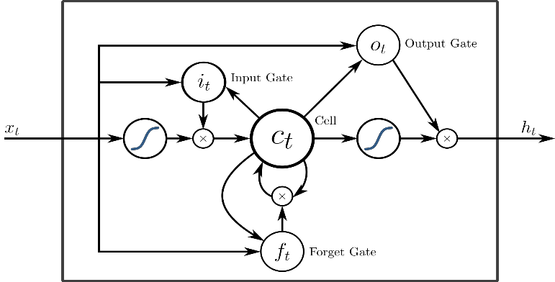

For training a RNN we use the backpropagation algorithm, but with a approach which differs from a usual one. Reason why approach differ from the traditional one is at every time steps the parameters used is common throughout the network, the calculated gradient at output step doesn’t depends only on present time step but also on the computations of the past steps. Consider an example, in which we have to calculate the gradient at t=5 then you would need to back propagate four step and add all the gradients. This method of computation is known as Back propagation through Time (BPTT). One drawback of training a RNN using Back propagation algorithm is long-term dependencies .This problem is known as vanishing or exploding gradient problem. To deal with such type of drawbacks there are some machineries which are utilised and some types of RNN were specifically designed to solve this problems [2]

B.Various STT Engines Using RNN
There are many engines used which are based on RNNs which uses python ,C,C++, java programming languages to build a Recurrent Neural Network. We have gone through CMU pocket-sphinx, snowboy hot word detection which uses python as primary language and RNN which shows good results also if we increase the database it will perform at it’s 100% efficiency. Unlike Google’s STT and Amazon’s Alexa , CMU pocket-sphinx is offline speech to text conversion engine provided that training of a dataset is performed online. Results of testing a speech are shown in the figure below. CMU is online training portal must be given a set of words which we have to train. Training process is same as discussed above in training of RNN model. It uses python language to build a LSTM network. Also recently launched engine Snowboy-hot word detection works offline but it is limited for detection of 1 particular hot word.

Fig. 8. Implementation using pocket-sphinx STT Engine
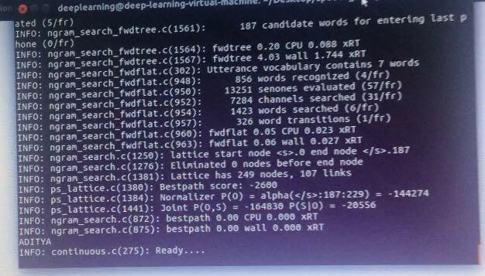

From the above figure, words which we want to use is trained using CMU pocketsphinx online tool and then on any linux based or windows based OS we can implement the code using proper commands by assigning microphone a proper port and trained model of words which we have to test .As described it will get an sound input here it is “N A M R A “ followed by pre- processing of it and finally feding it to RNN Network which will help to detect the word as shown in the above mentioned figure 7.

V. CONCLUSION & FUTURE USE

RNN is 1 of the best algorithm used for processing of speech signal and it has scope in emerging voice controlled technologies but training algorithm is again

very complicated .It shows better results than Multilayer perceptron .Speech recognition has attracted many scientists and researchers and can be influential to society. Hope this paper give basic understanding of Speech Processing using Recurrent Network and various STT Engine available which can be used for app development.

REFERENCES

[1]. Bhushan C.Kamble,”Speech recognition using artificial neural network” proc of Int'l Journal of Computing, Communications & Instrumentation Engg. (IJCCIE) Vol.
3, Issue 1 2016
[2]. Preeti Saini, Parneet Kaur,”Automatic Speech
Recognition: A Review” proc International Journal of
Engineering Trends and Technology- Volume4 Issue2-
2013
[3]. Yashwanth H, Harish Mahendrakar and Suman Davia,
“Automatic Speech recognition Using Audio Visual
Cues”, IEEE India Annual conference pp. 166-169, 2004 [4]. Urmila Shrawankar, Dr. Vilas Thakare, “Techniques for Feature Extraction in Speech Recognition System: A Comparative Study”, (IJCAETS), ISSN 0974-3596,pp
412-418, 2010.
[5]. M.A.Anusuya and S.K.Katti, “Speech Recognition by Machine: A Review”, (IJCSIS) International Journal of Computer Science and Information Security, vol. 6, no.
3, pp. 181-205, 2009.

