Name- dhruv patel

Charusat University

5th sem Btech

Computer Eng.

Roll no-19DCE096

# TRAVELLO WEBSITE USING PYTHON AND DJANGO

# 

# INTRO:

* This is a travel website in which you can search and view different destination.
* There is also a option to add your destination so that you can view for future refrence
* There is user registration and login form which user has to enter
* I had used postgresql and pgadmin4 as database
* This is code of my home/index page.
* I had downloaded this template so thats not created by me.

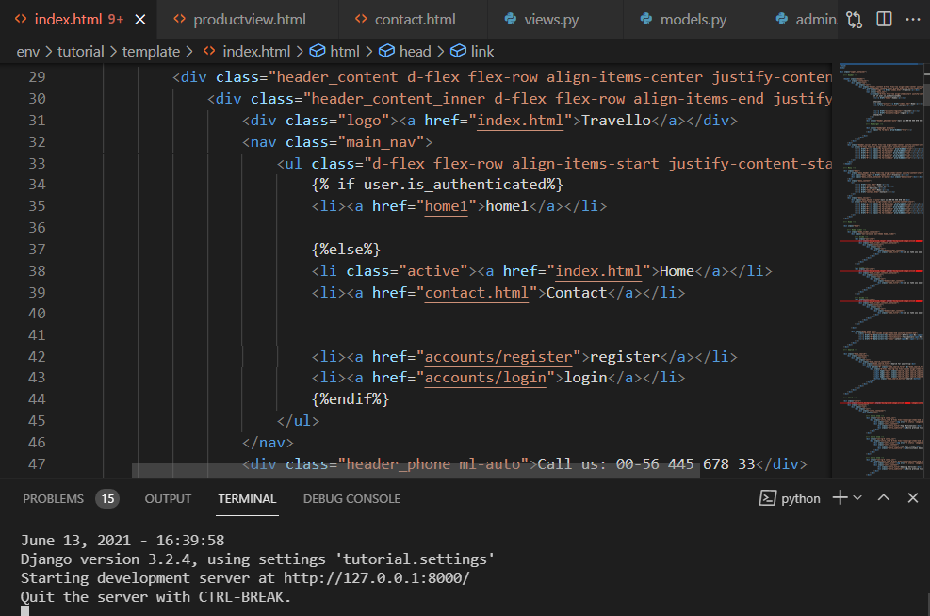

* This is screenshot of my home page where I had added registration and login page links

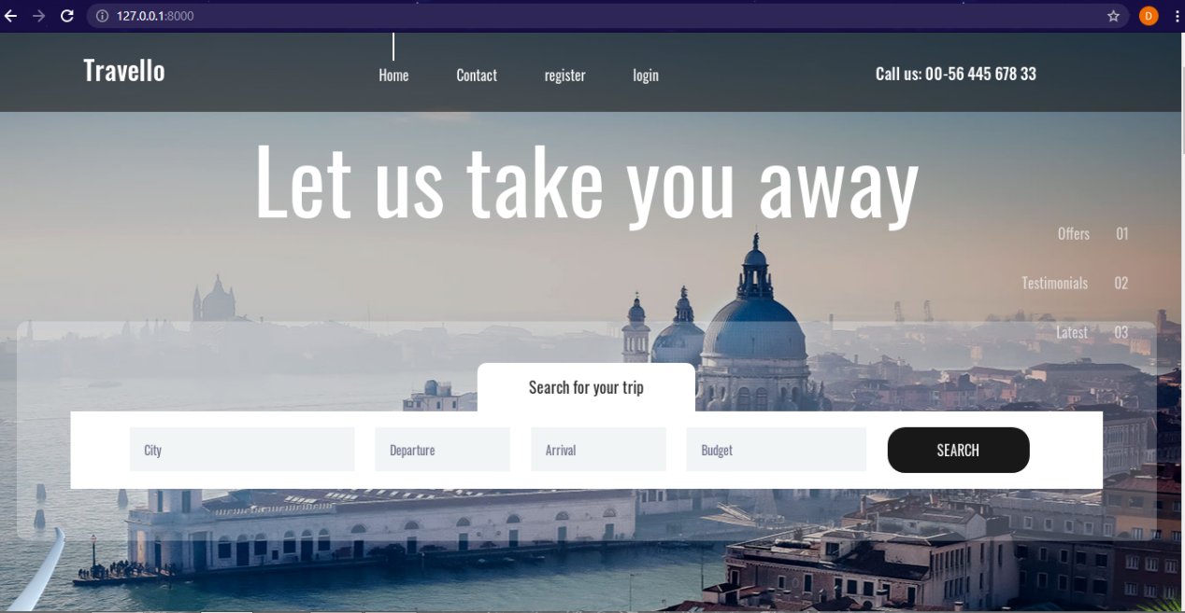

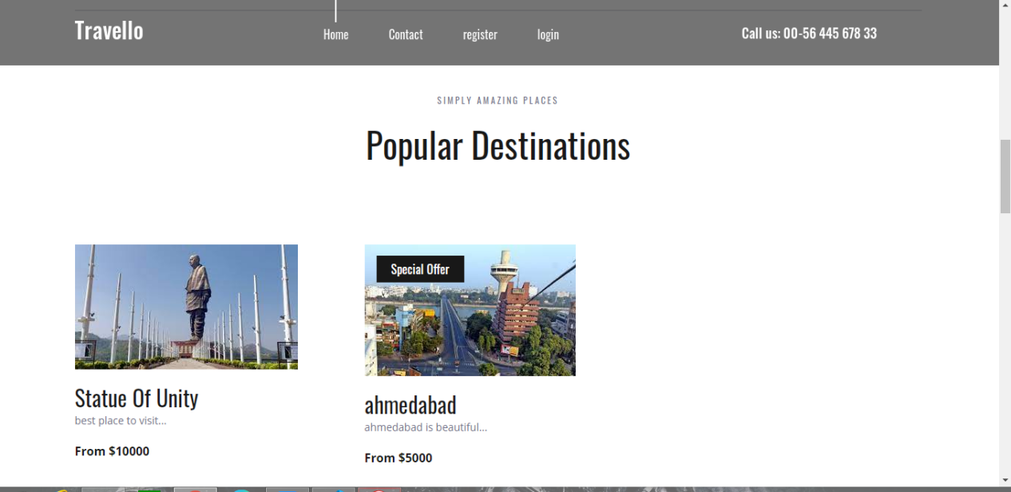

* Now we will click on register and make a new user, there is some need to apply css but for learning purpose I thought it will be fine

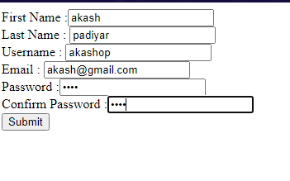

* Now after submit we will see in our database that a user of this field is created

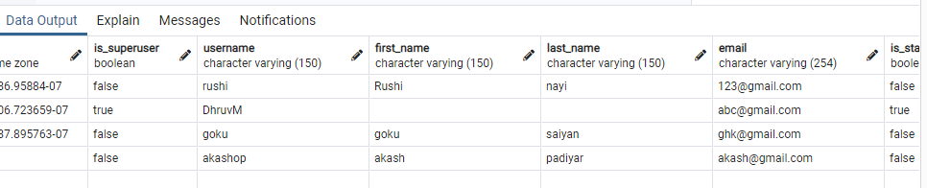

* User of username akashop is created
* Now lets login

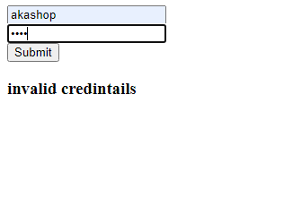

* If credential does not match message of invalid credential will appear
* After entering right credential will will be redirected to home page

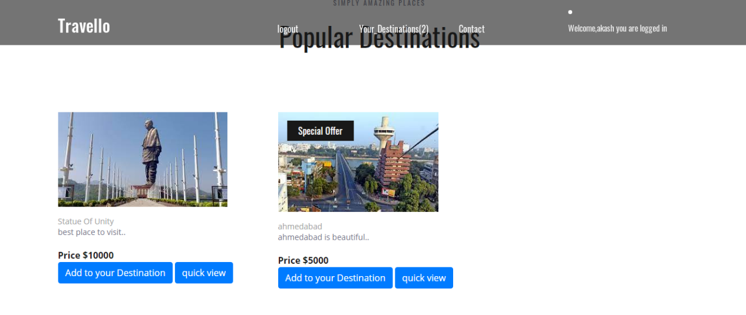

* Here you get options to add destination and quick view
* Clicking on quick view

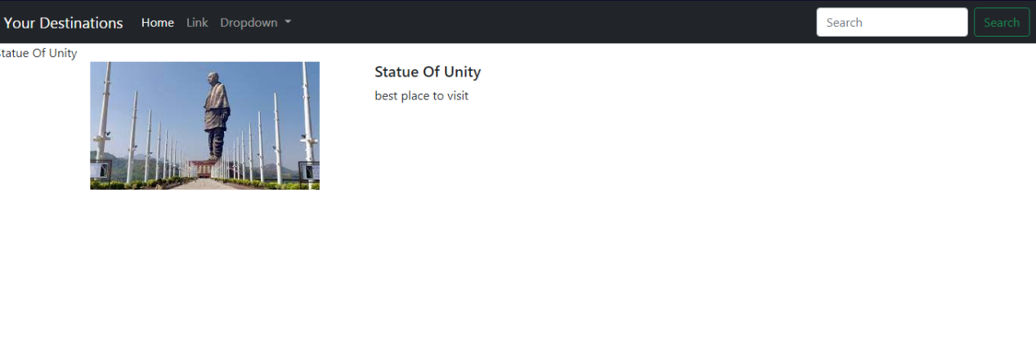

* Here admin can add description of destination , I had not added much
* Now click on add destination and click on your destination from navbar on home page

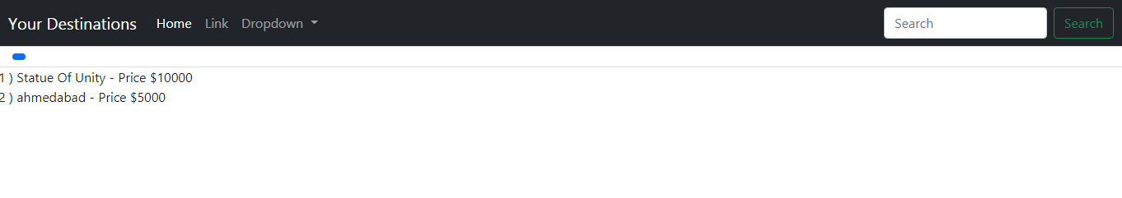

* Some better css needed
* And now you can logout….that was my whole project till now still making it better

I had also uploaded code in proper manner