1. Given a string of odd length greater than 7, return a new string made of the middle three characters

of a given String

Given:

str1 = "RakeshzipPetabb"

Output

zip

str2 = "JazzbonAyxx"

Output

bon

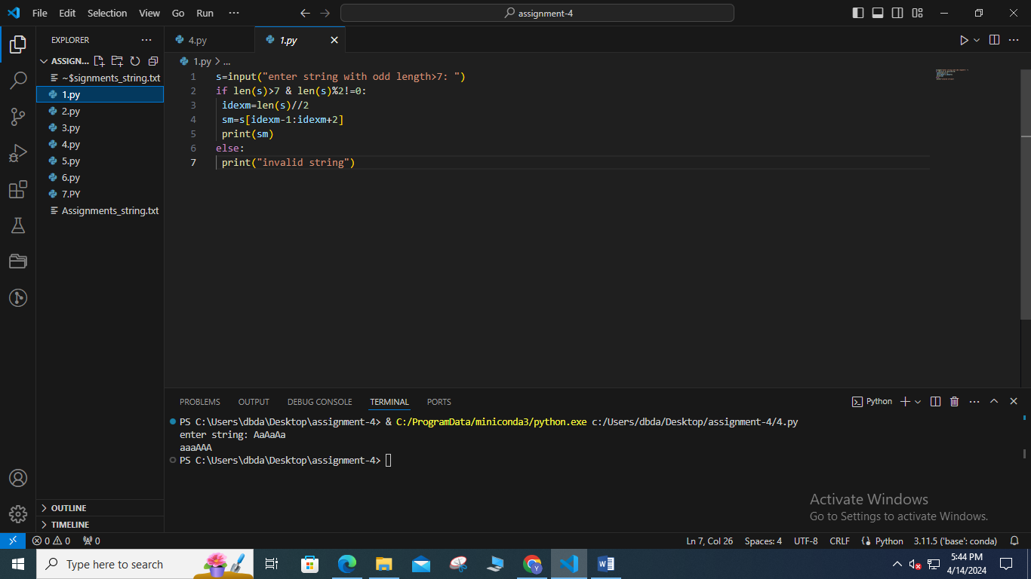

2. Given two strings, s1 and s2, create a new string by appending s2 in the middle of s1

Given:

s1 = "Ault"

s2 = "Kelly"

Expected Output:

AuKellylt

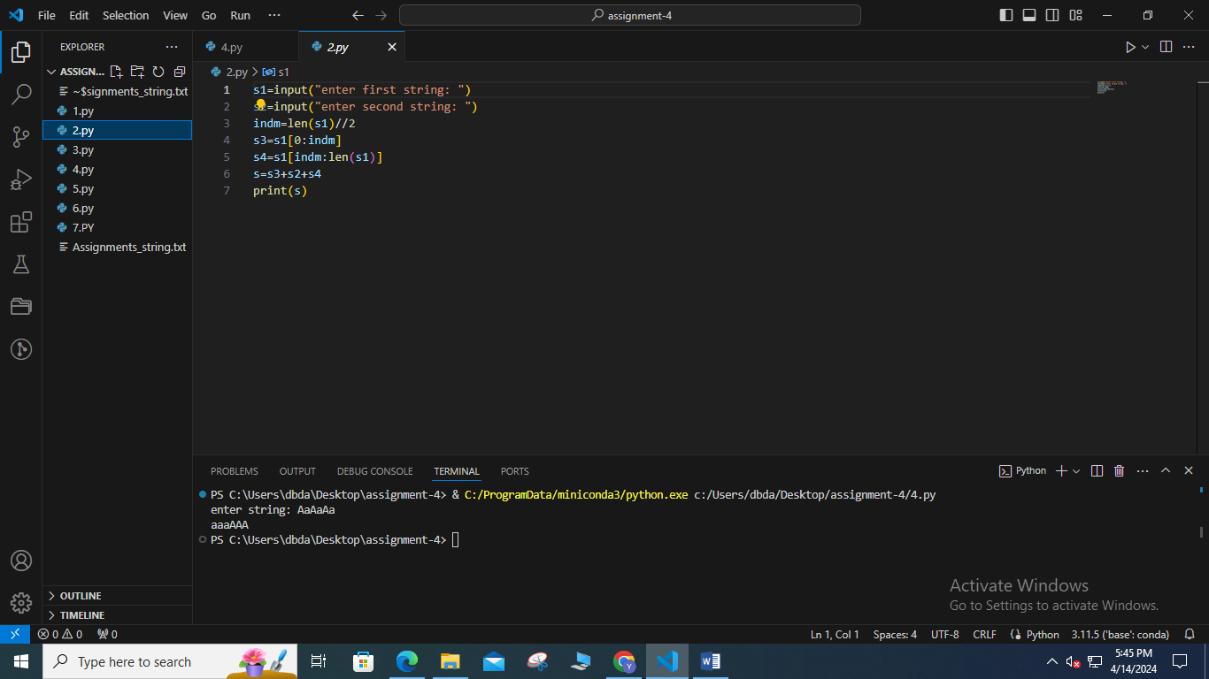

3. two strings, s1, and s2 return a new string made of the first, middle, and last characters each input

string

Given:

s1 = "America"

s2 = "Japan"

Expected Output:

AJrpan

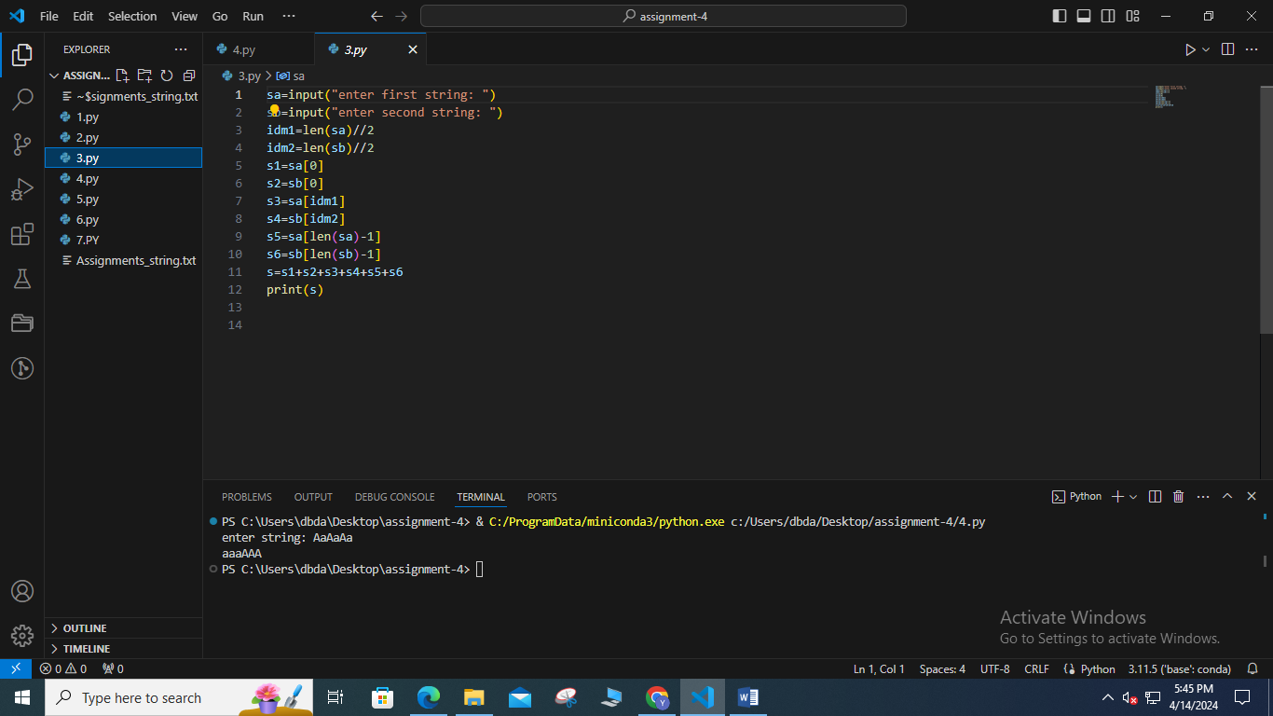

4. Given an input string with the combination of the lower and upper case arrange characters in such a

way that all lowercase letters should come first.

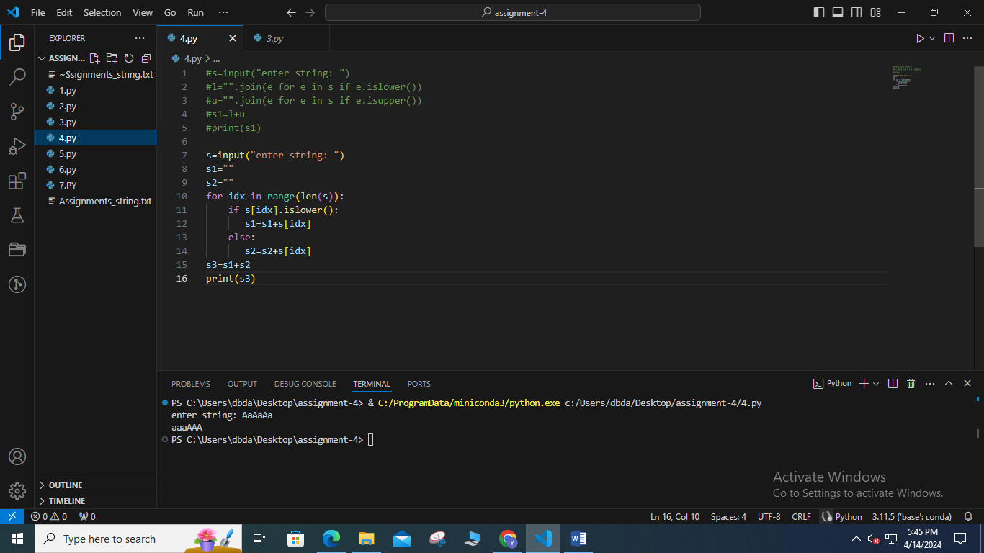

5. create a third-string made of the first char of s1 then the last char of s2, Next, the second char of s1

and second last char of s2, and so on. Any leftover chars go at the end of the result.

Given:

s1 = "Abc"

s2 = "Xyz"

Expected Output:

AzbycX

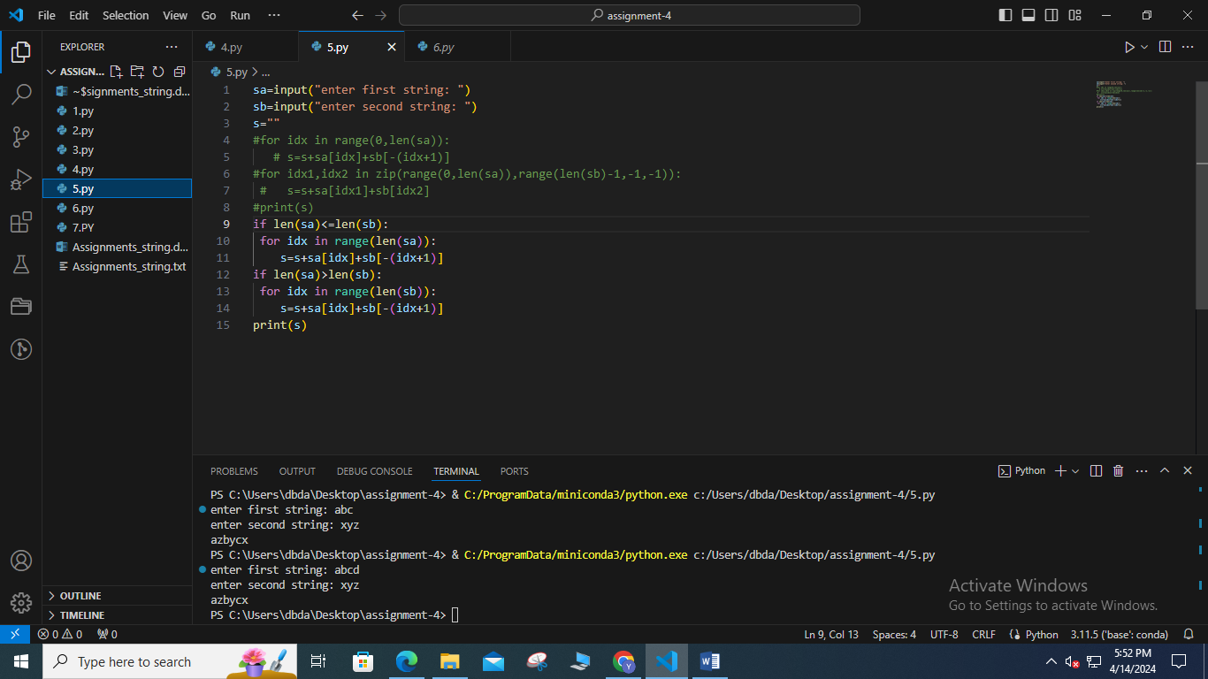

6. Find all occurrences of “USA” from right to left in a given string ignoring the case. also display the

starting position

Given:

str1 = "Welcome to USA. usa awesome, isn't it?

Expected answer : 16, 11

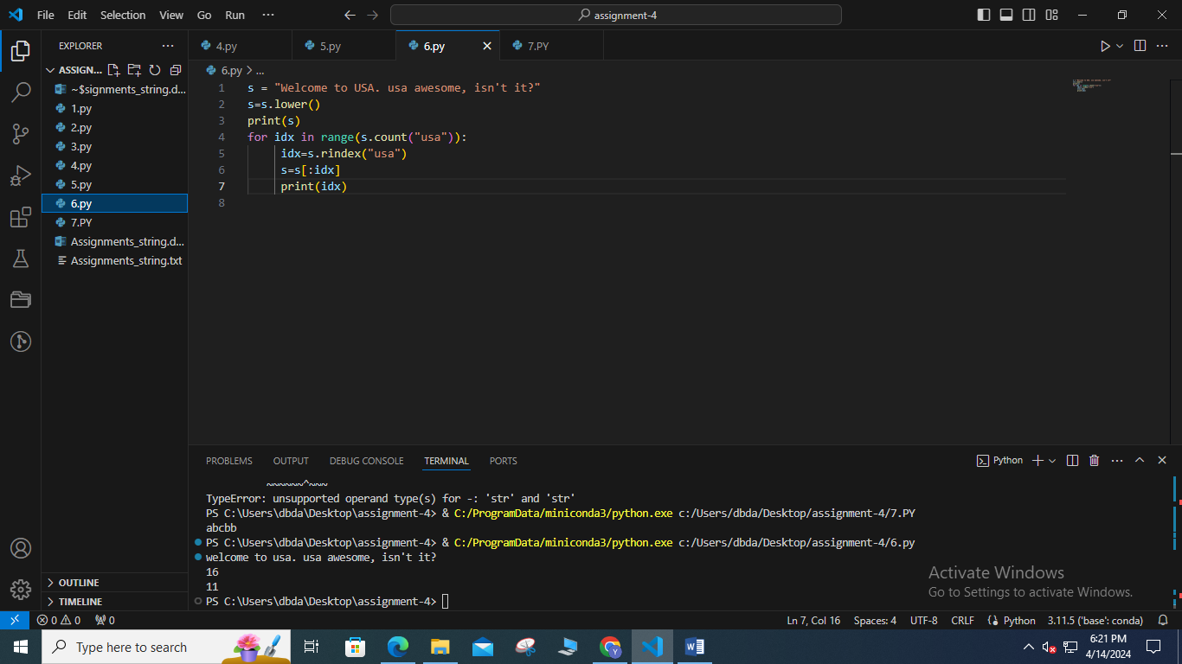

7. Find all overlapping occurrences of given substring in given string

Ex.

String = 0111

Substring = 11

Expected answer : 2

String : ANANAAAANNN

Substring: ANA

Expected answer : 2

String : ANANAAAANNN

Substring: AA

Expected answer : 3

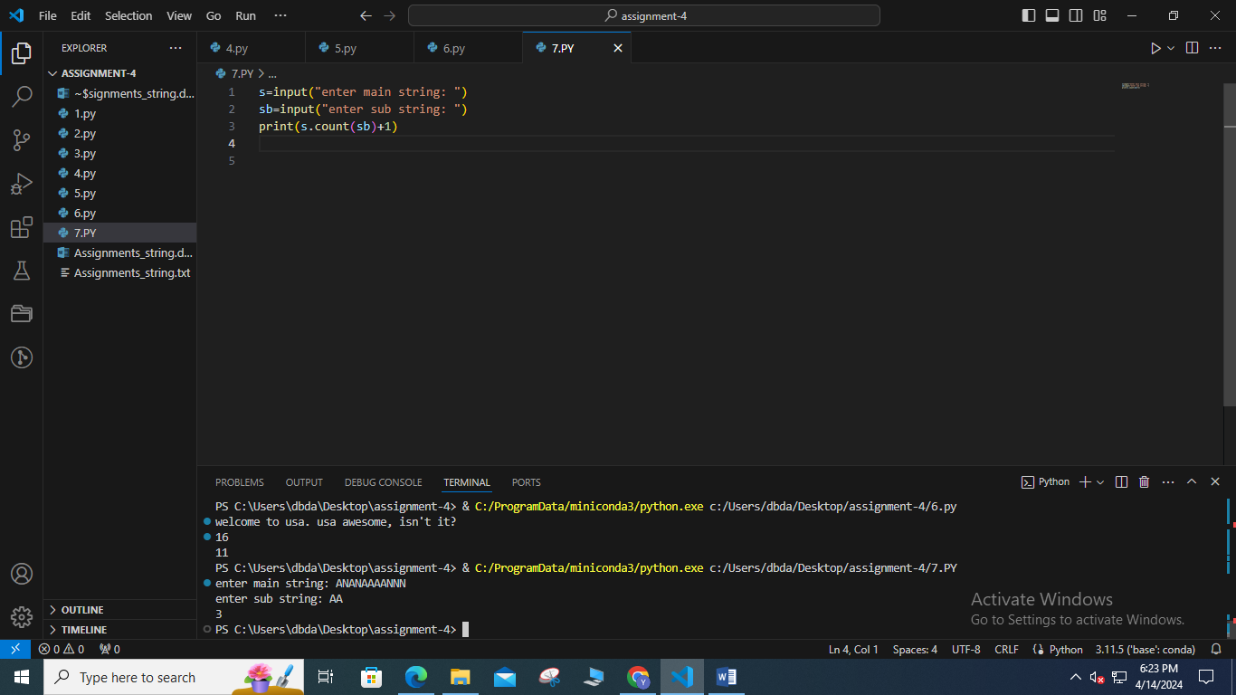

8. Given a string in format Emp_name:Emp_id

If emp_is is perfect square -- > Print only vowels from emp_name

Else if emp_id is prime -- > print alternate characters from emp_name

Else if emp_id is odd -- > print sum of ascii values of characters in emp_name

Else print None

9. Find all mobile number mentioned in given paragraph of text

Mobile number is always a 10 digit number no spaces no special characters

Ex. Input= “this is a good number 9089786756 and 8900000000 is a desired number”

Expected output: 9089786756 , 8900000000

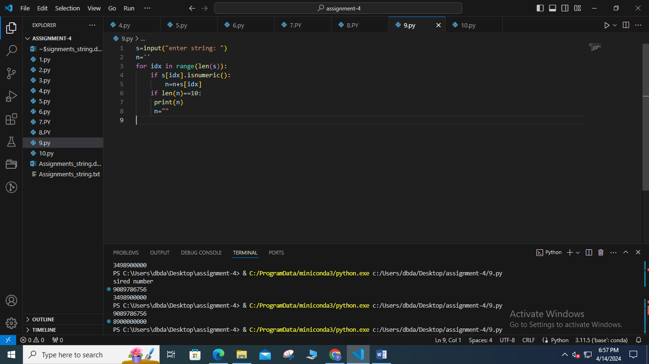

10. Count occurrence of spaces, and special characters in given string

Ex.

Input: Fgh^f #89

Expected output :

Spaces: 1

Special characters: 2

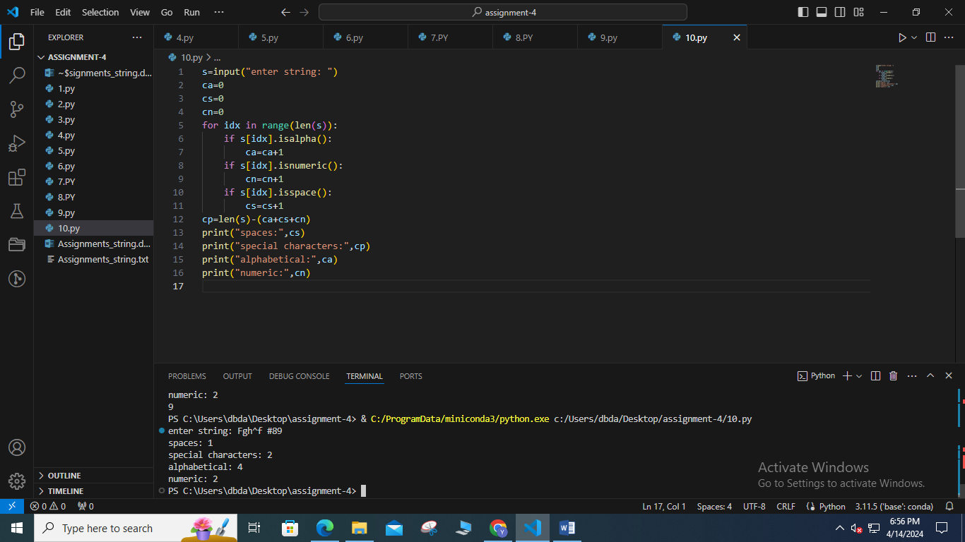

11. Given a paragraph count number of words, sentences. Every sentence ends with either . or ? or !

Print Count of how many normal sentences ending with . , how many interrogative sentences ( ending

with ?) and how many exclamatory sentences ( ending with !).

Ex.

Input : “I am at CDAC. What about you? I am surprised by current weather!”

Normal sentence : 1

Interrogative: 1

Exclamatory : 1

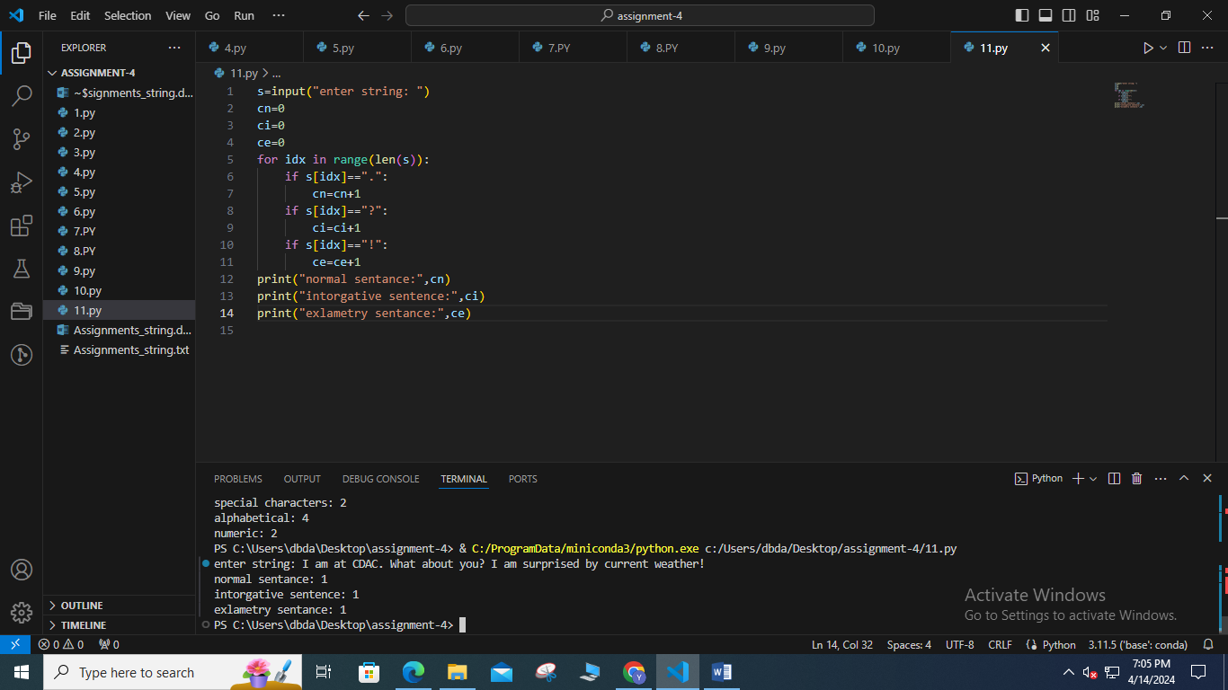

12. You are given a string S and width w.

Your task is to wrap the string into a paragraph of width w

Example .

String : “ABCDEFGHIJKLIMNOQRSTUVWXYZ”

Width: 4

Output:

ABCD

EFGH

IJKL

IMNO

QRST

UVWX

YZ

