ASSIGNMENT-2

Dhruva choudhary jampani

Python training(04/10/2019)

1 - Write a program to take out the element from their index values :x=[1,2,3,4,[10,20,30,40,[100,200,300,400],"riyazulhaque",5+5j],4000]

[10,20]

(5+5j)



[300,400]



[40,[100,200,300,400],"riyazulhaqu"]

Answer:

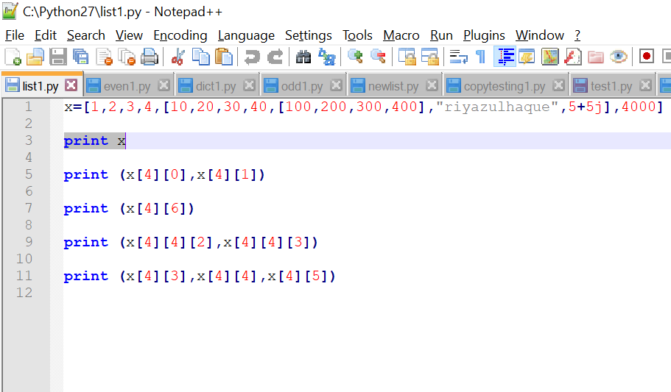

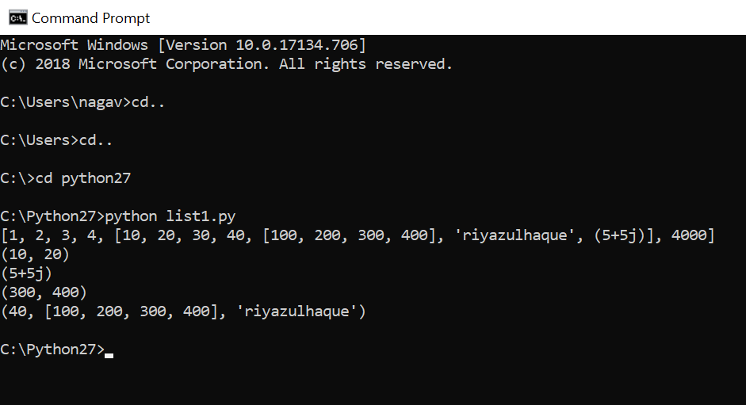

2 - Write a program to take out the pair of numbers whose sum is equal to an even number . You should return the list from the range of 1 to 21 .

Example: x=[1,2,3,4,5]

Pair should be (2,4) this will return the sum as 6 which is even .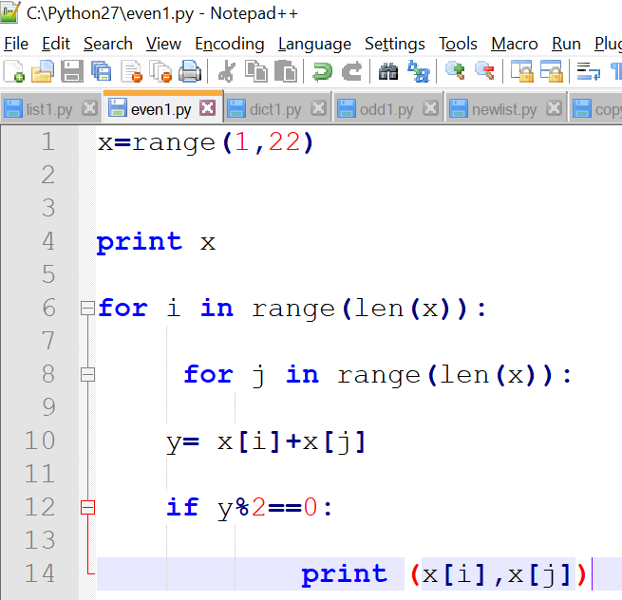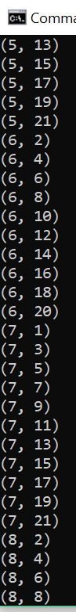

4 - Write a program to print the list of numbers which has a cube of odd numbers in the range of 1,50 .

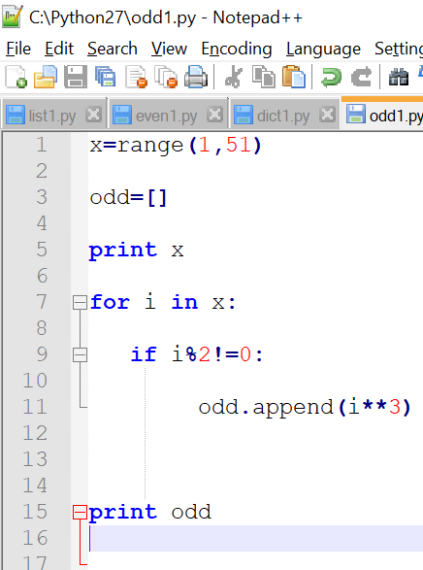

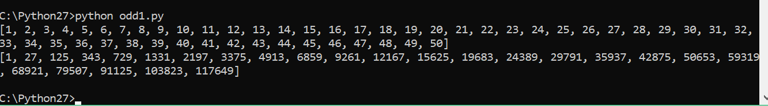

5 - Write a program to print the copy of list which has all the element multiplied by 3 but it should not reflect the result to the original list .

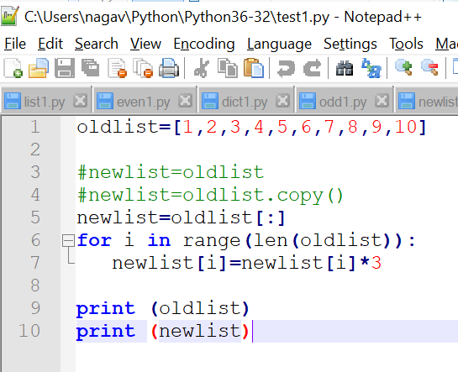

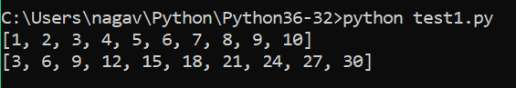

6 - Write a program to calculate the length of each word in the sentence .

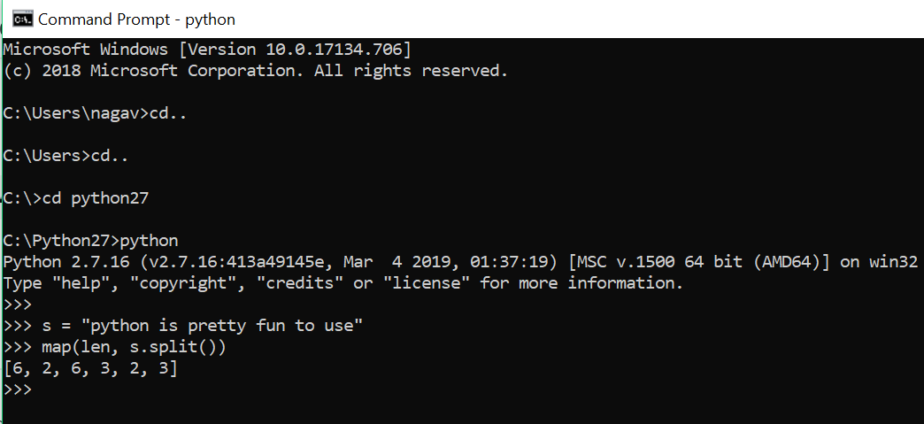

7 - Write a program to return True if the list consist only integer values only and if not return False .

