**Testing World Systems Theory in 2000s**

*An Application of Block Modeling Approach*

**Dhruval Bhatt**

March 25th, 2020

## Introduction

Human society is a complex web of interactions that spurs multitude effects on the individual participants as well as the network as a whole. In sociology, there are two prevalent views of a analyzing a network: interactionism and structuralism. While interactionism focuses on individual characterization, thought process and individual level relationships, structuralism focuses on the structures on the institutional level that guide individual roles. Interactionist viewpoint in network analysis theory is exemplified in works of Mark Granovetter on strength of ties and Ivan Chase who discussed interaction hierarchy through chicken pecking order. Notable thinkers that emphasized on the role of social structure on human behavior, include Karl Marx, who emphasized on two level class structure and Georg Simmel who extended the alter orientation on family.

This paper.. [After the paper is done]

- challenges the development economics for structure

- focuses on one paper, one theory

- using data from OECD

- Great stuff

## Theoretical Background

### World Systems Theory

World system theory, largely credited to Immanuel Wallerstein, is a line of thinking that encourages economic or social analysis from a total world wealth and event standpoint rather than using nations or isolated events such analysis. Specifically, in regard to economic development of nations, similar to dependency theory, world system theory disagrees with the, “linear notion that the historical growth of Western societies represents the pathway of development for the contemporary Third World” (Nemeth and Smith 518).

In the 1950s and 60s, Latin American scholars questioned the tenets of modernization theory that promoted the spread of rational thinking, capitalist ideology and democratic institutions to build the foundation for the economic advancement of all nations. They argued that countries remained underdeveloped due to the structure of international relations and not an inherent cultural or economic characteristic. While the dependence theorists emphasized on two-way relations between wealthy, advanced, imperial nations and less developed, colonized nations, the world system theorists extended this two-partition thinking into a grid of interdependence that can be divided into unequal exchange relations of necessary bulk commodities. Wallerstein theorizes that countries can be divided into three positions: “*core* states appropriate the surplus of the world economy as a whole and in particular of those states located in the *periphery*, which produce lower-ranking (labor intensive) goods, while states located in the *semiperiphery* are ‘both exploited and exploiters” (Breiger 354).

While core-semiperiphery-periphery division of the world gained acceptance, there was a lack of unified consensus on which countries held this position. In 1979 paper by Snyder and Kick, focused on a multinetwork analyses to find the structural positions of the country. They combine the world system theory with block model analysis to evaluate the structural positions that nations hold in world trade.

### Block Modelling

Block model analysis and CONCOR

“a block model approach to international trade assigns states to positions according to the structural similarity of the nations’ imports and exports to all other states, across various types of economic exchange” (Breiger 357)

to locate nations in structural positions within the world-system have recognized this need to study relationships between

1976). A key notion underlying multiple work analysis is the importance of grouping "actors" into blocks on the basis of their "structural similarity" to another (White, et al.)

1976: 739). Basically, two actors a network are structurally equivalent if they relate to all other actors in the system in exactly the

## Breiger’s “Structures of Economic Interdependence Among Nations"

Stemming from the conceptual framework of block model analyses in world system theory, Ronald Breiger conducted a block model analysis of the import and export of 24 nations (OECD nations of 1972 and Israel) for selected commodities. In his study, Breiger formed exchange network matrix for agricultural products, raw materials, manufactured goods and energy resources. The focus of the study is to find groups of nations that are structurally similar to each other and “examine the possibly distinctive patterns that these blocks induce on the original network data” (Breiger 357).

For his analysis, Breiger conducts a block model analysis for each of the trade networks to find partitions of groups of nations and how they trade among each other and other blocks of nations. A matrix of means of each partitioned network is found to determine on average the trade among blocks. He then forms a single partition across multiple matrices by applying the CONCOR algorithm

The study concludes that the core-periphery structure identified by Snyder and Kick holds but “adjusting for the total import and export levels of each country, … [reveals] the existence of multiple competing core” (Breiger 375). In the network diagrams (from Dr. Padgett’s notes) shown below, the pattern of competing core can be seen. USA, UK and Germany form the core while countries like Japan, Sweden and France form connections with additional countries but interesting do not overlap in trade between each.

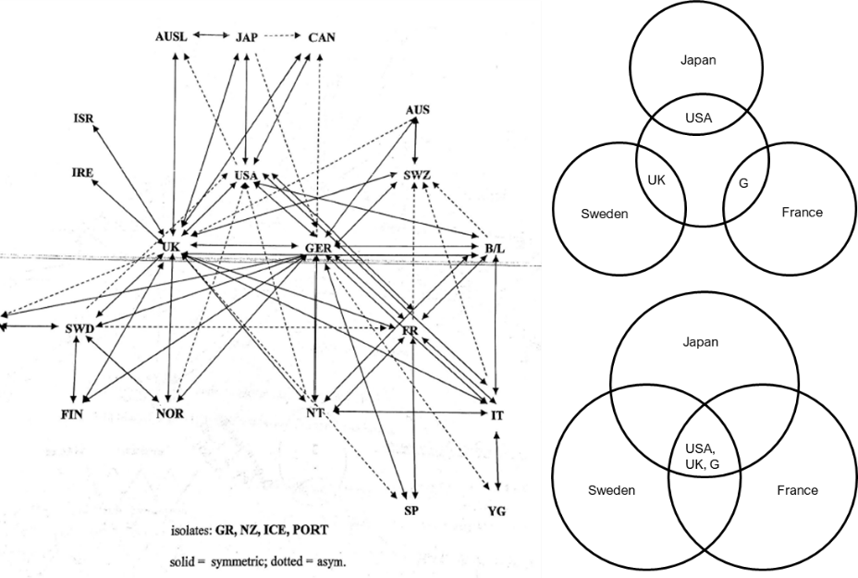

Figure 1 Network Diagram Created by Dr.Padget to Represent Breiger's 1972 Study

## From Harrison White and

## Data

For this study, we will be using data collected and maintained by Organization for Economic Co-operation and Development (OECD), an organization that “work[s] on establishing international norms and finding evidence-based solutions to a range of social, economic and environmental challenges” (OECD) They have a large database of international trade statistics that has been collected for more than 60 years. Beiger chose to limit his study to 24 OECD nations of 1972 and Israel, since the majority of world trade was accounted by them. However, that is no longer the case. The OECD has expanded to include 13 additional countries and non-OECD countries like India, China and Brazil that participate in world trade at a scale that cannot be ignored. According to world trade statistics, the merchandise trade was valued at US$ 19.67 trillion in 2018 and China was the leading merchandise trader (World Trade Statistics). The map shown below highlights the participation of countries in the merchandise trade. In 2018, “developing economies had a 44% share in world merchandise trade” (World Trade Statistics 14). In contrast when Breiger conducted his study for 1972, the highly industrialized OECD nations, accounted “for over 70 percent of the world totals in 1972” (Breiger 360)

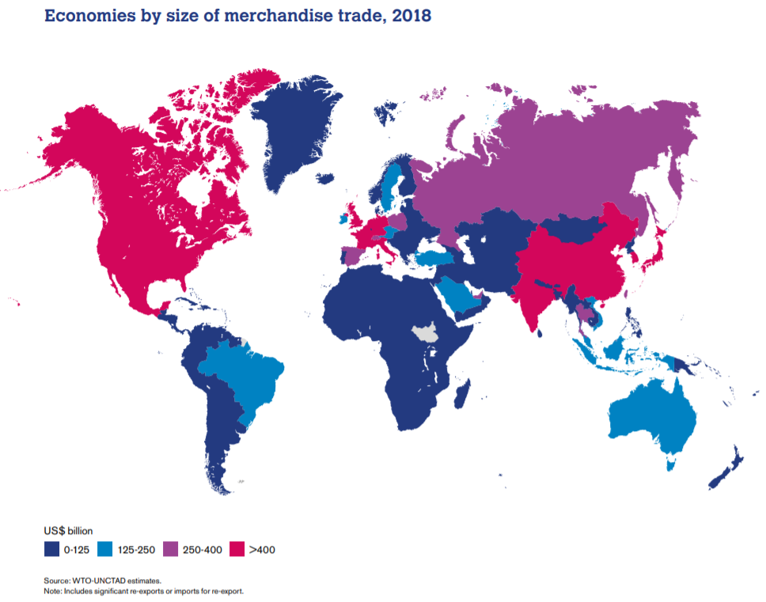

For this study, import-export trade data is collected from UN Comtrade database for commodity codes, 0, 2, 3, 6 (whose description can be found in the table below), for the years, 1971, 2007, 2008, 2013 and 2018.

Table 1 SITC Code Description for Data Collected

|  |  |
| --- | --- |
| **Commodity SITC Section Code** | **Description** |
| 0 | Food and live animals |
| 2 | Crude materials, inedible, except fuels |
| 3 | Mineral fuels, lubricants and related materials |
| 6 | Manufactured goods classified chiefly by material |

For the year 1971, only the original countries from Breiger’s study are considered to replicate the results that Breiger found to benchmark the analysis process and account for any discrepancy in methodology. The year 2018 is the latest available data and a decade earlier, 2008, marked a major global financial crisis.

Exploratory Data Analysis

Method



## The CONCOR

Join all 4 matrices

Create correlation matrices between all 3 matrices

Run CONCOR over matrices to find clusters

Apply blocking on each matrix to get average density blocks

## 1972

## 

2018

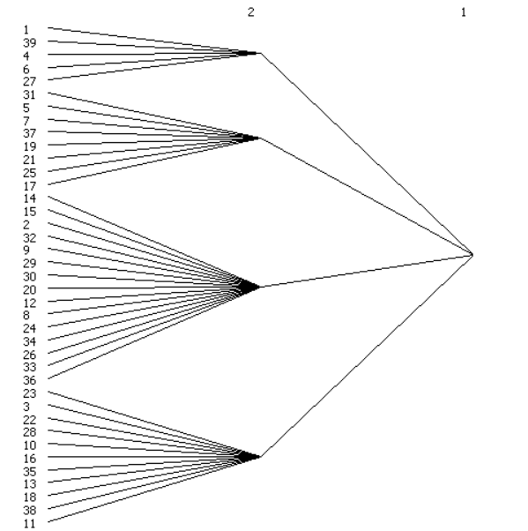

2008

## 

## Discussion

## Conclusion

## Future Work

Look at intellectual transfers and control of information and financial markets

## References

Breiger, Ronald, Blau, Peter M., et al. “Structures of Economic Interdependence Among Nations.” *Continuities in Structural Inquiry*, Sage, 1981.

Faust, Katherine, and Stanley Wasserman. “Blockmodels: Interpretation and Evaluation.” *Social Networks*, vol. 14, no. 1-2, 1992, pp. 5–61., doi:10.1016/0378-8733(92)90013-w.

Snyder, David, and Edward L. Kick. “Structural Position in the World System and Economic Growth, 1955-1970: A Multiple-Network Analysis of Transnational Interactions.” *American Journal of Sociology*, vol. 84, no. 5, 1979, pp. 1096–1126., doi:10.1086/226902.

Wallerstein, Immanuel. “The Rise and Future Demise of the World Capitalist System: Concepts for Comparative Analysis.” Toward a Just World Order, 2019, pp. 113–139., doi:10.4324/9780429269400-14.

“World Trade Statistical Review 2019.” World Trade Statistical Review, 2019, doi:10.30875/7195c6e1-en.