**Testing World Systems Theory in 2000s**

*An Application of Block Modeling Approach*

**Dhruval Bhatt**

March 28th, 2020

## Introduction

Human society is a complex web of interactions that spurs multitude effects on the individual participants as well as the network as a whole. In sociology, there are two prevalent views of a analyzing a network: interactionism and structuralism. While interactionism focuses on individual characterization, thought process and individual level relationships, structuralism focuses on the structures on the institutional level that guide individual roles. Interactionist viewpoint in network analysis theory is exemplified in works of Mark Granovetter on strength of ties and Ivan Chase who discussed interaction hierarchy through chicken pecking order. Notable thinkers that emphasized on the role of social structure on human behavior, include Karl Marx, who emphasized on two level class structure and Georg Simmel who extended the alter orientation on family.

In world economic theory, some, such as, development theorists or modernization theorists, look at nations as individual units of analysis while others, such as, world systems theorists argue that structural position of nations is important in globalization and macroeconomic studies. In this paper, I will review the background of world systems theory and a popular network analysis method, block-model approach, that is used to systematically determine the structural position of a nation. I will then replicate the approach used by Ronald Breiger to determine the positions of 1972 OECD nations in his work, “*Structures of Economic Interdependence Among Nations*”, to analyze how has the structural position of nations evolved in the 21st century. Considering, that new major economies, such as, China have emerged on world scene, I hypothesize to see shift in which countries form the core nations. However, the Breiger’s approach to analyze trade structures to understand the subtle relations among nations, would stand to be a viable approach in determining the position of nations in a world system.

## Literature Review

World system theory, largely credited to Immanuel Wallerstein, is a line of thinking that encourages economic or social analysis from a total world wealth and event standpoint rather than using nations or isolated events such analysis. Specifically, regarding economic development of nations, similar to dependency theory, world system theory disagrees with the, “linear notion that the historical growth of Western societies represents the pathway of development for the contemporary Third World” (Nemeth and Smith 518).

In the 1950s and 60s, Latin American scholars questioned the tenets of modernization theory that promoted the spread of rational thinking, capitalist ideology and democratic institutions to build the foundation for the economic advancement of all nations. They argued that countries remained underdeveloped due to the structure of international relations and not an inherent cultural or economic characteristic. While the dependence theorists emphasized on two-way relations between wealthy, advanced, imperial nations and less developed, colonized nations, the world system theorists extended this two-partition thinking into a grid of interdependence that can be divided into unequal exchange relations of necessary bulk commodities. Wallerstein theorizes that countries can be divided into three positions: “*core* states appropriate the surplus of the world economy as a whole and in particular of those states located in the *periphery*, which produce lower-ranking (labor intensive) goods, while states located in the *semiperiphery* are ‘both exploited and exploiters” (Breiger 354).

While core-semiperiphery-periphery division of the world gained acceptance, there was a lack of unified consensus on which countries held this position. In 1979 paper by Snyder and Kick, focused on a multinetwork analyses to find the structural positions of the country. They combine the world system theory with block model analysis to evaluate the structural positions that nations hold in world trade. Snyder and Kick, critique that the world systems theory, prior to their work, lacked operational rigor for classifying nation’s position in the system or even structural necessity of three-tiered model in a capitalist world economy (the dominant world system for decades, according to Wallerstein). Additionally, previous regression analyses required a choice between focusing on poor countries to test the “effect of economic or cultural imperialism on economic growth” or include all available data for all nations leading to dubious arguments like Rubinson’s claim that, “a nation’s exports and imports (as a percentage of the GDP) puts the state and its economic actors in a position of less power and control in the world economy” (Snyder and Kick 1101). These are refuted in the economic standings of countries like USA and Japan. Finally, they urge that previously utilized indicators such as investment dependence or trade concentration do not completely represent the nation’s position as they “do not fully specify the institutional locus of transnational flow” (Snyder and Kick 1102). To address this, Snyder and Kick, conduct a multinetwork, block-model analysis on data from 118 countries for four important networks: trade flows, military interventions, diplomatic exchanges, and conjoint treaty memberships. Their analysis strongly supported the world systems theory.

Snyder and Kick utilized the block-model approach of Breiger, White, and Boorman, Ronald Breiger, built on their work of world system theory to use different international trade networks to determine a nation’s structural position. Breiger proposed that, “a block-model approach to international trade assigns states to positions according to the structural similarity of nations’ imports and exports to all other states, across various types of economic exchange, rather than on the basis of definitional aggregation” (Breiger 357). Breiger’s main objective was also to operationalize procedures to identify core, semi-peripheral, peripheral nations based only on trade networks and determine if the core-periphery structures allowed competing centers. Additionally, he intended to explore “the distinctive elements of core-periphery structure in contrast to other ideal type structures that might characterize international exchange” and determine if different exchange networks presented the same results (Breiger 355). The following section of this paper, details Breiger’s approach and results as his paper, “*Structures on Economic Interdependence Among Nations”*, forms the basis of this paper’s analysis.

Following Breiger’s approach of using relational interaction of nations through international trade, Nemeth and Smith, also focus on international commodity exchanges in their paper, “*International Trade and World System Structure”*. The authors expand on Breiger’s work by using the same UN Comtrade data but including all nations with a population over a million (86 countries in total) and do not arbitrarily pick the commodities. Instead, they use a principal component analysis on all commodities and reduce to five categories of commodity groups. Using CONCOR block-model technique, Nemeth and Smith also uncover the core countries in accordance to world systems theory. The paper ends with recommend future work on longitudinal data to test the pattern of trade in different periods but do attest that the empirically method is valid for understanding world system structure. Nonetheless, they conclude that empirical analysis is a tool to understand modern world, but it should be used with in-depth comparative study.

Scholarly work refining the world systems theory, both qualitative and empirically, is extensive. However, here the focus was on key works that used the network analysis method of block-modelling to uncover the structural position of nations in world systems.

## Methodological Foundation

In this paper, the method from Breiger’s *Structures of Economic Interdependance Among Nations* will be replicated. He conducts a block model analysis of the import and export of 24 nations (OECD nations of 1972 and Israel) for selected commodities. In his study, Breiger formed exchange network matrix for agricultural products, raw materials, manufactured goods and energy resources. The focus of the study is to find groups of nations that are structurally like each other and “examine the possibly distinctive patterns that these blocks induce on the original network data” (Breiger 357).

Breiger creates a 24 by 24 matrix of countries import and export for each of the trade networks. He binarizes this matrix, by only considering the highest fifth of the interior cell values and then rearranges and partitions the rows and columns using block-model method. Robust block model algorithms for structural equivalence is a contribution by Harrison White, Scott Boorman and Ronald Breiger through their paper, *Social Structure from Multiple Networks. I. Blockmodels of Roles and Positions.* From this analysis, a distinct core-periphery pattern emerges that bears resemblance to the 118-country analysis of Snyder and Kick. However, he argues that world system theorist would not accept this empirical evaluation based on binarized trade data of one commodity as countries have unequal exchanges in import and export and the results imply that the “world is bound together by a few core states” (Breiger 364).

To address this concern, Breiger usises Schwartz’s technique to net out unequal exchange. For the network data, “row and column means were subtracted from each matrix, leaving residuals from an additive, two-way analysis of variance model” (Breiger 365). Positive values indicated statistical interactions, while negative values represented the opposite. This method was applied to a single correlation matrix created by multiple networks: agricultural products, raw materials, manufactured goods. The block model algorithm used to cluster countries is, CONCOR (Convergence of Iterated Correlations), “a divisive hierarchical clustering procedure that continuously splits actors into successively smaller groups” (Nemeth and Smith 532). The eigen structure of the resulting matrix was examined and plotted to reveal geographical clustered nations with insight of historical events. Here Breiger, does urge conducting a time series analysis to see how the positions differ in light of world economic events, such as, formal entry of UK into European Common Market. Breiger examines the correlations between the four matrices to establish that each of the trade matrices are quite different from each other. Therefore, to find any additional asymmetries, it is important to run a four block CONCOR partition to each of the networks. The correlation matrices are adjusted as previously described.

The study concludes that the core-periphery structure identified by Snyder and Kick holds but “adjusting for the total import and export levels of each country, … [reveals] the existence of multiple competing core” (Breiger 375). In the network diagrams (from Dr. Padgett’s notes) shown below, the pattern of competing core can be seen. USA, UK and Germany form the core while countries like Japan, Sweden and France form connections with additional countries but interesting do not overlap in trade between each.

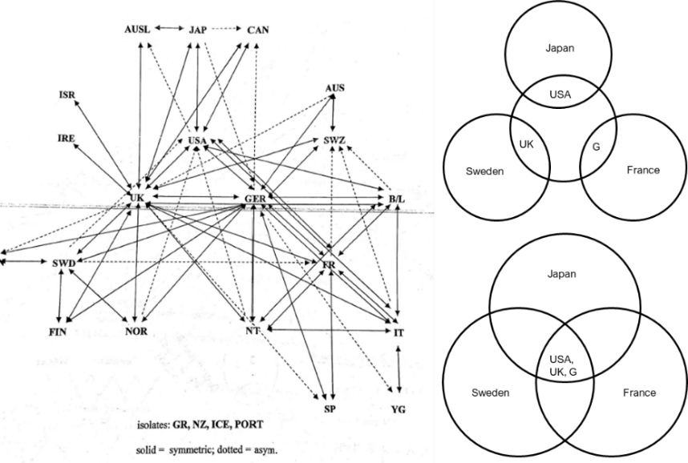

Figure 1 Network Diagram Created by Dr.Padget to Represent Breiger's 1972 Study

## Data

This study will use data collected and maintained by Organization for Economic Co-operation and Development (OECD), an organization that “work[s] on establishing international norms and finding evidence-based solutions to a range of social, economic and environmental challenges” (OECD) They have a large database of international trade statistics that has been collected for more than 60 years. Beiger chose to limit his study to 24 OECD nations of 1972 and Israel, since most of the world trade was accounted by them. However, that is no longer the case. The OECD has expanded to include 13 additional countries and non-OECD countries like India, China and Brazil, participate in world trade at a scale that cannot be ignored. According to world trade statistics, the merchandise trade was valued at US$ 19.67 trillion in 2018 and China was the leading merchandise trader (World Trade Statistics). The map shown below highlights the participation of countries in the merchandise trade. In 2018, “developing economies had a 44% share in world merchandise trade” (World Trade Statistics 14). In contrast when Breiger conducted his study for 1972, the highly industrialized OECD nations, accounted “for over 70 percent of the world totals in 1972” (Breiger 360)

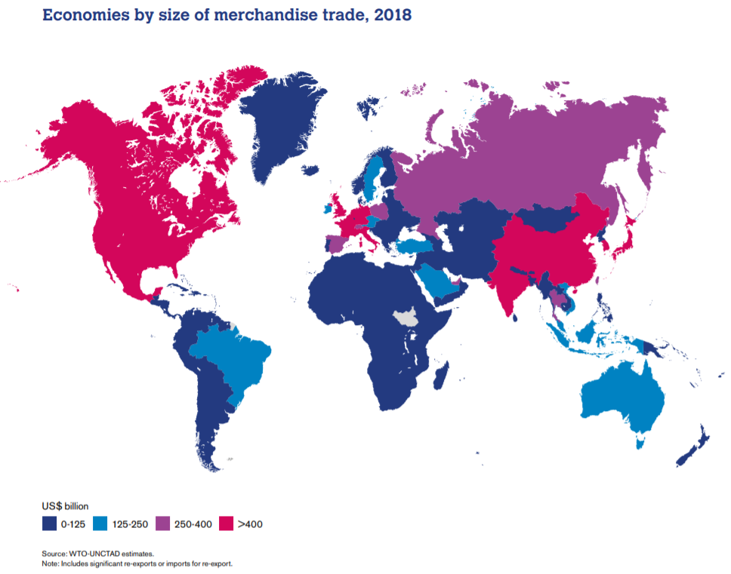

For this study, import-export trade data is collected from UN Comtrade database for the same commodity codes that Breiger used, 0, 2, 3, 6 (whose description can be found in the table below), for the years, 1971, 2007, 2008, 2013 and 2018.

Table 1 SITC Code Description for Data Collected

|  |  |
| --- | --- |
| **Commodity SITC Section Code** | **Description** |
| 0 | Food and live animals |
| 2 | Crude materials, inedible, except fuels |
| 3 | Mineral fuels, lubricants and related materials |
| 6 | Manufactured goods classified chiefly by material |

To determine the world structure in recent times, the latest data available, year 2018, will be used. However, “world systems analysis is directed to studies of social change in which the system itself is open to dynamic alterations”, therefore, a temporal analysis is done to evaluate, “the stability or fluidity of structure” (Nemeth and Smith 556). The year 2008 gives a picture of the world ten years prior. However, given that the year 2008 marked a major global financial crisis, to account for any situational differences, years 2007 and 2013 are considered to determine the structure of world in the recent times. For the year 1971, only the original countries from Breiger’s study are considered to replicate the results that Breiger found to benchmark the analysis process and account for any discrepancy in methodology.

Method

The same steps derived from Ronald Breiger’s approach to world analysis is applied to each of the five years of datasets. Before applying the block model analysis, a rigorous data extraction and preparation is conducted. From the UN COMTRADE database, the import-export data for each of the countries in consideration, in each of the years, is individually downloaded. Then, for each year in consideration, the data is cleaned and combined into one dataframe in Python’s Jupyter notebook. Then the combined dataframe is cleaned to retain the commodity exchange with only the countries in consideration. That is, only the countries in OECD and India, China, Brazil (OECD and Israel for 1971) are retained for creating the matrix of reporter and partner nation. Additionally, any data for export, re-export and re-import are removed. Nemeth and Smith point out, referring to works of Duran and Linnemann, that, “only import data are used because, as a result of number of factors, reports on imports and exports do not always match perfectly and there is reason to believe that import figures are more accurate” (Nemeth and Smith 526). This discrepancy is observed in the data extracted in this study and since, Breiger’s method to address this is not clear, this study utilizes the import data only approach of Nemeth and Smith. Finally, all the country names are standardized.

Using pandas groupby command and filtering by commodity code in python, the cleaned data is converted into a 39 by 39 (24 by 24 for 1971) matrix for each of the four international exchange networks. Additionally, since Breiger considers “only the highest fifth of interior cell values” in his first step in analysis, matrices that code 1 for the top fifth value and 0 for rest are also created. The data for each of the trade matrices is thus prepared and saved in csv format for block model analysis.

The block model analysis is conducted in a software specialized for network analysis – UCINET. The csv files are loaded into matrix editor and converted to UCINET native files and analyzed using UCINET’s CONCOR block model analysis. For each of the years in consideration, first the block model is applied to each of the trade networks to determine the structure of world-system using one network. Additionally, just like Breiger, a multinetwork analysis is conducted. First the correlations among all networks is determined. Then, to find the structure across multiple networks, the rows for all four trade exchange matrices are joined and a correlation matrix is created for the combined network. The CONCOR block model analysis is run on this correlation network. Additionally, just as Breiger had adjusted for different intensities of trade using the method proposed by Schwartz, a matrix normalization is conducted in on the rows and columns of the joined matrix using mean. A block model analysis is conducted on the correlation matrix of the normalized matrix as well.

Results

## Correlation Matrix



Figure 2 Comparison of Correlations among Trade Matrices for all Years

## 1972

### Part 1: Binarized for each trade networks

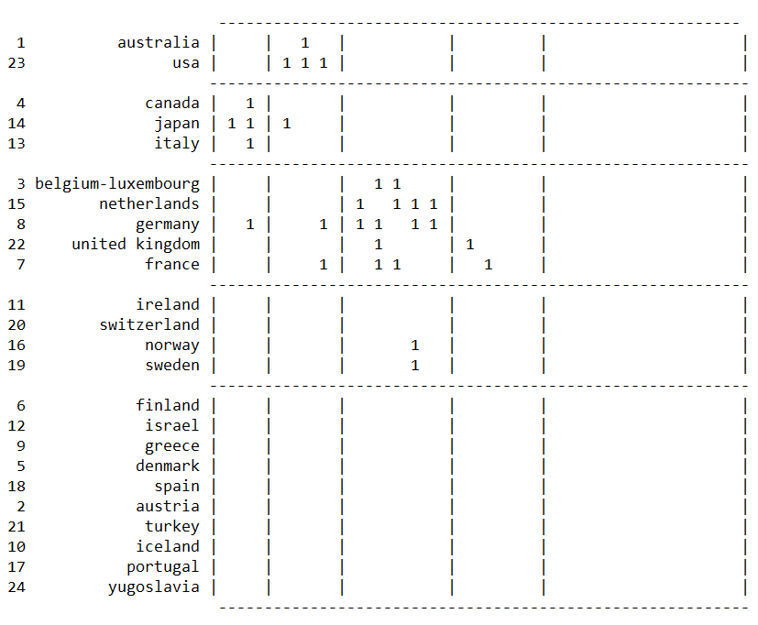

Figure 3 CONCOR Block Model for Manufactured Goods - 1972

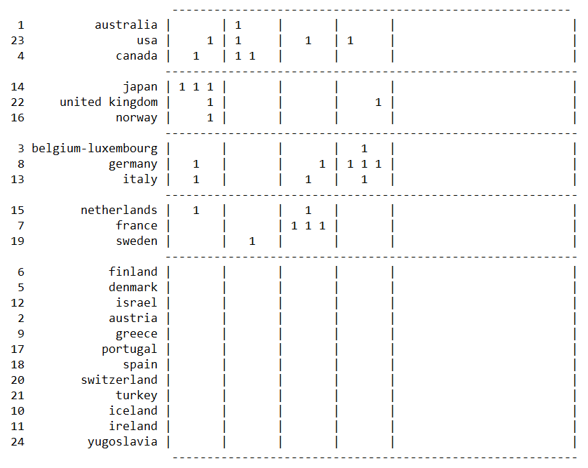

Figure 4 CONCOR Block Model for Raw Materials - 1972

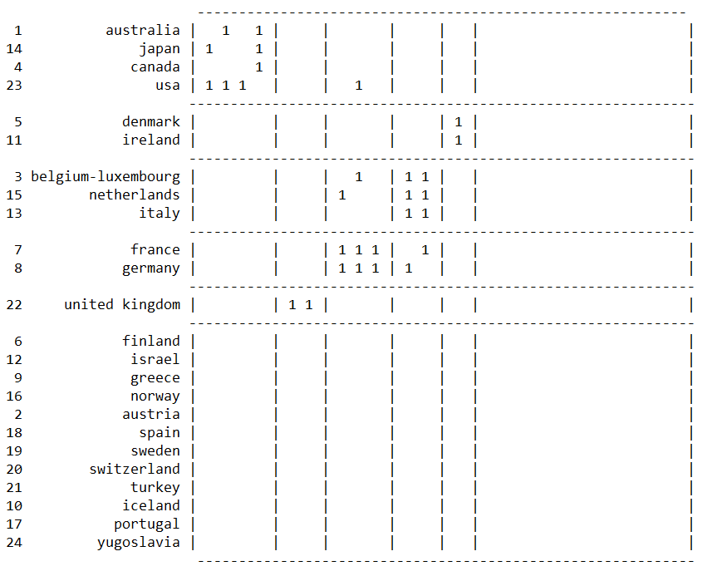

Figure 5 CONCOR Block Model for Agriculture Products – 1972

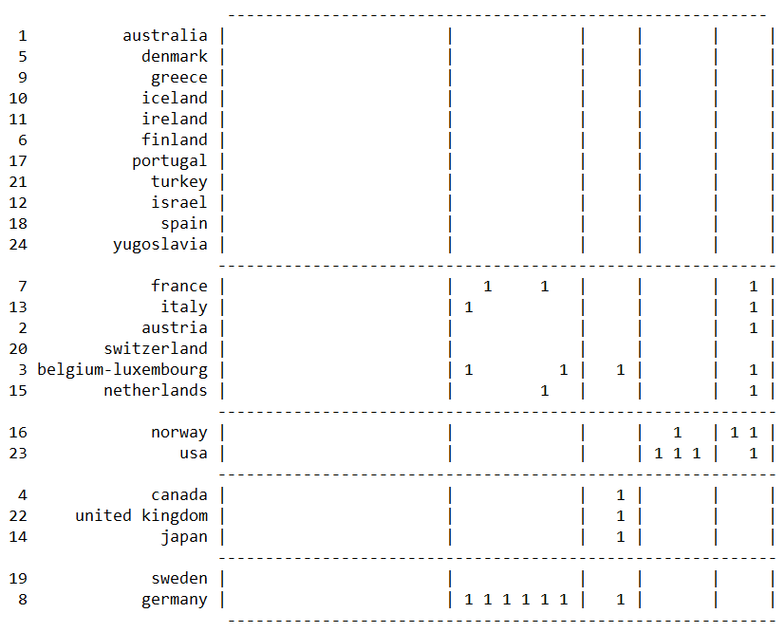

Figure 6 CONCOR Block Model for Energy Products – 1972

### Part 2: Multinetwork Analysis (Non-Normalized and Normalized)

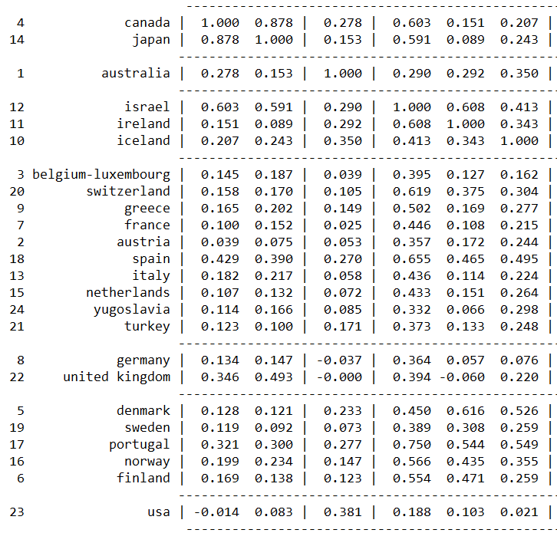

Figure 7 Part of CONCOR Blockmodel for Multinetworks (non-normalized)

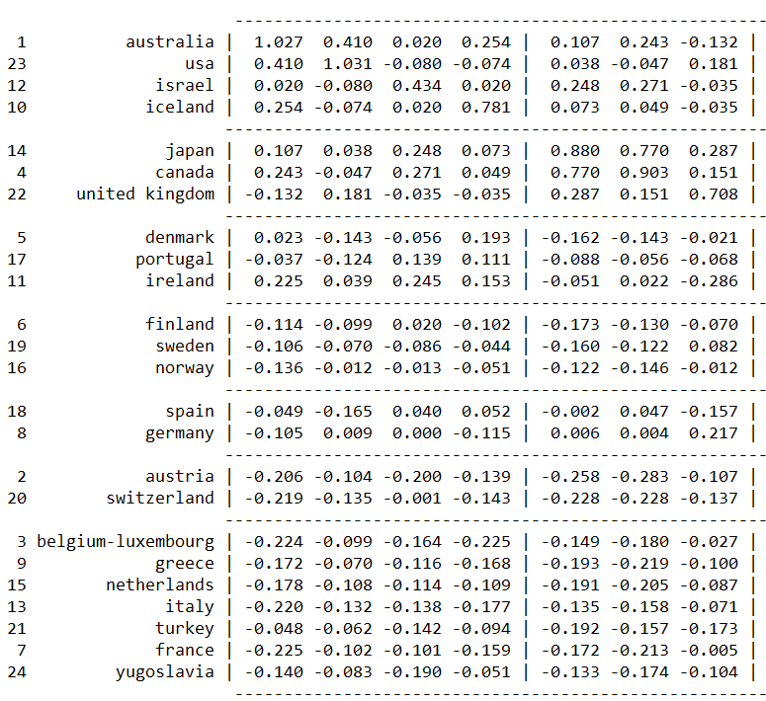

Figure 8 Part of CONCOR Blockmodel for Multinetworks (normalized)

## 2018

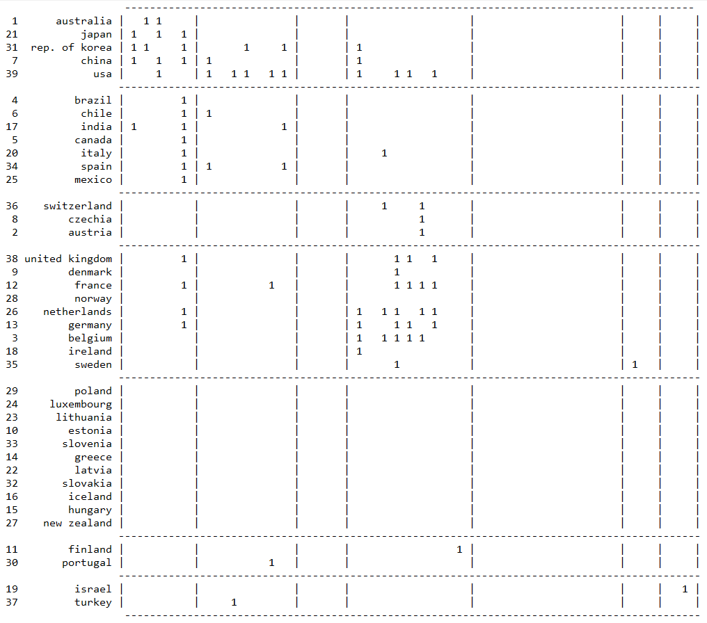

Figure 9 CONCOR Block Model for Manufacturing – 2018

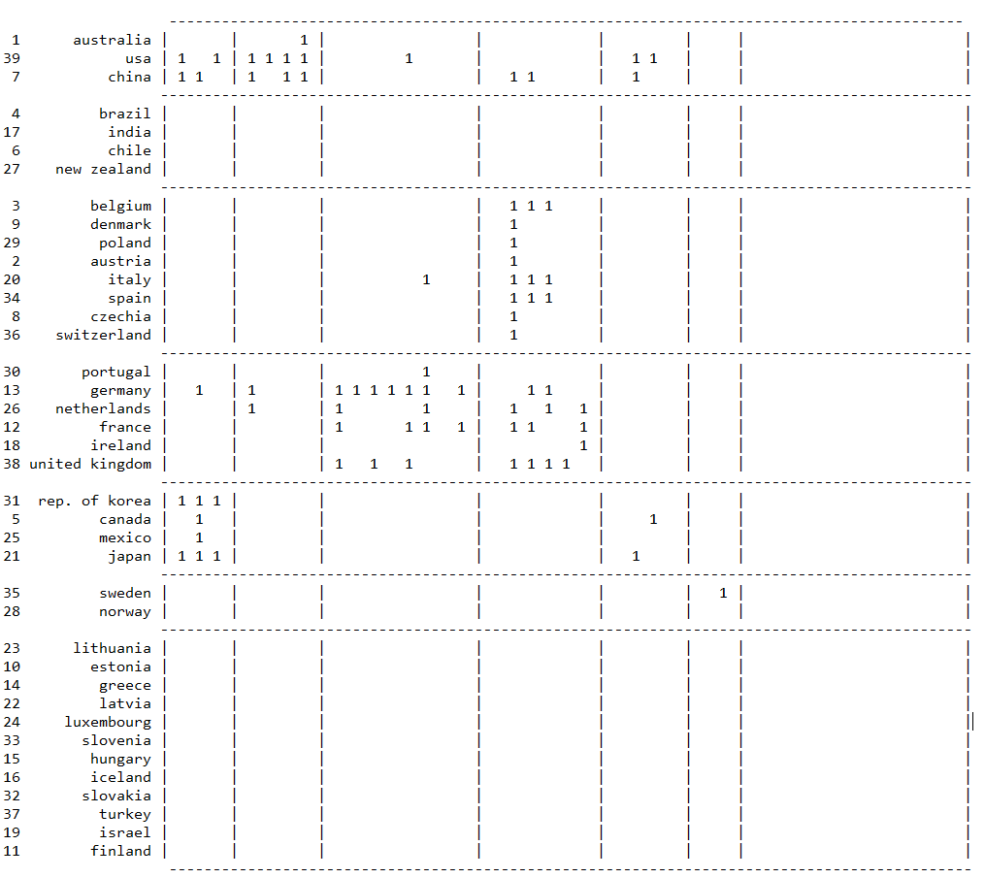

Figure 10 CONCOR Block Model for Agriculture Products – 2018

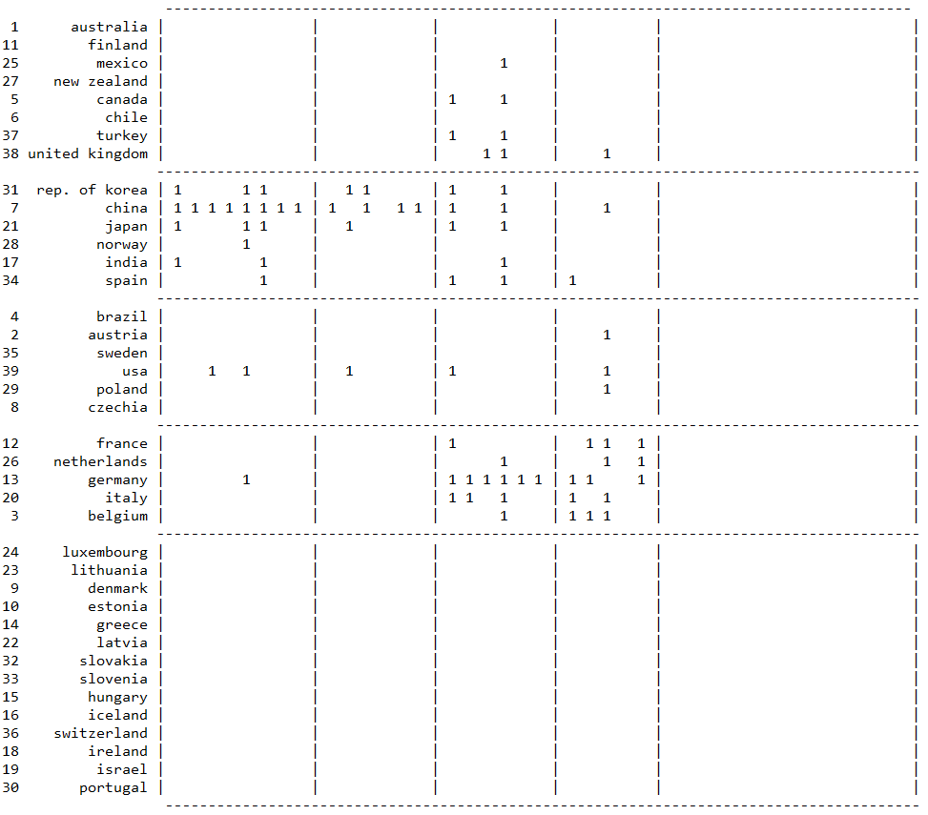

Figure 11 CONCOR Block Model for Raw Materials – 2018

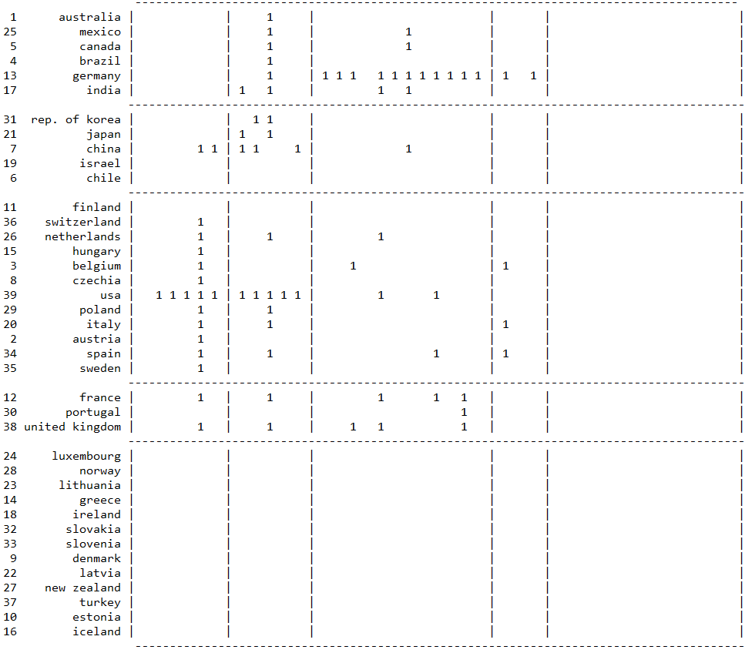

Figure 12 CONCOR Block Model for Energy Products – 2018

## 2008

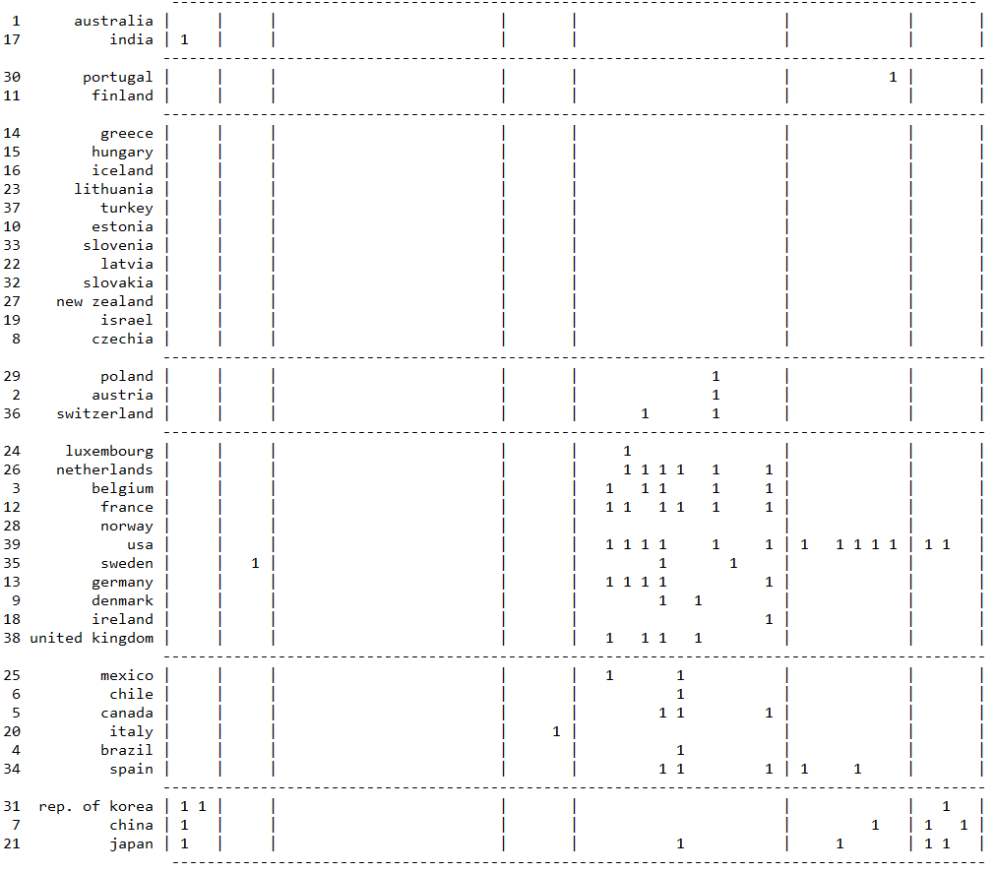

Figure 13 CONCOR Block Model for Manufacturing – 2008

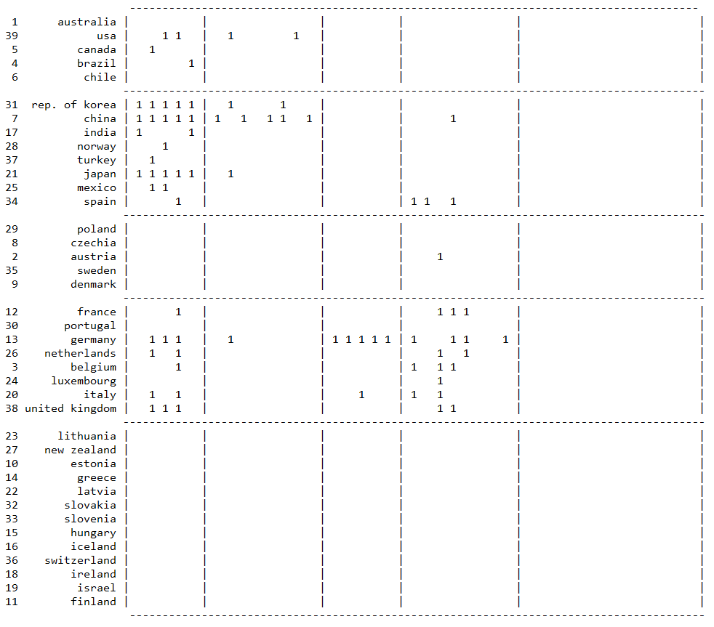

Figure 14 CONCOR Block Model for Raw Materials - 2008

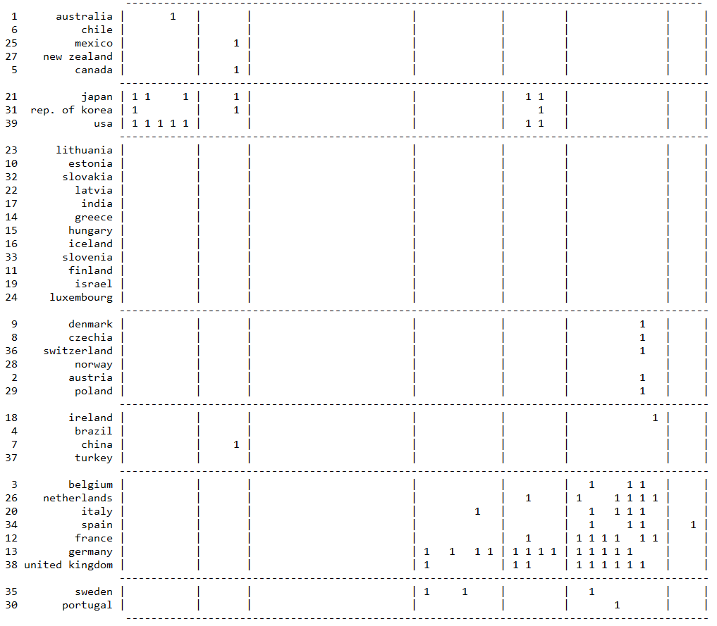

Figure 15 CONCOR Block Model for Agricultural Products – 2008

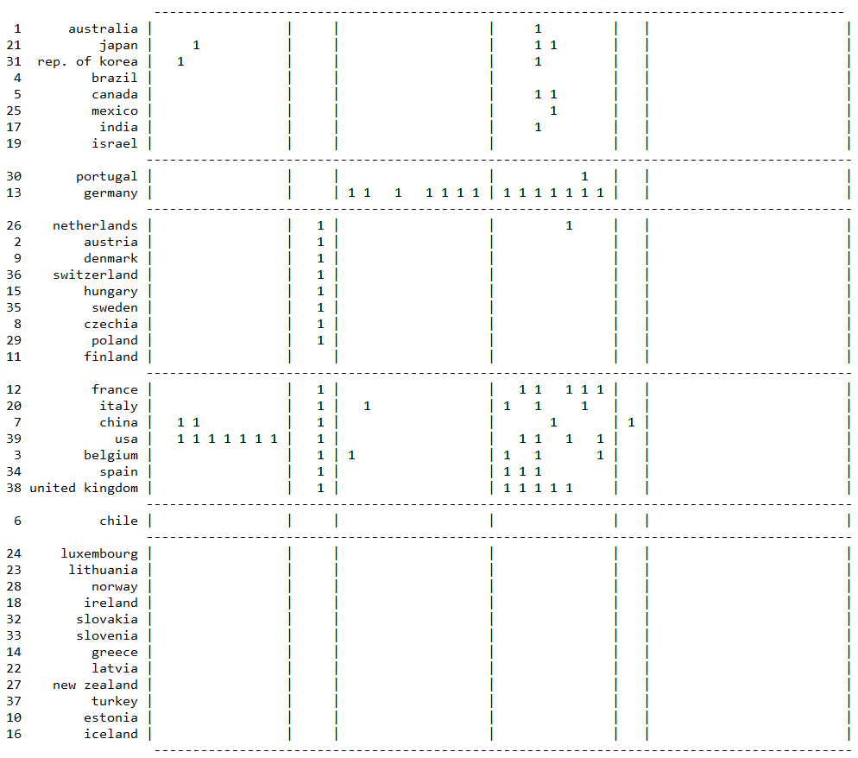

Figure 16 CONCOR Block Model for Energy Products – 2008

## 2007

## Discussion

## Conclusion

Network analysis in sociology requires strong theoretical reasoning and methodological implications.

## Future Work

Look at intellectual transfers and control of information and financial markets

“Unequal exchange initially created and continuously maintains the structural division

Add link to github

## References

Breiger, Ronald, Blau, Peter M., et al. “Structures of Economic Interdependence Among Nations.” *Continuities in Structural Inquiry*, Sage, 1981.

Faust, Katherine, and Stanley Wasserman. “Blockmodels: Interpretation and Evaluation.” *Social Networks*, vol. 14, no. 1-2, 1992, pp. 5–61., doi:10.1016/0378-8733(92)90013-w.

Nemeth, Roger J, and David A Smith. “International Trade and World-System Structure: A Multiple Network Analysis.” Review (Fernand Braudel Center), vol. 8, no. 4, 1985, pp. 517–560. JSTOR, doi:https://www.jstor.org/stable/40241006.

Snyder, David, and Edward L. Kick. “Structural Position in the World System and Economic Growth, 1955-1970: A Multiple-Network Analysis of Transnational Interactions.” *American Journal of Sociology*, vol. 84, no. 5, 1979, pp. 1096–1126., doi:10.1086/226902.

Wallerstein, Immanuel. “The Rise and Future Demise of the World Capitalist System: Concepts for Comparative Analysis.” Toward a Just World Order, 2019, pp. 113–139., doi:10.4324/9780429269400-14.

White, Harrison C., et al. “Social Structure from Multiple Networks. I. Blockmodels of Roles and Positions.” American Journal of Sociology, vol. 81, no. 4, 1976, pp. 730–780., doi:10.1086/226141.

“World Trade Statistical Review 2019.” World Trade Statistical Review, 2019, doi:10.30875/7195c6e1-en.

## Appendix

OECD Countries

UCINET Screenshots for Analysis