Dhruval Bhatt

Assignment #6

MACSS Perspectives – Dr. Evans

**Part 1**

The paper, “All Together Now: A perspective on Netflix Prize is written by the winners of Netflix prize, an open call competition hosted by Netflix to improve their algorithm to suggest movies to their customers. Netflix’s own algorithm Cinematch served as a baseline for the competition and the winners of the grand prize would be the team with the best improvement in Root Mean Square Error (RMSE). The competition sponsors expected at least a 10% improvement to be considered for judging.

At the beginning of the competition, the most common method for predicting movie ratings was nearest neighbors filtering method. This means that the rating for something is determined by knowing the similar movies or profiles of users and finding a weighted average. While this method does produce good results, the selection of similar items is arbitrary and could be challenged and some very similar movies could be counted more than once.

Many new ideas were proposed during the length of the competition and as the authors suggest, “many of the single models in Netflix prize were latent factor models … that use matrix factorization” (Bell et al.) However, to reach the top of the charts and meet the minimum criterion, collaborating among groups and combining models seemed like a helpful idea. Combining models with comparable root mean square errors was a good choice as they can be easily averaged over creating a new model that utilizes the best aspect of each model. Working with other groups enhanced the ideas and propelled everyone involved to a greater point of success.

The competition certainly served as a great tool to improve individual and collective knowledge in machine learning algorithms but also served as an example for widespread internet collaboration and power of open call competitions.

**Part 2**

a) Project Euler Login Detail

Username: dhruval

Friend Key: 1410689_9AmwA2CQKUgt5Wg1UXta2o6D8AgBrC3j

b) Archive problem: Multiples of 3 and 5

Code and answer to the problem:

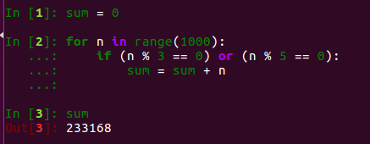

c) The awards I would like to get:

Baby Steps – "A journey of a thousand miles begins with a single step". I aspire for this award as if one doesn’t start somewhere, one doesn’t get anywhere.

State of The Art – It would be good to start with archives but this award would motivate me to work on more recent problems.

One Percenter – This award would be an indication for mastery of the matter which is gained with dedication and hard work. One percenter is brag-worthy title.

**Part 3**

a) Human Intelligence Task identified: Locate Hand features in Image

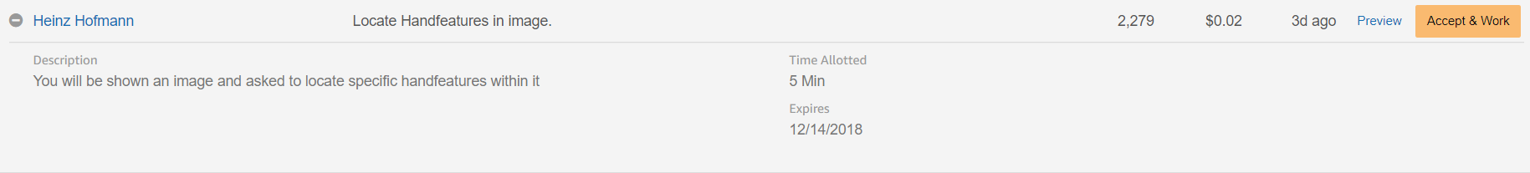

b) Payment $0.02 for each completed task

c) There are no qualifications or eligibility or restrictions which allowed me to try this task.

d) Time allotted is 5 mins. It is possible to complete the task in 5 mins, which means the minimum one can complete 12 tasks and make $0.24/hr. However, the task may not actually take all 5 mins and more can be complete with a potential to earn more.

e) The task expires on December 14th, 2018

f) Since there are no masters or premium qualifications, the cost is simplified. The creator must pay $0.02 to workers for each task completed and a 20% fee to amazon, $0.0004. However, the minimum cost per assignment is $0.01 which means for each HIT, the cost is $0.03. For a million people it is $0.03*1000000=\$30,000$. This is assuming no bonus was given.

**Part 4**

a) Registered on Kaggle with username, Dhruval and link is <https://www.kaggle.com/dhruvalb>

b) One of the open competitions on Kaggle is Google AI Open Images – Object Detection Track. This competition is sponsored by Google AI, that is a research group within Google that is working on artificial intelligence development. Google is a well-known technology company that was started by two Stanford students, Larry Page and Sergey Brin. The roots of the widespread success of Google was its optimized, efficient search engine but it has since then grown to offer many products such as email, cloud storage drive, maps and many more. Today, Google is a subsidiary of Alphabet, a company incorporated in 2015. Google AI is a research arm of Google that prides in conducting artificial intelligence research and its application with a mission “to organize the world’s information and make it universally accessible and useful” (About – Google AI).

The submission for the competition to detect objects in images will be evaluated by an evaluation criterion, mean Average Precision, that is calculated over 500 classes to get the final rank for each submission. The winners will need to submit a There are three prizes given. First place wins $15000, second place wins $10000 and third place will win $5000. In this competition, the participants are explicitly told to not make multiple accounts. Only those registered on the team can collaborate and any code that is not shared to all participants on the forum should not be shared privately. Team leaders can decide to merge teams, but the combined team submission still must be lower than the maximum allowed submission. The submissions are limited to 5 entries per day and up to 2 submissions can be sent for judging.

This competition had started on July 3, 2018 and the end date is August 30, 2018 at 11.59pm UTC. The entry deadline is on August 23rd, 2018 and the method description submission for winners is on September 3rd, 2018 at 11.59pm UTC. For this competition, the sponsors have specified that the submissions should be made directly from Kaggle Kernals with all collaborators added to it. In the submission file, Google AI expects to see a description of the box identifying the prediction for each of the object. The exact format for the submission file is given on Kaggle’s website.

c) This competition was sponsored by Google AI and it is likely going to be used to expand the services and products offered by Google. One example that comes to mind is Google photos that helps with identifying and categorizing pictures.

**References**

“About – Google AI.” *Google AI*, ai.google/about/.

*Google AI Open Images - Object Detection Track | Kaggle,* [www.kaggle.com/c/google-ai-open-images-object-detection-track#Evaluation](http://www.kaggle.com/c/google-ai-open-images-object-detection-track#Evaluation).

Bell, Robert M., Yehuda Koren, and Chris Volinsky, All Together Now: A Perspective on the Netix Prize," Chance, 2010, 23 (1), 24 – 29