|  |  |  |
| --- | --- | --- |
| SR No | Content |  |
| 1 | Introduction  1.1 Purpose  1.2 Scope  1.3 Document Conventions  1.4 Definitions, Acronyms and Abbreviations  1.5 References |  |
| 2 | Overall Description  2.1 Product Perspective  2.3 Production Function  2.4 Operating Environment  2.5 Assumptions and Dependencies  2.6 Requirement  2.7 Data Requirement |  |
| 3 | Other Non-functional Requirements  3.1 Performance Requirement  3.2 Safety Requirement  3.3 Security Requirement  3.4 Requirement attributes |  |
| 4 | Appendix |  |
| 5 | Class Diagram |  |

**1.Introduction:**

With the increase in the number of users, better management of Movie distribution system required. Either user want to download movie into phone or After downloading a movie it may have some lack of custom codec etc.The movie distribution system have all the latest movie as well as trailer on hand.

* 1. **Purpose:**

The main objective of this document is to identify the requirements of the project itself. The document gives the detailed description of the both functional and non-functional requirements proposed by the client. The final product of the team will be meeting the requirements of this document.

* 1. **Scope**:

-Maintaining the upcoming Movie list and Change it as per needed.

-Giving choice to the user to watch or to download the movie.

-User authentication

- login id for Security and save preference

**Out of Scope:**

1. Download Movie for the High quality .
2. Having a phone web-app using bootstrap.

**1.3 Document Conventions:**

The following are the list of Conventions and acronyms used in this document and the project as well:

•User: A general login id assigned to users

•SQL: used to retrieve info about a database

•Layer: Represents a section of the project

•User Interface Layer: The section of the assignment referring to what the user interacts with directly.

•Interface: Something used to communicate across different mediums

•Unique key: Used to different entries in a database

**1.4Definitions, Acronyms and Abbreviations:**

Acronyms and Abbreviations:

MDS-movie distribution syste

UML - Unified Modeling Language

WWW-world wide web

CSS- Cascading Style Sheets

HD- High definition

IEEE - Institute of Electrical and Electronics Engineers

Definitions:

-Streaming-Streaming video is content sent in compressed form over the Internet and displayed by the viewer in real time.

-Security-Only user can watch his/her history

-subscription -if there are specific channels that you like, subscribe to them. Once you do, any videos that channel publishes will show up in your Subscriptions feed.

**1.5 References:**

• Books & Websites

1.Software Requirements (Microsoft) Second Edition By Karl E. Wiegers

2.Software Engineering: A Practitioner’s Approach Fifth Edition By Roger S. Pressman

3. [www.w3school.com](http://www.w3school.com)

4. www.mistserver.org

**2. Overall Description:**

**2.1 Product Perspective:**

Use Case Diagram of MDS:

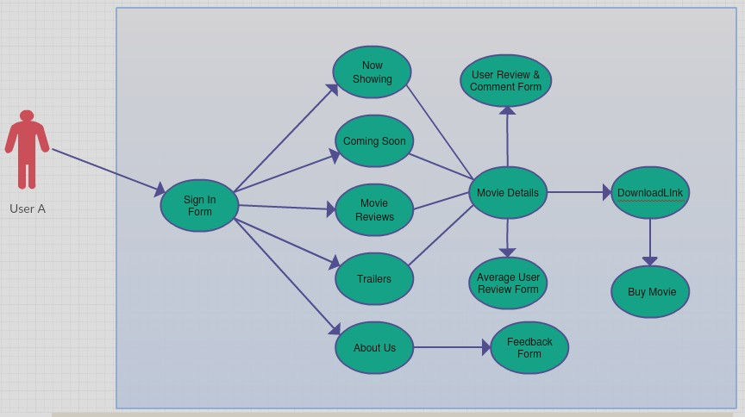

This is a broad level diagram of the project showing a basic overview. This System will provide a search functionality to facilitate the search of resources. This search will be based on various categories. Further the admin can add/update the resources and the resource users from the system. The users of the system can request download movie for which they would have to follow certain criteria.

**2.2 Production Function:**

1. Signin form: Sign in form used for identify the user.

2.Now showing: It contain the latest updated list of movies

3. Up-coming: this contains list of upcoming movies.

4..Login:

Input: Enter the membership number and password provided.

Output: User will be able to use the features of software.

5. Movie-review: Based on other user’s review, it ll shows reviews of particular movie.

6.Search-

Input: enter the movie name.

Output: Movie will be displayed related to keyword.

**2.3 Operating Environment:**

The item will work on windows environment. The Library Management System is a site and should work in every single well known program, for a model we are taking Microsoft Internet Explorer, Google Chrome and Mozilla Firefox. The main prerequisite to utilize this online item will be web association. The fundamental info gadgets are console, mouse and gadgets are screen, printer and so forth.

**2.4 Assumptions and Dependencies:**

The assumptions are:-

• The coding should be error free.

•The system should be user friendly so it is easy to understand.

•The system should have more storage capacity.

•The framework should give speedy connections and hunt choices.

•Users may access from any PC that has web association.

•Users must have their correct username and passwords to enter into their online accounts and do actions

The dependencies are:-

•The admin should have proper understanding of the product.

•The system should have general report stored.

**2.5Requirement:**

Software configuration:

Operating System: Windows 7/8/8.1/10

Language: JAVA, HTML

Hardware Configuration:

Processor: Pentium(R) Dual-core CPU

Hard Disk: 50GB

RAM: 256 MB or more

**2.6 Data Requirement:**

The output also includes the user receiving the details of their accounts. In this project the inputs will be the queries as fired by the users like create an account, selecting movie and putting into account. Now the output will be visible when the user requests the server to get details of their account in the form of time, date and which movie they are having currently in the account.

**3.Other Non-functional Requirements:**

**3.1Performance Requirement:**

-The performance of the system should be fast and accurate.

-System shall handle expected and non-expected errors in ways that prevent loss in information and long downtime period.

-Thus it should have inbuilt error testing to identify invalid username/password

-The system should be able to handle large amount of data.

**3.2 Safety Requirement:**

The database may get crashed at any certain time due to virus or operating system failure. Therefore, it is required to take the database backup so that database is not lost.

**3.3Security Requirement:**

-System will use secured data.

-System will have different types of users and every user has access constraints.

-Proper user authentication should be provided.

-No one should be able to hack user’s password.

**3.4Requirement attributes:**

-There may be multiple admins creating the project, all of them will have the right to create changes to the system. But the members or other users cannot do changes.

-The project should be open source.

-The Quality of the database is maintained in such a way so that it can be very user friendly to all the users of the database.

-The user be able to easily download and install the system.

**4.Appendix:**

A:Admin, Abbreviation, Acronym, Assumption

C:Class, Clients D: Data Requirement ,Download

M:Movie O: Operating System

S:Security, Safety, Scope U: User, User class

**5.Class Diagram:**

A class is an abstract, user-defined description of a type of data. It identifies the attributes of the data and the operations that can be performed on instances (i.e. objects) of the data. A class of data has a

name, a set of attributes that describes its characteristics, and a set of operations that can be performed on the objects of that class.

The classes’ structure and their relationships to each other frozen in time represent the static model. In this project there are certain main classes which are related to other classes required for their working. There are different kinds of relationships between the classes as shown in the diagram like normal association, aggregation, and generalization. The relationships are depicted using a role name and multiplicities. Here ‘Movie’, ‘Admin’ and ‘Make payment’ are the most important classes which are related to other classes.

