Swarajya

The world around you is unfair. Oppression and discrimination are its peak.

You, Raja Shivaji Bhonsle, the son of jagirdar from the hills of the western Deccan, raise your battle cry to attain Swarajya in its truest essence. You must fight mighty powers of the Sultanate forces around you!

You have the weapons to fight your war, but are you worthy of the fight?

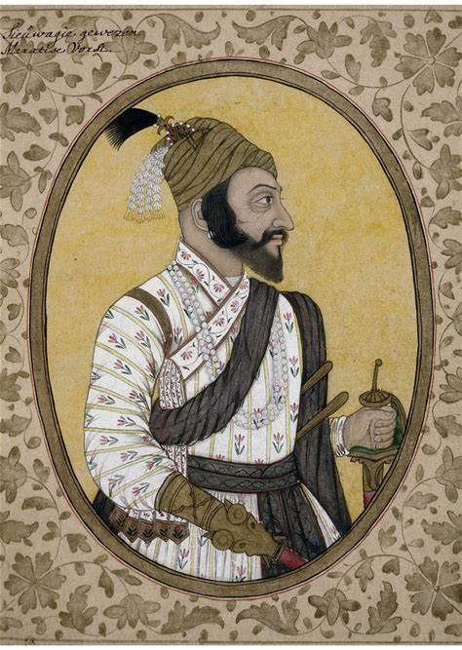

# Summary

* Target Audience :
  + - Age : 7+
    - Gender : Male
    - Class : All
* Target Platform :
  + - PC
    - Android
    - iOS
    - Consoles
* Genre : 2.5D action adventure platformer.

# Plot

Shivaji decides to fight the oppression from the Sultanates of Bijapur, Ahmednagar, Golconda and Delhi. He aspires to establish Swarajya, a self-rule concept that emphasises on equality and dignity for all irrespective of caste or religion.

As Shivaji marches towards fulfilling his dream of Swarajya, he is visited by Goddess Tulja Bhavani. She tells him that he has to prove that he is worthy of fighting for this cause. Acquiring two of the three blessed weapons while traversing the Deccan landscape, he is captured but escapes and acquires the third weapon too. Shivaji fights monsters and fiends to protect and help people that are distressed. He establishes the principles of Swarajya, but now he must fight his biggest enemy – himself.

Shivaji stands at a precipice where his ego can destroy every principle that he holds true.

# Gameplay

* The player traverses through a 3D world in a 2D perspective, moving horizontally using guerrilla movements like jumping, crouching, shimming, ziplining, wall running and hanging.

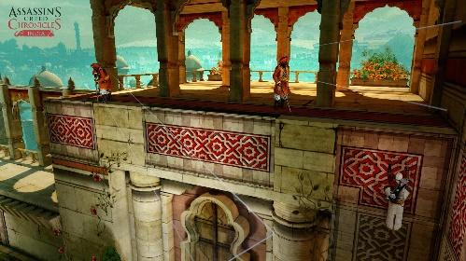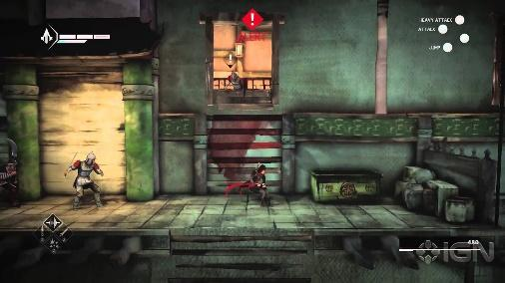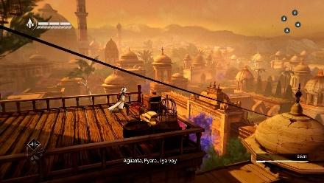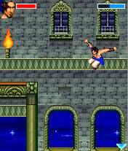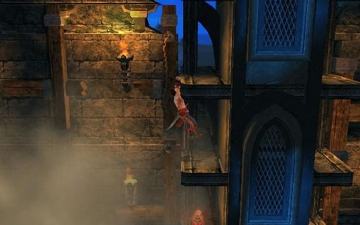

* The player uses three weapons with different styles :
  + - dand patta - a heavy broadsword with a gauntlet instead of a hilt.
    - firang - a colonial Spanish sabre
    - bagh nakh – an indigenous fist-load claw-like weapon
  + the dan patta has heavy slash. Extremely effective against cavalry type and armoured enemies. Can only block incoming attacks
  + The firang is a fast and light weapon useful against infantry type and fast enemies. Can block and parry.
  + The bagh nakh is a quick weapon used mostly for stealth purposes. Can only dodge.

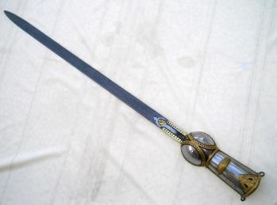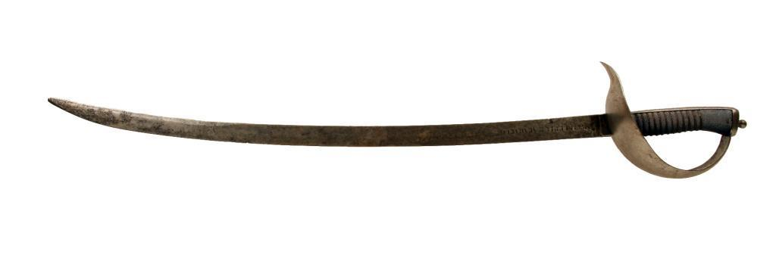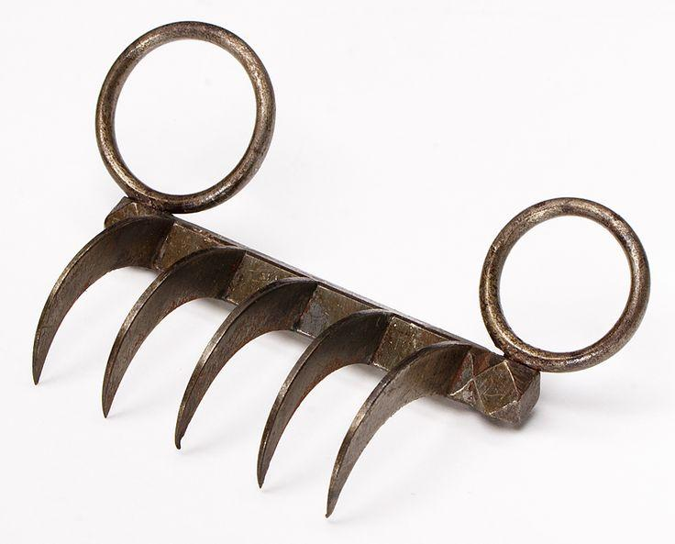

* + The combat varies depending on the weapon selected and the enemy faced. Mismatching the weapon and enemy types will lead to less efficiency of weapons.

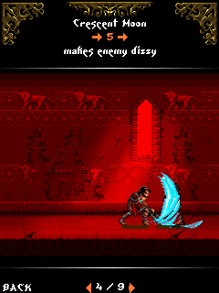 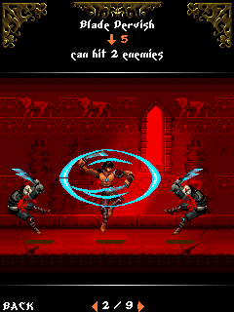 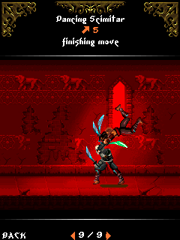

* + Shivaji has different actions depending on the weapon chosen.
  + The combat will be single button combined with direction for easy access
  + Shivaji can parry and block incoming attacks. The blocking strength again depends on the weapon selected and enemy type. There will be two blocks, front and rear.
  + Elements of guerilla tactics to be included
  + There will be horseback chases where he must avoid obstacles and enemies alike.

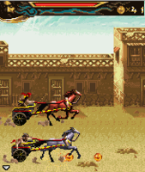

* + Shivaji can also jump over enemies.
  + The enemies will have different classes
    - Armoured- heavy and slow. Deals massive damage.
    - Mounted- heavy and fast. Initial attack deals massive damage
    - Infantry- foot soldiers. balanced attack and speed
    - Blitz- fastest and lightest. Deals low damage

# World Design

* Medieval forts, cities, forests, coasts and mountains of Deccan Plateau.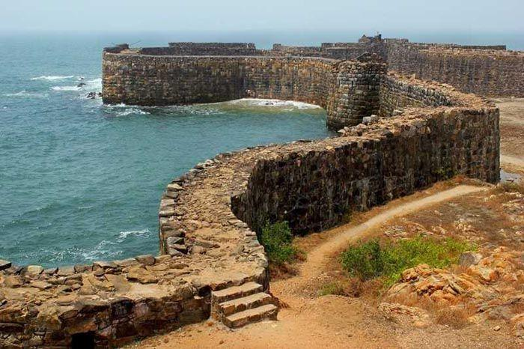 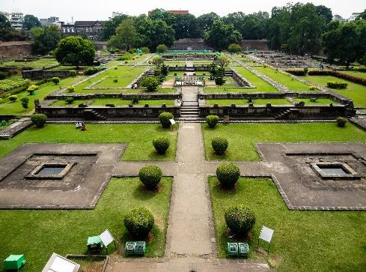

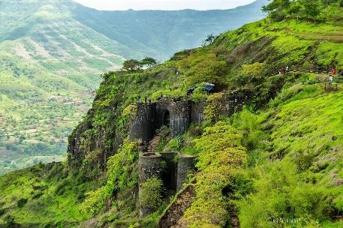 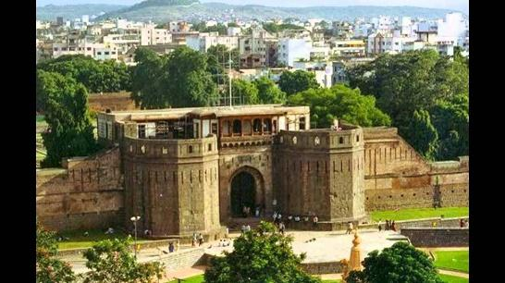

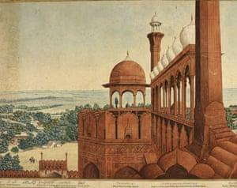 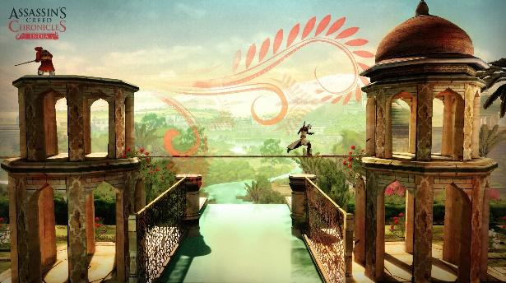

* Rain has to be a part of the design
* The player can move along the horizontal axis as well as depth axis
* The colour palette is very similar to Mughal art style with a few offset elements.
* The enemies will be based on monsters of Hindu mythology

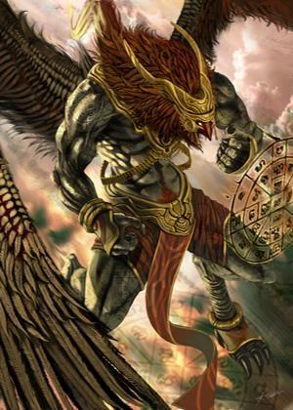 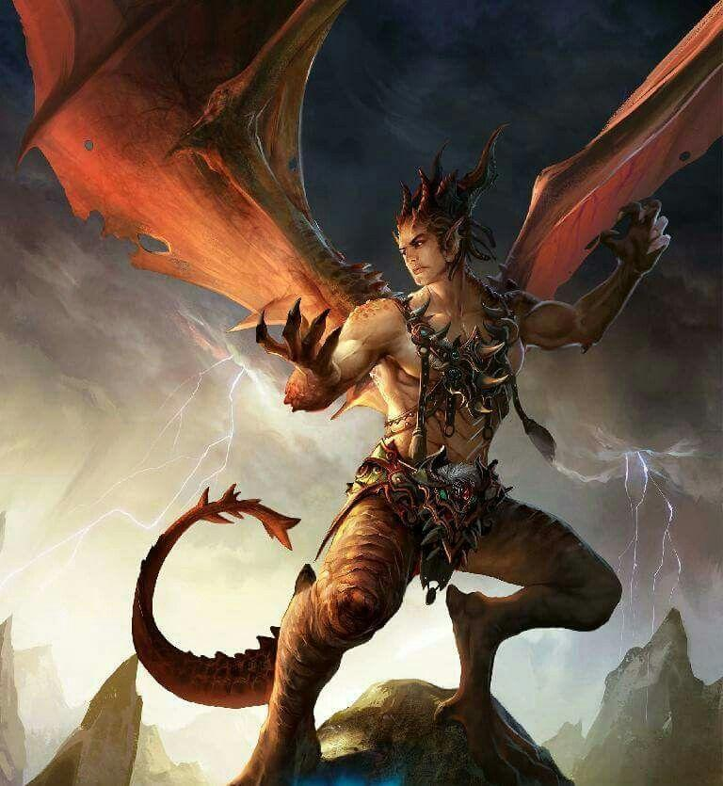 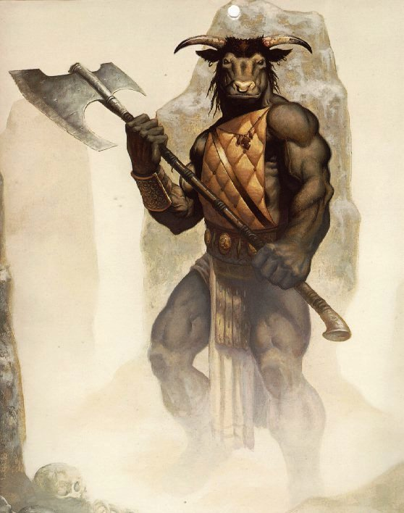 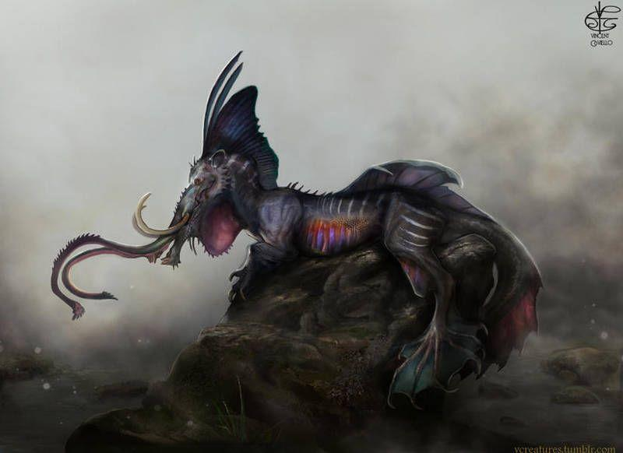 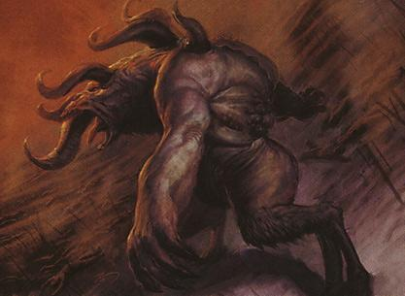

* Shivaji will be modelled as in his early twenties.

# USP

* + Live through a time of India’s medieval life.
  + Accompany Shivaji on a journey that laid the foundations of Swarajya.
  + Play as the young revolutionary as he finds himself before he faces mighty forces.