HW2 Report

Dhruv Parikh

CSCI 677 Prof. Nevatia

A starting note – The code has been submitted in a Jupyter notebook file, and thus it was not possible to, as such, make the code ‘interactive’ using argparse as one could, had a command line interface been used to run the file.

The various strategies were instead run using the main function, one after the other, and the output windows with images were stored. A strategy argument was passed in main for this purpose.

**IMAGE 1 Results**

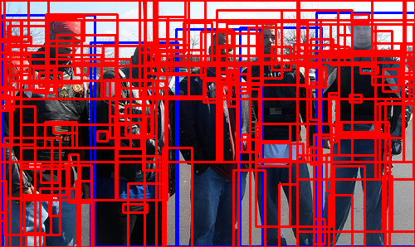**Color**

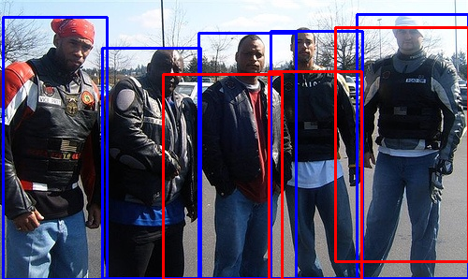

**All**

Note, for a multiple strategy, the weight of all the strategies was considered equal. It would be possible to get better results by cross-validating over the weights to select the weights which maximize recall, this however was not done here.

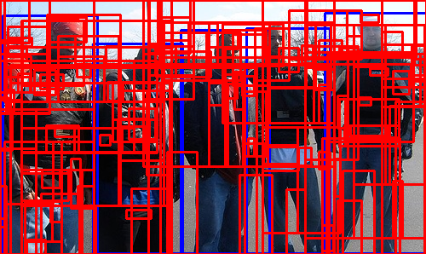

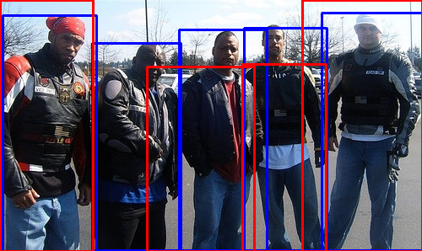

**IMAGE 2 Results**

**Color**

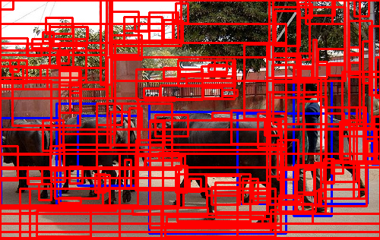

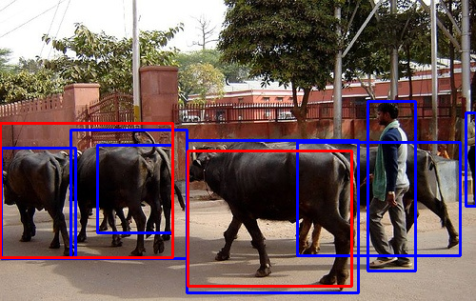

**All**

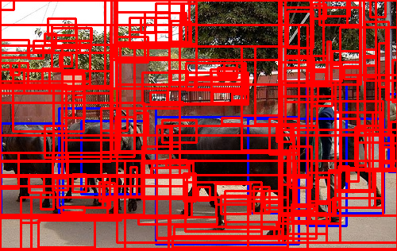



**IMAGE 3 Results**

**Color**

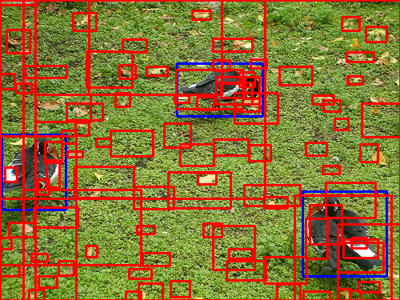

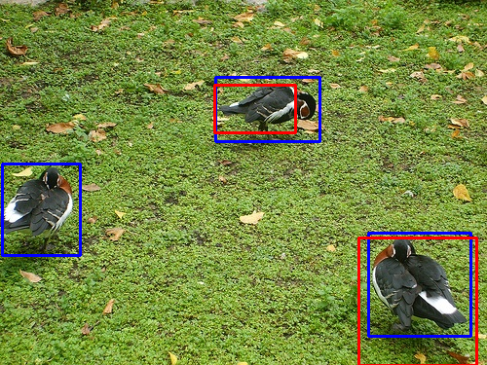

**All**

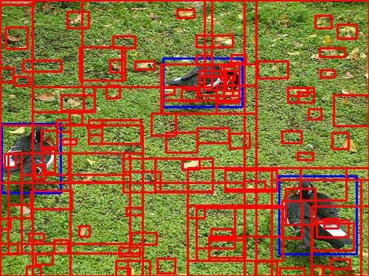

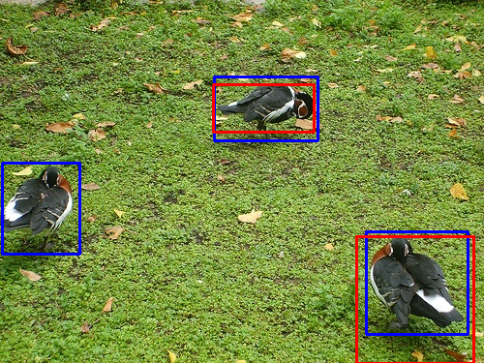

**Additional Note**

Strategies Fill, Texture and Size were also implemented; however, their images have not been placed in the report – they can be found in the documents submitted along with the code.

For **recall analysis**, we will use all the strategies and see what their recall looks like.

|  |  |  |  |  |  |
| --- | --- | --- | --- | --- | --- |
|  | Color | Texture | Size | Fill | All |
| Image 1 (People) | 0.6 | 0.4 | 1 | 0.8 | 0.8 |
| Image 2 (Cows) | 0.28 | 0.28 | 0.42 | 0.28 | 0.28 |
| Image 3 (Birds) | 0.66 | 0.66 | 0.66 | 0.66 | 0.66 |

Again, the visualized results for Texture, Size and Fill can be found in the documents.

**Comments on the results**

One can clearly see that the strategy **Size** provides the best recall across all images – specifically it identifies all the individuals in the **People** image.

The **Cows** image has the poorest performance – a simple reason for this could be the fact that the **Cows** image contain a lot of ground truth bounding boxes that overlap.

For some reason, irrespective of the strategy used, for **Birds**, the leftmost bird was just never bounded with an IoU above the threshold. Despite much tinkering with the weights and the strategies, this bird always managed to escape a relevant bounding box – which does perplex me a little since there doesn’t seem to be much difference between the leftmost bird and the other two birds.

Despite the weights, for my code, for the ‘all’ strategy was equal, modifying them according to the results obtained by using different weights (that is, say, increasing the weight of size) could possibly improve the result for ‘all’.

**Again** – the leftmost bird not being found is a major dilemma. The **Cows** image is able to identify the two leftmost cows, however is unable to identify a man and a cow on the rightmost side of the image. The **People** image, overall, had good results across most strategies.