For (1) and (2) below, you're choosing between two candidates to hire. Discuss the pros and cons of choosing one candidate over the other in the following situations.

1. **Both are predicted to have the same productivity score of 75, but have the following probabilistic forecasts.**

[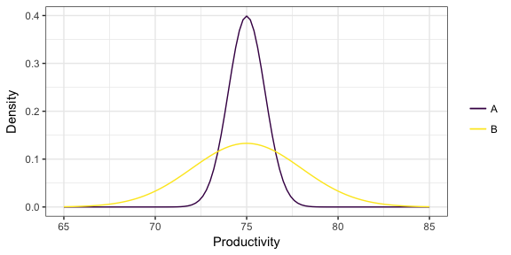](https://github.com/vincenzocoia/BAIT509/blob/master/class_meetings/cm08-beyond_mean_mode_files/figure-html/unnamed-chunk-17-1.png)

For the above situation, we have predicted Productivity score of 75.

For Candidate A we have a narrow uncertainty and for Candidate B we have broad uncertainty. It means A has less variance when compared to B. It is less risky to hire Candidate A, as the productivity is for sure between 72 to 77. However, it is more of a gamble situation if we hire B. B’s productivity can go till 80-83, also it can to less productivity which is below 70. The decision is uncertain here.

1. **Two "non-overlapping" forecasts:**

[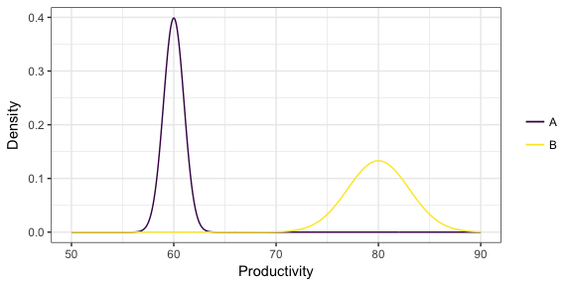](https://github.com/vincenzocoia/BAIT509/blob/master/class_meetings/cm08-beyond_mean_mode_files/figure-html/unnamed-chunk-18-1.png)

For the above situation, Candidate B is having higher Productivity than Candidate A. For B the productivity starts from around 70 to 75 till 85 for sure even though there is low density (Around 0.15).

However, for A there is less productivity at 60 with density of 0.4. Candidate B is better to hire than Candidate A.

1. **You've formed a probabilistic forecast for a particular value of the predictors, displayed below as a density. You then collect test data for that same value of the predictor, indicated as the points below the density. What is the problem with the probabilistic forecast?**

[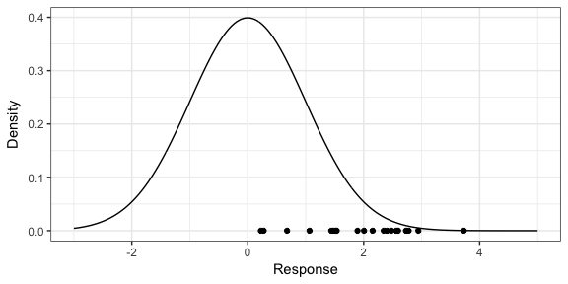](https://github.com/vincenzocoia/BAIT509/blob/master/class_meetings/cm08-beyond_mean_mode_files/figure-html/unnamed-chunk-19-1.png)

The problem with the above Probabilistic Forecast is biased. As the test set values range from 0 to 3. However, our predicted values show from -3 to 3. We do not see any negative values for the test set.