In-class Exercise

**Consider the following data, decision boundary, and margin boundaries.**

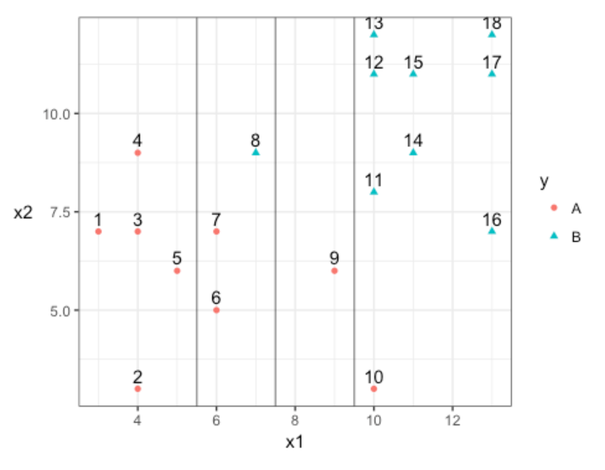

1. **Construct the decision rule according to this classification boundary. How would you classify a new observation that has x1=6 and x2=10?**

The decision stump is x1 < 7.5

For the point the decision we choose is A.

1. **What size is the margin here?**

The size of the margin is 2 units.

1. **Which observations receive a penalty? Which observations are the support vectors?**

Support vectors are these the observations which do receive penalty.

6,7,8,9,10 are the observations which receive penalty.

6,7,9,10- Red (A)

8-Blue (B)

1. **What is the total penalty here?**

6- 0.25

7-0.25

8- 1.25

9-1.75

10-2.25

**Total Penalty- 5.75**

1. **Can I choose a bigger margin if my total allowable penalty is 6?**

Yes, we can choose the bigger margin if my total allowable penalty is 6.

1. **Are the data separable? If so, what are the support vectors?**

Yes, the data is separable. We can separate the clusters.

4,8,9 are the support vectors.