* Is this for the full duration? If so, maybe you can indicate what are the regions of high EKE and low EKE. Could be done simply by drawing little lines at the top that mark that day 120 – 160 (or something) was high and the other low. You could also indicate this by choosing a threshold and coloring the line in SLA plot with two colors – red when high EKE (above thereshold) and blue when low EKE.
* As Andy said, try to use a non-discrete but still diverging colorbar for the O2. Maybe you can try deep, or solar from cmocean. Solar should look similar to what you have, but without the jumps.
* You had some plots of T in the slides you had showed us (SOGOS update 10_9.pdf). It was helpful to be able to see the intrusion in temperature and show some lateral structure.
* It would help to have a plot of buoyancy or dbdx along with db/dz. I know that if you just do a db/dx simply things look very stripy. You can try to fix this by taking larger dt or dx steps, this can help to suppress some of the noise. You can also try doing a running average before calculating the gradient. Probably for this poster, the details of this averaging are not super relevant.

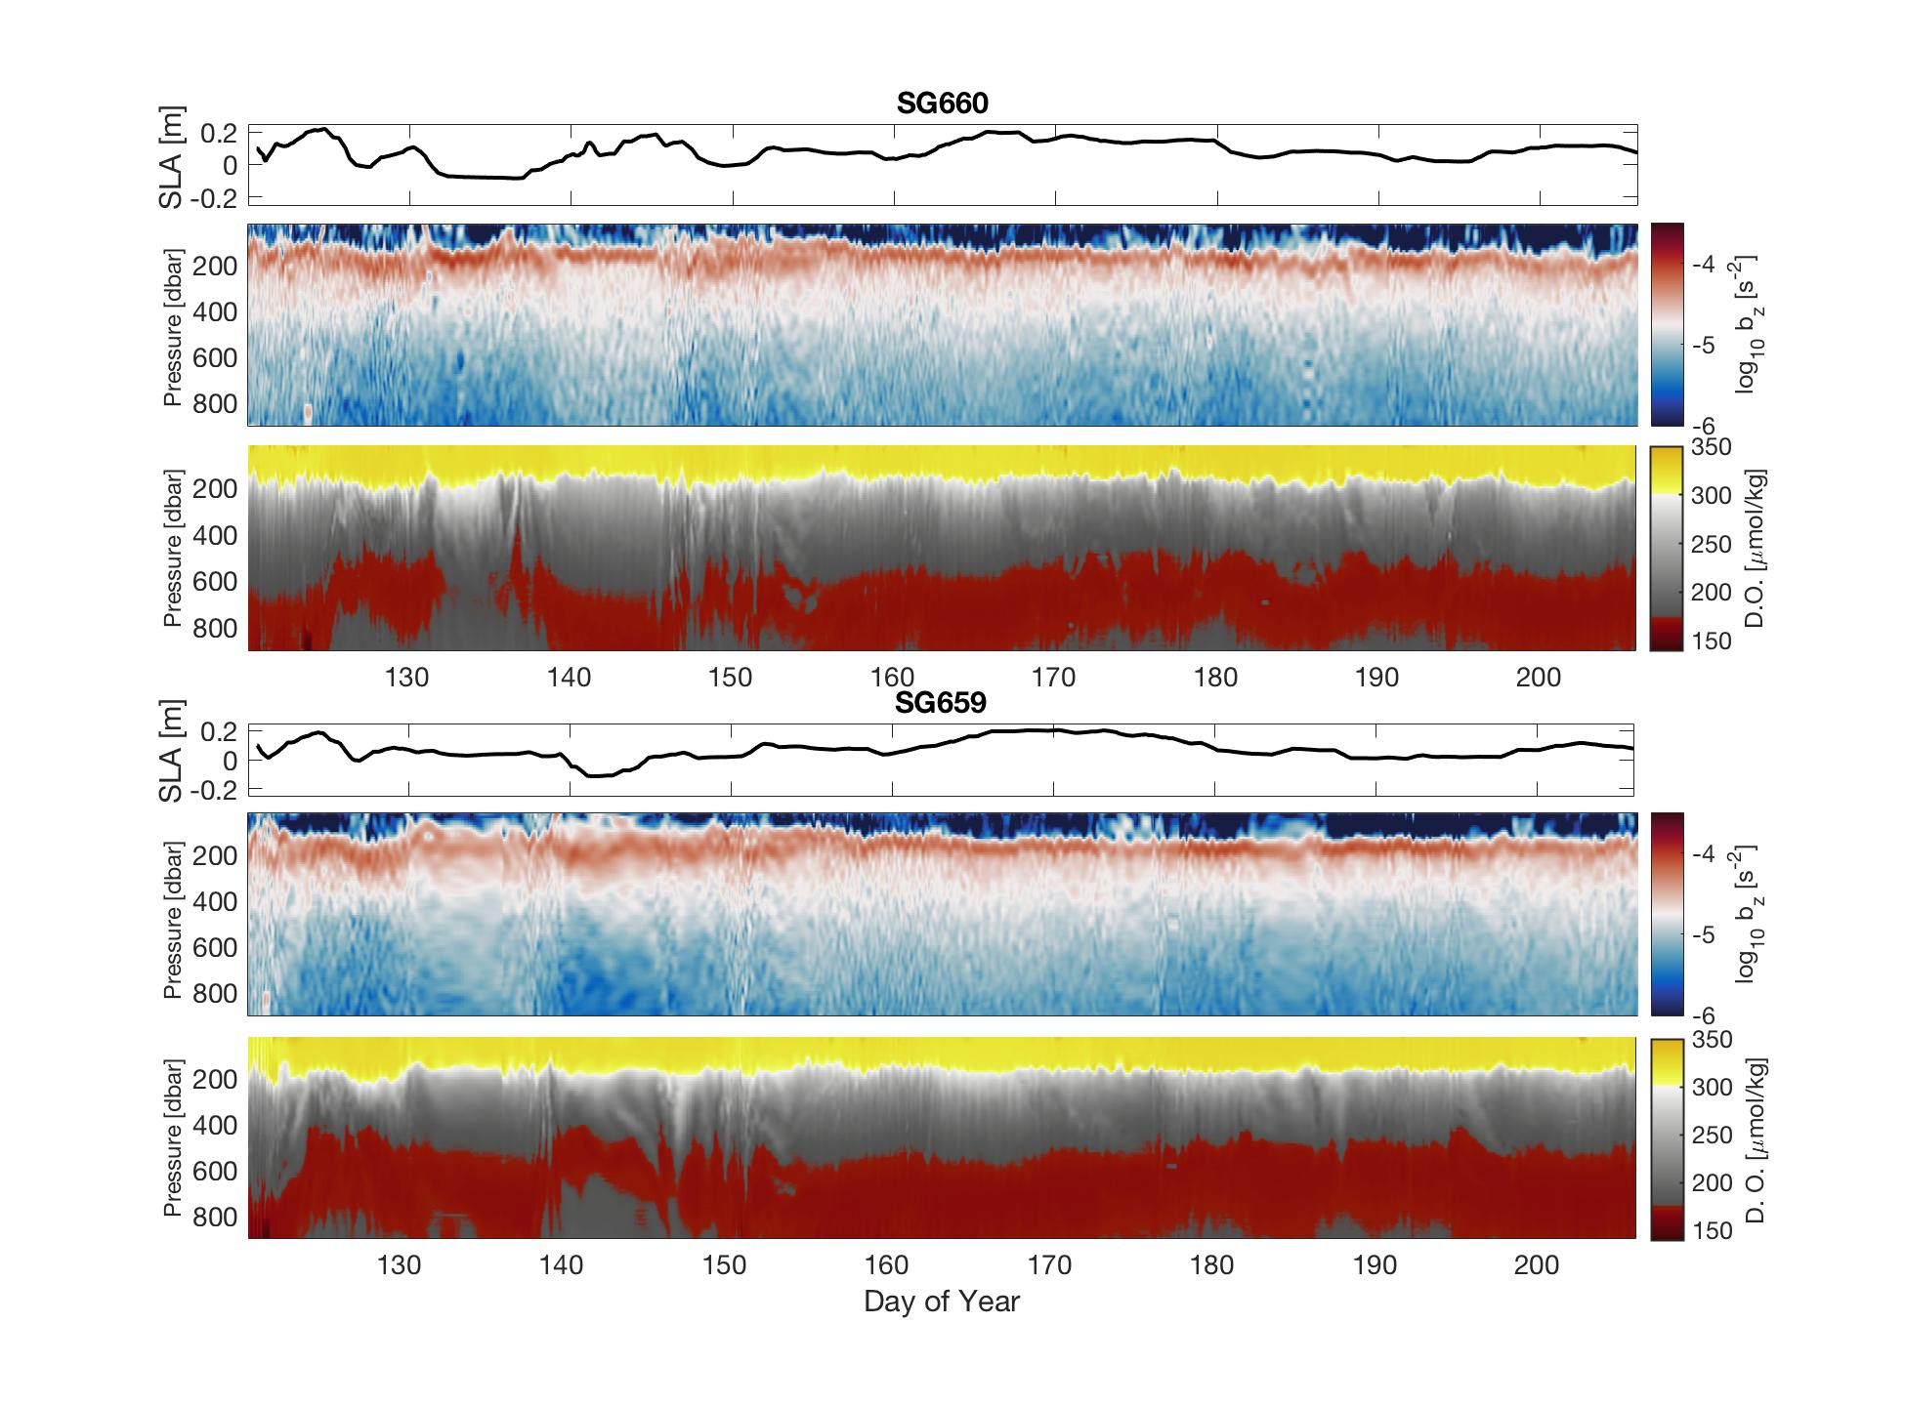

For the TS plot with backscatter:

* The most striking feature to me is the along isopycnal gradients in back scatter (700um particularly). Might help to show if the regions of low back scatter are early in the year or associated with a specific region. Is is the case that backscatter at depth increases when chlorophyll in the surface layer starts to increases? Or with some lag after that?
* For float 12888 we saw high backscatter at depth initially after the deployment, when the POC/chl in the mixed layer was high. By end of June the Chl in the ML had declined, and with a short lag the highbackscatter values at depth declined too. Do you see something similar?
* It is interesting to see that the TS variability at depth, below isopycnal 27~27.1 and above ~27.5, gets so inflated along an isopycnal, before starting to decrease again. I think this happens because the water at depth is well mixed, while the water at the surface is directly being forced in this region and at this time of the year by the atmosphere to be a certain value. The inflation in the interior is a combined result of seasonal+regional variation in the end member value at the surface and lateral advection of these values from the mixed layer to the interior along isopycnals.

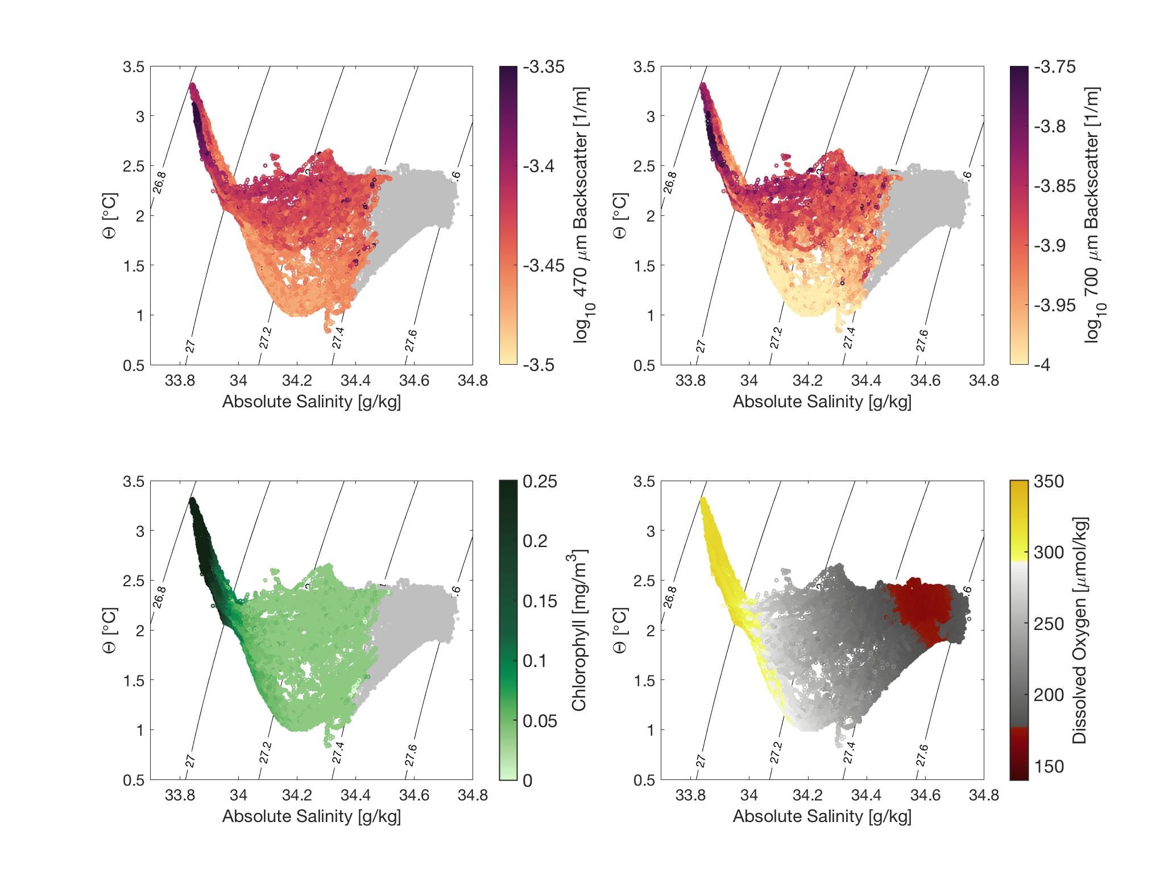

The introduction to the project plot looks really nice.

* You can mark on the large region plot that the cruise was I06.
* For the Lat vs time plot, I would suggest marking fewer contours with black.
* Also you can get rid of one of the legends, preferably from the middle plot, since it is taking up some much real estate on the plot. 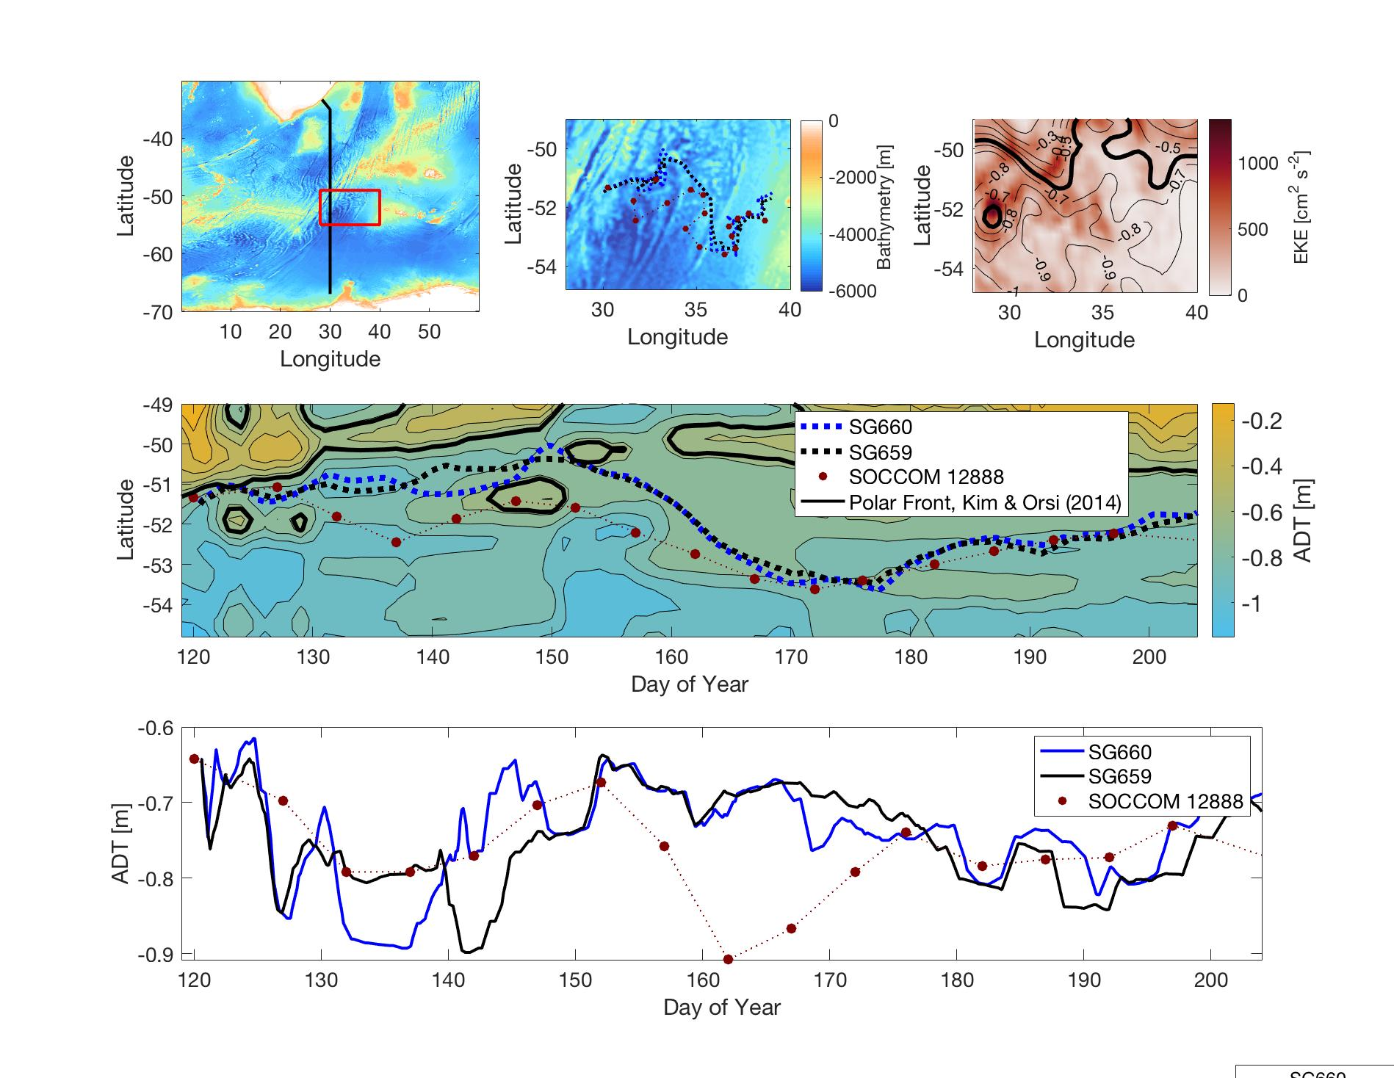

Nice histogram plot,

* you can probably get rid of the bins smaller than around 10^-8, or club them into one.
* It would help to show how this changes as you smooth (or take larger dx) before calculating b_x. I would guess that the contrast between high and low EKE regions would increase as you increase smoothing and get rid of internal waves to see the underlying structure.
* 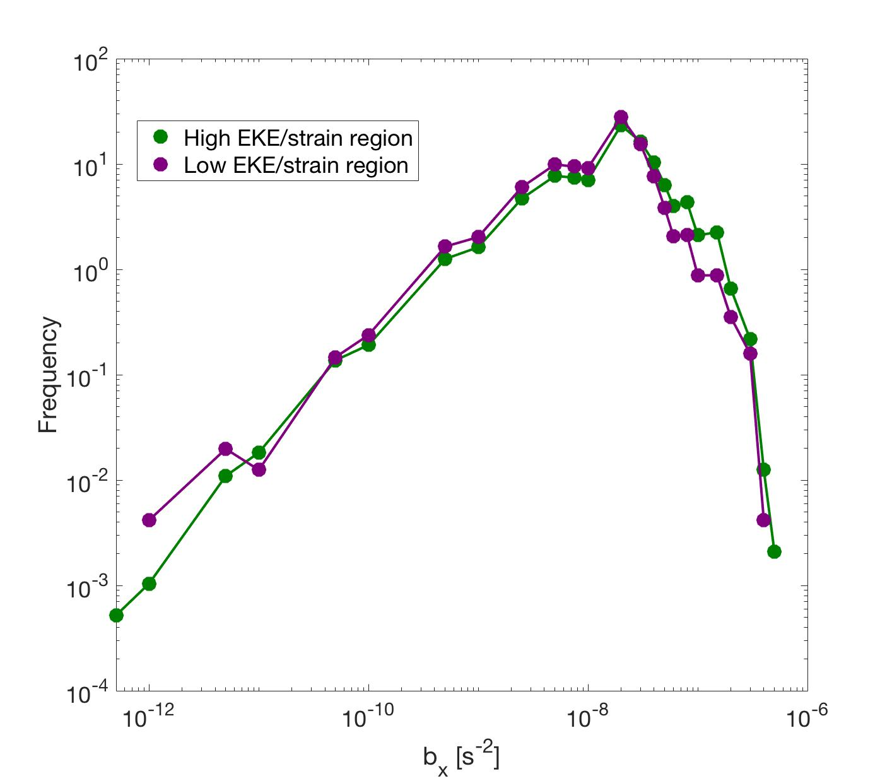

The plot with floats and gliders is really nice. I am wondering if you have some lower vertical resolution data? I believe the float data I have has uniform sampling upto 1000m. Regardless that is not super important.

* 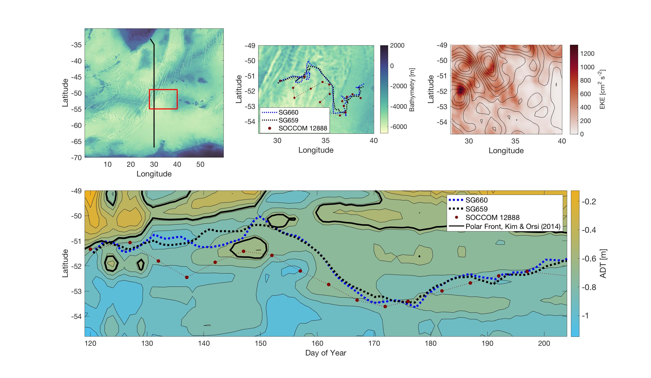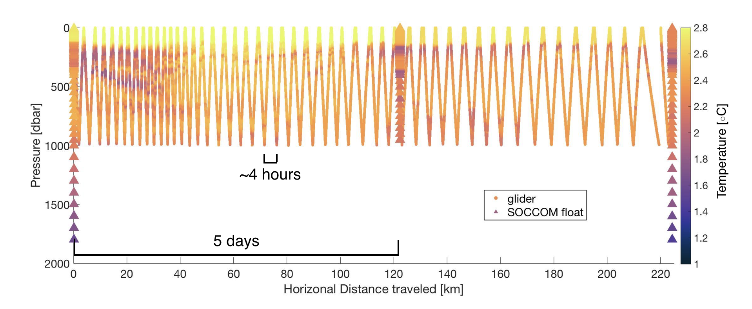

**Andy’s email to Dhruv:**

• I think the T/S/\sigma section of I6S could be useful to set help readers understand the regime in which the glider is sampling, especially as it is near the transition between T-stratified and S-stratified.    
  
• I really like the N^2 plots showing a minima in the core of the ACC, at least during part of the year.  Lily is working on stratification figures from the glider now and we can decide whether we need both float and glider info.  
  
• Can you send your color scheme for the bathymetry to Lily -- it is nice one with separate scales for land and seafloor.  
  
• We will also be looking at some T/S plots but coloring with backscatter/O2/fluorescence to see what is there.  We might come back to the float data for this.

**Andy’s email to Lily:**

• For the study context figure, I would suggest setting the coloraxis (caxis command) to be [-5000 0] or something similar, but only plotting those values <0.  You can play around with the color scale to see what shows off the ridge the best.  As for colorbar -- the color scheme you used looks pretty good.  When doing bathymetry, I often use one that simply goes from dark blue to white.  I also attach a Matlab script to generate a "haxby" color scheme -- this is often used by geologists and geophysicists to map bathymetry.   
  
• For the top right hand panel (SSH and EKE), what are the contours?  They look like SLA (sea level anomaly) -- do you have the mean ADT (absolute dynamic topography) fields?  That might be a better job of showing the mean position of the ACC and colors will show nicely where the variability is high.   
  
• Lower panel looks good -- I would also be curious to simply see the line plots where the float and glider are plotted with SSH on the y-axis (i.e. without the latitude information).  It might be easier to see quickly how far away the gliders/float was in SSH space.   
  
• The glider_vs_float plot is brilliant!  This is a really striking way to show how much structure the float is missing even when it samples at 5 days.  Nicely done -- this will be a nice figure in the methods section.   
  
So, I would say on to some of the center figures.  We can revisit format, label sizes, etc.  Let's see if we can get a couple of good plots of depth-time plots of N2, M2 (lateral buoyancy gradient), and O2.  The other thing that would be nice to include are some of the nice T/S plots colored with backscatter/O2/fluorescence, etc. I'll let you decide whether it makes sense to show the whole water column or the upper ocean only.

**Lily to Andy:**

Attached are a few more figures, along with an update on the study context figure (changed SLA to ADT in the EKE figure, updated bathymetry colorbar, and added the time vs SLA plot you suggested). As always, I'm happy to shift things around or plot up something new.  
  
-The lateral buoyancy gradients are still super messy looking with internal waves, so I tried the histogram approach. It does seem there is a tendency of higher probabilities of higher b_x within the high EKE region. Let me know what you think of it - I think there's room for improvement but I'm a little stuck on what to try next.  
  
-The SLA/N2/O2 sections of the two gliders tell the same story - I'm not sure if there's value in having both or if one would suffice. The O2 (or AOU) is potentially more interesting to plot in density space.  
  
-The TS plots of the backscatter are pretty striking, chlorophyll (unsurprisingly) and O2 less so. I plotted the entire T/S plot in grey behind to illustrate that we have the optical data just from the upper ocean.

**Andy to Lily:**

• With regard to lateral buoyancy gradients -- I would still be interested in seeing what a time series looks like.  Even if noisy due to internal waves, you might try to plot some shorter periods that are characteristic of the high and lower EKE regions to contrast the two.  Is the histogram showing the entire water column or just the lateral buoyancy gradient in the mixed layer.  If the former, maybe there would be a clearer story if we just considered the mixed layer for now (that's what I did in our OSMOSIS study).  Also, at this point, we might be better off pointing to some anecdotal features, for instance the few instances where we saw coherent, deep lateral buoyancy gradients at the edge of eddies.  If you do keep the histogram plot, playing around with the range on the x- and y-axes might pull out the different between the green and purple curves a bit more.  
  
• The vertical buoyancy gradient or N^2 plots are very nice, even just for context.  I agree you don't need both -- just choose the one you like.  Also, I know that is the cmocean O2 colorbar, but I don't like it very juch.  The position of the yellow and red always feels arbitrary to me.  Can you mess around with some other things (suggestions, Alison?).  
  
What happens if you plot the maximum value of N2 for each profile against SLA (the anomaly) or maybe better, SLA gradient?  If you did a histogram of N^2 at the base of the mixed layer you would get quite a spread.  Can we find anything that this correlates with (maybe T/S properties if the stratification is set on either side of the PF?).  
  
• The T/S scatter colored by backscatter are really striking.  I don't really understand this yet, but it would be great to add to the poster so we can get feedback on it.  I would love to show this to some of the EXPORTS folks.  Can you try also coloring with the ratio of chlorophyll to backscatter (see Zach's 2016 paper) and coloring with the ratio of the 400/700 wavelengths?  
  
• New maps look great!  Thanks for updating those.  
  
• FYI, here are my plans for the rest of the week.  I'm trying to wrap up an NSF proposal, so it is a little bit manic, but the proposal is in decent shape.  I am in Pasadena M-W and then down at Scripps Th-Fr.  I'll be back home on Saturday before heading to Ocean Sciences.  If we can have the poster ready by morning/mid-day on Friday, I can send it to the GPS printer and pick it up on Saturday.  In a pinch, I could print on Saturday.  Let's start arranging some figures on the poster -- I can help with text as needed.