CHAROTAR UNIVERSITY OF SCIENCE AND TECHNOLOGY (CHARUSAT)
Chandubhai S. Patel Institute of Technology (CSPIT)
Department of Computer Engineering
―――――――――――――――――――――――――――――――――――――――――――――
LABORATORY PRACTICALTICAL SUBMISSION RECORD
ITUE203 — Web Development Frameworks
Practical 7 to 14
Project: Student Hub

Student Name | Dhruv Bhoi
Student ID | D26CE154
Department | Computer Engineering (CSPIT-CE)
Academic Year / Term | 2026 - 2027 (ODD Semester)
Semester | 3rd Semester, B. Tech CE
Institute | CSPIT

Table of Contents / Index of Practicals (7 to 14)
Practical No. | Practical Title & Topic
Practical 7 | PHP Form Processing with Server-Side Validation & CSV/JSON Storage
Practical 8 | MySQL Schema Design, ER Model, PDO Connectivity & Diagnostics
Practical 9 | Secure User Registration with Duplicate Check & Password Hashing
Practical 10 | Secure Login/Logout with Sessions, RBAC, Timeout & Remember-Me
Practical 11 | Student Management CRUD with Search, Filter & Soft Delete
Practical 12 | Event Management CRUD with Poster Upload & File Validation
Practical 13 | PHP JSON API and AJAX/Fetch-Based CRUD without Page Reload
Practical 14 | Admin Dashboard with Role-Based Access Control & Audit Log

Practical 7: PHP Form Processing with Server-Side Validation and CSV/JSON File Storage
Practical Aim & Tools
Aim: Implement PHP form processing for contact and feedback submissions with server-side validation, data sanitization, CSRF protection, and persistent storage in JSON/CSV files.
Tools & Technologies: PHP 8.x, CSV File I/O (`fputcsv`), JSON Storage (`json_encode`), CSRF Protection

1. Server-Side Processing Architecture
Client-side validation is easily bypassed; therefore, robust server-side processing is mandatory for security. StudentHub implements two storage workflows:
1. Contact Us (`contact.php`): Validates user inquiries, strips HTML tags (`clean()`), checks email formats (`FILTER_VALIDATE_EMAIL`), verifies anti-CSRF session tokens, and appends records atomically to `data/contacts.csv` using `fputcsv()` with exclusive file locks (`LOCK_EX`).
2. Student Feedback (`feedback.php`): Collects user star ratings (1 to 5) and comments, validates data integrity, and stores entries in `data/feedback.json`. Recent feedback cards are dynamically read and rendered below the form.

2. Implementation Code: Contact Processing & Atomic CSV Write
Listing: contact.php — Input Sanitization, CSRF Verification, and Atomic File Append
// contact.php - Server-Side Processing
if ($_SERVER['REQUEST_METHOD'] === 'POST') {
if (!csrf_check()) {
$errors['form'] = 'Security validation failed (Invalid CSRF token).';
} else {
$name = clean($_POST['name'] ?? '');
$email = clean($_POST['email'] ?? '');
$message = clean($_POST['message'] ?? '');
if (strlen($name) < 2) $errors['name'] = 'Name must be at least 2 characters.';
if (!filter_var($email, FILTER_VALIDATE_EMAIL)) $errors['email'] = 'Invalid email address.';
if (strlen($message) < 10) $errors['message'] = 'Message must be at least 10 characters.';
if (!$errors) {
$fp = fopen(BASE_PATH . '/data/contacts.csv', 'a');
if ($fp && flock($fp, LOCK_EX)) {
fputcsv($fp, [date('Y-m-d H:i:s'), $name, $email, $message, $_SERVER['REMOTE_ADDR']]);
flock($fp, LOCK_UN);
fclose($fp);
flash('success', 'Thank you! Your message has been recorded.');
redirect('contact.php');
}
}
}
}

3. Verification Screenshot: Feedback & Rating System
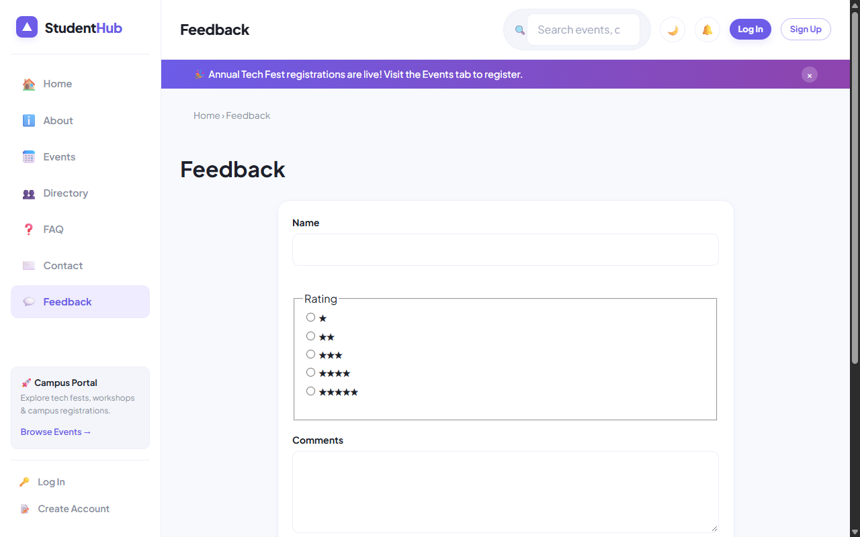
Figure: Feedback Submission Form with Star Ratings and Persisted JSON Feed

4. Verification Screenshot: Contact Inquiries Portal
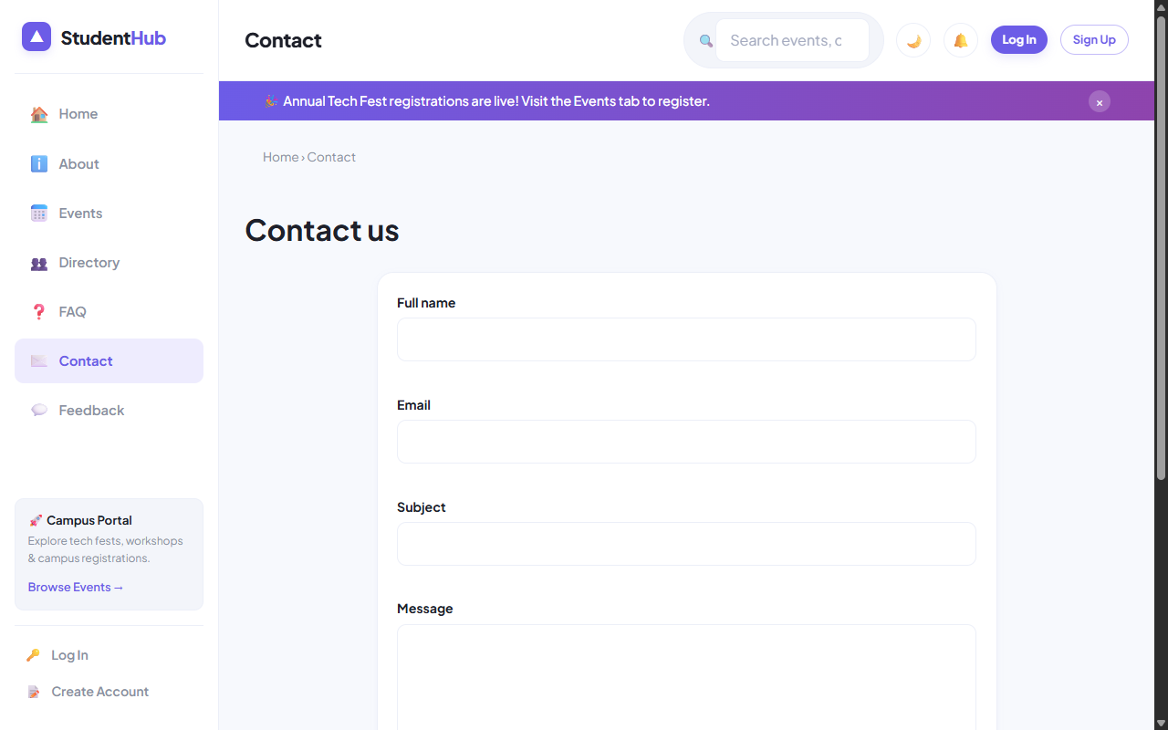
Figure: Contact Inquiries Form with Server-Side Validation and CSV Audit Logging

5. Key Questions & Analysis
Q: Why must form data be submitted using POST instead of GET?
Ans: GET appends parameters to the query string in browser history, server logs, and HTTP referrers, making it insecure for sensitive data. POST transmits data inside the HTTP message body, supports unlimited payload sizes, and complies with HTTP idempotency standards.
Q: How is file writing handled safely against concurrent race conditions?
Ans: By invoking `flock($fp, LOCK_EX)` before performing file writes. Exclusive locking prevents data corruption when multiple users submit forms simultaneously.

Practical 8: MySQL Schema Design, ER Model, Database Connectivity, and Diagnostics
Practical Aim & Tools
Aim: Design a normalized (3NF) relational database schema for StudentHub, construct an ER model, establish PDO and MySQLi connections, and implement a diagnostic connection test suite.
Tools & Technologies: MySQL 8.x, InnoDB Engine, Foreign Key Constraints, PDO, MySQLi Prepared Statements

1. Entity-Relationship Model & 3NF Normalization
The StudentHub database (`studenthub`) is designed in Third Normal Form (3NF) to eliminate data redundancy and ensure relational integrity:
• `users`: Authentication credentials, roles (admin/student), password hashes, and activity status.
• `students`: Academic profiles (course, year, contact, student ID) bound to `users.id` with a 1-to-1 foreign key and `ON DELETE CASCADE`.
• `events`: Campus events, dates, venues, capacities, and poster image filenames.
• `registrations`: Student-to-event registrations (Many-to-Many mapping) with a `UNIQUE KEY (event_id, student_id)` preventing duplicate registrations.
• `remember_tokens`: Cryptographic selectors and SHA-256 token hashes for persistent 'Remember Me' sessions.
• `audit_logs`: Immutable security audit trail recording user logins, updates, IP addresses, and timestamps.
• Stored Procedures: `sp_registrations_by_month` (analytics grouping) and `sp_event_registration_count` (dynamic count aggregation).

2. Implementation Code: Dual Database Driver (`includes/db.php`)
Listing: includes/db.php — UTF-8MB4 Dual PDO and MySQLi Initialization
// includes/db.php - Secure Dual Database Driver
define('DB_HOST', 'localhost');
define('DB_NAME', 'studenthub');
define('DB_USER', 'root');
define('DB_PASS', '');
// 1. PDO Driver (Object-Oriented, Exception-driven)
$dsn = 'mysql:host=' . DB_HOST . ';dbname=' . DB_NAME . ';charset=utf8mb4';
$opt = [
PDO::ATTR_ERRMODE => PDO::ERRMODE_EXCEPTION,
PDO::ATTR_DEFAULT_FETCH_MODE => PDO::FETCH_ASSOC,
PDO::ATTR_EMULATE_PREPARES => false,
];
$pdo = new PDO($dsn, DB_USER, DB_PASS, $opt);
// 2. MySQLi Driver (For explicit prepared statements & multi-queries)
$mysqli = new mysqli(DB_HOST, DB_USER, DB_PASS, DB_NAME);
$mysqli->set_charset('utf8mb4');

3. Verification Screenshot: Comprehensive DB Diagnostic Test Suite
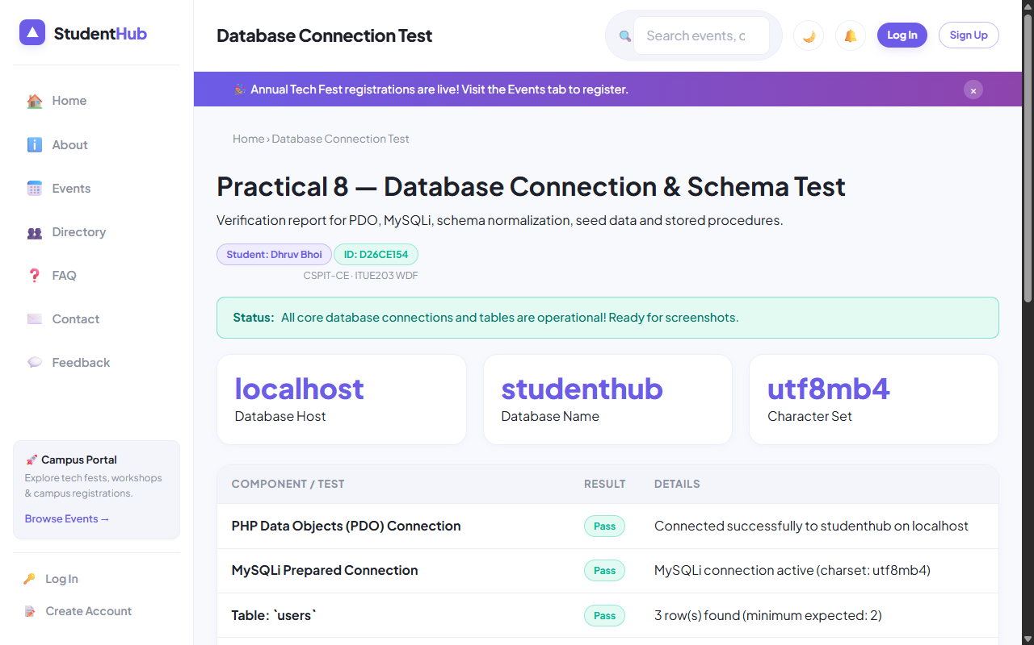
Figure: Live Diagnostic Test Suite (db-test.php) Demonstrating 6/6 PASS for Dhruv Bhoi

4. Key Questions & Analysis
Q: Is the schema normalized properly into 3NF?
Ans: Yes. 1NF is satisfied (all attributes are atomic; no repeating groups). 2NF is satisfied (no partial dependencies on composite keys). 3NF is satisfied (no transitive dependencies; non-key attributes depend solely on the primary key).
Q: Why is `ATTR_EMULATE_PREPARES => false` specified in PDO?
Ans: Native prepared statements ensure that SQL statement parsing and user data binding happen in separate network packets inside MySQL server. This completely eliminates SQL Injection vulnerabilities regardless of character encodings.

Practical 9: Secure User Registration with Database Insert, Duplicate Email Check, and Password Hashing
Practical Aim & Tools
Aim: Build secure user registration with server-side validation, duplicate email check, bcrypt password hashing (`password_hash`), database transactions, and audit logging.
Tools & Technologies: PHP 8.x, MySQLi Prepared Statements, Bcrypt Algorithm, ACID Database Transactions

1. Secure Registration Workflow & Threat Mitigation
User registration (`register.php`) establishes student identities securely through five defensive layers:
1. Server Validation: Re-executes all pattern validations independently of frontend checks.
2. Duplicate Check: Executes a parameterized SELECT query to verify email uniqueness before attempting insertion.
3. Cryptographic Hashing: Generates secure Bcrypt salted hashes using `password_hash($password, PASSWORD_DEFAULT)` with default cost factor 10.
4. Database Transactions: Wraps `users` insert and `students` insert within `$mysqli->begin_transaction()`. If either fails, `$mysqli->rollback()` ensures zero orphaned records.
5. Security Audit Log: Records registration event, user ID, client IP address, and timestamp into `audit_logs`.

2. Implementation Code: Transactional Registration
Listing: register.php — Atomic ACID Registration with Bcrypt Hashing
// register.php - Transactional Registration
$hash = password_hash($d['password'], PASSWORD_DEFAULT);
$mysqli->begin_transaction();
try {
$u = $mysqli->prepare('INSERT INTO users (name, email, password_hash, role) VALUES (?, ?, ?, ?)');
$role = 'student';
$u->bind_param('ssss', $old['name'], $d['email'], $hash, $role);
$u->execute();
$uid = $mysqli->insert_id;
$s = $mysqli->prepare('INSERT INTO students (user_id, name, email, mobile, course, year, gender) VALUES (?, ?, ?, ?, ?, ?, ?)');
$s->bind_param('issssis', $uid, $old['name'], $d['email'], $d['mobile'], $d['course'], $d['year'], $d['gender']);
$s->execute();
$mysqli->commit();
flash('success', 'Registration successful! You may now log in.');
redirect('login.php');
} catch (Exception $e) {
$mysqli->rollback();
$errors['form'] = 'Registration failed. Please try again.';
}

3. Verification Screenshot: Registration Form & Error States
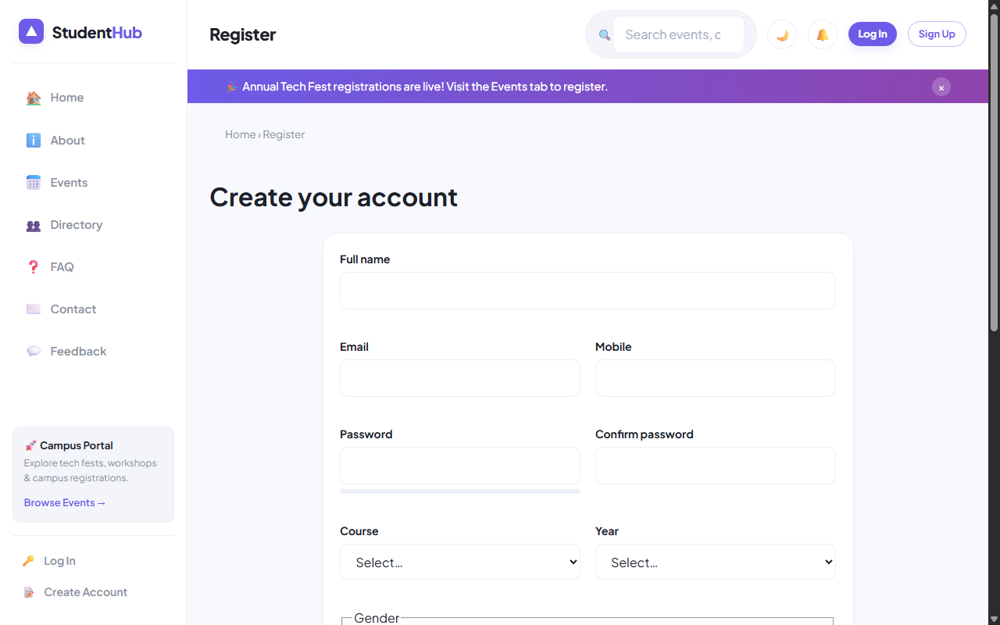
Figure: Registration Form Demonstrating Validation Cues and Account Creation

4. Key Questions & Analysis
Q: Why should MD5 or SHA1 never be used for password storage?
Ans: MD5 and SHA-1 are high-speed general hashing algorithms that lack computational work factors. Modern GPUs compute billions of MD5 hashes per second, making rainbow table and brute-force attacks trivial. Bcrypt incorporates an adaptive slow cost factor and automatic random salt generation.
Q: How does the system prevent duplicate account registrations?
Ans: Through a two-step defense: 1) A parameterized SQL query verifies if the email exists prior to hashing, and 2) A database-level `UNIQUE KEY (email)` constraint on the `users` table acts as a failsafe, catching race conditions via SQL exception code 1062.

Practical 10: Secure Login/Logout with Sessions, Role-Based Access, Timeout, and Remember-Me Token
Practical Aim & Tools
Aim: Implement secure authentication (login/logout) using PHP sessions, `password_verify()`, session regeneration against fixation, role-based access control (RBAC), 15-minute inactivity timeout, and secure remember-me cookies.
Tools & Technologies: PHP Sessions, Cryptographic Tokens, HTTPOnly/Secure Cookies, RBAC Architecture

1. Session Management & Defense-in-Depth Authentication
StudentHub (`login.php`, `logout.php`, `includes/functions.php`) enforces enterprise security standards:
• Secure Authentication: Uses `password_verify($password, $hash)` resisting timing attacks.
• Session Fixation Defense: Calls `session_regenerate_id(true)` upon successful authentication to destroy the pre-login session ID.
• Inactivity Timeout: Automatically tracks `$_SESSION['last_activity']`. Sessions exceeding 15 minutes (`SESSION_TIMEOUT = 900`) are destroyed with a timeout redirect.
• Split-Token Remember-Me: Stores a public 12-byte hex selector and a private 32-byte token hash in `remember_tokens`. Cookies are marked `HttpOnly`, `SameSite=Lax`, and `Expires = 14 days`.
• Role-Based Access Control (RBAC): `require_role('admin')` blocks students from administrative scripts (`students.php`, `manage_events.php`, `admin/`).

2. Implementation Code: Secure Login & Remember-Me
Listing: login.php — Authentication, Session Regeneration, and Split-Token Generation
// login.php - Authentication & Token Issue
$st = $pdo->prepare('SELECT * FROM users WHERE email = ? AND status = "active"');
$st->execute([$email]);
$u = $st->fetch();
if ($u && password_verify($pass, $u['password_hash'])) {
session_regenerate_id(true);
$_SESSION['user'] = ['id' => $u['id'], 'name' => $u['name'], 'email' => $u['email'], 'role' => $u['role']];
$_SESSION['last_activity'] = time();
$pdo->prepare('UPDATE users SET last_login = NOW() WHERE id = ?')->execute([$u['id']]);
if (!empty($_POST['remember'])) {
$sel = bin2hex(random_bytes(12));
$tok = bin2hex(random_bytes(32));
$pdo->prepare('INSERT INTO remember_tokens (user_id, selector, token_hash, expires_at) VALUES (?, ?, ?, DATE_ADD(NOW(), INTERVAL 14 DAY))')
->execute([$u['id'], $sel, hash('sha256', $tok)]);
setcookie('remember', "$sel:$tok", ['expires' => time() + 14*86400, 'path' => '/', 'httponly' => true, 'samesite' => 'Lax']);
}
redirect($u['role'] === 'admin' ? 'admin/dashboard.php' : 'dashboard.php');
}

3. Verification Screenshot: Login Portal & Demo Helper
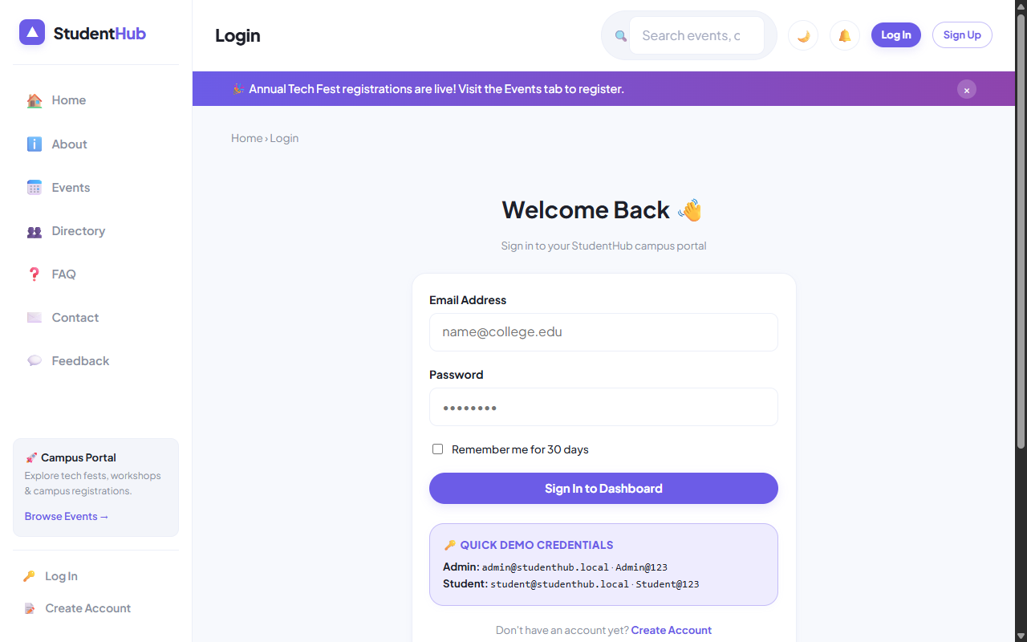
Figure: Secure Login Screen with Role Credentials Helper and Remember-Me Toggle

4. Verification Screenshot: Student Dashboard (Dhruv Bhoi)
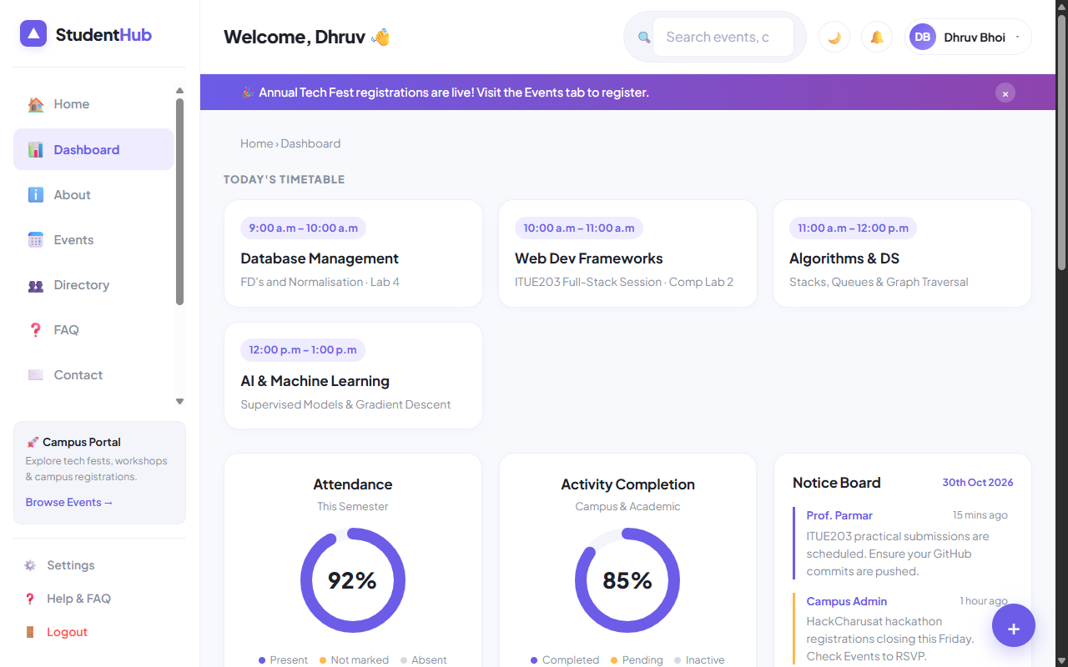
Figure: Authenticated Student Dashboard with Timetable, Progress Donuts, and Events Feed

5. Key Questions & Analysis
Q: How does `session_regenerate_id(true)` protect against session fixation attacks?
Ans: In a session fixation attack, an adversary tricks the victim into using a predetermined session ID. Calling `session_regenerate_id(true)` issues a brand new cryptographically random session identifier while deleting the old session storage, invalidating any fixation token held by the attacker.
Q: How does the split-token 'Remember Me' mechanism prevent database leakage attacks?
Ans: The database stores only the public selector and a SHA-256 hash of the validator token. If an attacker breaches the database, they cannot forge session cookies because the raw validator token is never stored server-side.

Practical 11: Student Management CRUD with Search, Filter, Pagination, Soft Delete, and CSV Export
Practical Aim & Tools
Aim: Develop complete Student Management CRUD operations for administrators with MySQLi prepared statements, search, course filter, pagination, soft delete/restore, and CSV export.
Tools & Technologies: PHP, MySQLi Prepared Statements, CSV Stream Generation, Soft Delete Architecture

1. Administrative CRUD Features (`students.php`)
StudentHub empowers administrators to oversee student records with enterprise-grade safeguards:
• Parameterized CRUD: All Create, Read, Update, and Delete operations use strict MySQLi prepared statements.
• Search & Course Filters: Instant lookup across student name, email, and mobile, coupled with academic course dropdowns.
• Pagination Algorithm: Efficient `LIMIT ?, ?` pagination with calculated offsets (`($page - 1) * $perPage`).
• Soft Delete & Restore: Rather than irrevocably purging database rows, deletions toggle `status = 'deleted'`. Administrators can toggle between 'Active' and 'Deleted' views to restore records.
• On-Demand CSV Export: Clicking 'Export CSV' streams database records directly via `fputcsv()` with HTTP headers `Content-Type: text/csv`.

2. Implementation Code: Prepared CRUD & Soft Delete
Listing: students.php — Prepared Statement Soft Delete and Audit Logging
// students.php - Soft Delete / Restore
if ($_SERVER['REQUEST_METHOD'] === 'POST' && in_array($_POST['do'], ['delete', 'restore'])) {
if (!csrf_check()) flash('error', 'Security token invalid.');
else {
$id = (int)$_POST['id'];
$status = $_POST['do'] === 'delete' ? 'deleted' : 'active';
$st = $mysqli->prepare('UPDATE students SET status=? WHERE id=?');
$st->bind_param('si', $status, $id);
$st->execute();
audit($pdo, 'student_' . $status, 'Student ID: ' . $id);
flash('success', $status === 'deleted' ? 'Student moved to deleted (soft delete).' : 'Student restored successfully.');
}
redirect('students.php');
}

3. Verification Screenshot: Student Management CRUD Interface
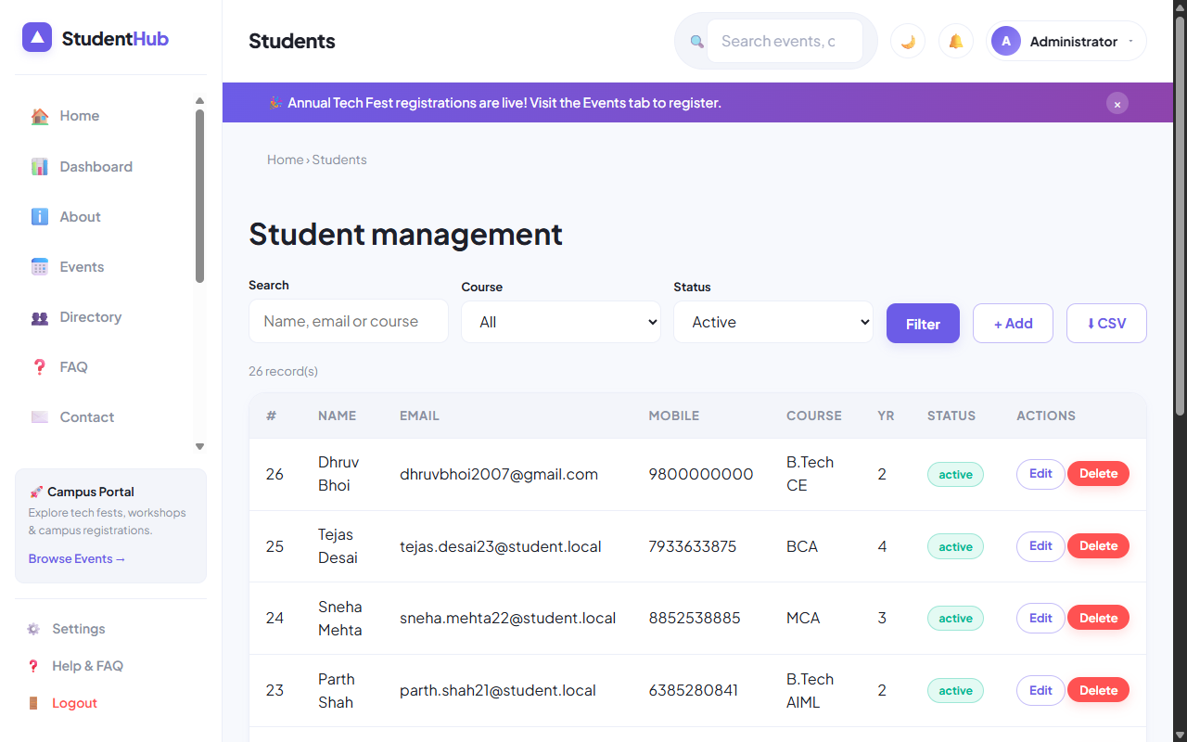
Figure: Student Management CRUD with Search Toolbar, Course Filter, Pagination, and Status Badges

4. Key Questions & Analysis
Q: Why is soft delete preferable over hard delete in enterprise applications?
Ans: Hard delete immediately destroys historical data, breaking foreign key relationships in audit logs, event registrations, and invoices. Soft delete preserves data integrity, prevents accidental data loss, complies with data retention laws, and allows 1-click recovery.
Q: How is CSV export streamed efficiently without exhausting server memory?
Ans: By opening the output stream wrapper `fopen('php://output', 'w')` and writing records iteratively with `fputcsv($out, $row)` directly to the HTTP client socket, buffering 0 intermediate memory.

Practical 12: Event Management CRUD with Poster Upload and File Validation
Practical Aim & Tools
Aim: Build an Event Management CRUD interface with poster image upload, MIME type and size validation, secure unique filename generation, directory permissions, and database tracking.
Tools & Technologies: PHP File Upload Handling (`$_FILES`), MIME Type Detection (`finfo`), File Security

1. Secure File Upload Architecture (`manage_events.php`)
File uploading is one of the most common web attack vectors (Remote Code Execution, Malicious Script Injection). StudentHub defends poster uploads through 5 strict verification checks:
1. HTTP POST & Error Check: Verifies `is_uploaded_file()` and checks `$_FILES['poster']['error'] === UPLOAD_ERR_OK`.
2. File Size Cap: Restricts files to a strict 2 Megabyte ceiling (`2 * 1024 * 1024` bytes).
3. MIME Content Inspection: Uses PHP's `finfo(FILEINFO_MIME_TYPE)` on temporary file bytes, permitting only `image/jpeg`, `image/png`, and `image/webp`. Never relies on client-supplied extensions.
4. Cryptographic Renaming: Files are renamed using `bin2hex(random_bytes(16)) . '.' . $ext` to prevent path traversal and execution.
5. Directory Execution Prevention: The `uploads/` folder contains an `index.php` and an `.htaccess` disabling script execution.

2. Implementation Code: Poster Upload & MIME Inspection
Listing: manage_events.php — MIME Type Verification and Cryptographic Renaming
// manage_events.php - Poster Validation
if (!empty($_FILES['poster']['name'])) {
$f = $_FILES['poster'];
if ($f['size'] > 2 * 1024 * 1024) $errors['poster'] = 'Poster must be under 2 MB.';
else {
$finfo = new finfo(FILEINFO_MIME_TYPE);
$mime = $finfo->file($f['tmp_name']);
$map = ['image/jpeg'=>'jpg', 'image/png'=>'png', 'image/webp'=>'webp'];
if (!isset($map[$mime])) {
$errors['poster'] = 'Invalid format. Only JPG, PNG, and WEBP allowed.';
} else {
$filename = bin2hex(random_bytes(16)) . '.' . $map[$mime];
move_uploaded_file($f['tmp_name'], BASE_PATH . '/uploads/' . $filename);
$posterPath = 'uploads/' . $filename;
}
}
}

3. Verification Screenshot: Event Management CRUD
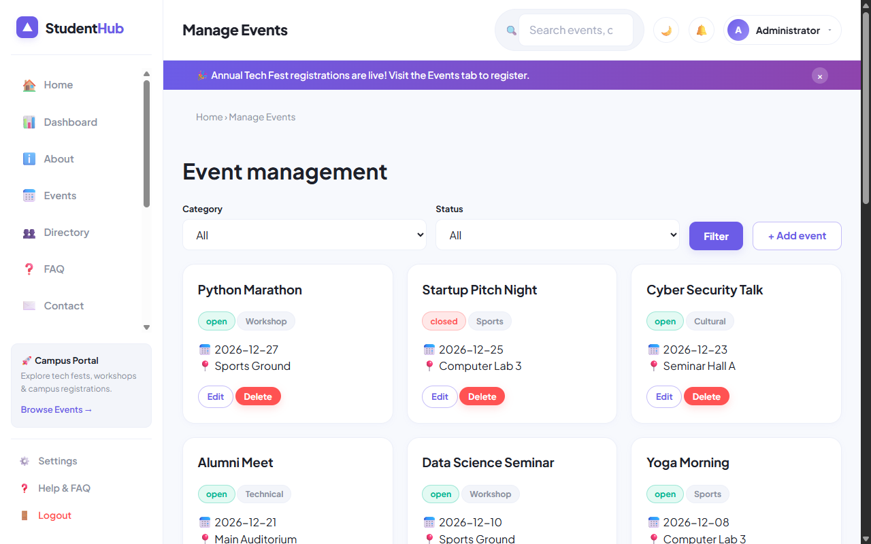
Figure: Event Management CRUD Interface with Poster Upload Field and Live Status Controls

4. Key Questions & Analysis
Q: Why should `$_FILES['poster']['type']` never be trusted?
Ans: `$_FILES['...']['type']` is a client-provided HTTP header that can be spoofed trivially using Postman or Burp Suite. A malicious user could upload a PHP shell named `shell.php` with header `Content-Type: image/jpeg`. Server-side verification must use `finfo_file` to read file magic bytes directly.
Q: How does cryptographic file renaming mitigate path traversal?
Ans: Renaming files to random hashes (e.g. `a3f8c...jpg`) strips dangerous characters like `../` or null bytes, preventing attackers from overwriting existing system files or guessing uploaded filenames.

Practical 13: PHP JSON API and AJAX/Fetch-Based CRUD without Page Reload
Practical Aim & Tools
Aim: Create a RESTful PHP JSON API endpoint (`api/events.php`) supporting GET and POST, and integrate AJAX/Fetch CRUD operations without page reloads, including loading spinners and toast notifications.
Tools & Technologies: PHP REST API, JSON Serialization, AJAX, Fetch API, DOM Replacement

1. RESTful JSON API Architecture (`api/events.php`)
StudentHub implements a dedicated headless API endpoint adhering to REST conventions:
• Content Negotiation: Emits `Content-Type: application/json; charset=utf-8` on every response.
• HTTP Verbs & Routing: GET requests query events with optional debounced search filters; POST requests handle authenticated CRUD actions (create, delete, toggle status).
• Standard HTTP Status Codes: Returns `200 OK` on success, `401 Unauthorized` for guests, `403 Forbidden` for invalid CSRF tokens, `422 Unprocessable Entity` for validation errors, and `500 Internal Error` for failures.
• Client-Side Controller (`assets/js/api-crud.js`): Intercepts form submissions, transmits JSON payloads with `X-CSRF-Token` headers, and smoothly updates the DOM table without full page refreshes.

2. Implementation Code: API Router & AJAX Client
Listing: api/events.php — Parameterized REST API with HTTP Status Emission
// api/events.php - JSON API Router
header('Content-Type: application/json; charset=utf-8');
require_once __DIR__ . '/../includes/functions.php';
require_once __DIR__ . '/../includes/db.php';
require_login(); // Requires authenticated session (401 response on failure)
if ($_SERVER['REQUEST_METHOD'] === 'GET') {
$q = clean($_GET['q'] ?? '');
$sql = 'SELECT id, title, category, event_date, venue, status FROM events';
if ($q !== '') $sql .= ' WHERE title LIKE ? OR venue LIKE ?';
$st = $pdo->prepare($sql);
$q !== '' ? $st->execute(["%$q%", "%$q%"]) : $st->execute();
echo json_encode(['success' => true, 'data' => $st->fetchAll()]);
exit;
}

3. Verification Screenshot: Live AJAX Events Interface
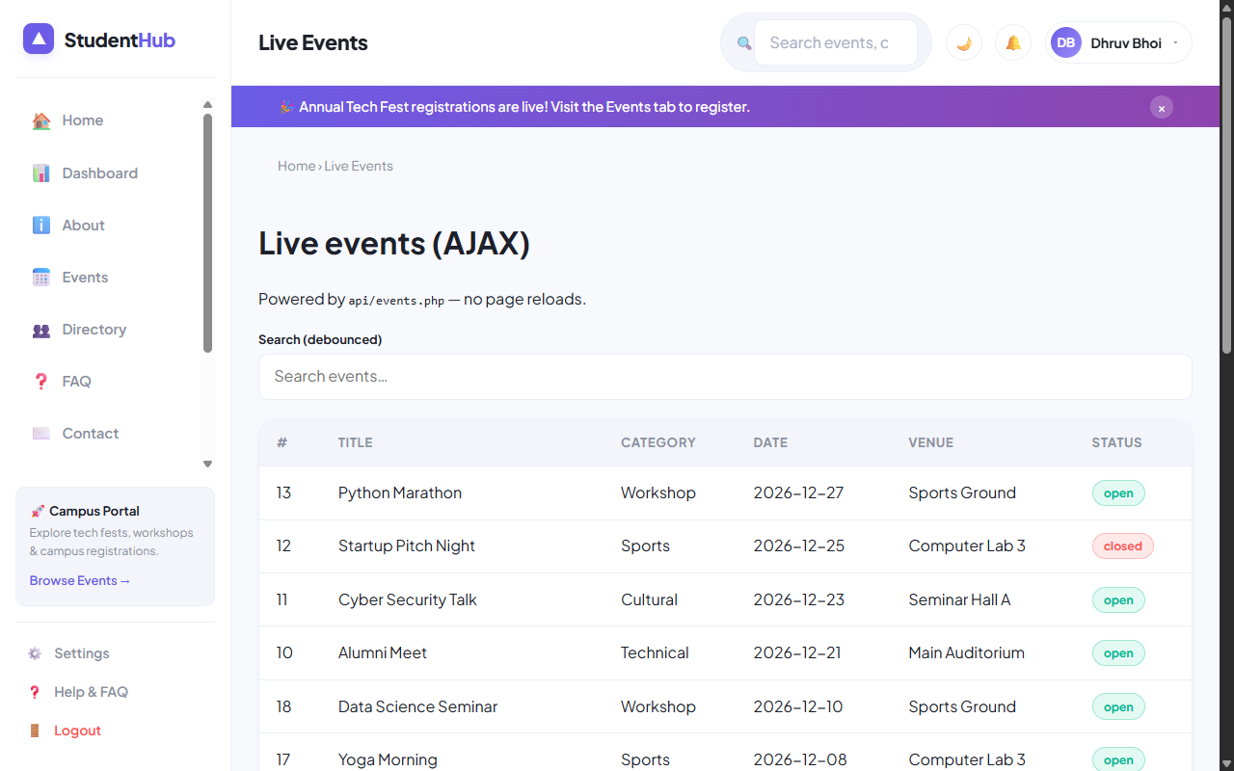
Figure: Live AJAX Events Dashboard (api-demo.php) Rendering Real-Time Updates without Reloads

4. Key Questions & Analysis
Q: How are CSRF tokens transmitted during asynchronous AJAX requests?
Ans: During page generation, the server places a CSRF token in a data attribute (`data-csrf="..."`). The JavaScript controller attaches this token to the custom request header `X-CSRF-Token`, which PHP validates via `csrf_check($_SERVER['HTTP_X_CSRF_TOKEN'])`.
Q: What are the benefits of Single Page Application (SPA) AJAX updates over traditional server-rendered pages?
Ans: AJAX updates significantly reduce network bandwidth by exchanging lightweight JSON rather than full HTML documents. The user experience is seamless without screen flashing, form inputs preserve focus, and responsiveness feels like a native desktop app.

Practical 14: Admin Dashboard with Role-Based Access Control, Dynamic Menu, and Audit Log
Practical Aim & Tools
Aim: Develop an Admin Dashboard with role-based access control, KPI metric cards, dynamic navigation, stored procedure monthly registration charts, user active/inactive toggles, and an audit trail viewer.
Tools & Technologies: PHP, MySQL Stored Procedures, Role-Based Access Control (RBAC), CSS Data Visualization

1. Enterprise Admin Features (`admin/dashboard.php` & `admin/audit.php`)
The administrative module provides executive-level monitoring of the entire StudentHub portal:
• KPI Stat Metric Cards: Real-time calculation of Total Students, Active Campus Events, Total RSVP Registrations, and Security Audit Actions.
• Stored Procedure Execution: Calls MySQL stored procedure `CALL sp_registrations_by_month()` to compute month-by-month registration velocity, rendering pure CSS proportional bar charts.
• User Lifecycle Controls: Interactive table displaying registered campus users with 1-click status toggles ('Active' ↔ 'Inactive') and last login timestamps.
• Security Audit Trail (`admin/audit.php`): Full system audit trail logging actions (`login`, `register`, `student_create`, `event_delete`), actor email, IP address, and timestamps.

2. Implementation Code: Stored Procedure & Dynamic Analytics
Listing: admin/dashboard.php — Stored Procedure Execution and User Lifecycle Management
// admin/dashboard.php - Stored Procedure Invocation & Analytics
require_once __DIR__ . '/../includes/functions.php';
require_once __DIR__ . '/../includes/db.php';
require_role('admin'); // Restricts access exclusively to administrators
// Execute Stored Procedure
$monthly = $pdo->query('CALL sp_registrations_by_month()')->fetchAll();
$pdo->query('SELECT 1')->closeCursor(); // Free connection cursor for subsequent queries
// User Active / Inactive Status Toggle
if ($_SERVER['REQUEST_METHOD'] === 'POST' && ($_POST['do'] ?? '') === 'toggle') {
if (csrf_check()) {
$uid = (int)$_POST['user_id'];
$u = $pdo->prepare('SELECT status, email FROM users WHERE id=?');
$u->execute([$uid]);
$row = $u->fetch();
$next = $row['status'] === 'active' ? 'inactive' : 'active';
$pdo->prepare('UPDATE users SET status=? WHERE id=?')->execute([$next, $uid]);
audit($pdo, 'user_status_' . $next, 'User: ' . $row['email']);
flash('success', 'User account ' . $next . ' successfully.');
}
redirect('dashboard.php');
}

3. Verification Screenshot: Executive Admin Dashboard

Figure: Admin Dashboard with KPI Stat Cards, Stored Procedure Monthly Chart, and User Status Toggles

4. Verification Screenshot: Security Audit Log Viewer
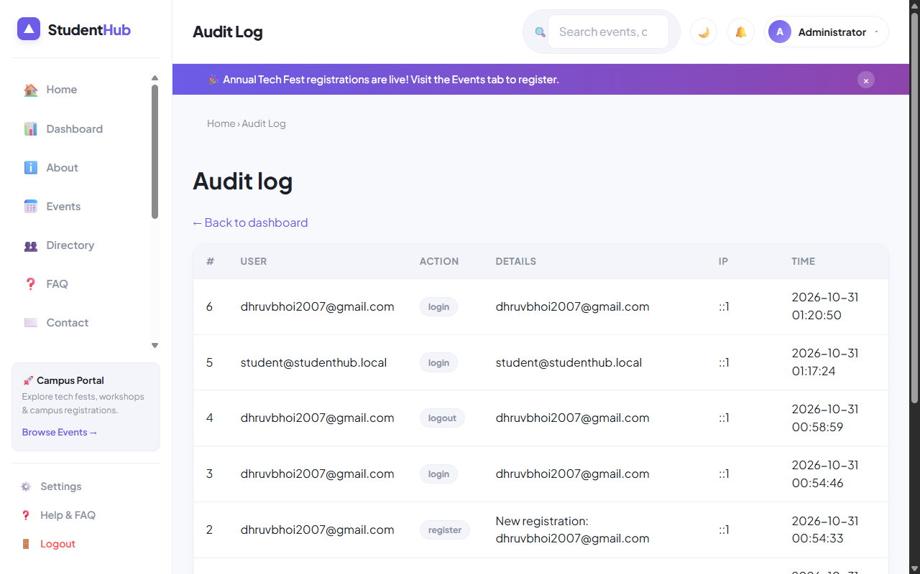
Figure: Immutable Security Audit Trail (admin/audit.php) Tracking User Actions and IP Addresses

5. Key Questions & Analysis
Q: How does `require_role('admin')` enforce access control across sensitive endpoints?
Ans: It checks `$_SESSION['user']['role'] === 'admin'`. If a student or guest attempts to access the script directly via URL, the function emits `HTTP 403 Forbidden`, dispatches an access denied flash message, and redirects the client to `dashboard.php`.
Q: Why are stored procedures used for aggregation queries like monthly registrations?
Ans: Stored procedures are pre-compiled and optimized on the MySQL database server. They minimize network latency by executing complex multi-table groupings internally, provide access abstraction, and enhance enterprise security.

