CHAROTAR UNIVERSITY OF SCIENCE AND TECHNOLOGY (CHARUSAT)
CSPIT — Department of Computer Engineering · ITUE203 Web Development Frameworks
Student Name | Dhruv Bhoi | Student ID | D26CE154
Academic Year | 2026–27 (ODD) | Semester | 3rd Semester, B.Tech CE
――――――――――――――――――――――――――――――――――――――――――――――――――――――――――

Practical 1: Project Initiation, Requirement Analysis, Sitemap, Wireframe, and GitHub Setup
Practical Aim & Tools
Aim: Initiate the semester-long Student Hub portal by identifying the problem scope, user roles, key modules, navigation flow, and minimum 10 pages. Create a sitemap, low-fidelity wireframe, project folder structure, README file, and GitHub repository.
Tools & Technologies: VS Code, Draw.io, Git, GitHub, Markdown

1. Project Overview & Problem Statement
StudentHub is a modern, unified campus management web application designed for Charotar University of Science and Technology (CHARUSAT). Historically, college students have had to navigate multiple fragmented portals for attendance, course details, campus events, and administrative notices. StudentHub consolidates these functions behind a single secure login with role-based access control (Student vs. Administrator), presenting users with a sleek modern SaaS dashboard layout featuring timetable cards, circular SVG donut progress rings, and a live notice board feed.

2. User Roles & Modules
• Guest / Public: Landing page (hero slider), about page, event catalog, student directory with dependent state-city filters, FAQ accordion, contact form, and feedback submission.
• Student: Secure authentication, personal timetable, attendance & assignment progress donuts, 1-click event RSVP & cancellation, and student profile management.
• Administrator: Student management CRUD (search, filter, pagination, soft delete/restore, CSV export), Event management CRUD (with poster image uploads), dynamic Admin Dashboard with stored procedure monthly registration bar chart, and user active/inactive toggles.

3. Sitemap & Navigation Architecture
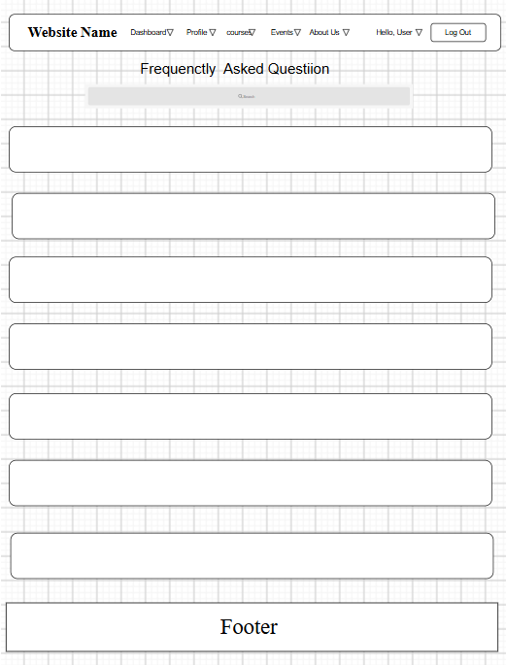
Figure: StudentHub Hierarchical Sitemap & Navigation Map

4. Low-Fidelity Wireframes
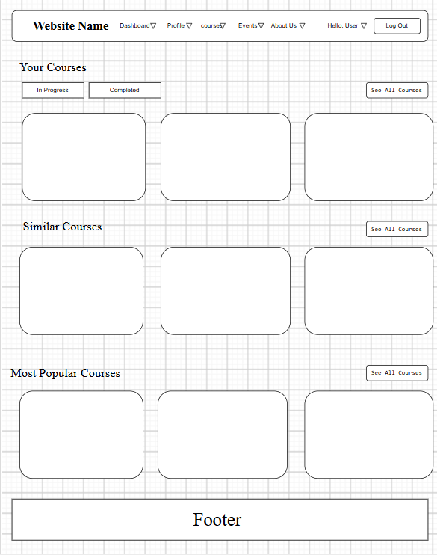
Figure: Low-Fidelity Dashboard Wireframe (Left Sidebar, Schedule Cards & Stat Widgets)
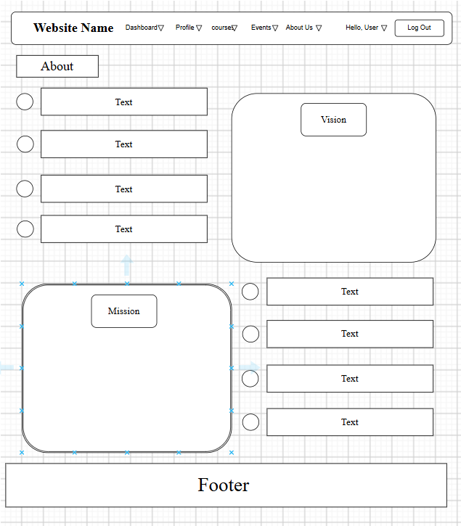
Figure: Low-Fidelity Events Wireframe (Toolbar, Search, Cards Grid & Pagination)

5. Project Folder Structure
Listing: Clean, Production-Ready Directory Structure
studenthub/
├── assets/
│ ├── css/style.css # Acade SaaS design tokens, layout shell, schedule cards
│ ├── js/ # main.js, validation.js, data-render.js, api-crud.js
│ └── images/ # logos, banners, placeholders
├── data/
│ ├── events.json # Sample JSON dataset for campus events
│ ├── students.json # Sample JSON dataset for student directory
│ ├── contacts.csv # Server-side CSV storage for contact inquiries
│ └── feedback.json # Server-side JSON storage for rating feedback
├── database/
│ └── studenthub.sql # Normalized 3NF MySQL schema, triggers, seed data
├── docs/ # requirements.md, sitemap.md, wireframes.md, er-diagram.md
├── includes/
│ ├── config.php # Environment constants, session lifetime, credentials
│ ├── db.php # Secure PDO & MySQLi dual connection helper
│ ├── functions.php # Auth, CSRF, flash messaging, audit trail
│ ├── header.php # Acade layout sidebar drawer & top search/greeting bar
│ └── footer.php # Shared footer attribution & dynamic scripts
├── static/ # 12 accessible static HTML5 mockups (Practical 2)
├── admin/
│ ├── dashboard.php # KPI stat cards, stored procedure charts, user toggles
│ └── audit.php # System activity audit trail log viewer
├── api/
│ └── events.php # RESTful JSON API endpoint for events CRUD
├── index.php, login.php, register.php, dashboard.php, profile.php, events.php
└── students.php, manage_events.php, api-demo.php, db-test.php

6. Key Questions & Analysis
Q: What is a URL and what are its constituent parts?
Ans: A Uniform Resource Locator (URL) is a standardized web address referencing a resource over a network. Its parts include: 1) Scheme/Protocol (http, https), 2) Subdomain & Domain Name (studenthub.local or charusat.edu.in), 3) Port (:80, :443), 4) Path (/events.php), 5) Query String (?category=Workshop&sort=date:asc), and 6) Fragment identifier (#main).
Q: How does a web browser process an HTML file?
Ans: The browser performs: 1) Conversion of raw bytes into characters based on UTF-8, 2) Tokenization into HTML tags, 3) Construction of the Document Object Model (DOM) tree, 4) Processing of linked CSS stylesheets into the CSSOM tree, 5) Combining DOM and CSSOM into a Render Tree, 6) Layout computation (geometric positions of elements), and 7) Painting pixels to screen.
Q: How will page navigation flow be managed among all pages?
Ans: Through a unified, responsive application shell (`includes/header.php`) featuring a fixed left navigation sidebar on desktop that collapses into an accessible slide-out mobile drawer with an overlay. Links dynamically highlight the active page using `aria-current="page"`.

Practical 1 Conclusion & Learning Outcomes
Successfully initiated the StudentHub campus portal. The problem definition, functional and non-functional requirements, user roles (Student, Admin, Guest), modular hierarchical sitemap, low-fidelity wireframes, structured directory layout, and GitHub version control repository were successfully established.

