CHAROTAR UNIVERSITY OF SCIENCE AND TECHNOLOGY (CHARUSAT)
CSPIT — Department of Computer Engineering · ITUE203 Web Development Frameworks
Student Name | Dhruv Bhoi | Student ID | D26CE154
Academic Year | 2026–27 (ODD) | Semester | 3rd Semester, B.Tech CE
――――――――――――――――――――――――――――――――――――――――――――――――――――――――――

Practical 11: Student Management CRUD with Search, Filter, Pagination, Soft Delete, and CSV Export
Practical Aim & Tools
Aim: Develop complete Student Management CRUD operations for administrators with MySQLi prepared statements, search, course filter, pagination, soft delete/restore, and CSV export.
Tools & Technologies: PHP, MySQLi Prepared Statements, CSV Stream Generation, Soft Delete Architecture

1. Administrative CRUD Features (`students.php`)
StudentHub empowers administrators to oversee student records with enterprise-grade safeguards:
• Parameterized CRUD: All Create, Read, Update, and Delete operations use strict MySQLi prepared statements.
• Search & Course Filters: Instant lookup across student name, email, and mobile, coupled with academic course dropdowns.
• Pagination Algorithm: Efficient `LIMIT ?, ?` pagination with calculated offsets (`($page - 1) * $perPage`).
• Soft Delete & Restore: Rather than irrevocably purging database rows, deletions toggle `status = 'deleted'`. Administrators can toggle between 'Active' and 'Deleted' views to restore records.
• On-Demand CSV Export: Clicking 'Export CSV' streams database records directly via `fputcsv()` with HTTP headers `Content-Type: text/csv`.

2. Implementation Code: Prepared CRUD & Soft Delete
Listing: students.php — Prepared Statement Soft Delete and Audit Logging
// students.php - Soft Delete / Restore
if ($_SERVER['REQUEST_METHOD'] === 'POST' && in_array($_POST['do'], ['delete', 'restore'])) {
if (!csrf_check()) flash('error', 'Security token invalid.');
else {
$id = (int)$_POST['id'];
$status = $_POST['do'] === 'delete' ? 'deleted' : 'active';
$st = $mysqli->prepare('UPDATE students SET status=? WHERE id=?');
$st->bind_param('si', $status, $id);
$st->execute();
audit($pdo, 'student_' . $status, 'Student ID: ' . $id);
flash('success', $status === 'deleted' ? 'Student moved to deleted (soft delete).' : 'Student restored successfully.');
}
redirect('students.php');
}

3. Verification Screenshot: Student Management CRUD Interface
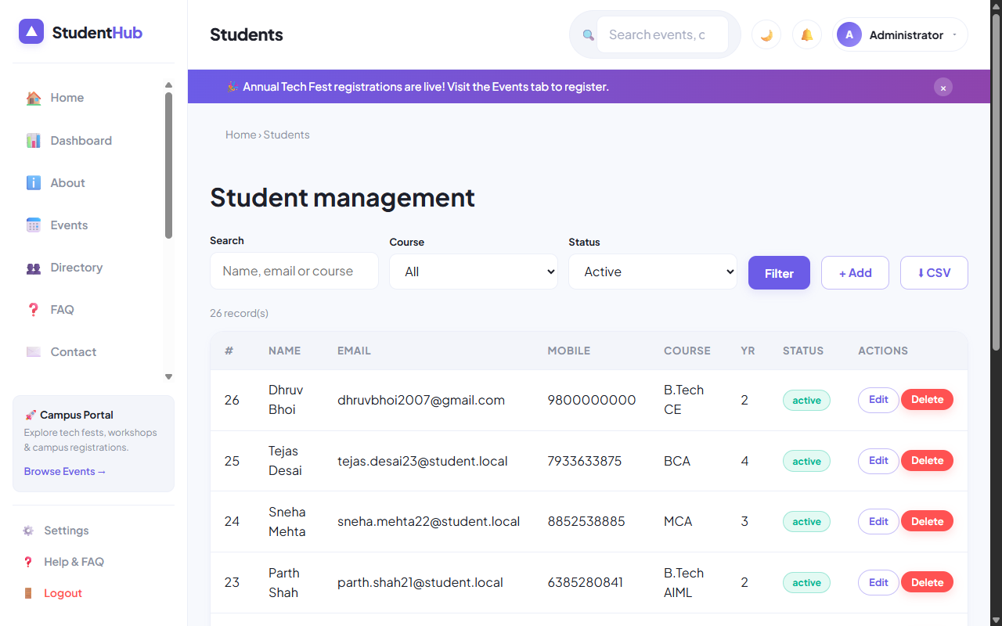
Figure: Student Management CRUD with Search Toolbar, Course Filter, Pagination, and Status Badges

4. Key Questions & Analysis
Q: Why is soft delete preferable over hard delete in enterprise applications?
Ans: Hard delete immediately destroys historical data, breaking foreign key relationships in audit logs, event registrations, and invoices. Soft delete preserves data integrity, prevents accidental data loss, complies with data retention laws, and allows 1-click recovery.
Q: How is CSV export streamed efficiently without exhausting server memory?
Ans: By opening the output stream wrapper `fopen('php://output', 'w')` and writing records iteratively with `fputcsv($out, $row)` directly to the HTTP client socket, buffering 0 intermediate memory.

Practical 11 Conclusion & Learning Outcomes
Developed full administrative Student Management CRUD operations utilizing MySQLi prepared statements. Implemented multi-field search, course filtering, LIMIT/OFFSET pagination, non-destructive soft delete/restore mechanisms, and streaming CSV export.

