CHAROTAR UNIVERSITY OF SCIENCE AND TECHNOLOGY (CHARUSAT)
CSPIT — Department of Computer Engineering · ITUE203 Web Development Frameworks
Student Name | Dhruv Bhoi | Student ID | D26CE154
Academic Year | 2026–27 (ODD) | Semester | 3rd Semester, B.Tech CE
――――――――――――――――――――――――――――――――――――――――――――――――――――――――――

Practical 14: Admin Dashboard with Role-Based Access Control, Dynamic Menu, and Audit Log
Practical Aim & Tools
Aim: Develop an Admin Dashboard with role-based access control, KPI metric cards, dynamic navigation, stored procedure monthly registration charts, user active/inactive toggles, and an audit trail viewer.
Tools & Technologies: PHP, MySQL Stored Procedures, Role-Based Access Control (RBAC), CSS Data Visualization

1. Enterprise Admin Features (`admin/dashboard.php` & `admin/audit.php`)
The administrative module provides executive-level monitoring of the entire StudentHub portal:
• KPI Stat Metric Cards: Real-time calculation of Total Students, Active Campus Events, Total RSVP Registrations, and Security Audit Actions.
• Stored Procedure Execution: Calls MySQL stored procedure `CALL sp_registrations_by_month()` to compute month-by-month registration velocity, rendering pure CSS proportional bar charts.
• User Lifecycle Controls: Interactive table displaying registered campus users with 1-click status toggles ('Active' ↔ 'Inactive') and last login timestamps.
• Security Audit Trail (`admin/audit.php`): Full system audit trail logging actions (`login`, `register`, `student_create`, `event_delete`), actor email, IP address, and timestamps.

2. Implementation Code: Stored Procedure & Dynamic Analytics
Listing: admin/dashboard.php — Stored Procedure Execution and User Lifecycle Management
// admin/dashboard.php - Stored Procedure Invocation & Analytics
require_once __DIR__ . '/../includes/functions.php';
require_once __DIR__ . '/../includes/db.php';
require_role('admin'); // Restricts access exclusively to administrators
// Execute Stored Procedure
$monthly = $pdo->query('CALL sp_registrations_by_month()')->fetchAll();
$pdo->query('SELECT 1')->closeCursor(); // Free connection cursor for subsequent queries
// User Active / Inactive Status Toggle
if ($_SERVER['REQUEST_METHOD'] === 'POST' && ($_POST['do'] ?? '') === 'toggle') {
if (csrf_check()) {
$uid = (int)$_POST['user_id'];
$u = $pdo->prepare('SELECT status, email FROM users WHERE id=?');
$u->execute([$uid]);
$row = $u->fetch();
$next = $row['status'] === 'active' ? 'inactive' : 'active';
$pdo->prepare('UPDATE users SET status=? WHERE id=?')->execute([$next, $uid]);
audit($pdo, 'user_status_' . $next, 'User: ' . $row['email']);
flash('success', 'User account ' . $next . ' successfully.');
}
redirect('dashboard.php');
}

3. Verification Screenshot: Executive Admin Dashboard
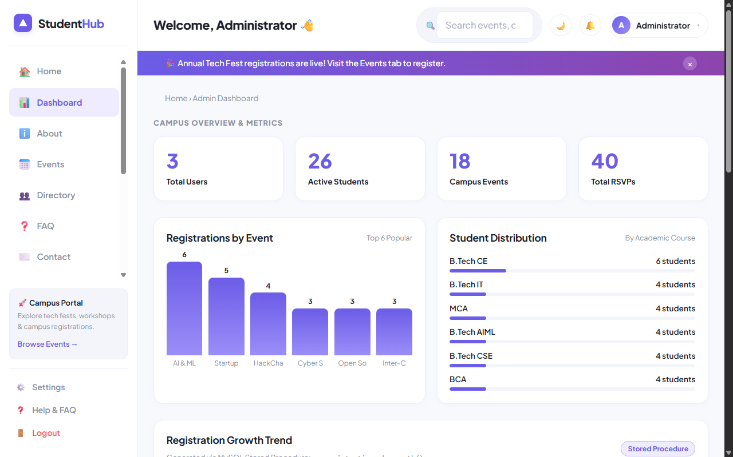
Figure: Admin Dashboard with KPI Stat Cards, Stored Procedure Monthly Chart, and User Status Toggles

4. Verification Screenshot: Security Audit Log Viewer
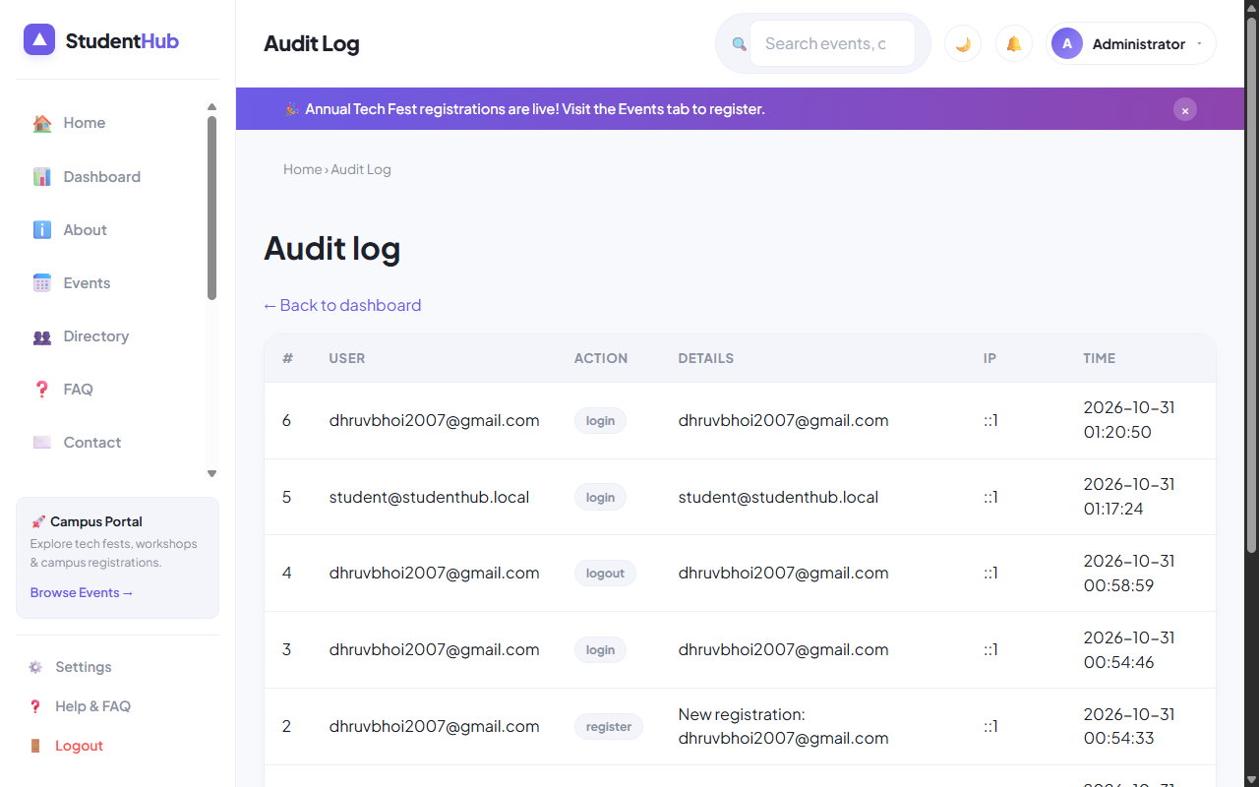
Figure: Immutable Security Audit Trail (admin/audit.php) Tracking User Actions and IP Addresses

5. Key Questions & Analysis
Q: How does `require_role('admin')` enforce access control across sensitive endpoints?
Ans: It checks `$_SESSION['user']['role'] === 'admin'`. If a student or guest attempts to access the script directly via URL, the function emits `HTTP 403 Forbidden`, dispatches an access denied flash message, and redirects the client to `dashboard.php`.
Q: Why are stored procedures used for aggregation queries like monthly registrations?
Ans: Stored procedures are pre-compiled and optimized on the MySQL database server. They minimize network latency by executing complex multi-table groupings internally, provide access abstraction, and enhance enterprise security.

Practical 14 Conclusion & Learning Outcomes
Developed an executive Admin Dashboard featuring real-time KPI metric calculation, stored procedure execution (sp_registrations_by_month) with CSS bar charts, user active/inactive toggles, and an immutable security audit trail (admin/audit.php).

