CHAROTAR UNIVERSITY OF SCIENCE AND TECHNOLOGY (CHARUSAT)
CSPIT — Department of Computer Engineering · ITUE203 Web Development Frameworks
Student Name | Dhruv Bhoi | Student ID | D26CE154
Academic Year | 2026–27 (ODD) | Semester | 3rd Semester, B.Tech CE
――――――――――――――――――――――――――――――――――――――――――――――――――――――――――

Practical 2: Semantic HTML5 Pages with Accessibility-Ready Structure
Practical Aim & Tools
Aim: Develop static HTML5 skeletons for at least 10 Student_Hub pages such as Home, About, Register, Login, Dashboard, Profile, Events, Directory, FAQ, Contact, Feedback, and Admin using semantic tags with accessibility support.
Tools & Technologies: VS Code, HTML5, WAI-ARIA, Screen Reader Testing

1. Semantic Architecture & WAI-ARIA Landmarks
Modern web standards require semantic HTML5 elements over generic <div> tags to enable screen readers, assistive technology, and search engine spiders to understand page hierarchy. In StudentHub, every page adheres to the following landmark structure:
• <header> & <aside class="app-sidebar">: Application branding, search input, and main navigation landmark.
• <main id="main" class="container">: Primary landmark holding core page content, paired with a <a class="skip-link" href="#main"> for keyboard accessibility.
• <section> & <article>: Grouping logical modules (e.g. event cards, student profile sections, notice boards).
• <footer>: Site metadata, university credentials, and copyright attribution.
• ARIA attributes: aria-live="polite" on dynamic search results and error messages, aria-expanded="false" on accordions and menus, and role="status" on alerts.

2. Minimum 10 Implemented Pages Inventory
StudentHub implements 14 full pages (exceeding the syllabus requirement of 10):
1. index.php (Home / Hero Slider) | 2. about.php (Project & Credentials) | 3. events.php (Catalog & Filters)
4. directory.php (Dependent Filters) | 5. faq.php (Accordion UI) | 6. contact.php (CSV File Storage)
7. feedback.php (Star Rating/JSON) | 8. login.php (Auth & Remember Me) | 9. register.php (Validation & CAPTCHA)
10. dashboard.php (Acade SaaS) | 11. profile.php (User Profile) | 12. students.php (CRUD & CSV Export)
13. manage_events.php (Uploads) | 14. admin/dashboard.php (Charts/RBAC) | 15. db-test.php (Diagnostic Test Suite)

3. Implementation Code: Semantic Shell
Listing: Semantic HTML5 Shell with Skip-Link and WAI-ARIA
<!-- Accessible Semantic Structure Skeleton -->
<!DOCTYPE html>
<html lang="en">
<head>
<meta charset="UTF-8">
<meta name="viewport" content="width=device-width, initial-scale=1">
<title>StudentHub | Modern Campus Portal</title>
<link rel="stylesheet" href="assets/css/style.css">
</head>
<body>
<a class="skip-link" href="#main">Skip to main content</a>
<div class="app-layout">
<aside class="app-sidebar" id="appSidebar" aria-label="Main Navigation">
<a class="sidebar-brand" href="index.php"><div class="sidebar-brand-icon">▲</div><span>StudentHub</span></a>
<nav aria-label="Sidebar Menu">
<ul class="sidebar-nav">
<li><a href="dashboard.php" class="nav-item active" aria-current="page"><i>📊</i><span>Dashboard</span></a></li>
<li><a href="events.php" class="nav-item"><i>📅</i><span>Events</span></a></li>
</ul>
</nav>
</aside>
<div class="app-main">
<header class="app-topbar">
<button class="hamburger" id="hamburger" aria-label="Toggle menu" aria-expanded="false">☰</button>
<div class="topbar-search"><input type="search" placeholder="Search events, courses…" aria-label="Search"></div>
</header>
<main id="main" class="container app-content" tabindex="-1">
<!-- Main page content here -->
</main>
<footer class="site-footer"><small>&copy; 2026 StudentHub - Developed by Dhruv Bhoi (D26CE154)</small></footer>
</div>
</div>
</body>
</html>

4. Verification Screenshot: Static Home & Navigation
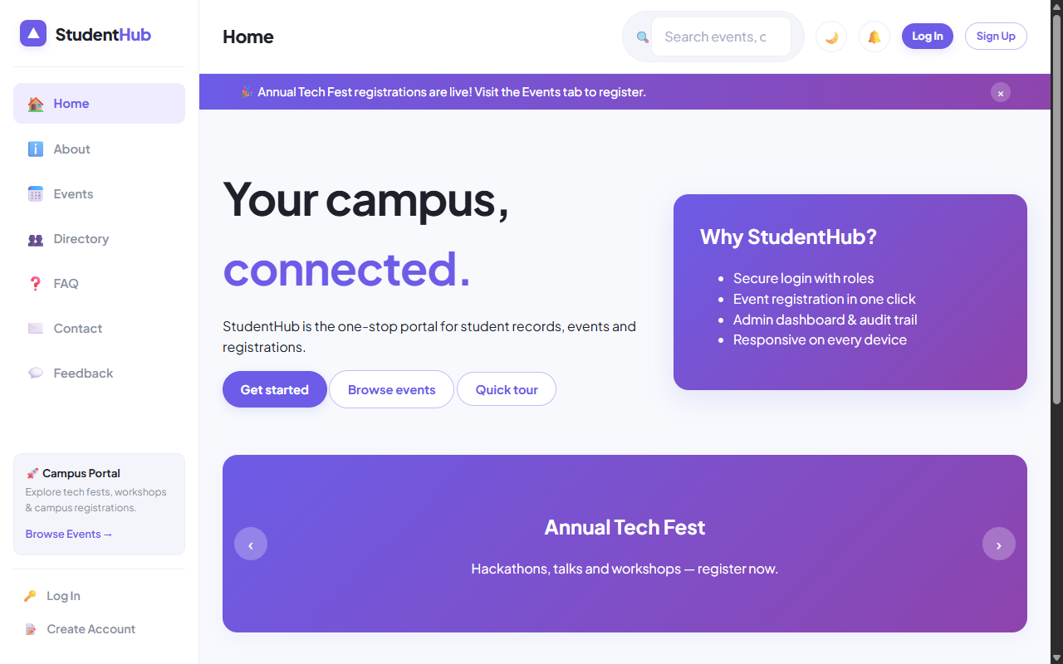
Figure: Semantic Static Landing Page with Accessible Hero and Highlights

5. Key Questions & Analysis
Q: Are semantic elements like header, nav, main, section, article, and footer used properly?
Ans: Yes. StudentHub strictly avoids <div> soup. The page layout uses <header> for titles/tools, <aside> for sidebar navigation, <main> for the single central document body, <article> for self-contained cards (events, reviews), and <footer> for attributions.
Q: Is the website accessibility-ready (WAI-ARIA, skip link, forms)?
Ans: Yes. It implements: 1) Skip link pointing to `#main`, 2) Distinct `<label for="...">` bindings for all form inputs, 3) `aria-live="polite"` regions for live search counts and validation feedback, and 4) `aria-expanded` attributes on interactive menus.

Practical 2 Conclusion & Learning Outcomes
Successfully developed semantic, accessible HTML5 page skeletons for all 14 core modules of StudentHub (exceeding the syllabus requirement of 10). Implemented WAI-ARIA landmarks, keyboard skip links, accessible form labels, and live status regions.

